Name: Prashant Ranjan Roll No: 24mc3035

Sol1:
#include <iostream>
using namespace std;

class SerialObject {
private:
static int count;
int serialNumber;

public:
SerialObject() {
count++;
serialNumber = count;
}

void reportSerial() {
cout << "I am object number " << serialNumber << endl;
}
};

int SerialObject::count = 0;

int main() {
SerialObject obj1;
SerialObject obj2;
SerialObject obj3;

obj1.reportSerial();
obj2.reportSerial();
obj3.reportSerial();

return 0;
}

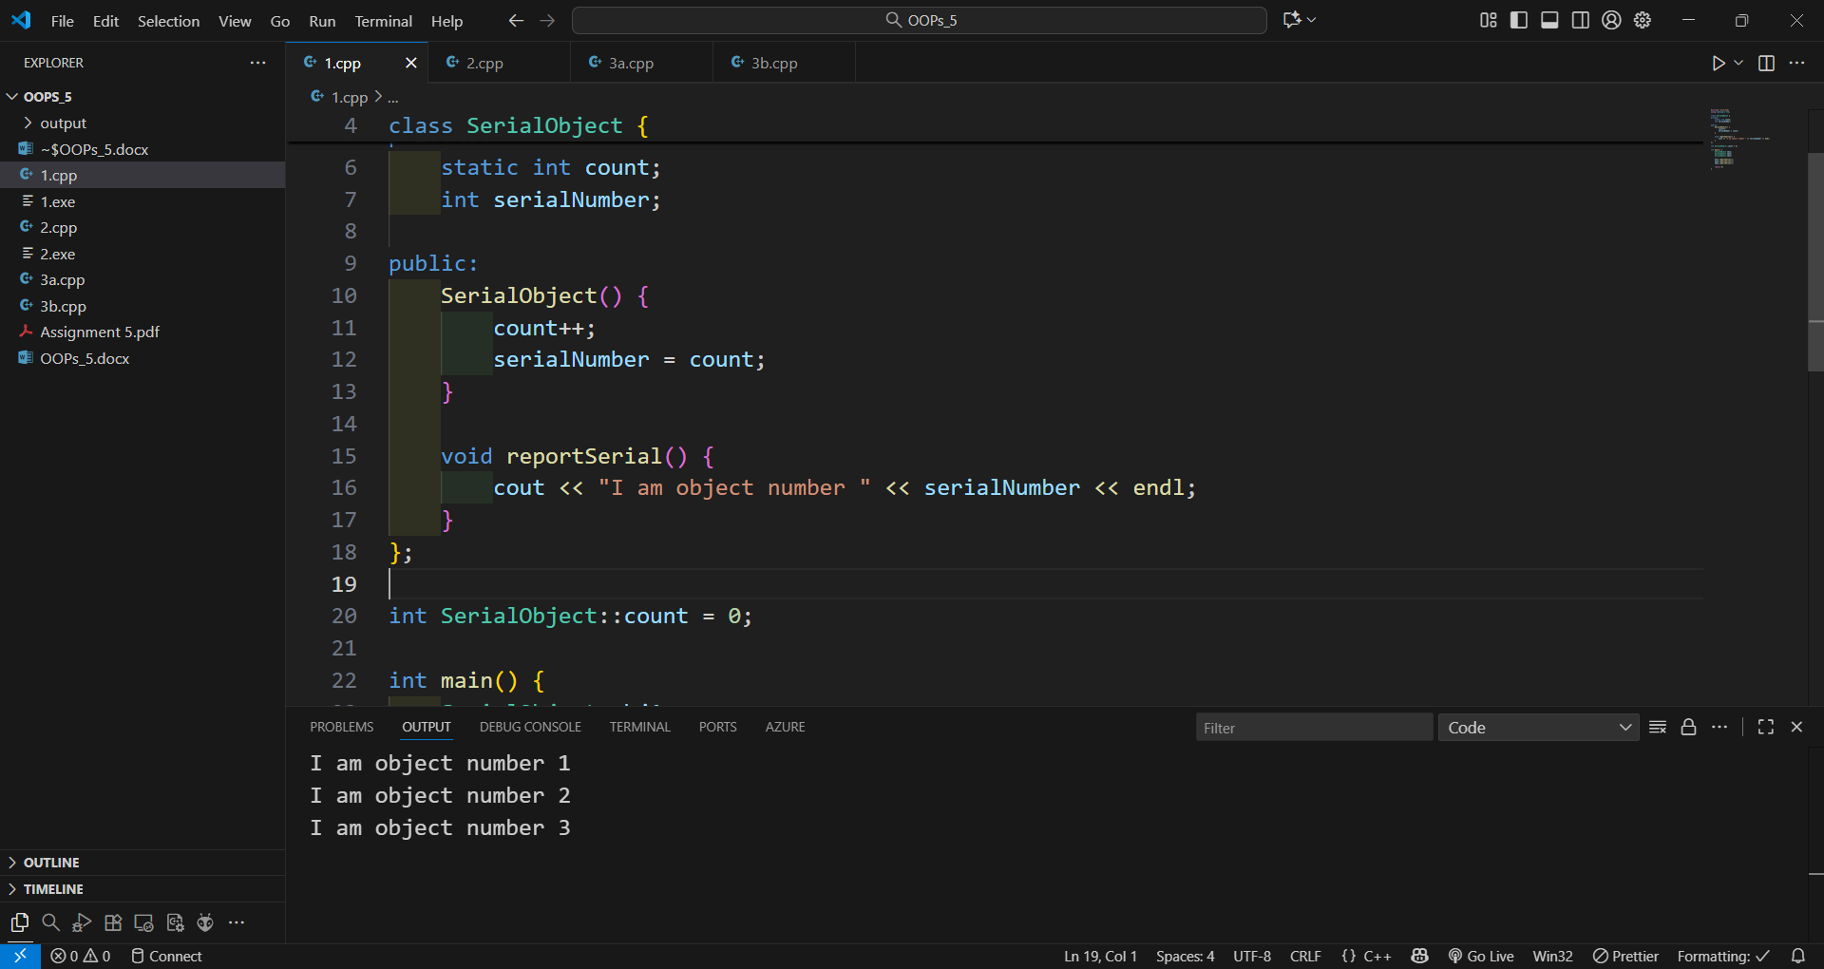
Sol 2:
#include <iostream>
#include <iomanip>
using namespace std;

class Time {
private:
int hours;
int minutes;
int seconds;

public:
Time() : hours(0), minutes(0), seconds(0) {}

Time(int h, int m, int s) : hours(h), minutes(m), seconds(s) {}

void display() const {
cout << setfill('0') << setw(2) << hours << ":"
<< setw(2) << minutes << ":"
<< setw(2) << seconds << endl;
}

void addTime(const Time& t1, const Time& t2) {
seconds = t1.seconds + t2.seconds;
minutes = t1.minutes + t2.minutes + seconds / 60;
seconds %= 60;
hours = t1.hours + t2.hours + minutes / 60;
minutes %= 60;
}
};

int main() {
const Time time1(5, 30, 45);
const Time time2(3, 50, 30);
Time time3;

time3.addTime(time1, time2);

cout << "Sum of times: ";
time3.display();

return 0;
}

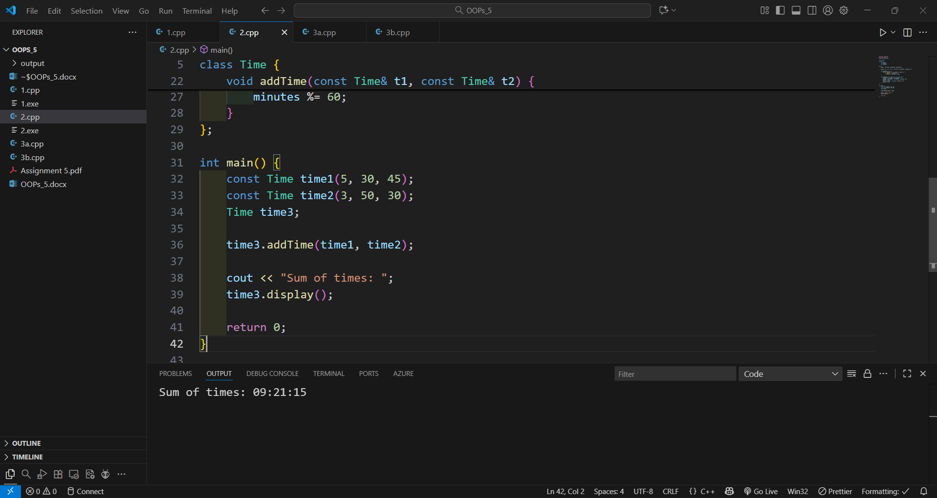Sol 3a:
#include <iostream>
using namespace std;

int main() {
int studentClass, failedSubjects, graceMarks = 0;

cout << "Enter the class obtained (1/2/3): ";
cin >> studentClass;

cout << "Enter number of subjects failed: ";
cin >> failedSubjects;

switch(studentClass) {
case 1:
if(failedSubjects <= 3)
graceMarks = 5 * failedSubjects;
else
graceMarks = 0;
break;

case 2:
if(failedSubjects <= 2)
graceMarks = 4 * failedSubjects;
else
graceMarks = 0;
break;

case 3:
if(failedSubjects <= 1)
graceMarks = 5 * failedSubjects;
else
graceMarks = 0;
break;

default:
cout << "Invalid class entered" << endl;
return 1;
}

if(graceMarks > 0)
cout << "Grace marks awarded: " << graceMarks << endl;
else
cout << "No grace marks awarded" << endl;

return 0;
}
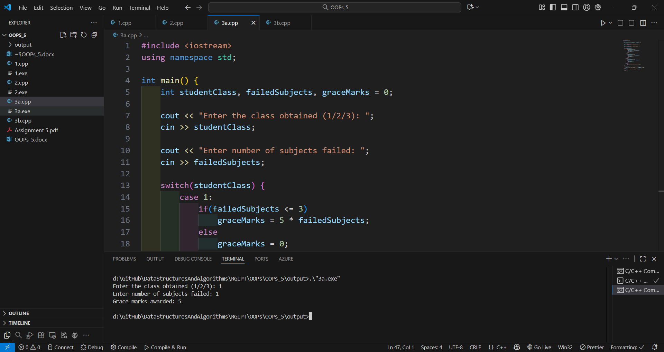

Sol 3b:
#include <iostream>
#include <iomanip>
using namespace std;

class Angle {
private:
int degrees;
float minutes;
char direction;

public:
Angle() : degrees(0), minutes(0.0), direction('N') {}

Angle(int deg, float min, char dir) : degrees(deg), minutes(min), direction(dir) {}

void getAngle() {
cout << "Enter degrees: ";
cin >> degrees;
cout << "Enter minutes: ";
cin >> minutes;
cout << "Enter direction (N/S/E/W): ";
cin >> direction;
}

void displayAngle() const {
cout << degrees << (char)248 << fixed << setprecision(1)
<< minutes << "' " << direction << endl;
}
};

int main() {
Angle angle1(149, 34.8, 'W');

cout << "Initial angle: ";
angle1.displayAngle();

char choice;
do {
Angle userAngle;
cout << "\nEnter angle details:" << endl;
userAngle.getAngle();

cout << "You entered: ";
userAngle.displayAngle();

cout << "\nEnter another angle? (y/n): ";
cin >> choice;
} while(choice == 'y' || choice == 'Y');

return 0;
}

