Prashant Ranjan – 24MC3035

// 1. Write a program in C++ to find the area of circle using input value.
#include <iostream>
using namespace std;

int main() {
double radius, area, pi = 3.14159265359;
cout << "Enter the radius of circle: ";
cin >> radius;
area = pi * pow(radius, 2);
cout << "Area of circle: " << area << endl;
return 0;
}

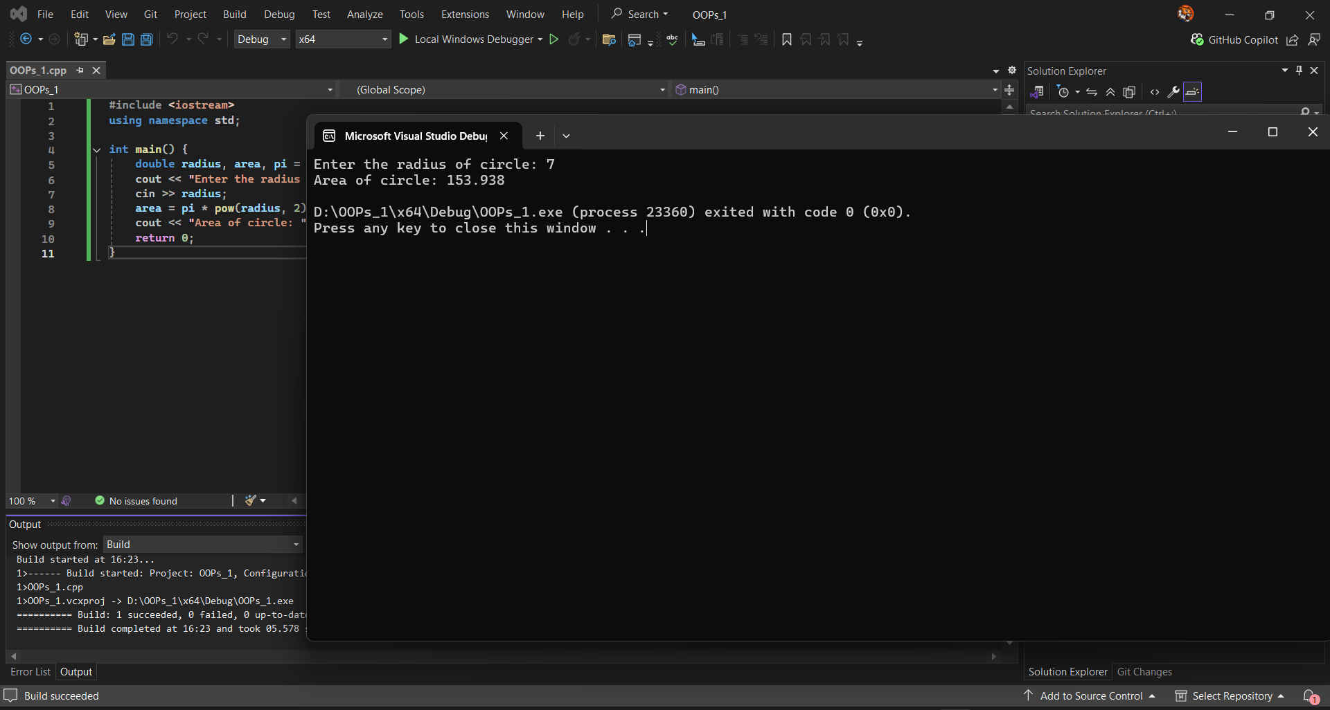

// 2. Write a program in C++ to Arithmetic operations of two integers
#include <iostream>
using namespace std;

int main() {
int num1, num2;
cout << "Enter two integers: ";
cin >> num1 >> num2;
cout << "Sum: " << num1 + num2 << endl;
cout << "Difference: " << num1 - num2 << endl;
cout << "Product: " << num1 * num2 << endl;
cout << "Quotient: " << num1 / num2 << endl;
cout << "Remainder: " << num1 % num2 << endl;
return 0;
}

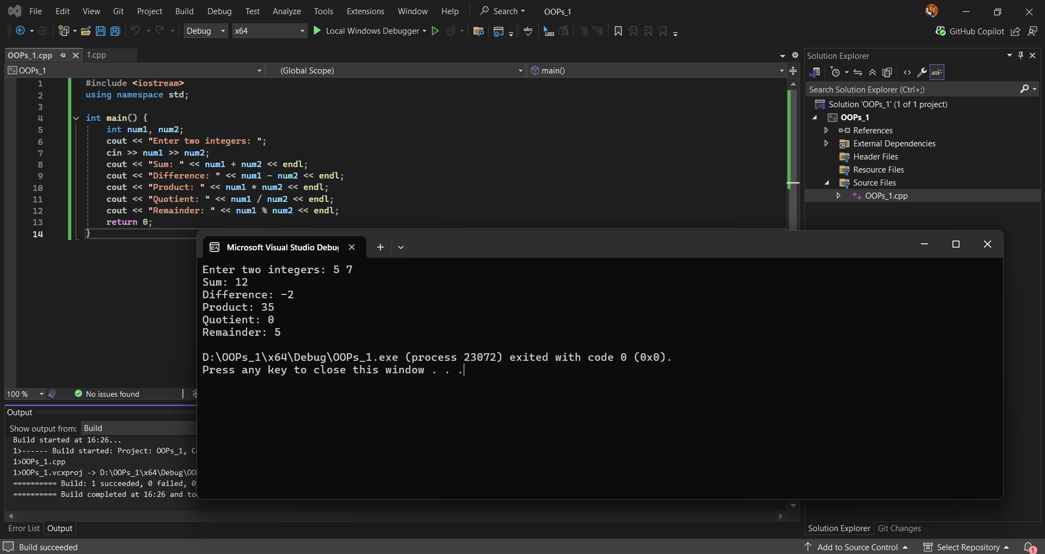

//3. Write a program in C++ to print the upper case letters to lower case.
#include <iostream>
#include <cctype>
using namespace std;

int main() {
char upper;
cout << "Enter an uppercase letter: ";
cin >> upper;
cout << "Lowercase: " << char(tolower(upper)) << endl;
return 0;
}

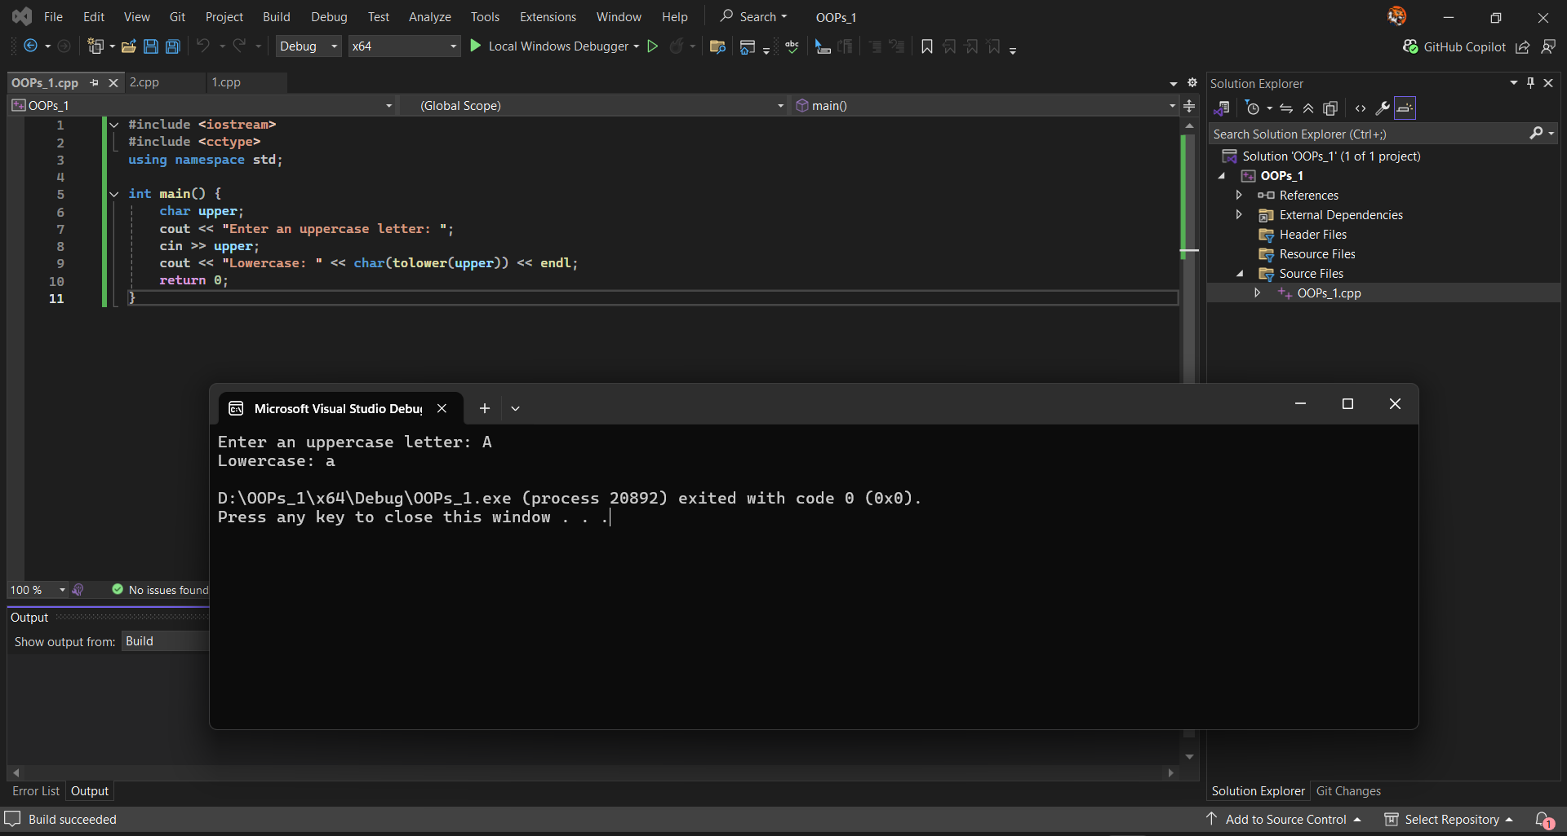

//4. Write a program in C++ to show of a numeric value of a variable using //hex, oct, and dec manipulator functions.
#include <iostream>
#include <iomanip>
using namespace std;

int main() {
int num;
cout << "Enter a number: ";
cin >> num;
cout << "Decimal: " << dec << num << endl;
cout << "Octal: " << oct << num << endl;
cout << "Hexadecimal: " << hex << num << endl;
return 0;
}

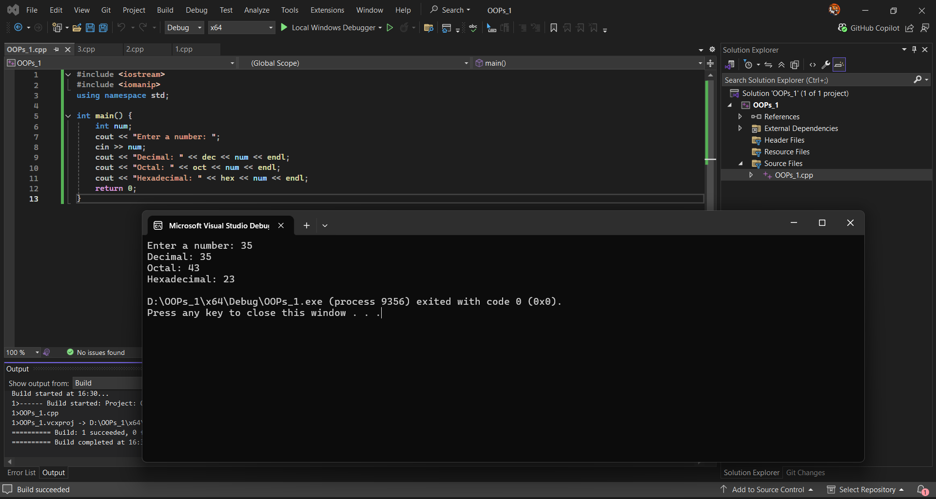

// 5. Write a program in C++ to check whether the given character upper, // lower , number or not.
#include <iostream>
#include <cctype>
using namespace std;

int main() {
char ch;
cout << "Enter a character: ";
cin >> ch;
if (isupper(ch)) cout << "Uppercase letter" << endl;
else if (islower(ch)) cout << "Lowercase letter" << endl;
else if (isdigit(ch)) cout << "Number" << endl;
else cout << "Other character" << endl;
return 0;
}

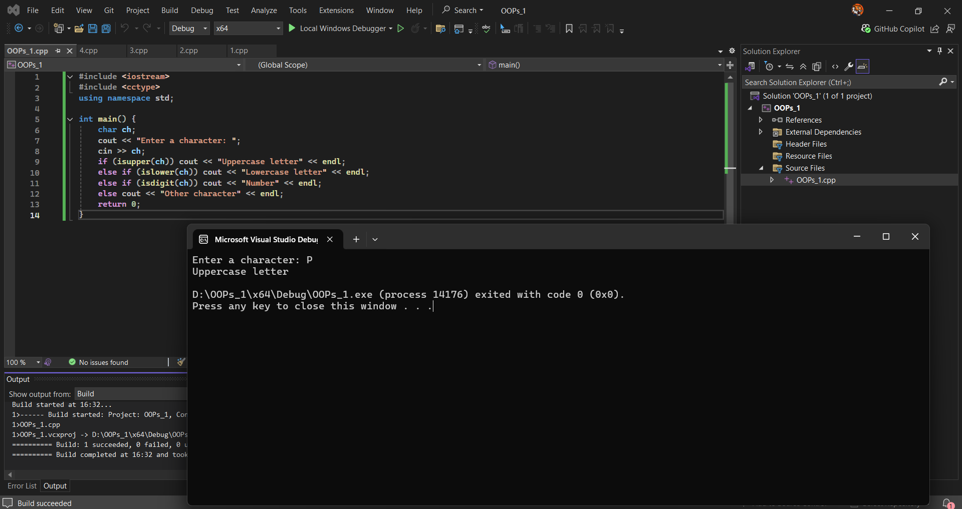

// 6. Write a program in C++ to find biggest of three given numbers.
#include <iostream>
using namespace std;

int main() {
int a, b, c;
cout << "Enter three numbers: ";
cin >> a >> b >> c;
int max = (a > b) ? (a > c ? a : c) : (b > c ? b : c);
cout << "Biggest number: " << max << endl;
return 0;
}

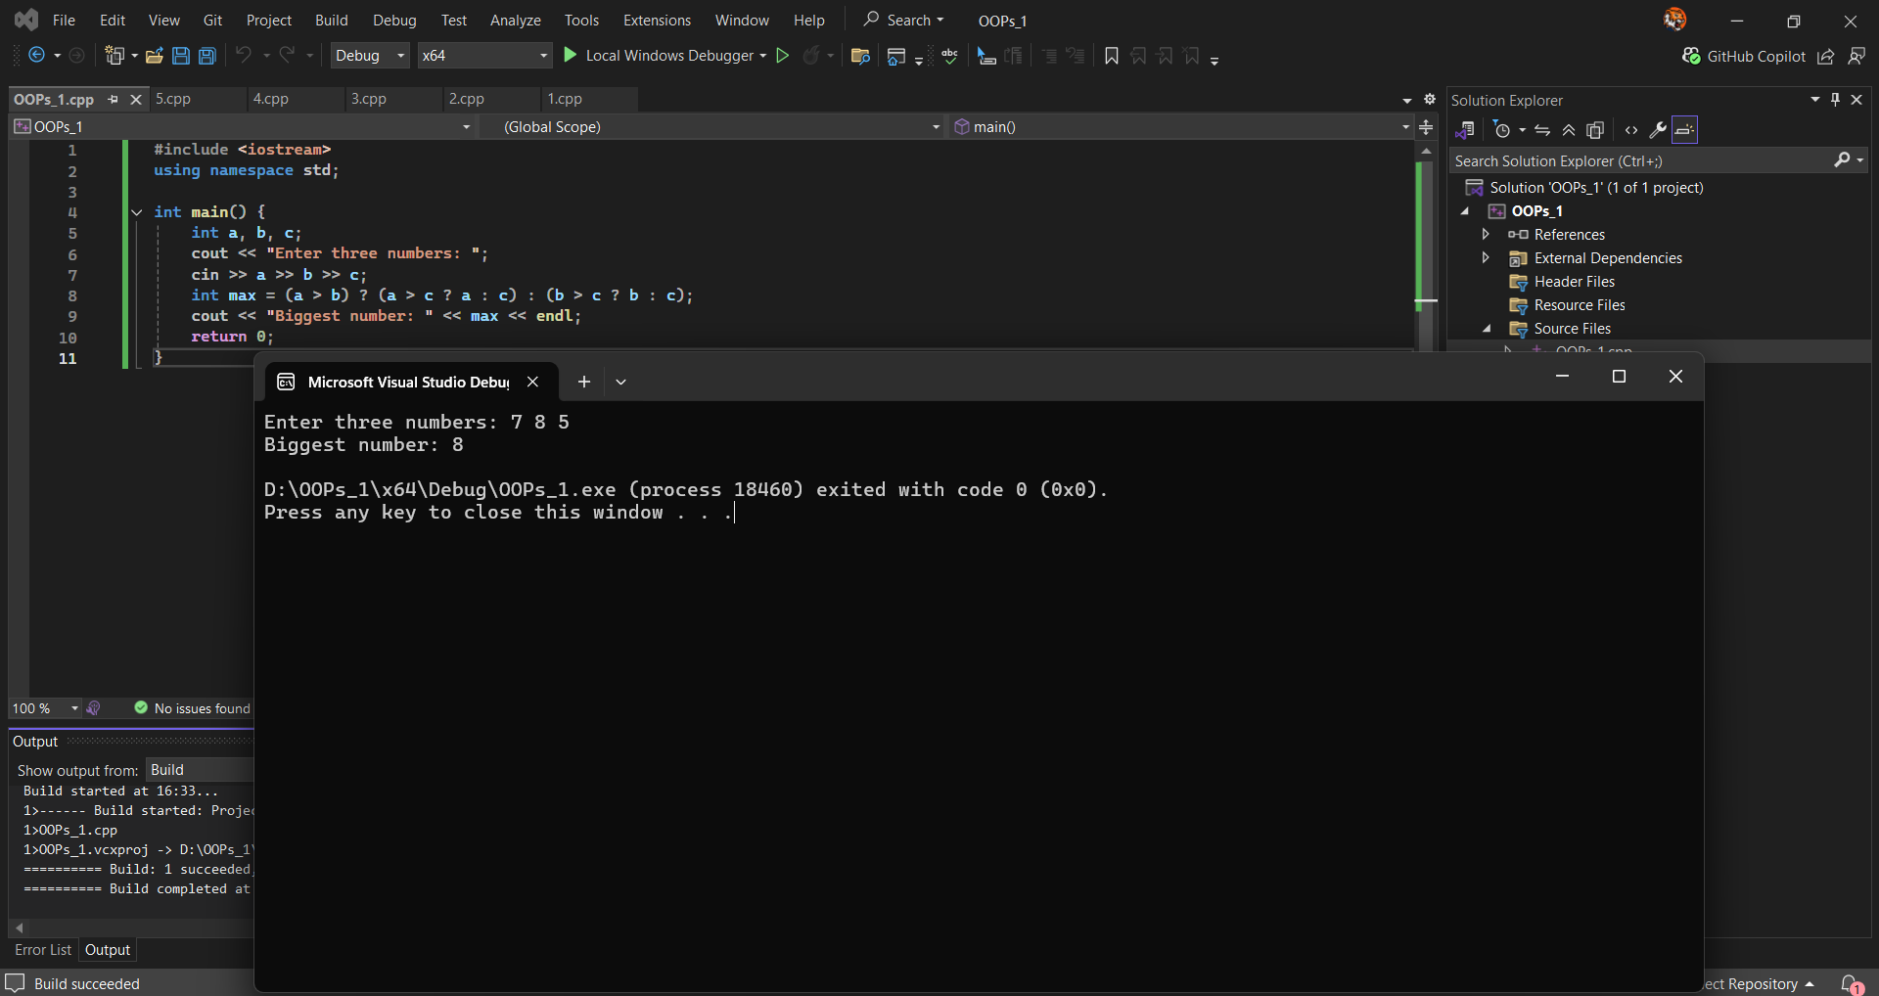

// 7. Write a program in C++ to display the name of the day in a week here // given input range is 1 to 7.
#include <iostream>
using namespace std;

int main() {
int day;
cout << "Enter day number (1-7): ";
cin >> day;
switch (day) {
case 1: cout << "Monday"; break;
case 2: cout << "Tuesday"; break;
case 3: cout << "Wednesday"; break;
case 4: cout << "Thursday"; break;
case 5: cout << "Friday"; break;
case 6: cout << "Saturday"; break;
case 7: cout << "Sunday"; break;
default: cout << "Invalid input";
}
return 0;
}

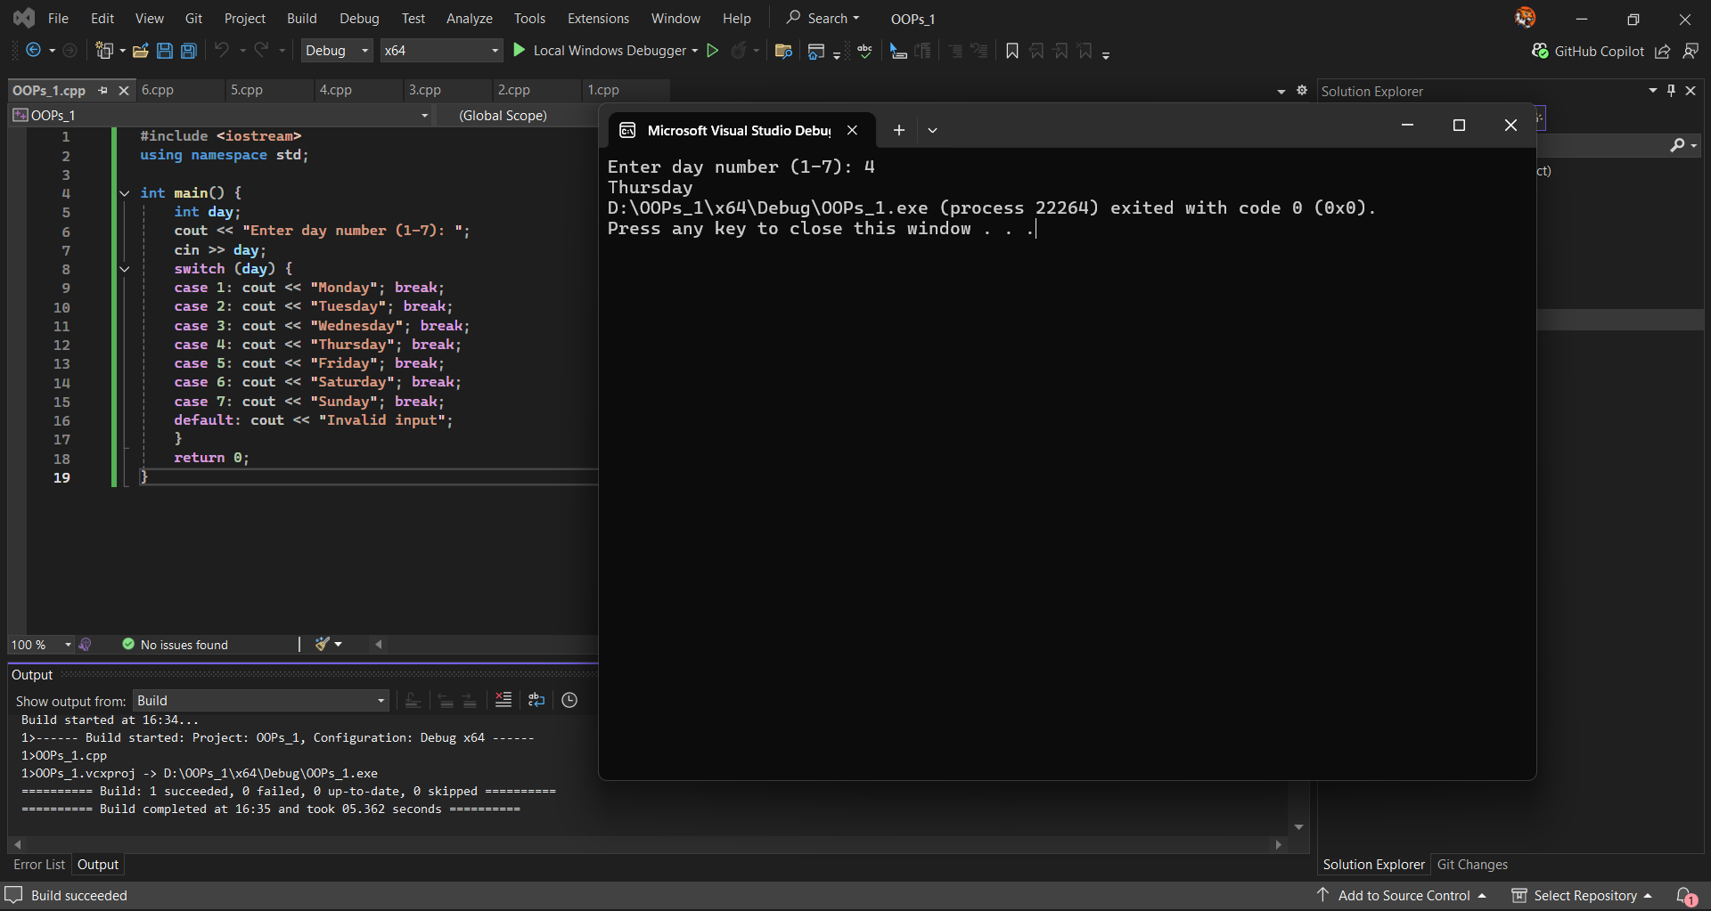

// 8. Write a program in C++ to display the even or odd numbers between 1 // to 100 using while loop.
#include <iostream>
using namespace std;

int main() {
int i = 1;
cout << "Even numbers: ";
while (i <= 100) {
if (i % 2 == 0) cout << i << " ";
i++;
}
cout << "\nOdd numbers: ";
i = 1;
while (i <= 100) {
if (i % 2 != 0) cout << i << " ";
i++;
}
return 0;
}

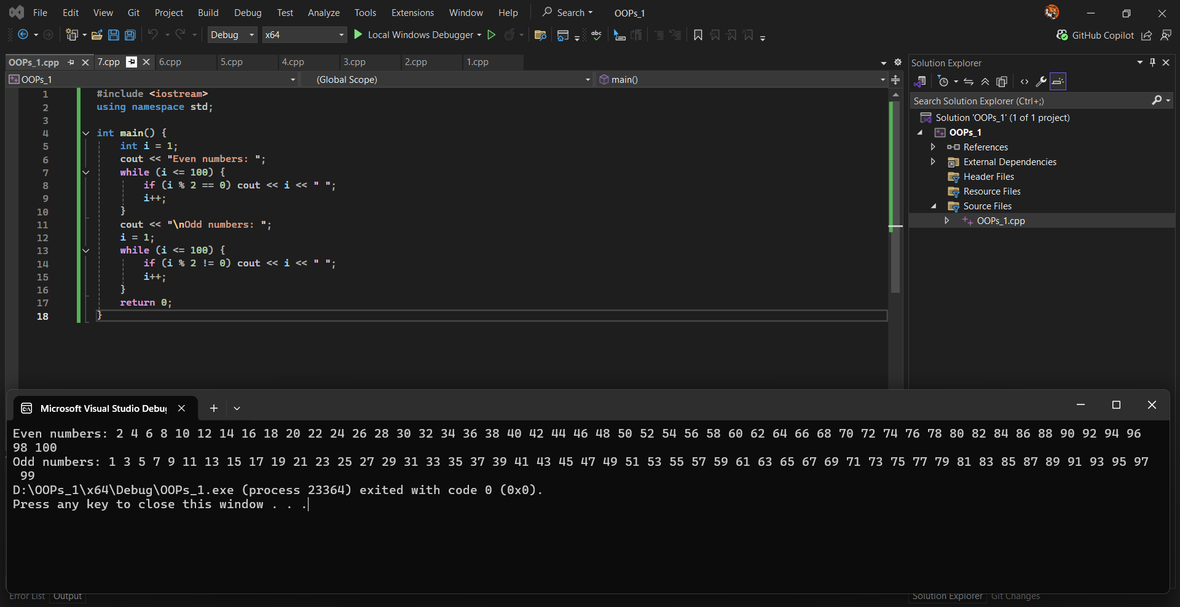

// 9. Write a program in C++ to print a word form of given number between // 0 to 9 using Switch.
#include <iostream>
using namespace std;

int main() {
int num;
cout << "Enter a number (0-9): ";
cin >> num;
switch (num) {
case 0: cout << "Zero"; break;
case 1: cout << "One"; break;
case 2: cout << "Two"; break;
case 3: cout << "Three"; break;
case 4: cout << "Four"; break;
case 5: cout << "Five"; break;
case 6: cout << "Six"; break;
case 7: cout << "Seven"; break;
case 8: cout << "Eight"; break;
case 9: cout << "Nine"; break;
default: cout << "Invalid number";
}
return 0;
}

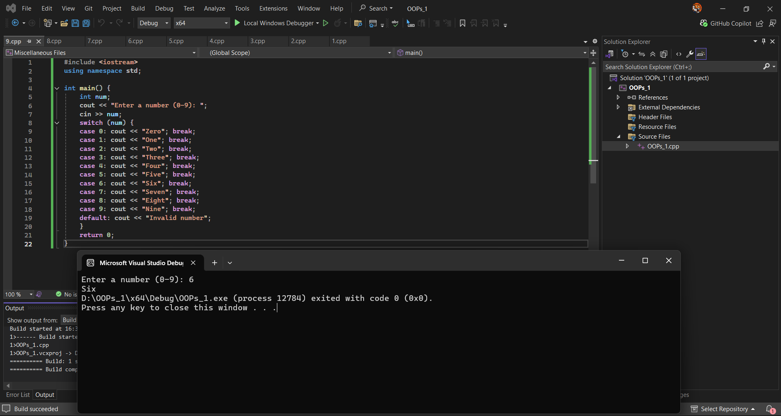

// 10. Write a program in C++ to find the smallest of 10 numbers.
#include <iostream>
#include <climits>
using namespace std;

int main() {
int smallest = INT_MAX, num;
cout << "Enter 10 numbers: ";
for (int i = 0; i < 10; i++) {
cin >> num;
if (num < smallest) smallest = num;
}
cout << "Smallest number: " << smallest << endl;
return 0;
}

