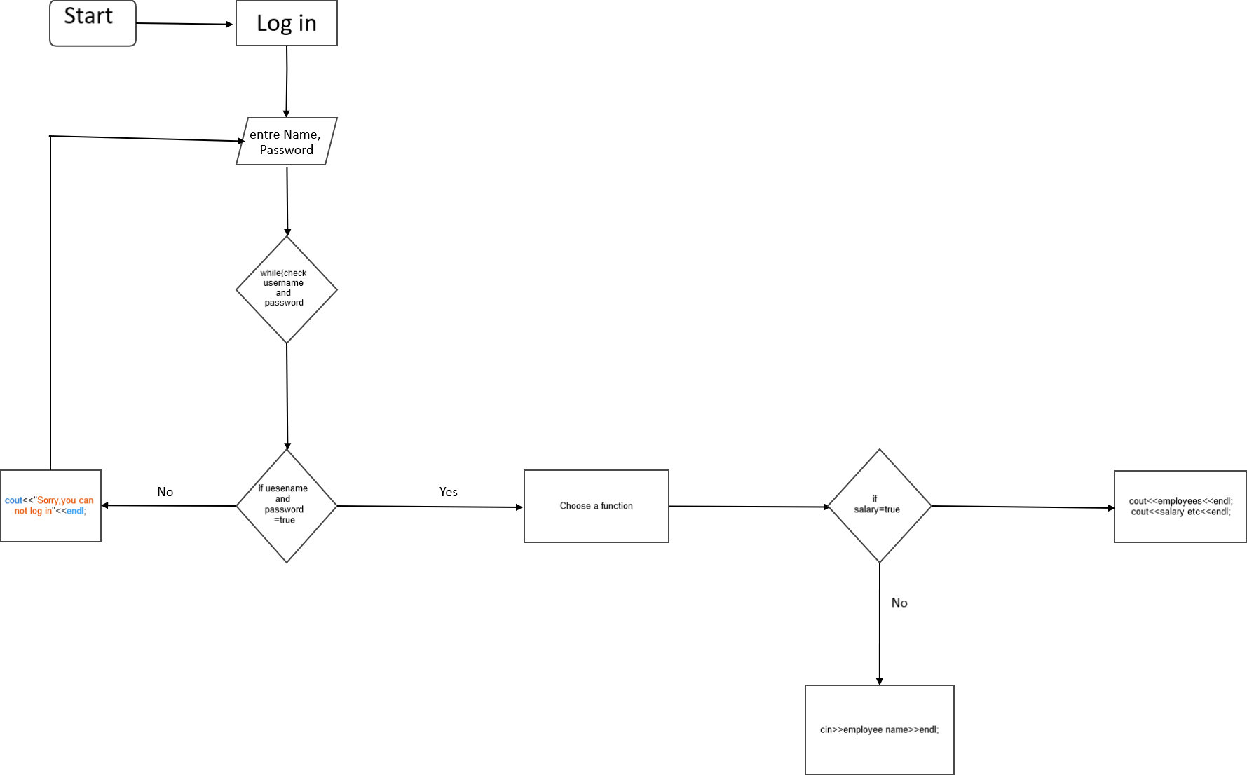

Start

Log in

entre Name, Password

**while(check username**

**and password**

No

Yes

cout<<"Sorry you can

not log in"<<endl;

**if uesename**

**and password**

**=true**

Choose a function

**salary=true**

cout<<employees<<endl; cout<<salary etc<<endl;

**No**

cin>>employee name>>endl;