**Topics: Descriptive Statistics and Probability**

1. Look at the data given below. Plot the data, find the outliers and find out $μ, σ, σ^{2}$

|  |  |
| --- | --- |
| **Name of company** | **Measure X** |
| Allied Signal | 24.23% |
| Bankers Trust | 25.53% |
| General Mills | 25.41% |
| ITT Industries | 24.14% |
| J.P.Morgan & Co. | 29.62% |
| Lehman Brothers | 28.25% |
| Marriott | 25.81% |
| MCI | 24.39% |
| Merrill Lynch | 40.26% |
| Microsoft | 32.95% |
| Morgan Stanley | 91.36% |
| Sun Microsystems | 25.99% |
| Travelers | 39.42% |
| US Airways | 26.71% |
| Warner-Lambert | 35.00% |

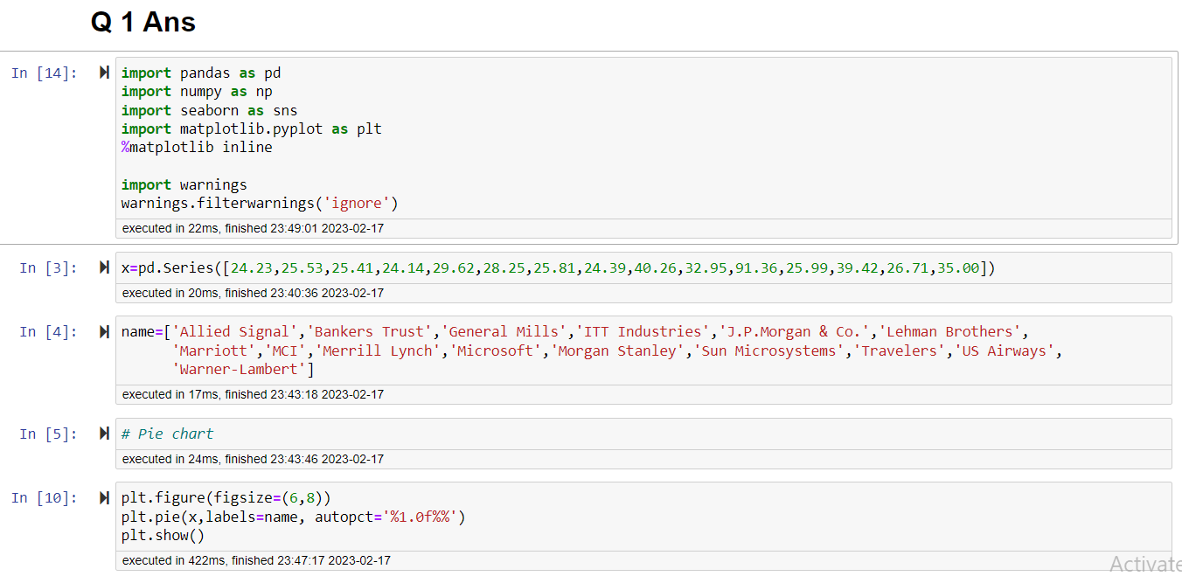

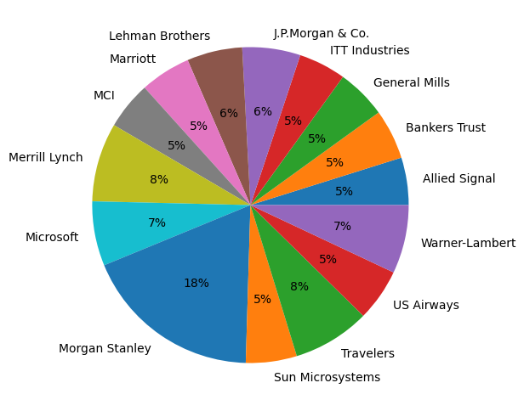

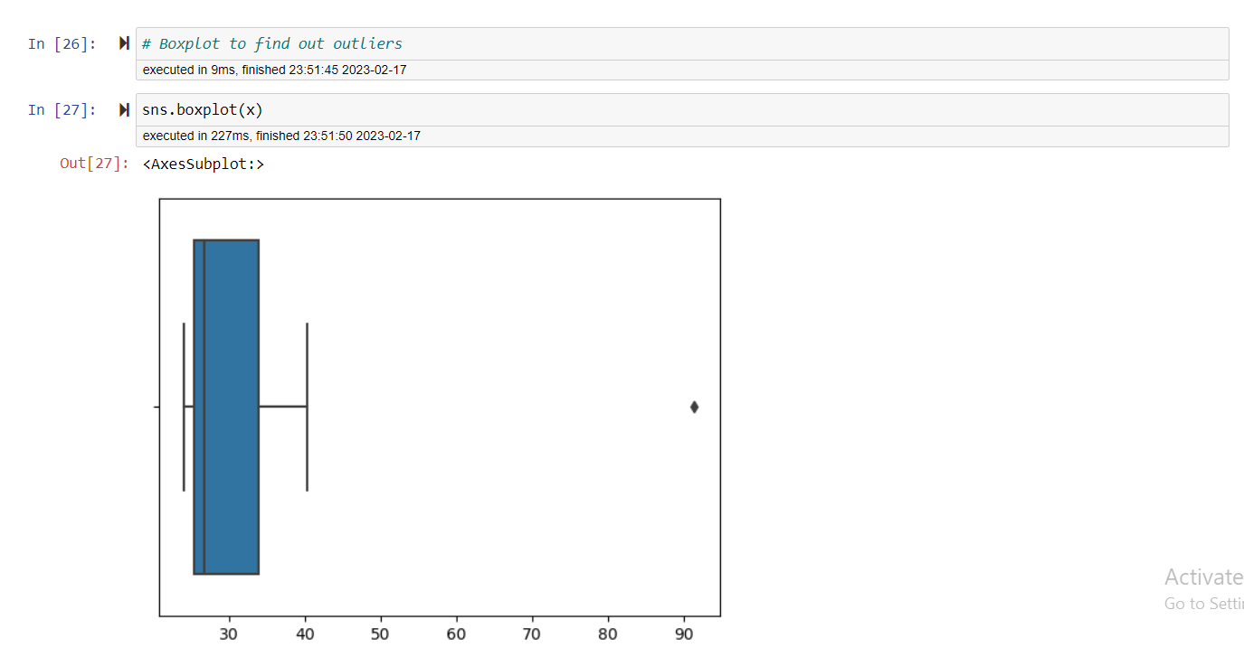

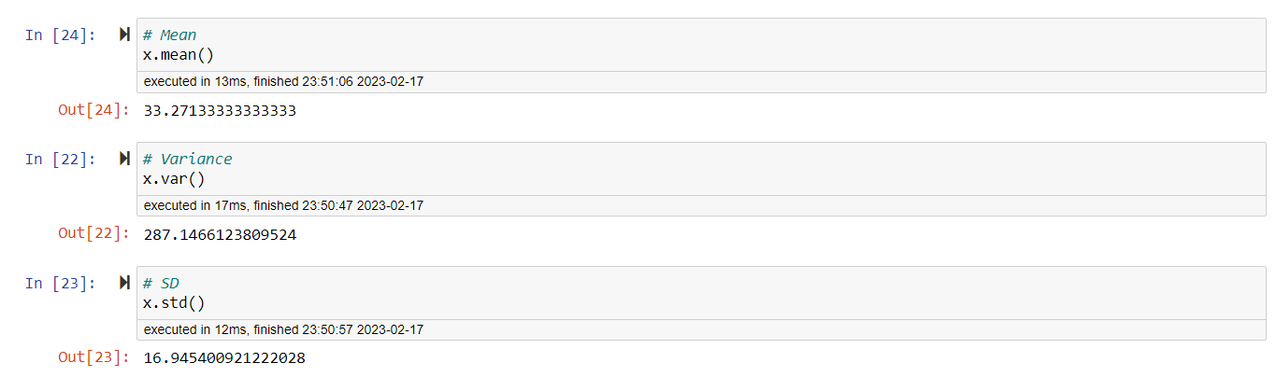

There is one outlier Morgan Stanley at 91.36%

Mean = $μ$ = 33.2713

Variance = $σ$ = 287.1466

Standard Deviation = $σ^{2}$ = 16.9454



Answer the following three questions based on the box-plot above.

1. What is inter-quartile range of this dataset? (please approximate the numbers) In one line, explain what this value implies.

**ANS =** IQR = (Q3-Q1) = 12-5 = 7 , The IQR of this dataset is 7 & it represents the range which contains 50 % of the data point.

1. What can we say about the skewness of this dataset?

**ANS =** The above dataset is right skewed data / positive skewed.

1. If it was found that the data point with the value 25 is actually 2.5, how would the new box-plot be affected?

**ANS =** If 25 is actually 2.5 then it is not considered as an outlier & the new boxplot is start from 0 to 20.



Answer the following three questions based on the histogram above.

1. Where would the mode of this dataset lie?

**ANS =** The mode of the dataset is lir between 4 to 8.

1. Comment on the skewness of the dataset.

**ANS =** The above dataset is right skewed / positive skewed.

1. Suppose that the above histogram and the box-plot in question 2 are plotted for the same dataset. Explain how these graphs complement each other in providing information about any dataset.

**ANS =** In boxplot median of the dataset is shown

In histogram mode of the dataset is shown

Histogram provides the frequency distribution of the data points at the certain range.

Boxplot provides the range of 5 to 12 where the 50% data lies.

The main purpose of the plotting the boxplot is to find out the outliers, here we can see 25 is the

Outlier.

1. AT&T was running commercials in 1990 aimed at luring back customers who had switched to one of the other long-distance phone service providers. One such commercial shows a businessman trying to reach Phoenix and mistakenly getting Fiji, where a half-naked native on a beach responds incomprehensibly in Polynesian. When asked about this advertisement, AT&T admitted that the portrayed incident did not actually take place but added that this was an enactment of something that “could happen.” Suppose that one in 200 long-distance telephone calls is misdirected. What is the probability that at least one in five attempted telephone calls reaches the wrong number? (Assume independence of attempts.)

**ANS =**

1 in 200 long-distance telephone calls is misdirected

Probability of call misdirecting = p = 1/200

Probability of call not misdirecting = q = 199/200

Number of calls = n = 5

P(x) = nCx px qn-x

P(x) = (5C1) (1/200)^1 (199/200)^5-1

P(x) = 0.0245

1. Returns on a certain business venture, to the nearest $1,000, are known to follow the following probability distribution

|  |  |
| --- | --- |
| x | P(x) |
| -2,000 | 0.1 |
| -1,000 | 0.1 |
| 0 | 0.2 |
| 1000 | 0.2 |
| 2000 | 0.3 |
| 3000 | 0.1 |

1. What is the most likely monetary outcome of the business venture?

**ANS =** The maximum probability is 0.3 for venture. So the monetary outcome of the business venture is 2000.

1. Is the venture likely to be successful? Explain

**ANS =** TheP(x) = 0.6 states the chances of the venture to be profitable. So the venture likely to be successful.

1. What is the long-term average earning of business ventures of this kind? Explain

**ANS =** Earning average = x * P(x) = 800. So the long term average earning of business venture is 800.

1. What is the good measure of the risk involved in a venture of this kind? Compute this measure

**ANS =** P(loss) = P(0.1) + P(0.1) = 0.2 , So the risk associated with the venture is 20.