Topics: Confidence Intervals

- For each of the following statements, indicate whether it is True/False. If false, explain why.

- The sample size of the survey should at least be a fixed percentage of the population size in order to produce representative results.
ANS = False, sample size must be random.

- The sampling frame is a list of every item that appears in a survey sample, including those that did not respond to questions.
ANS = False, the sampling frame is a list of items which responds to the question and
not the list of which do not respond to the question.

- Larger surveys convey a more accurate impression of the population than smaller surveys.
ANS = True.

- PC Magazine asked all of its readers to participate in a survey of their satisfaction with different brands of electronics. In the 2004 survey, which was included in an issue of the magazine that year, more than 9000 readers rated the products on a scale from 1 to 10. The magazine reported that the average rating assigned by 225 readers to a Kodak compact digital camera was 7.5. For this product, identify the following:

- The population
- The parameter of interest
- The sampling frame
- The sample size
- The sampling design
- Any potential sources of bias or other problems with the survey or sample
ANS = The population = 9000 readers out of total readers
The parameter of interest = 7.5
The sampling frame = Total readers
The sample size = 225
The sample design = Kodak compact digital camera
Any potential sources of bias or other problems with the survey or sample =
Source is PC Magazine

- For each of the following statements, indicate whether it is True/False. If false, explain why.

- If the 95% confidence interval for the average purchase of customers at a department store is $50 to $110, then $100 is a plausible value for the population mean at this level of confidence.
ANS = True
- If the 95% confidence interval for the number of moviegoers who purchase concessions is 30% to 45%, this means that fewer than half of all moviegoers purchase concessions.
ANS = True

- The 95% Confidence-Interval for μ only applies if the sample data are nearly normally distributed.
ANS = False. 95% interval confidence means, if we have to take 100 different samples
& compute a 95% confidence interval for each sample, then approximately 95
of the 100 confidence interval will contain the true mean value(μ).

- What are the chances that ?

- ¼
- ½
- ¾
- 1
ANS = D. 1
X̄ = µ , The expected value of the mean of the sample is (X̄) is equal to the mean
of the population (µ). The law of large numbers says that (X̄) will be close to µ
for large size of the sample.

- In January 2005, a company that monitors Internet traffic (WebSideStory) reported that its sampling revealed that the Mozilla Firefox browser launched in 2004 had grabbed a 4.6% share of the market.

- If the sample were based on 2,000 users, could Microsoft conclude that Mozilla has a less than 5% share of the market?

- WebSideStory claims that its sample includes all the daily Internet users. If that’s the case, then can Microsoft conclude that Mozilla has a less than 5% share of the market?
ANS =
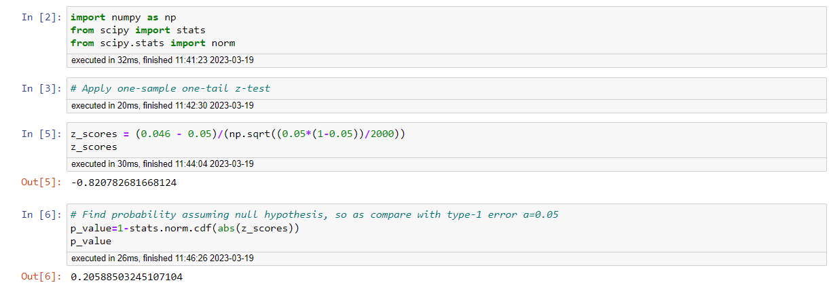

- A book publisher monitors the size of shipments of its textbooks to university bookstores. For a sample of texts used at various schools, the 95% confidence interval for the size of the shipment was 250 ± 45 books. Which, if any, of the following interpretations of this interval are correct?

- All shipments are between 205 and 295 books.
ANS = Above statement is incorrect. Because the given interval (250 ± 45) is not for 100%
it is only for the 95% confidence interval.

- 95% of shipments are between 205 and 295 books.
ANS = Above statement is incorrect. Because the interval doesn’t specify the individuals

- The procedure that produced this interval generates ranges that hold the population mean for 95% of samples.
ANS = Above statement is correct. Because 95% of the interval contains the population
mean.

- If we get another sample, then we can be 95% sure that the mean of this second sample is between 205 and 295.
ANS = Above statement is incorrect. Because interval doesn’t describe the mean of the
another sample.

- We can be 95% confident that the range 160 to 340 holds the population mean.
ANS = Above statement is incorrect. Because the given interval doesn’t belong to
95% confident interval.

- Which is shorter: a 95% z-interval or a 95% t-interval for μ if we know that σ =s?

- The z-interval is shorter
- The t-interval is shorter
- Both are equal
- We cannot say
ANS = A. The z-interval is shorter.
The Z value for 95% confidence is Z = 1.96
The t value for 95% confidence is t = 2.262

Questions 8 and 9 are based on the following: To prepare a report on the economy, analysts need to estimate the percentage of businesses that plan to hire additional employees in the next 60 days.

- How many randomly selected employers (minimum number) must we contact in order to guarantee a margin of error of no more than 4% (at 95% confidence)?

- 600
- 400
- 550
- 1000
ANS = A. 600
Margins of error estimate is 1/sqrt(n)
If 0.04 = 1/25 is margin of error
Then n = 25^2 or 625 = 600.

- Suppose we want the above margin of error to be based on a 98% confidence level. What sample size (minimum) must we now use?

- 1000
- 757
- 848
- 543
ANS = C. 848
Number of employee = n and assume that p = 0.0 & q = 0.5 margin of error = 0.04
Z score for 98% C.I. is 2.33
Margin of error = Z*√pq/n
0.04 = 2.33 √0.5*0.5/n
n = 2.33^2*0.5*0.5/0.04^2
= 1.357225/0.0016
n = 848.26

