Cairo University  
Faculty of Computers and Artificial Intelligent

**CS251 - Software Engineering I**

Parking Garage

Software Requirements Specifications (SRS)

May 2022

Contents

Team 2

Document Purpose and Audience 3

Introduction 3

Software Purpose 3

Software Scope 3

Requirements 4

Functional Requirements 4

Non Functional Requirements 4

System Models 5

Use Case Model 6

Use Case Tables 6

# 

# Document Purpose and Audience

This document is a brief explanation about an application that manages a parking space. Each parking space (slot) has dimensions; the application has some functions that facilitates the parking process and payment

Presented to our project owner and to the customer.

# Introduction

## Software Purpose

The purpose of this software is to facilitate the parking process in a parking garage. The system stores data of a vehicle (like model name, unique identification number, Model year and vehicle dimensions, etc.). The user of the system (garage owner or garage worker) will be able to know busy or available slots and choose the suitable slot for the vehicle; also will be able to know exactly the fees required by a vehicle when the system calculates time-to-stay of the vehicle (time between arrival and departure). There is also a function that calculates total number of vehicles in the garage and another that calculates total fees at some point of time.

## Software Scope

There are many functions in this software scope that is concerned with facilitating the process these functions are:

1. Park-in Function: this function marks the arrival time of the vehicle automatically from the system if there is at least one available slot. It picks a free slot based on a configuration that the user (garage owner or garage worker) chooses and it is whether to find the nearest slot or best-fit approach (slot with minimum dimensions to fit the vehicle)

2. Park-Out Function: this function marks the departure time of the vehicle automatically from the system and return the departed slot to the available slots. It calculates the parking fees based on the time-of-stay with an hourly rate of 5 EGP.

3. Display Available Slots Function: this function show how many available slots and where are they located in the parking space.

4. Calculate Income Function: this Function Calculates the total number of vehicles that used the parking garage at any given point in time to calculate the total income.

# Requirements

## Functional Requirements

1) The parking garage application should organize the process of cars parking in the garage

2) The program will display available slots

3) The application must mark the arrival time of the vehicle automatically if there is at least one available slot.

4) The application must show the vehicle's owner active slot configuration, the first configuration is finding the nearest slot, the second configuration is finding a slot with minimum dimensions to fit the vehicle, the application must choose the slot based on the vehicle's owner choice.

5) The application must mark the departure time of the vehicle automatically and put the departed slot in the available slots.

6) Calculate the time between arrival and departure to calculate the fees during the time-of-stay, each hour costs fee of 5 EGP.

7) The program will calculate income and count number of cars parked.

## Non Functional Requirements

1)The system should contain friendly interface.

2)The system should response on time for the user every time the user chooses to do a certain operation.

3)Information of user and the parked cars are secured can't be accessed easily.

# System Models

## Use Case Model

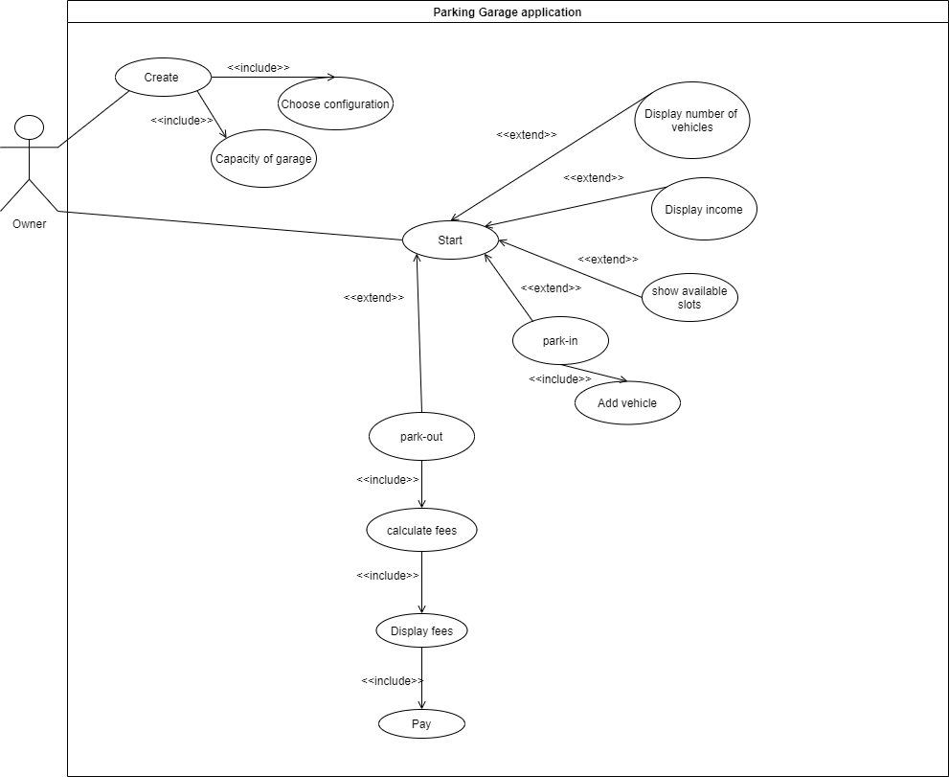

## 

## Use Case Tables

|  |  |  |
| --- | --- | --- |
| Use Case ID: | 1 | |
| Use Case Name: | Park in | |
| Actors: | Owner | |
| Pre-Condition: | Available slots for parking | |
| Post-Condition: |  | |
| Flow of Events: | User Action | System Action |
| 1. the owner choose park in |  |
|  | 2. chooses the available slots according to the system configuration, displays the position of the slot |
| 3. Heads to the slot position |  |
|  | 4. Mark time of arrival, deletes the slot from available slots |
| Exceptions: | User Action | System Action |
| 1. the owner choose to park in |  |
|  | 2. No available slots. |
| Includes: | Add vehicle | |
| Extends: |  | |
| Notes and issues: |  | |

|  |  |  |
| --- | --- | --- |
| Use Case ID: | 2 | |
| Use Case Name: | Park out | |
| Actors: | owner | |
| Pre-Condition: | Park in | |
| Post-Condition: | pay | |
| Flow of Events: | User Action | System Action |
| 1.The owner chooses to park out |  |
|  | 2. ask for the car id |
| 3.enter car id |  |
|  | 3. marks the departure time and adds the slot to the available slots |
|  | 4.calculate fees |
|  |  | 5.display fees |
|  | 6.confirm payment |  |
| Exceptions: | User Action | System Action |
| include: | Calculate fees | |
| Notes and issues: |  | |

|  |  |  |
| --- | --- | --- |
| Use Case ID: | 3 | |
| Use Case Name: | Show Available Slots | |
| Actors: | owner | |
| Pre-Condition: |  | |
| Post-Condition: |  | |
| Flow of Events: | User Action | System Action |
| 1-owner ask to Show Available Slots |  |
|  | 2- check the slots not parked in |
|  | 3-system display the Available Slots |
| Exceptions: | User Action | System Action |
| 1-owner ask to Show Available Slots |  |
|  | 2- check the slots not parked in |
|  |  | 3-there is no Available Slots |
|  |  | 4-display that no Available Slots |
| Includes: |  | |
| Notes and issues: |  | |

|  |  |  |
| --- | --- | --- |
| Use Case ID: | 4 | |
| Use Case Name: | Display Income | |
| Actors: | owner | |
| Pre-Condition: |  | |
| Post-Condition: |  | |
| Flow of Events: | User Action | System Action |
| 1-owner ask to Display Income |  |
|  | 2-Get information of income from system |
|  | 3-display the fees for each customer and the hours he parked in |
| Exceptions: | User Action | System Action |
| Includes: |  | |
| Notes and issues: |  | |

|  |  |  |
| --- | --- | --- |
| Use Case ID: | 5 | |
| Use Case Name: | Display Number of Vehicles | |
| Actors: | owner | |
| Pre-Condition: |  | |
| Post-Condition: |  | |
| Flow of Events: | User Action | System Action |
| 1-owner ask show Number of Vehicles |  |
|  | 2-Get information of vehicles parked from system |
|  | 3-display the Number of Vehicles |
| Exceptions: | User Action | System Action |
| Includes: |  | |
| Notes and issues: |  | |

# 