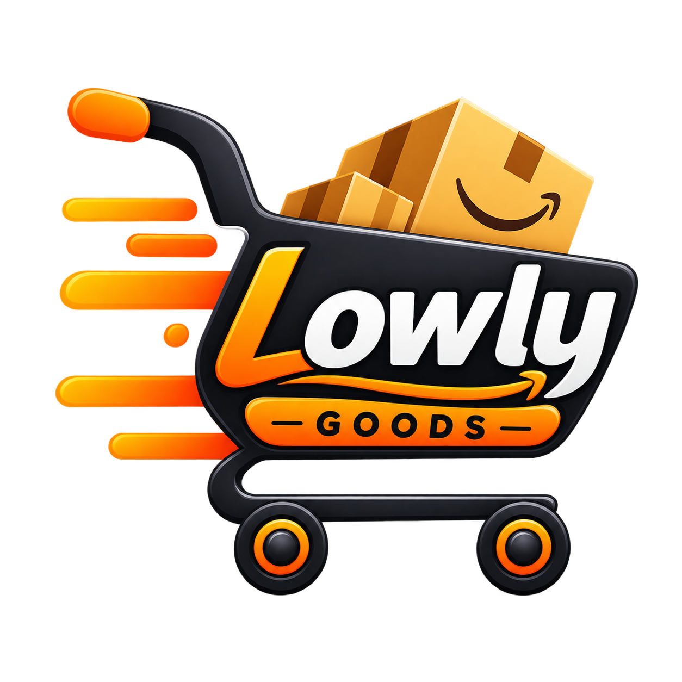
Deal Drop — Smart Price Tracking Platform
Comprehensive Technical Project Report & Architectural Documentation
Project Title: | Deal Drop (Smart Price Tracker & Notification Platform)
Developer / Author: | Sachidananda Panigrahi (Kanha) | hqkanhasonu@gmail.com
Live Production URL: | https://price-drop-flax.vercel.app/
Core Tech Stack: | Next.js 16 (App Router), React 19, Tailwind CSS v4, Cheerio, Firecrawl
Auth & Security: | Google OAuth 2.0 (PKCE/Manual flow), Jose JWT, SHA-256 OTP Engine
Documentation Scope: | Full System Architecture, Data Pipeline, Schemas, & DevOps

1. Executive Summary & Problem Statement
Modern e-commerce retail platforms employ dynamic algorithmic pricing that fluctuates hourly based on consumer demand, browsing cookies, competitor inventory, and flash sales. Consumers are often subjected to price anchoring and false discount labels, forcing them to manually revisit product pages repeatedly to check whether an item has actually become cheaper.
Deal Drop is a modern, full-stack price monitoring web application designed to eliminate this friction. By simply submitting a product URL, users can track products across major retail platforms (Amazon, Flipkart, Walmart, and others). The system autonomously scrapes, parses, and logs historical pricing trends, visualizes fluctuations through interactive charts, and dispatches real-time email notifications the moment an item drops below a user-defined threshold.
Core Mission
Key Value Proposition: Autonomous 24/7 price intelligence, instantaneous tracking setup with zero browser extension requirements, and sub-second price drop notification dispatch.

2. Feature Matrix & Capabilities
- One-Click Product Tracking: Users paste any product link; Deal Drop canonicalizes the URL and extracts metadata.
- Multi-Currency Extraction Engine: Autonomous regex parser supporting INR (₹), USD ($), EUR (€), and GBP (£).
- 30-Day Historical Price Visualizer: Interactive SVG charts with min/max price points powered by Recharts and Motion.
- Target Price Threshold Triggers: Users specify their target budget; system triggers instant alerts when hit.
- In-House Secure Authentication: Dual-mode sign-in featuring Google OAuth 2.0 and passwordless Email OTP.
- Automated Cron Polling: Serverless cron workers continuously poll tracked products without human intervention.
3. System Architecture & Component Topology
Deal Drop is engineered as an event-driven, decoupled full-stack application built upon Next.js 16 and the React 19 App Router architecture. The architecture is partitioned into four primary layers: the Client Presentation Layer, the Next.js API & Authentication Gateway, the Core Extraction & Notification Engines, and the Atomic JSON Persistence Store.
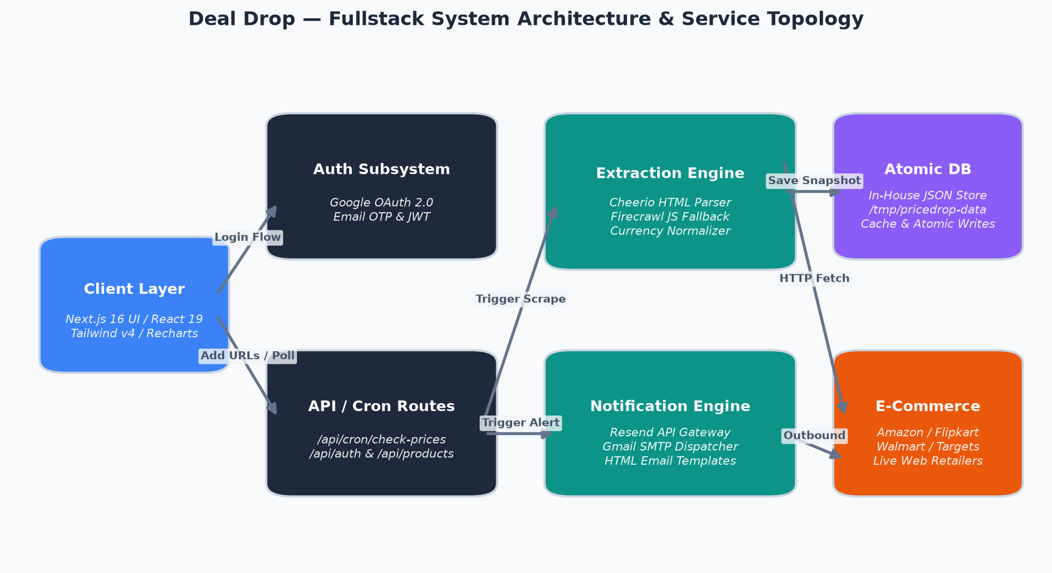
Figure 1: Deal Drop System Architecture & Service Topology
Architectural Layer Breakdown:
- Client Layer: Server-rendered React 19 components with client-side hydration, styled via Tailwind CSS v4 and animated using Motion.
- API & Auth Gateway: Edge-ready Next.js Route Handlers managing Google OAuth 2.0 callbacks, OTP verification, and JWT session cookies.
- Scraping Engine: Cheerio DOM parser with fallback to Firecrawl headless browser API for dynamic JavaScript-rendered single-page apps.
- Monitoring Engine: Cron poller triggering multi-threaded HTTP requests, evaluating price drop conditions, and queueing transactional email dispatches via Resend API.
- Persistence Store: Lightweight, high-performance ACID-like JSON database with in-memory caching and atomic file writes designed for serverless containers.
4. E-Commerce Web Scraping & Extraction Engine
Extracting reliable product prices across disparate e-commerce platforms is a major technical challenge due to anti-bot measures, obfuscated CSS classes, affiliate tracking query bloat, and locale-specific currency formats.
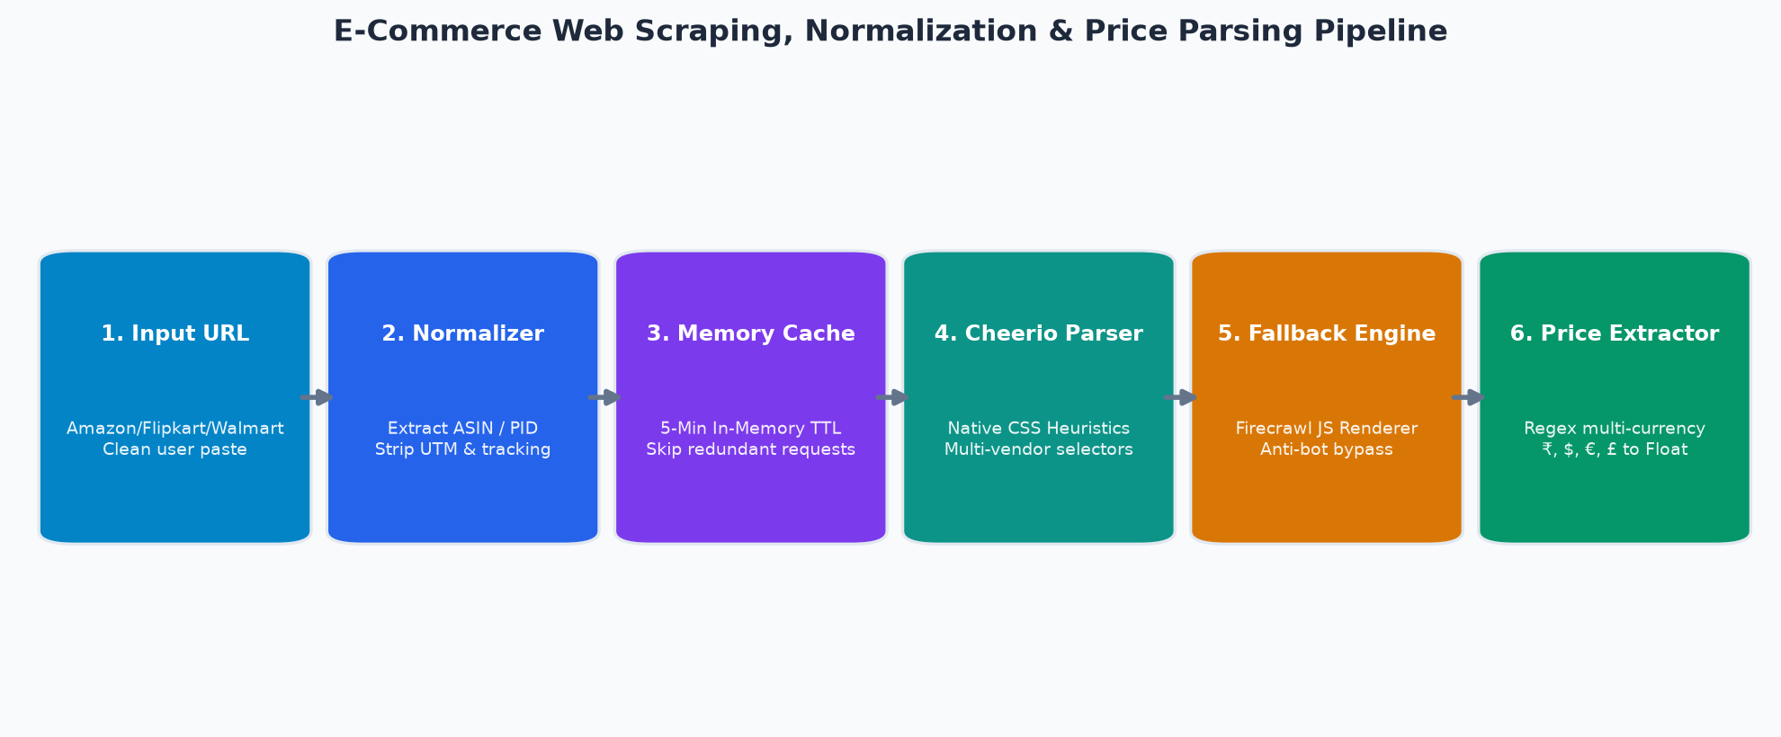
Figure 2: Multi-Stage Scraping, Normalization & Currency Extraction Pipeline
4.1 URL Canonicalization
Tracking links often carry noisy tracking parameters (utm_source, ref, fbclid, tag). Deal Drop's normalizer sanitizes raw links into clean canonical paths. For Amazon products, it isolates the 10-character ASIN (e.g., amazon.com/dp/B0CX23V258). For Flipkart, it isolates the Product Identifier (PID). This guarantees deduplication and prevents duplicate entries for the same product.
4.2 Dual-Tier Extraction Heuristics
The extraction engine utilizes a two-tier fallback architecture:
1. Tier 1 (Native Cheerio HTTP Scraping): Executes lightweight, ultra-fast HTTP requests with randomized User-Agents and multi-selector DOM queries targeting price containers (.a-price-whole, ._30jeq3, etc.).
2. Tier 2 (Firecrawl Headless Fallback): If native Cheerio detects CAPTCHAs, bot challenges, or client-rendered dynamic DOMs, it seamlessly routes the request to Firecrawl's cloud browser fleet to extract the rendered Markdown/HTML.
4.3 In-Memory Scrape Cache
To avoid hitting vendor rate limits and optimize server response times, an in-memory TTL cache (5-minute expiration) stores scrape results. Multiple requests for the same URL within this window return instantaneously from memory without outbound network overhead.

5. Data Storage & Relational Entity Model
Deal Drop implements an in-house, atomic JSON database engine (Lowlysales/lib/db/index.js) that combines the simplicity of document storage with strict relational integrity. The storage engine maintains an in-memory copy with file-mtime cache validation and commits writes sequentially using write-queuing promises to eliminate race conditions.
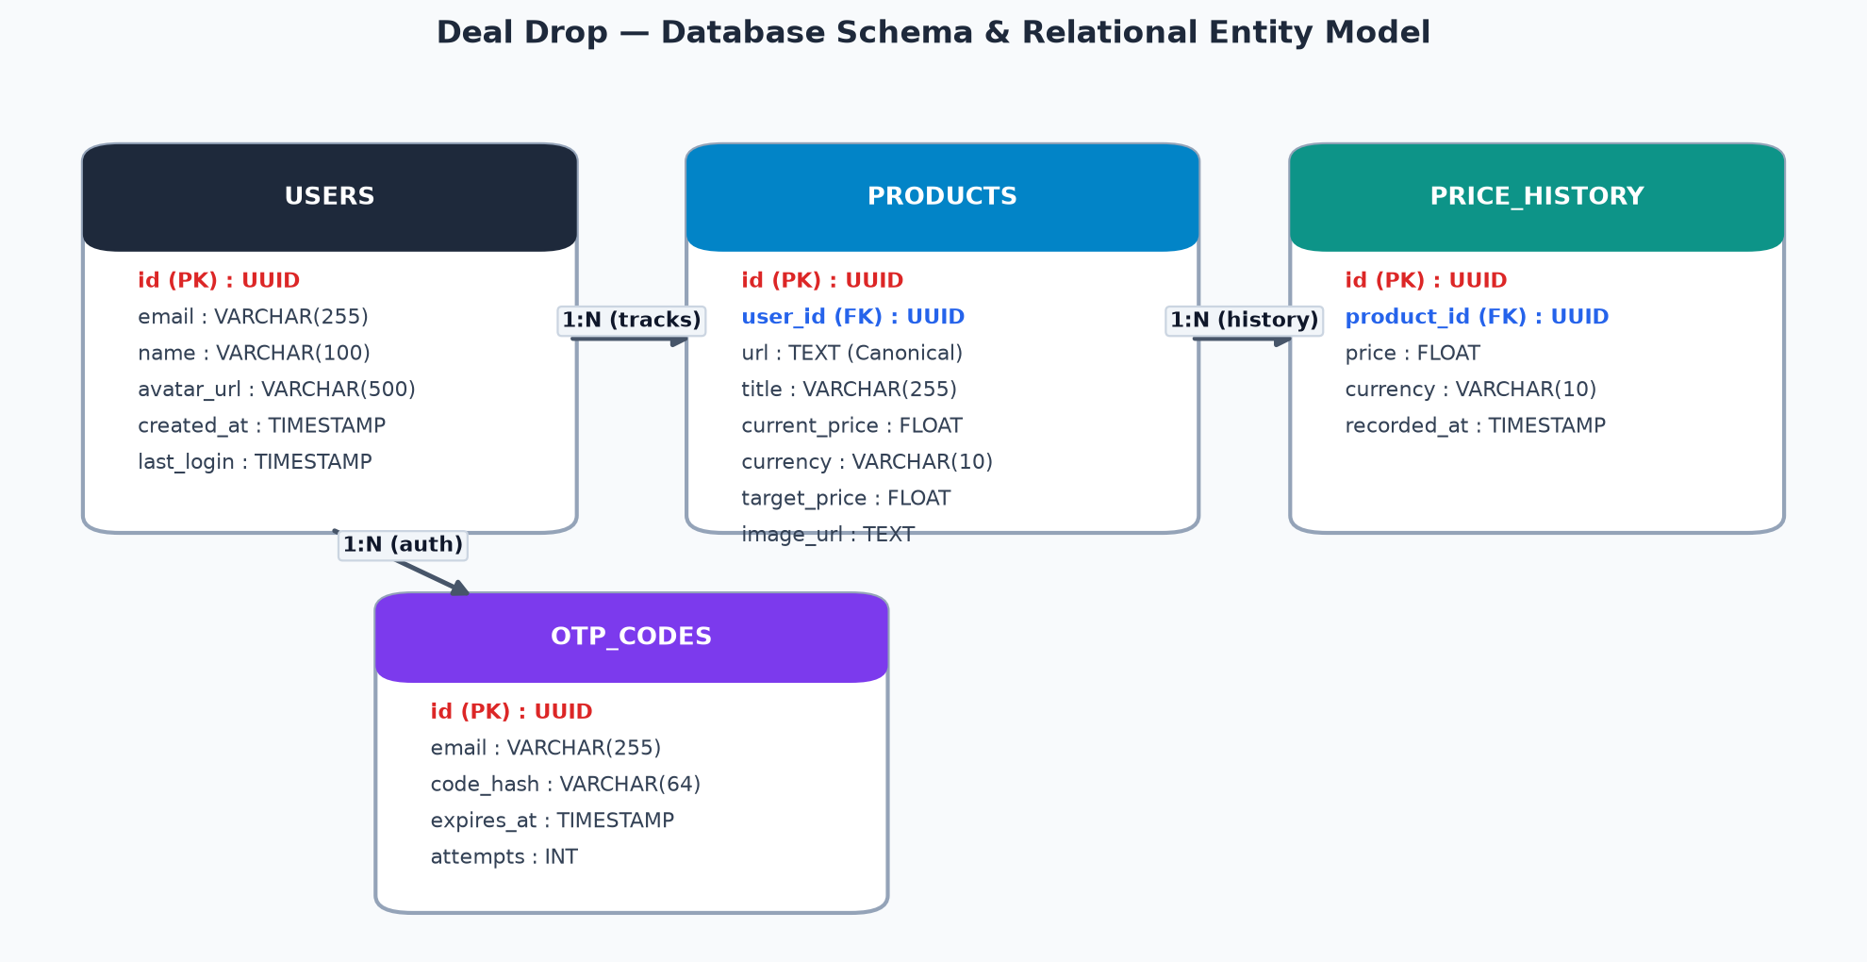
Figure 3: Relational Entity-Relationship (ER) Schema Model
Entity Table | Key Fields & Relationships | Storage Description
USERS | id (PK), email, name, avatar_url, created_at | Stores authenticated user profiles and OAuth associations.
PRODUCTS | id (PK), user_id (FK), url, title, current_price, target_price | Stores tracked items, canonical links, and user target thresholds.
PRICE_HISTORY | id (PK), product_id (FK), price, currency, recorded_at | Time-series ledger of historical price snapshots for charting.
OTP_CODES | id (PK), email, code_hash, expires_at, attempts | Cryptographic OTP verification records with 10-minute TTL.
6. Price Monitoring & Notification Engine
The core functionality of Deal Drop relies on scheduled monitoring and automated alert dispatch. The server exposes a secure cron route (/api/cron/check-prices) guarded by a cryptographic authorization bearer token (CRON_SECRET). When triggered, the poller iterates over active products, fetches real-time prices, appends a record to price_history, and checks if the new price is lower than the previous price or less than or equal to the user's target_price.
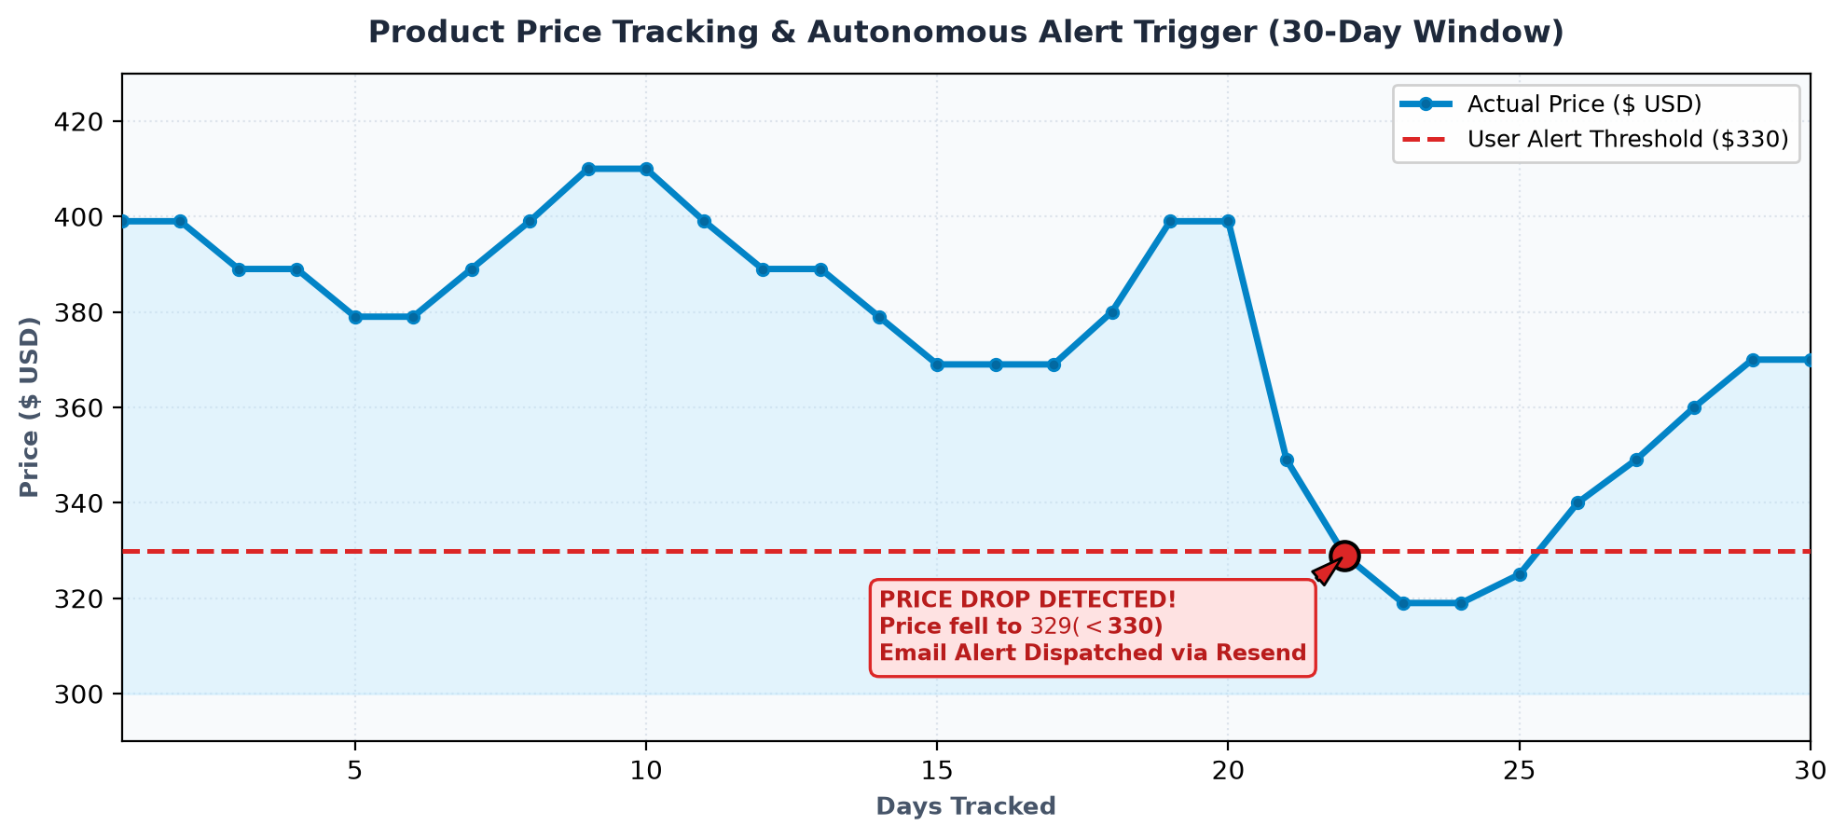
Figure 4: 30-Day Simulated Price History & Autonomous Alert Trigger Event
6.1 Dual Email Gateway Support
When a price drop condition evaluates to true, the notification service (Lowlysales/lib/email.js) formats a responsive, custom HTML alert email with product photo, original price, new price, savings amount, and a direct checkout button. The service natively supports two dispatch providers:
- Option 1 (Resend API): Production-grade transactional email dispatch via Resend SDK.
- Option 2 (SMTP Relay): Standard Gmail or custom enterprise SMTP relay via Nodemailer.
7. Security Architecture & Authentication Subsystem
Deal Drop provides a frictionless, zero-friction user authentication experience using an in-house dual-mode authentication engine:
- 1. Google OAuth 2.0: A native OAuth 2.0 authorization code flow that requests openid, email, and profile scopes, exchanges authorization codes server-side, and upserts user records in the local database.
- 2. Email OTP Engine: A passwordless authentication mechanism where users enter their email, receive a cryptographically random 6-digit numeric OTP, and authenticate upon verification. OTP codes are stored as SHA-256 hashes with 10-minute expiry and attempt-rate limiting.
- 3. Stateless JWT Sessions: Upon successful authentication, the server generates a cryptographically signed JOSE JWT session token containing user metadata. The token is stored in an HttpOnly, SameSite=Lax, Secure cookie to completely prevent cross-site scripting (XSS) token exfiltration.
8. Complete Technology Stack Matrix
Layer | Technology Used | Role in Deal Drop
Frontend Framework | Next.js 16 (App Router) & React 19 | Server components, client hydration, and routing
Styling & UI Kit | Tailwind CSS v4 & Motion (Framer Motion) | Responsive modern styling, animations, and modal overlays
Data Visualization | Recharts & Lucide React | Interactive price history graphs and vector iconography
Scraping Engine | Cheerio & Firecrawl JS SDK | Fast DOM parsing with cloud headless browser fallback
Authentication | Google OAuth 2.0 & Jose JWT | Secure Single Sign-On and stateless signed sessions
Email Dispatch | Resend API & Nodemailer SMTP | Automated transactional price drop alert notifications
9. Project Conclusion & Future Roadmap
Deal Drop demonstrates an end-to-end modern full-stack web application that combines practical consumer utility with a robust engineering foundation. By coupling automated web scraping with intelligent URL normalization, time-series data visualization, and automated transactional notifications, the application solves real-world e-commerce price volatility.
Future Development Milestones:
- Machine Learning Price Forecasting: Predictive AI algorithms forecasting whether a price is likely to drop further based on seasonal trends.
- Browser Extension Companion: Native Chrome/Firefox extension enabling one-click tracking directly while browsing retail stores.
- Instant Messaging Alerts: Multi-channel notification integration with Telegram Bot and WhatsApp Business API.
- Expanded Retailer Support: Expanding native DOM scrapers to support international fashion, electronics, and grocery outlets.

