### ASSIGNMENT 2

### CS5691 Pattern Recognition and Machine Learning

**CS5691 Assignment 2**

### Team Members: CS24M039 Sagar Biswas

### CS24M043 Saurabh Kumar Sahu

### Indian Institute of Technology, Madras

**Dataset-1:**

1. **K-Nearest Neighbour Classifier for K=1, K=5 and K=9**

Table of Classification Accuracies of the Model for Training data, Validation data, and Test data:

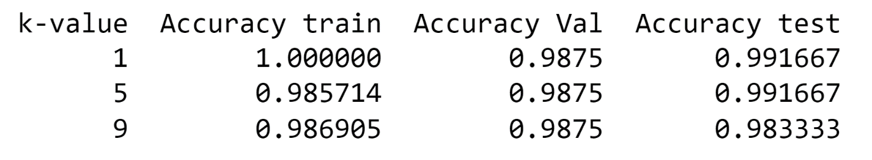

Confusion Matrix for the best configuration of the model, on training data and test data:

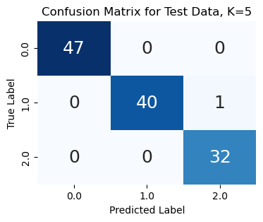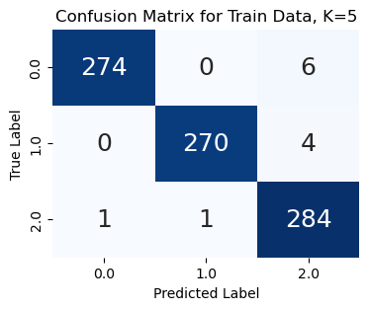

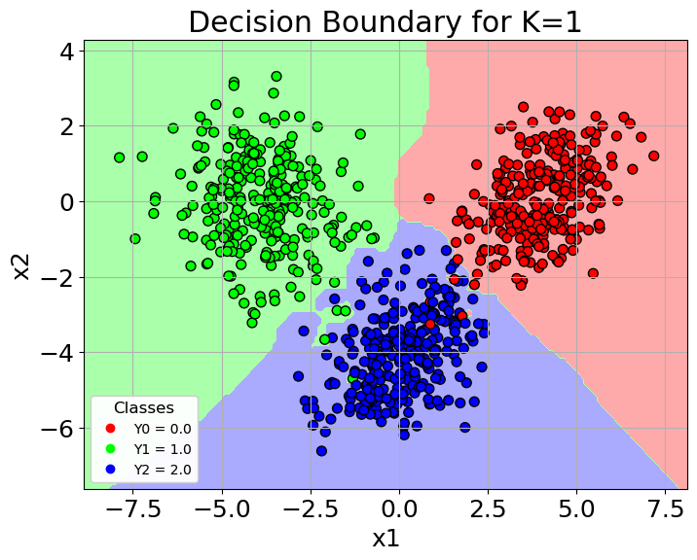Decision Region Plots:

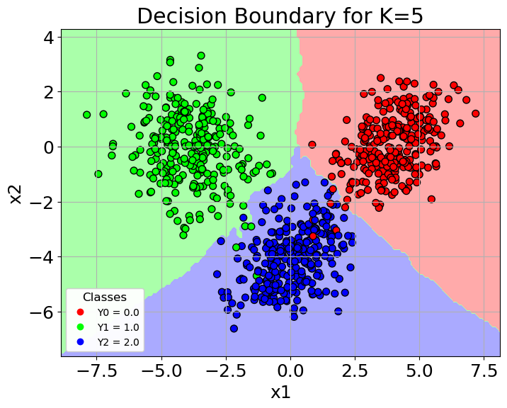

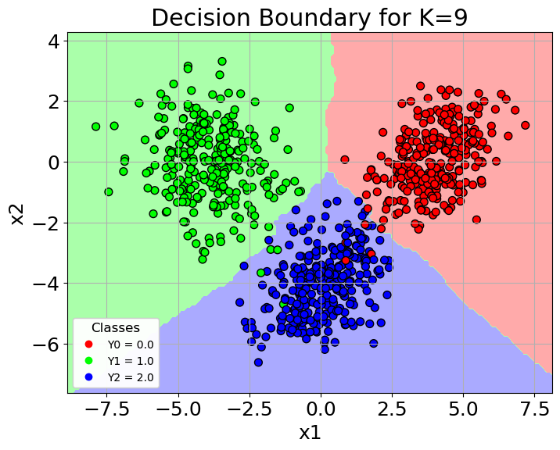

1. **Bayes Classifier with a Gaussian Distribution for every class**
2. *Covariance matrices for all the classes are the same*

Table of Classification Accuracies of the Model for Training data, Validation data, and Test data:

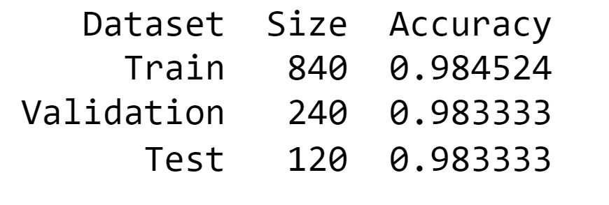

Confusion Matrix for the best configuration of the model, on training data and test data:

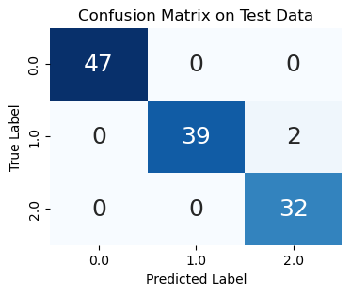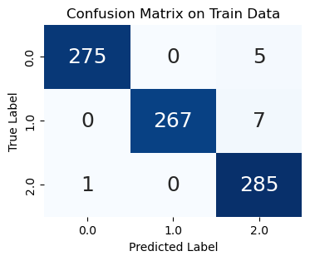

Decision Region Plot:

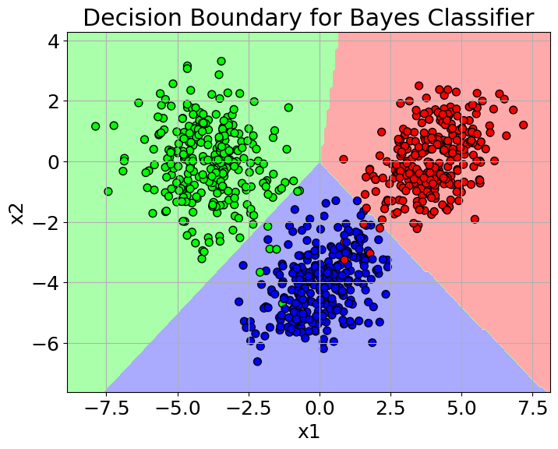

Decision Region Plot with Level curves on Training Data:

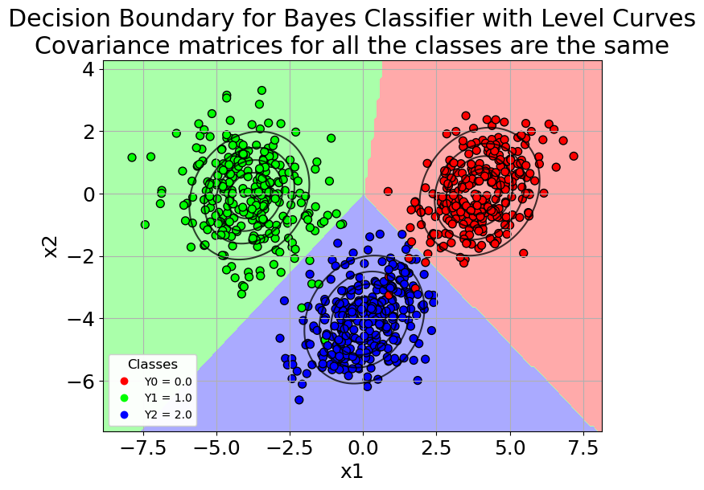

1. *Covariance matrices are different*

Table of Classification Accuracies of the Model for Training data, Validation data, and Test data:

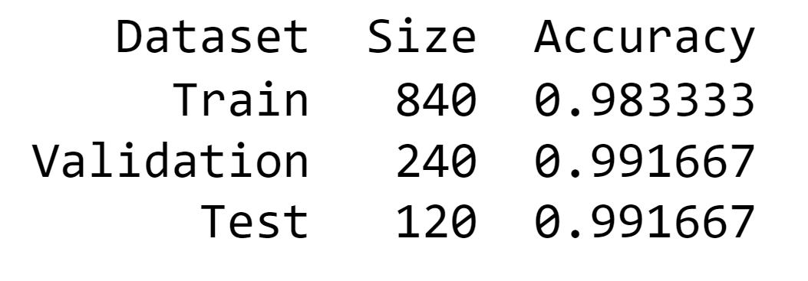

Confusion Matrix for the best configuration of the model, on training data and test data:

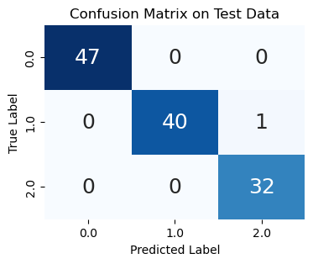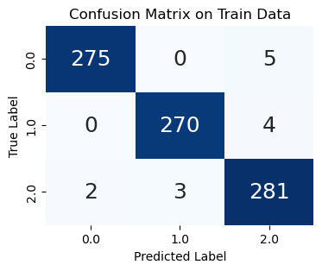

Decision Region Plot:

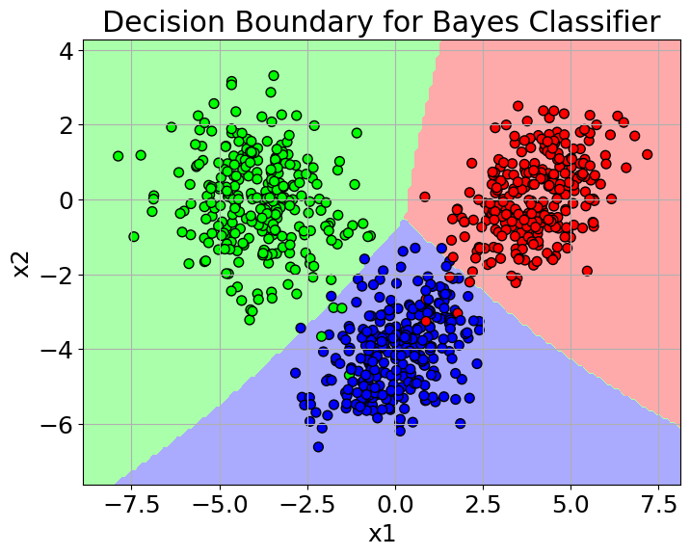

Decision Region Plot with Level curves on Training Data:

