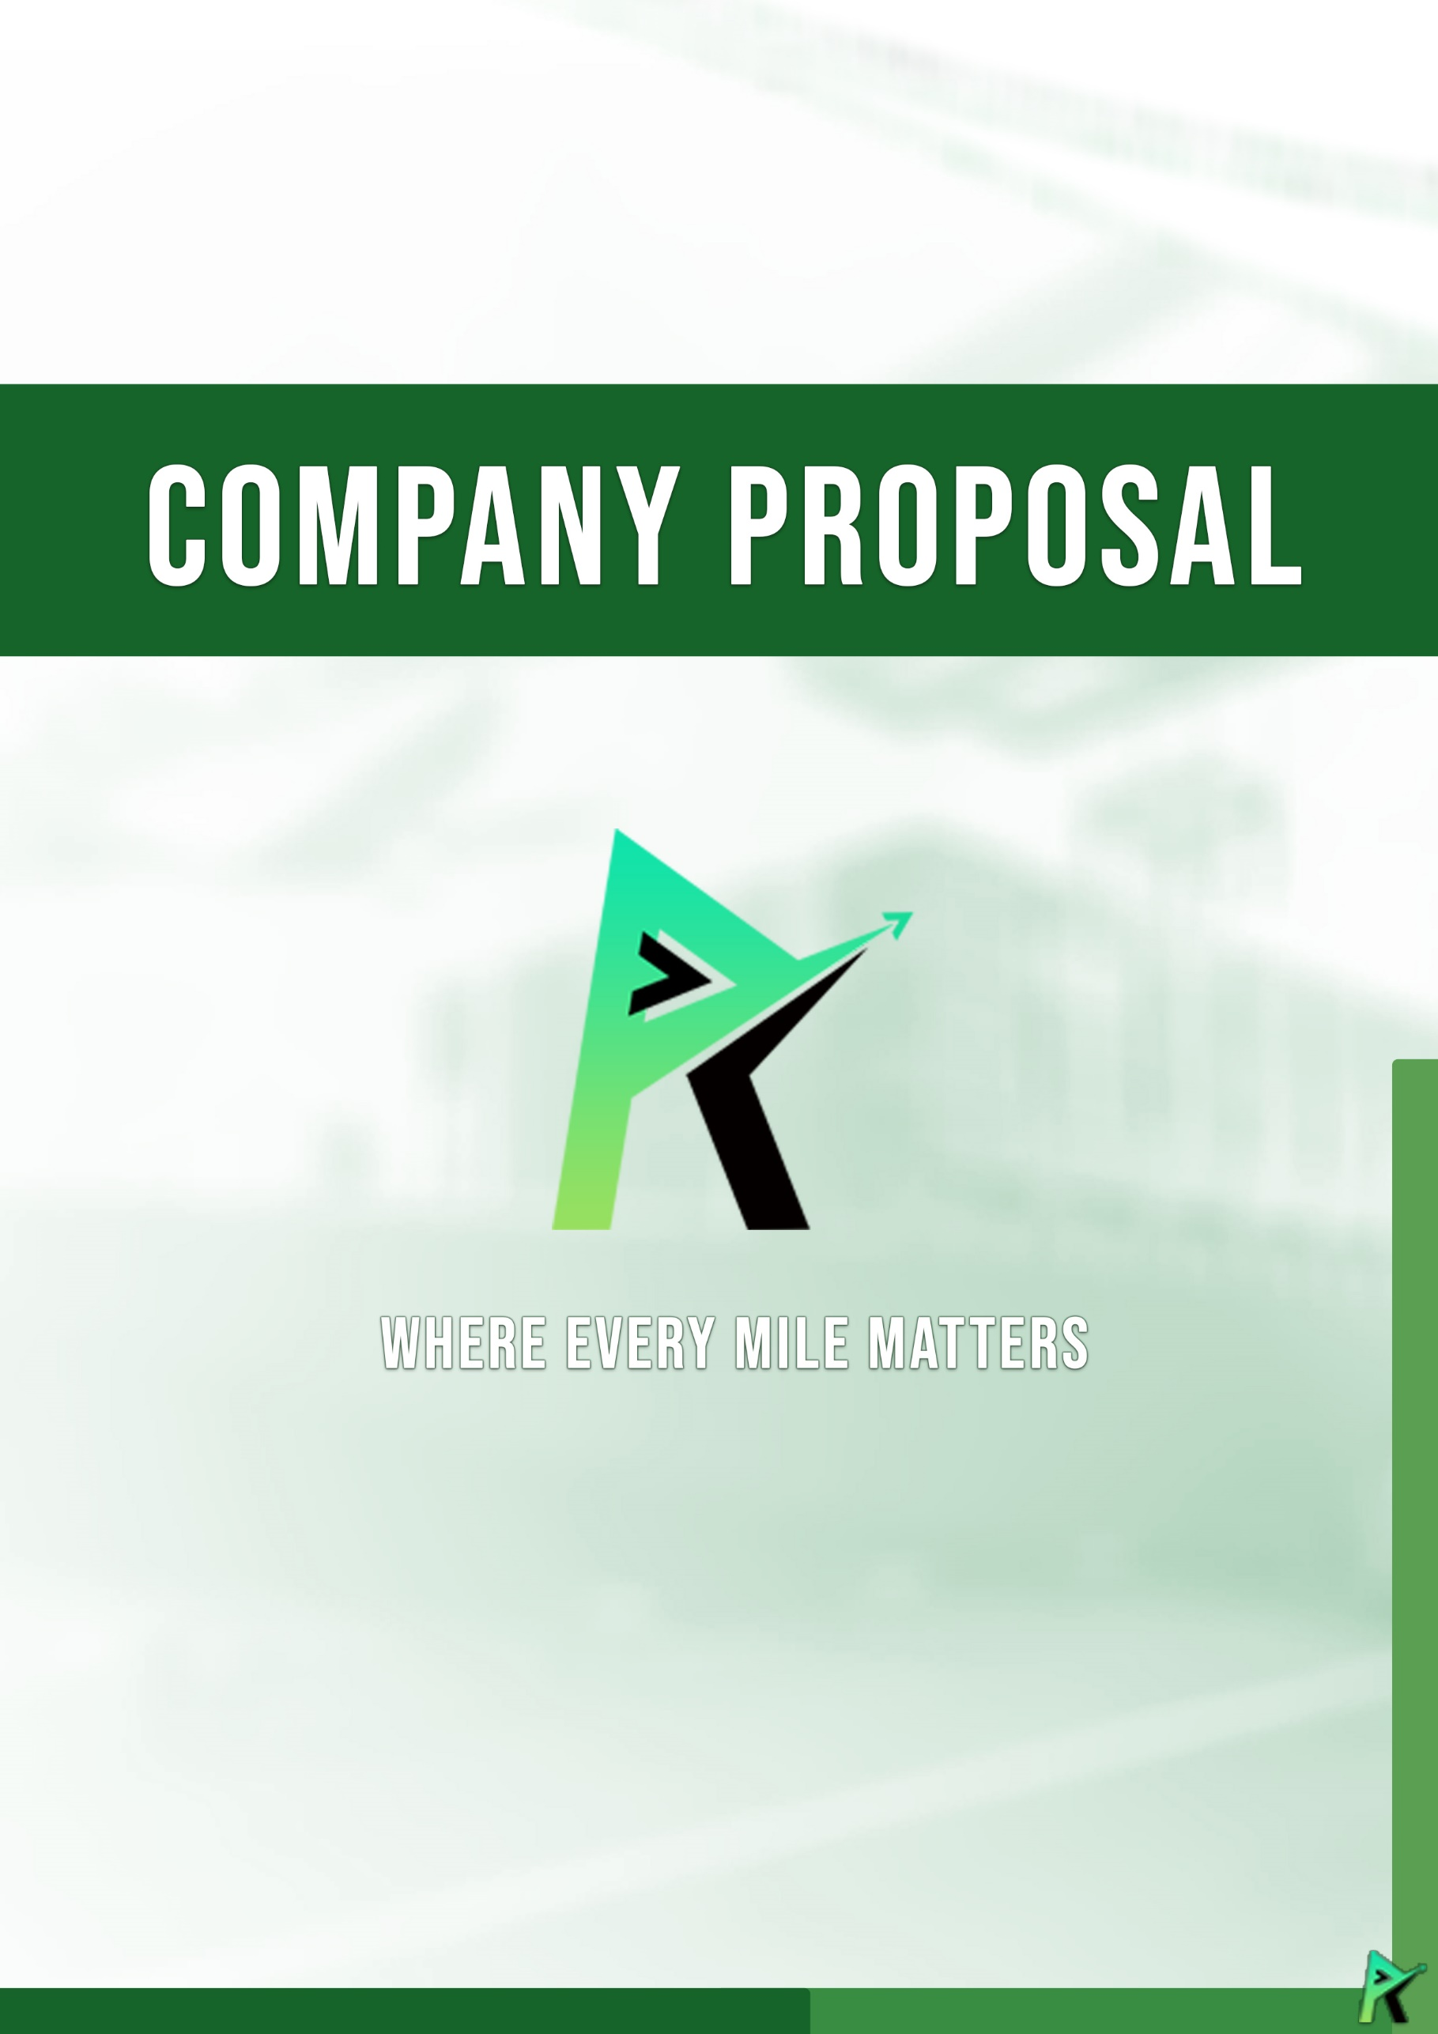

Owner’s Background

ABOUT US

Our owner brings a wealth of knowledge from his five years of hands-on experience working in a leading logistics company. His keen understanding of the industry's dynamics and commitment to excellence are the cornerstones of **Road2go Trucking Services**. His vision is to offer unparalleled delivery solutions that not only meet but surpass the needs and expectations of our clients.

**Road2go Trucking Services** was foundand established in ***2024*** with a mission to redefine delivery services by exceeding customer expectations. Our company is built on the extensive experience and insights of our owner, who has spent five years in the logistics industry. Recognizing the profitability and potential for innovation within this sector, he decided to create a company that combines reliability, efficiency, and superior customer service.

We offer a comprehensive range of delivery services tailored to meet the diverse needs of our clients. Whether it's time-sensitive parcels or large freight, **Road2go Trucking Services** is equipped to handle all types of deliveries with precision and care.

Join us as we pave the road to exceptional delivery services, ensuring that your shipments arrive safely and on time, every time. With **Road2go Trucking Services**, you can expect nothing less than the best.

OUR Services

At **Road2go Trucking Services**, our goal is to venture into the delivery services market with a fresh perspective, providing top-notch services that go beyond traditional boundaries. We are dedicated to achieving this by leveraging advanced logistics strategies, maintaining a customer-centric approach, and continuously improving our processes to ensure the highest level of satisfaction.

OUR Aim



**To be the leading trucking service provider known for our commitment to excellence, innovation, and sustainability, setting the standard for the transportation industry.**

Vision

**To provide reliable, efficient, and safe transportation solutions that exceed our customers' expectations, while fostering a culture of integrity, teamwork, and continuous improvement.**

Mission

**Scope of services**

Trucking Roro Load

Special Packaging and Crating

Pick Up and Special Delivery

Trucking Roro Load

Pick Up and Special Delivery

**Our Services**

**Block 9, Lot 14, Banner Avenue, San Antonio, Paranaque City**

**0917-3727-085**

**Mon-Fri: 9AM –6PM**

**Road2go.services@gmail.com**

**Contact us**

–––