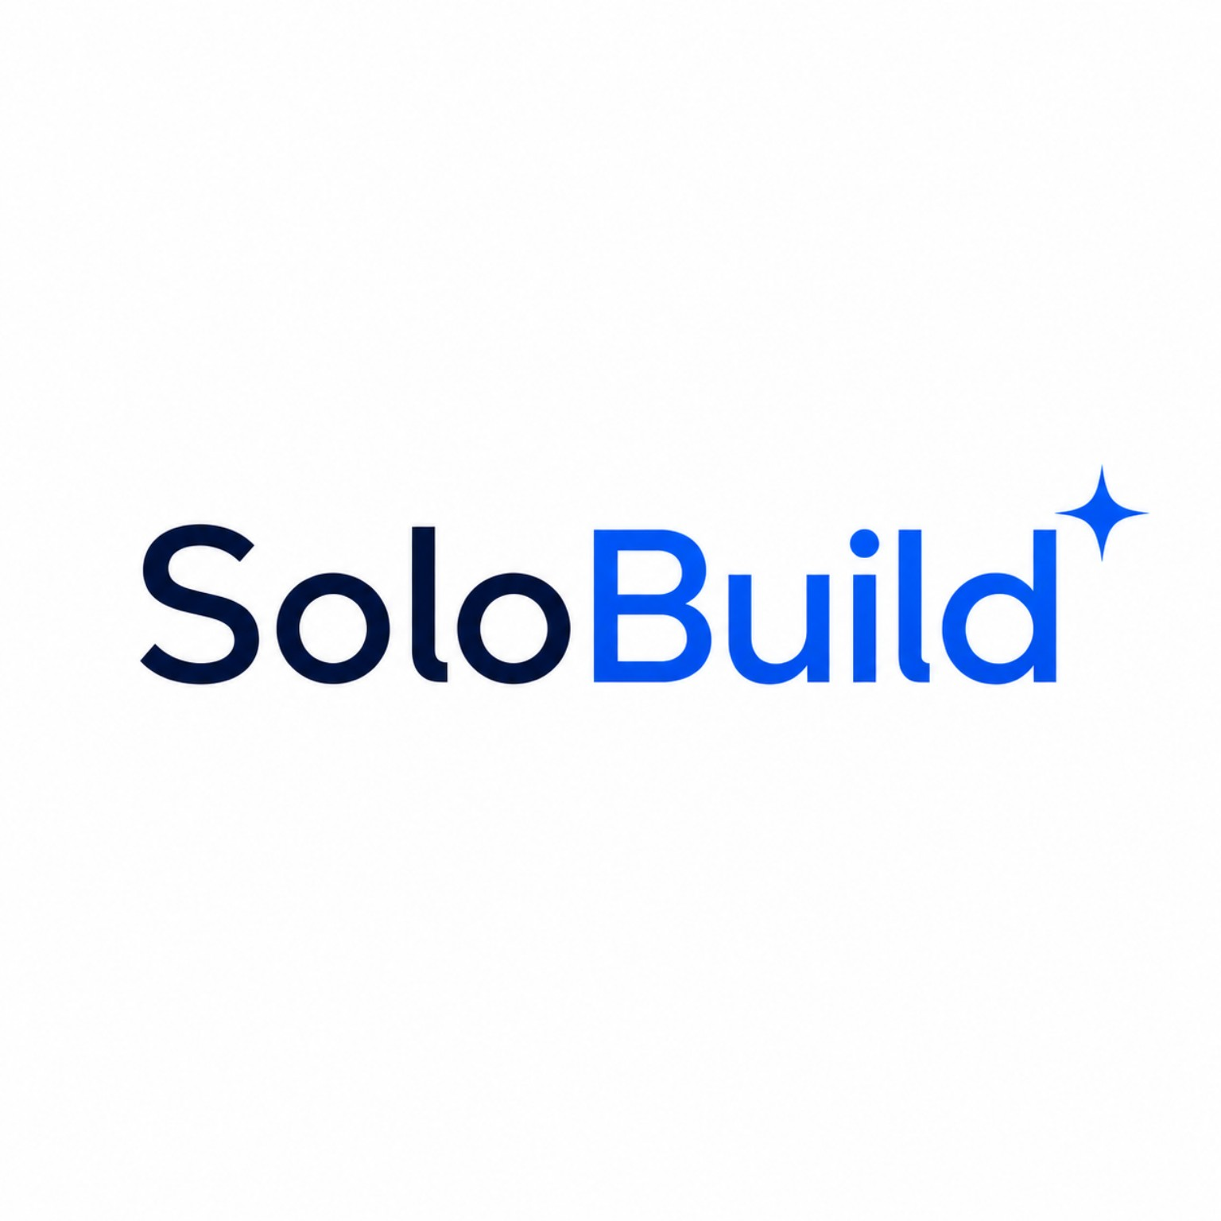

PROPOSAL

Sales & Operations Automation Proposal
Prepared For: {{client_company_name}}
Prepared By: SoloBuild
Date: {{proposal_date}}
Building predictable sales, operations, and follow-up systems through automation.
Confidential Business Proposal – Prepared exclusively for {{client_company_name}}

Understanding Your Requirements
Based on our discussion, we understand your current operational and sales workflow has opportunities for improvement in the following areas.

Client Details
Company Name: {{client_company_name}}
Industry: {{industry}}
Point of Contact: {{contact_person}}
Team Size: {{team_size}}
Current Tools Used: {{current_tools}}
Business Model: {{business_model}}

Current Challenges
{{pain_points}}

Desired Outcomes
{{desired_outcomes}}

About SoloBuild
SoloBuild helps businesses simplify sales, operations, and internal workflows through automation-first systems. We focus on CRM deployment, sales process automation, WhatsApp communication systems, AI-assisted workflows, team productivity systems, and reporting visibility.

Proposed Scope of Work
The following modules are proposed based on current requirements extracted from client discussions.

Selected Modules
{{scope_of_work}}

Recommended Automations
{{recommended_automations}}

Deliverables
- Complete deployment
- User onboarding
- Team training
- Initial support period
- System setup documentation

Estimated Timeline
{{deployment_timeline}}

Commercial Proposal

Recommended Investment
Selected Package: {{package_name}}
Annual Investment: {{pricing}}

Add-ons (If Applicable)
{{addons}}

Terms & Conditions
- Third-party API costs excluded
- WhatsApp API/Meta charges separate
- Additional custom requirements outside approved scope billed separately
- Timelines begin post approval

Support
Post-deployment support included for {{support_duration}}

Approval
Name | Signature | Date

