First make sure you have node installed

Move the demos to where you want to use them.



now install the dependencies, it may take some time and it may skip optional dependencies at the end.

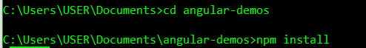

now deploy the application on a node server

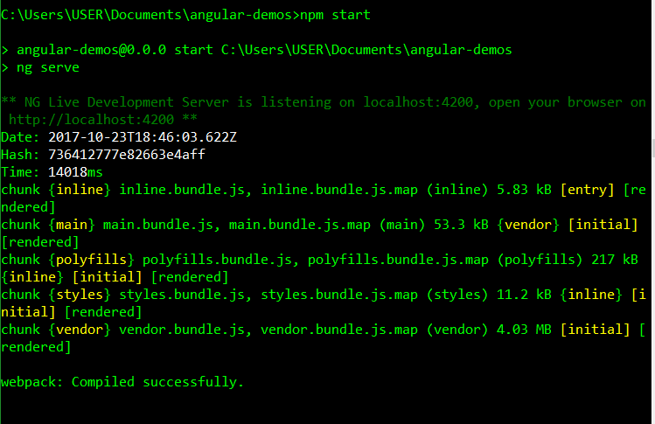

This will automatically update anytime you make changes.