**Project_On_Pizzas_Sales_using_SQL**

**Q1. Retrive the total number of orders placed**

**Select * from orders**

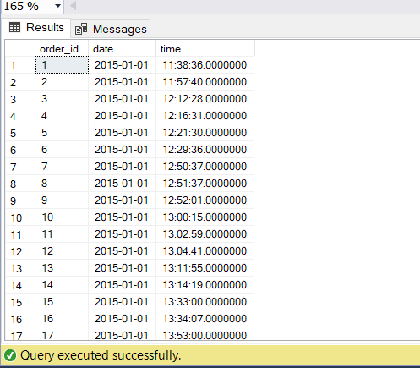

**Select max(order_id) AS total_orders**

**from orders**

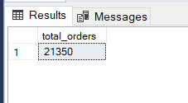

**Q2. Calculate the total revenue from the pizza sales**

**SELECT**

**SUM(order_details.quantity * CAST(pizzas.price AS DECIMAL(10, 2))) AS total_sales**

**FROM**

**order_details**

**JOIN**

**pizzas ON pizzas.pizza_id = order_details.pizza_id;**

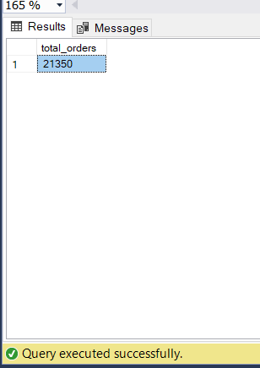

**Q3. Identify the higest-priced pizza**

**Select top 1 pizzas.price, pizza_types.name**

**from pizza_types**

**join pizzas on pizza_types.pizza_type_id = pizzas.pizza_type_id**

**order by pizzas.price desc**

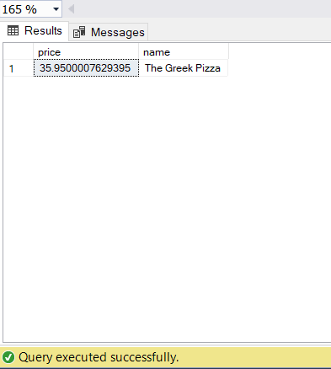

**Q4. Identify the most common pizza size ordered**

**Select top 1 pizzas.size, COUNT(order_details.order_details_id) as most_common_pizzas_ordered**

**from pizzas**

**join order_details on order_details.pizza_id = pizzas.pizza_id**

**group by pizzas.size**

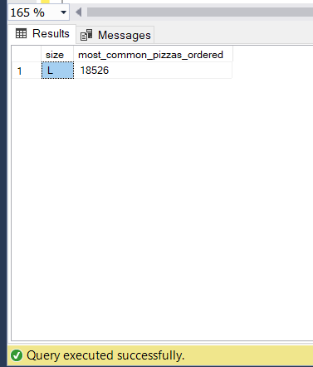

**Q5. List the top 5 most ordered pizzas along with their quantity**

**Select top 5 pizza_types.name,sum (order_details.quantity) as quantity**

**from pizza_types**

**join pizzas on pizzas.pizza_type_id = pizza_types.pizza_type_id**

**join order_details on order_details.pizza_id = pizzas.pizza_id**

**group by pizza_types.name**

**order by quantity desc**

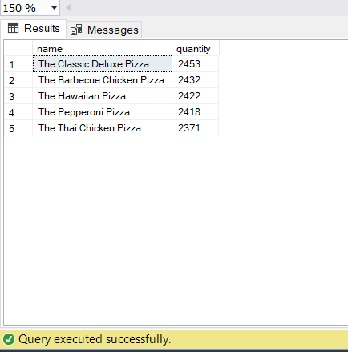

**Q6. Join the necessary tables to find the total quantity of each pizza category ordered.**

**Select top 5 pizza_types.category,sum (order_details.quantity) as quantity**

**from pizza_types**

**join pizzas on pizzas.pizza_type_id = pizza_types.pizza_type_id**

**join order_details on order_details.pizza_id = pizzas.pizza_id**

**group by pizza_types.category**

**order by quantity desc**

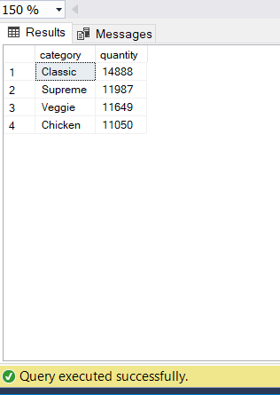

**Q7. Determine the distribution of orders by hour of the day.**

**SELECT**

**DATEPART(HOUR, time) AS Hour,**

**COUNT(order_id) AS order_count**

**FROM**

**orders**

**GROUP BY**

**DATEPART(HOUR, time)**

**ORDER BY**

**Hour;**

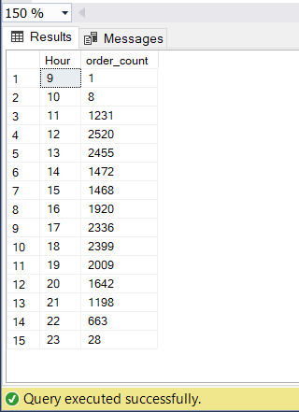

**Q8. Join relevant tables to find the category wise distribution of pizzas**

**Select category, count(name)**

**from pizza_types**

**group by category**

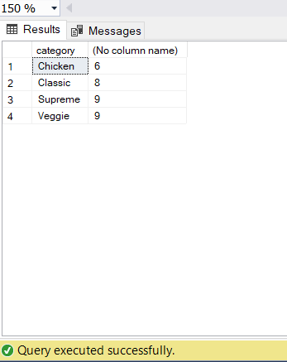

**Q9. Group the orders by date and calculate the sum number of pizzas ordered per day**

**Select avg(quantity) from**

**(Select orders.date, sum(order_details.quantity) as Quantity**

**From orders**

**Join order_details on order_details.order_id = orders.order_id**

**group by orders.date) as ordered_quantity**

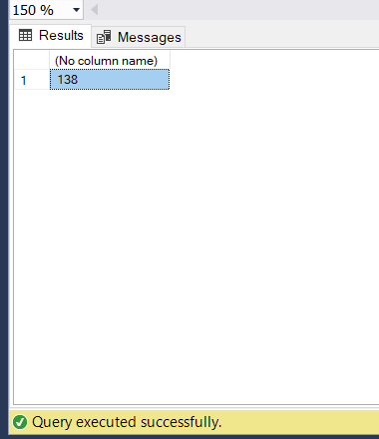

**Q10. Determine the top 3 most ordered pizzas types based on revenue**

**Select top 3 pizza_types.name,sum (order_details.quantity * pizzas.price) as total_revenue**

**from pizza_types**

**join pizzas on pizzas.pizza_type_id = pizza_types.pizza_type_id**

**join order_details on order_details.pizza_id = pizzas.pizza_id**

**group by pizza_types.name**

**order by total_revenue desc**

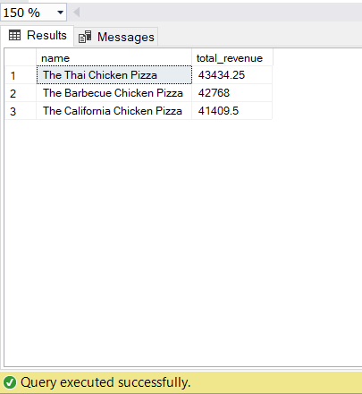

**Q11. Calculate the percentage contribution of each pizza type to total revenue.**

**SELECT**

**pizza_types.name,**

**ROUND((SUM(order_details.quantity * pizzas.price) /**

**(SELECT SUM(order_details.quantity * pizzas.price)**

**FROM pizzas**

**JOIN order_details ON order_details.pizza_id = pizzas.pizza_id)**

**) * 100, 2) AS revenue_percentage**

**FROM**

**pizza_types**

**JOIN**

**pizzas ON pizza_types.pizza_type_id = pizzas.pizza_type_id**

**JOIN**

**order_details ON order_details.pizza_id = pizzas.pizza_id**

**GROUP BY**

**pizza_types.name**

**ORDER BY**

**revenue_percentage DESC;**

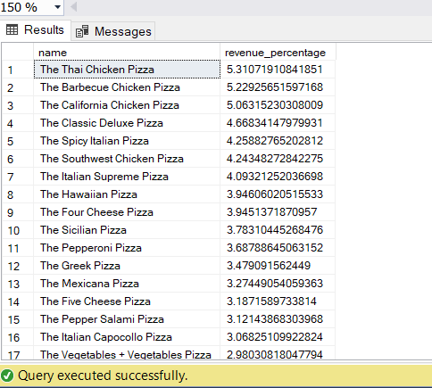

**Q12. Analyse the cumulative revenue generated over time.**

**SELECT**

**date,**

**ROUND(SUM(revenue) OVER (ORDER BY date), 2) AS cum_revenue**

**FROM**

**(**

**SELECT**

**orders.date,**

**SUM(order_details.quantity * pizzas.price) AS revenue**

**FROM**

**orders**

**JOIN**

**order_details ON orders.order_id = order_details.order_id**

**JOIN**

**pizzas ON order_details.pizza_id = pizzas.pizza_id**

**GROUP BY**

**orders.date**

**) AS sales**

**ORDER BY**

**date;**

