**PIZZA SALES QUERIES**

1. **KPI’s**
2. **Total Revenue:**

Select Sum(total_price) AS Total_Revenue from pizza_sales_excel_file

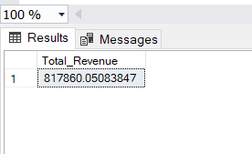

1. **Average Order Value**:

Select Sum(total_price) / Count(Distinct order_id) as Avg_Order_Value from pizza_sales_excel_file

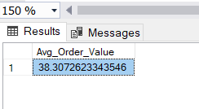

1. **Total Pizzas Sold:**

Select Sum(quantity) As Total_Pizza_Sold from pizza_sales_excel_file

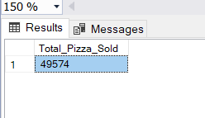

1. **Total Orders:**

Select Count(Distinct order_id) AS Total_orders from pizza_sales_excel_file

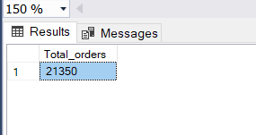

1. **Average Pizza Per Order:**

Select Cast (Cast (Sum(quantity) As Decimal(10,2)) /

Cast (Count(Distinct order_id) As Decimal (10,2)) As Decimal(10,2)) AS Avg_pizza_per_order

from pizza_sales_excel_file

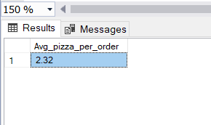

**Problem Statement**

**Charts Requirement**

1. **Daily Trend for total orders:**

Select Datename(DW, order_date) as order_day, Count(Distinct order_id) As Total_Order

From pizza_sales_excel_file

Group by Datename(DW, order_date)

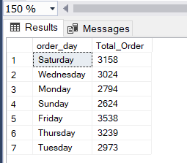

1. **Monthly Trend for total Orders:**

Select Datename(Month, order_date) AS Month_Name, Count(Distinct order_id) As Total_Orders

From pizza_sales_excel_file

Group by Datename(Month, order_date)

Order by Total_Orders DESC

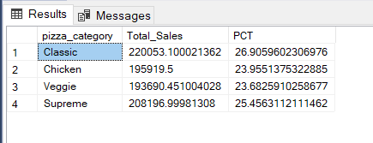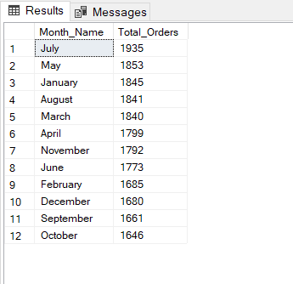

1. **Percentage of sales by pizza category**

Select pizza_category, sum(total_price) as Total_Sales, sum(total_price) * 100/ (Select Sum(total_price) from pizza_sales_excel_file) As PCT

From pizza_sales_excel_file

Group By pizza_category

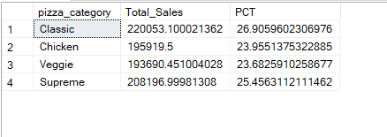

1. **Top 5 best sellers by revenue, total quantity and total orders**

Select Top 5 pizza_name, Sum(total_price) as Total_revenue from pizza_sales_excel_file

Group by pizza_name

Order by Total_revenue DESC

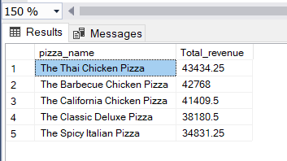

Select Top 5 pizza_name, Sum(quantity) as Total_Quantity from pizza_sales_excel_file

Group by pizza_name

Order by Total_Quantity DESC

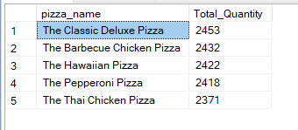

Select Top 5 pizza_name, COUNT(DISTINCT order_id) as Total_Orders from pizza_sales_excel_file

Group by pizza_name

Order by Total_Orders DESC

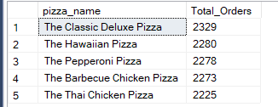

1. **Bottom 5 best sellers by revenue, total quality and total orders**

Select Top 5 pizza_name, Sum(total_price) as Total_revenue from pizza_sales_excel_file

Group by pizza_name

Order by Total_revenue ASC

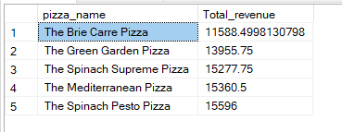

Select Top 5 pizza_name, Sum(quantity) as Total_Quantity from pizza_sales_excel_file

Group by pizza_name

Order by Total_Quantity ASC

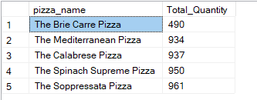

Select Top 5 pizza_name, COUNT(DISTINCT order_id) as Total_Orders from pizza_sales_excel_file

Group by pizza_name

Order by Total_Orders ASC

