

**SMART WATER FOUNTAINS USING IoT**



**Prepared BY**

Saravanan N,

Meiyarasan S,

Ganeshmoorthy E,

Kaviyarasu G

**Abstract**

A smart water fountain is a water fountain that uses IoT technology to monitor and control its operation. This can include features such as:

* Real-time monitoring of water quality and quantity
* Automated water refilling
* Remote control of the fountain's functions
* Leak detection and prevention
* Water conservation measures

Smart water fountains can be used in a variety of settings, including parks, schools, office buildings, and homes.

**Module**

The following is a basic module for a smart water fountain using IoT:

Hardware:

* Microcontroller (e.g., Arduino, Raspberry Pi)
* Water level sensor
* Water quality sensor
* Pump
* Solenoid valve
* IoT communication module (e.g., WiFi, Ethernet, cellular)

Software:

* Firmware for the microcontroller
* IoT platform for data storage and visualization
* Mobile app for remote control

Operation:

The water level sensor and water quality sensor are used to monitor the fountain's operation. The microcontroller uses this data to control the pump and solenoid valve to maintain the desired water level and quality. The IoT communication module is used to send data to the IoT platform and receive commands from the mobile app. The mobile app can be used to remotely control the fountain's functions, such as turning it on and off, setting the desired water level, and viewing the fountain's status. The IoT platform can be used to store and visualize data from the fountain, such as water level, water quality, and energy consumption.

**Project Flow Diagram**

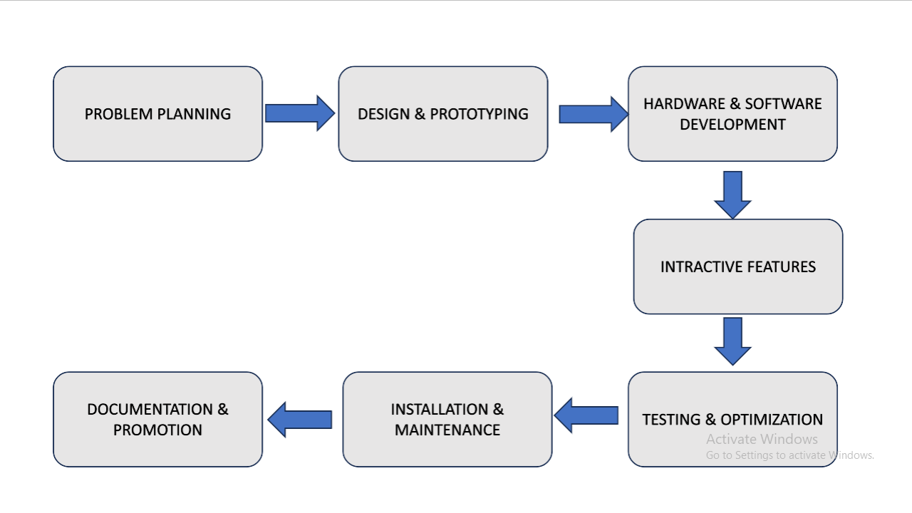

**Additional features**

In addition to the basic features listed above, smart water fountains can also include a variety of other features, such as:

* LED lighting
* Musical displays
* Integration with other smart devices (e.g., smart irrigation systems, weather stations)

These additional features can make smart water fountains more visually appealing and engaging, as well as more efficient and water-saving.

**Benefits of using IoT in water fountains**

There are a number of benefits to using IoT in water fountains, including:

* Improved water quality and safety
* Reduced water consumption
* Reduced maintenance costs
* Increased convenience and accessibility
* Enhanced aesthetics and engagement

**Conclusion**

Smart water fountains are a new and innovative way to manage water resources. By using IoT technology, smart water fountains can improve water quality and safety, reduce water consumption, reduce maintenance costs, and increase convenience and accessibility.