**A**

**Mini Project Report on**

**“Attendance System”**

**Submitted by**

**Saurabh Digambar Chorge**

**MCA II(Semester: III)**

**Guided by**

**“Dr. Manoj Sathe”**





 **P.E. Society's**



**Modern Institute of Business Studies,**

**Nigdi, Pune - 411044**

**2023-24**

**Progressive Education Society’s**

**Modern Institute of Business Studies**

**Nigdi, Pune**  **________________________________________**

**CERTIFICATE**

This is to certify that the Mini Project entitled **Attendance System (AttendX)** is submitted by**, Saurabh Digambar Chorge** a bonafide student of this Institute, studying for a Master of Computer Application, has successfully carried out semester-III Mini Project. This project report is submitted in partial fulfilment of M.C.A. Semester-III (A.Y. 2024-25) curriculum as per the

Savitribai Phule Pune University norms.

**Director Internal Guide External Examiner**

**PES MIBS (Dr. Manoj Sathe)**

**(Prof. Dr. Maithali Ajrunwadkar)**

Date :

Place : Nigdi

ACKNOWLEDGEMENT

It is my proud privilege to express my profound gratitude to the entire management of Progressive Education Society’s Modern Institute of Business Studies and teachers of the institute for providing me with the opportunity to avail the excellent facilities and infrastructure of the institute. The knowledge and values inculcated have proved to be of immense help to my career.

I am grateful to **Prof. Dr. Maithili Arjunwadkar** (Director, PES-MIBS) for their astute guidance, constant encouragement and sincere support for this project work.

I express my sincere gratitude to **Prof. Dr. Manoj Sathe** for their inspiration, constructive suggestion, mastermind analysis and affectionate guidance in my work, without which this project work completion would have been impossible for me. Sincere thanks to all my seniors and colleagues at the company for their support and assistance throughout the project.

I would like to thank all the faculties for providing me with an opportunity to pursue my industrial training, as it is an important part of the MCA course. I feel proud and privileged in expressing my deep sense of gratitude to all those who have helped me in presenting this assignment. I would be failing in my endeavor if I do not place my acknowledgement.

**Student Name & Sign**

INDEX

|  |  |  |  |
| --- | --- | --- | --- |
| **Sr.No.** | **Title** | | **Page No.** |
| **1.** | **Chapter 1: Introduction** | | **5-10** |
|  | 1.1 | Introduction of project | 5 |
| 1.2 | Existing System and Need for System | 5 |
| 1.3 | Scope of Work | 6 |
| 1.4 | Operating Environment - Hardware and Software | 6 |
| 1.5 | Detail Description of Technology Used | 8 |
| 1.6 | Module Description | 9 |
| **2.** | **Chapter 2: PROPOSED SYSTEMS** | | **11-13** |
|  | 2.1 | Proposed System | 11 |
| 2.2 | Objectives of System | 12 |
| 2.3 | User Requirements | 13 |
| **3.** | **Chapter 3: ANALYSIS AND DESIGN** | | **14-19** |
|  | 3.1 | Entity Relationship Diagram (ERD) | 14 |
| 3.2 | Use Case Diagrams | 15 |
| 3.3 | Activity Diagram | 16 |
| 3.4 | Class Diagram | 19 |
| **4.** | **Chapter 4: Drawbacks and Limitations** | | **20** |
| **5.** | **Chapter 6: Proposed Enhancements** | | **21** |
| **6.** | **Chapter 7: Conclusion** | | **22** |
| **7.** | **Bibliography** | | **23** |
| **8.** | **ANNEXURES** | | **24** |

# Chapter 1: INTRODUCTION

**1.1 Introduction of project:**

**AttendX** is an Android-based attendance management system developed using the Android Studio Koala version. The system simplifies the process of recording and managing attendance for educational institutions. It is designed for administrators, faculty, and students, allowing seamless interaction between users for managing attendance records efficiently. The project leverages **Java** and **XML** for the application’s logic and user interface, while **SQLite** serves as the database for storing relevant data such as student and faculty information, as well as attendance records.This system aims to replace the traditional, manual attendance tracking methods with a digital solution that is more accurate, reliable, and easy to use.

**1.2 Existing System and Need for System:**

* **Existing System:** 
  + - **Time-consuming**: Manually taking and recording attendance for each class is slow and inefficient.
    - **Error-prone**: Human errors like incorrect entries or misplacing records are common.
    - **Lack of real-time data**: Attendance data is often not readily available for immediate analysis, which delays decision-making.
    - **Difficulty in managing large volumes of data**: As the number of students increases, tracking and managing attendance becomes more complex and unmanageable.
    - **No centralization**: In institutions with multiple departments, there is often no centralized system for accessing and managing attendance data across branches and faculties.
* **Need for System:** 
  + - * User authentication via OTP, a widely used and secure method for verifying phone numbers.
      * Firebase integration for managing real-time data and user sessions.
      * Building a basic chat interface, which can be expanded into a full-fledged messaging system.

**1.3 Scope of Work:**

* **User Authentication:**

• Simple login functionality allowing faculty and students to access the system.

* **Profile Management:**

• Users can create and manage their profiles within the system after logging in.

* **Attendance Management:** 
  + - * + Faculty can add attendance records for students, enabling efficient tracking of student attendance.
        + Students can view their attendance records and ensure accuracy.
* **Faculty Management:** 
  + - * + Admin-level functionality allows adding faculty members to the system.
        + View and manage faculty profiles as needed.
* **Student Management:**

• The system provides the ability to add student profiles, track them by branches, and view their academic records.

* **Real-time Database Integration:**

• The application integrates with SQLite for offline storage, with potential for future enhancements.

**1.4 Operating Environment - Hardware and Software:**

* **Hardware Requirements:**

1. **Development Machine**:

* **Processor**: Minimum 2.0 GHz Dual-core processor (Quadcore recommended). o RAM: 8 GB (16 GB recommended for smooth performance with Android Studio).
* **Storage:** Minimum 10 GB of free space for Android Studio, SDK, and project files. o Display: Full HD (1920x1080) resolution monitor for optimal UI design experience. o Android Device (Optional): A physical Android phone for testing purposes (Android 5.0 or later).

2. **Emulator (if no physical device)**:

* Integrated within Android Studio for testing the application.
* **Software Requirements:**

1. **Operating System**:

* Windows 10/11 (64-bit), macOS (latest), or Linux (Ubuntu

18.04 or higher).

2. **Development Tools**:

* **Android Studio:** Primary IDE used for Android application development.Version: 4.x or higher.
* **Java Development Kit (JDK):** JDK 8 or higher for writing Java code.

3. **Android SDK**:

* **API Level:** Minimum SDK version 21 (Android 5.0

Lollipop) and Target SDK version 30 (Android 11).

**4. Database:**

* **SQLite:** A lightweight, embedded database used for storing application data, including attendance records, faculty, and student profiles.

5. **Libraries and Dependencies**:

* **Google Play Services:** Required for Firebase integration. o Firebase Auth SDK: To enable OTP authentication.
* **Gradle:** For project build automation.
* **Testing Environment:** 
  + - **Android Emulator**: For simulating app behavior on various device configurations.

**1.5 Detail Description of Technology Used:**

* **Java:**
* Java is the primary programming language used for building the WhatsApp clone. It provides a solid foundation for Android development due to its object-oriented nature, scalability, and vast support for libraries.
* Key Features:

**Object-Oriented Programming (OOP)** helps in organizing the app’s structure.

**Android APIs** written in Java facilitate smooth integration with Android components like activities, services, and notifications.

* **Android Studio:**
* Android Studio is the official IDE for Android development. It offers a robust platform for writing, testing, and debugging Android apps.
  + - * Integrated Gradle Build System: Automates the build process and manages dependencies.
      * Layout Editor: Allows for designing user interfaces visually, which is essential for creating login and OTP verification screens.
      * Emulator: A built-in emulator for testing the app on virtual devices with different Android versions.
      * Logcat: Provides real-time logs for debugging.
* **SQLite:**
* SQLite is a lightweight, serverless database engine used for local data storage in the AttendX application. It provides a reliable and efficient way to store user profiles, attendance records, and other relevant data without the need for a complex database server.
* **XML (eXtensible Markup Language):**
* **Key Uses:** 
  + - * + **Layouts**: Defining the structure of various screens like the login page and OTP verification page. o **Widgets**: Used for buttons, text fields, and other input controls that users interact with during login.
        + **Responsiveness**: Ensuring the app UI works well across various screen sizes and orientations.
* **Gradle:**
* Gradle is the build automation system used in Android projects. It manages project dependencies, including libraries like Firebase and Play Services.
* **Key Features:** Dependency Management: Simplifies adding and updating libraries, such as Firebase Authentication and Realtime Database.
* **Build Configurations:** Manages different build types (e.g., debug and release) for testing and final deployment.

**1.6 Module Description:**

* **User Authentication Module (OTP Login)** 
  + - * + **Description:** This module handles user login and authentication. Users (faculty and students) can log into the system using their credentials.
        + **Key Functions:**

Input validation for username and password.

Access control based on user roles (faculty or student).

* **Admin Module:** 
  + - * + **Description:** This module provides administrative functionalities for managing users and overseeing the entire system.
        + **Key Functions:**

o Add, edit, and remove faculty and student profiles.

o Monitor attendance records and generate reports for review.

* **Profile Management Module** 
  + - * + **Description:** This module allows users to create, view, and manage their profiles after logging in.
        + **Key Functions:**
        + Create user profiles for both faculty and students.
        + Edit profile information, including personal details and contact information. • View profile details for verification.

* **Faculty Management Module:** 
  + - * + **Description:** This module facilitates the management of faculty profiles within the application.
* **Student Management Module:** 
  + - * + **Description:** This module allows for the management of student profiles and records.
        + **Key Functions:**

Add new student profiles, including branch information.

View student details and attendance records.

* **Database Module** 
  + - * + **Description:** This module handles all database-related operations using SQLite.
        + **Key Functions:**

o Create and manage tables for users, attendance records, and profiles. o Perform CRUD (Create, Read, Update, Delete)

# Chapter 2 : PROPOSED SYSTEMS

**2.1 Proposed System:**

* **Streamlined Attendance Tracking:**

• Automate the process of recording and managing student attendance, reducing the administrative burden on faculty members and improving accuracy.

* **User-Friendly Interface:**

• Develop an intuitive and accessible user interface for both faculty and students, ensuring ease of use for all stakeholders.

* **Role-Based Access Control:**

• Implement a role-based access control system that differentiates between students, faculty, and admin users, ensuring that each user can access the functionalities relevant to their role.

* **Comprehensive Data Management:**

• Facilitate the addition and management of faculty and student profiles, along with their corresponding attendance records, allowing for better data organization and retrieval.

* **Real-Time Data Updates:**

• While the current implementation uses SQLite, future enhancements could include real-time data synchronization capabilities using cloud services, providing instant updates and access to data.

* **Data Filtering and Reporting:**

• Enable users to filter and view attendance data by various criteria, such as branch or date, and generate reports for academic performance analysis and institutional requirements.

* **Security and Data Integrity:**

• Ensure that all user data and attendance records are securely stored and managed, protecting sensitive information and maintaining data integrity.

* **Future Scalability:**

• Design the system with scalability in mind, allowing for future enhancements, such as integrating additional features like notifications, messaging, or advanced reporting functionalities.

**2.2 Objectives of System:**

* **Enhance Attendance Accuracy:**

• To improve the accuracy of attendance records by automating the process and minimizing human errors associated with manual attendance tracking.

* **Simplify Attendance Management:**

• To provide a streamlined interface for faculty to efficiently manage attendance records, making it easy to add, update, and view attendance data.

* **Facilitate User Management:**

• To allow administrators to manage user profiles seamlessly, enabling the addition, modification, and deletion of faculty and student profiles.

* **Enable Real-Time Reporting:**

• To provide functionality for generating attendance reports, allowing faculty and administrators to analyze attendance patterns and trends effectively.

* **Support Data Filtering:**

• To implement filtering options for viewing attendance data based on various criteria (e.g., branch, date), enhancing data organization and usability.

* **Ensure Data Security:**

• To implement measures that safeguard user data and attendance records, maintaining confidentiality and integrity of the information stored within the system.

* **Promote User Engagement:**

• To create an engaging user experience that encourages both faculty and students to utilize the system effectively for managing attendance.

**2.3 User Requirements:**

**1. Students:**

* **Account Creation and Login:** 
  + Students should be able to create accounts and log in to the system using their credentials.
* **View Attendance Records:** 
  + Students must have access to their attendance records, enabling them to track their attendance status.
* **Profile Management:** 
  + Students should be able to update their personal information within their profiles.

**2. Faculty:**

* **Account Creation and Login:** 
  + Faculty members should be able to create accounts and log in securely to the system.
* **Manage Attendance:** 
  + Faculty should be able to add, update, and view attendance records for their respective classes.
* **Profile Management:** 
  + Faculty members need the ability to manage and update their profiles.

**3. Administrators:**

* **Admin Login:** 
  + Administrators must have a secure login to access the admin functionalities of the system.
* **User Management:** 
  + Administrators should be able to add, edit, and remove faculty and student profiles as necessary.
* **Attendance Monitoring:** 
  + Administrators need to monitor attendance records and ensure data accuracy and integrity.

# Chapter 3 : ANALYSIS AND DESIGN

**3.1 Entity Relationship Diagram (ERD):**

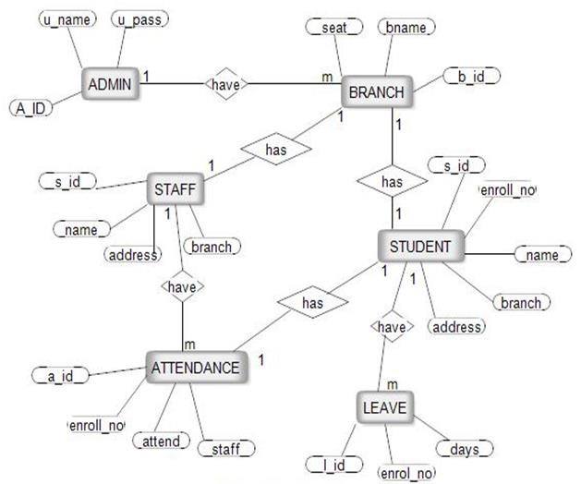

**3.2 Use Case Diagrams:**

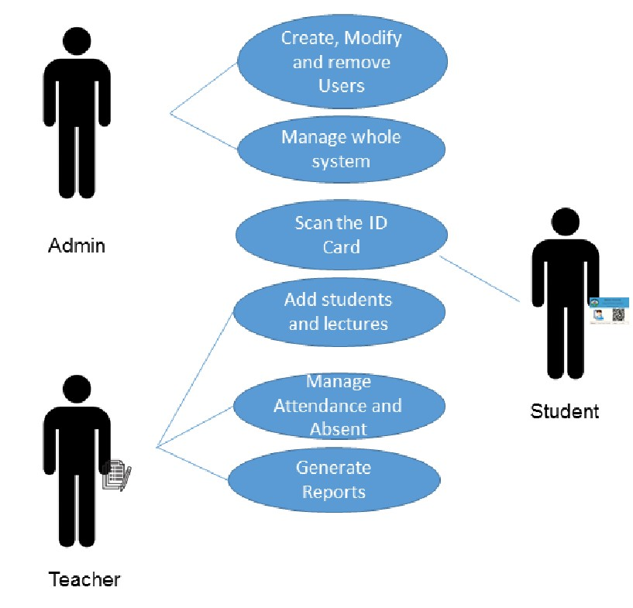

**3.3 Activity Diagram:**

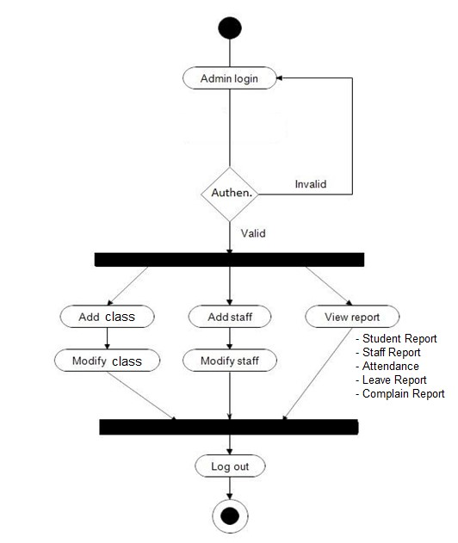

*Admin Activity Diagram*

*Faculty Activity Diagram*

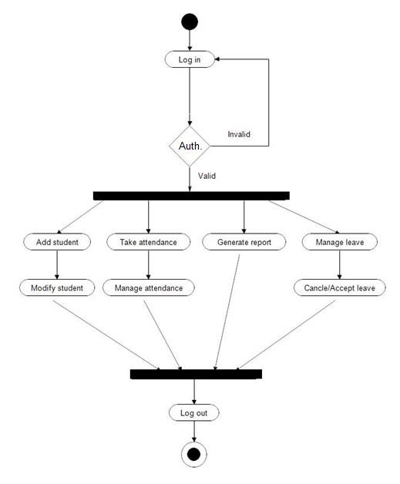

*Student Activity Diagram*

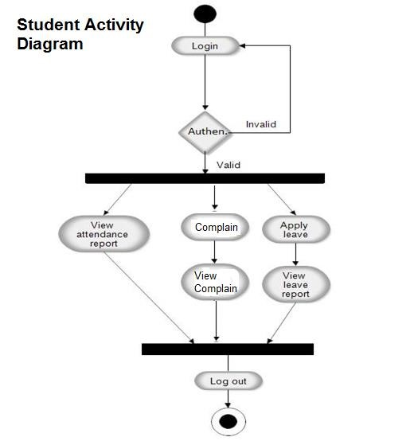

**3.4 Class Diagram**

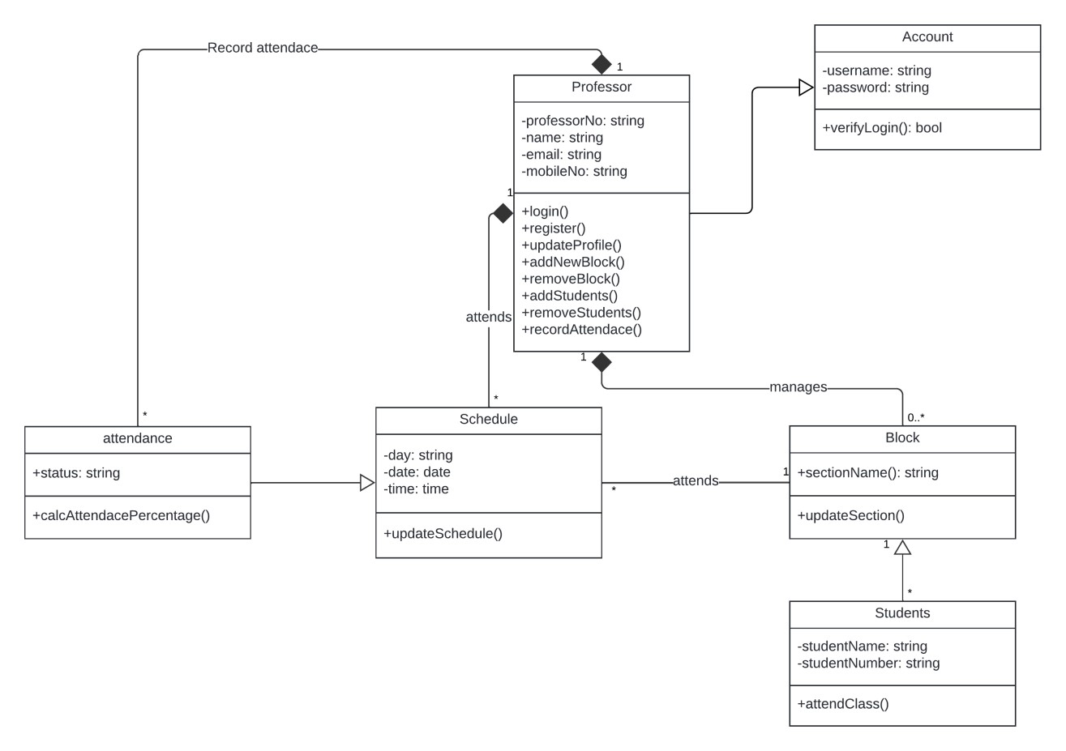

# Chapter 4: Drawbacks and Limitations

* **Dependence on Manual Data Entry:** 
  + The system requires manual input for attendance tracking, which can still lead to human errors if not diligently monitored by faculty members. This dependence may affect the accuracy of attendance records.
* **Limited Offline Functionality:** 
  + Currently, the application relies on SQLite for local data storage. In environments with limited connectivity, users may face challenges accessing the application or updating records if a robust offline mode is not implemented.
* **Scalability Challenges:** 
  + As the number of users grows (especially in larger institutions), performance issues may arise. Without proper optimization, the system may experience slower response times and increased load on the database.
* **Security Concerns:** 
  + While measures are taken to ensure data security, vulnerabilities may still exist, especially if sensitive information is stored. There is always a risk of unauthorized access if security protocols are not rigorously implemented and updated.
* **User Training Requirements:** 
  + Users may require training or guidance to fully utilize the system's features, especially those who are not technologically inclined. This may necessitate additional time and resources for onboarding.
* **Lack of Real-Time Features:** 
  + Currently, the system does not include real-time notifications or updates for attendance changes. This may limit timely communication between faculty and students regarding attendance-related matters.
* **Limited Reporting Capabilities:** 
  + The reporting features may be basic and may not meet all the analytical needs of faculty and administrators.

# Chapter 6: Proposed Enhancements

* **Real-Time Notifications:**

• Implement a notification system to alert students and faculty about attendance updates, changes, or reminders. This feature could enhance communication and ensure that all users are informed in a timely manner.

* **Cloud Integration:** 
  + - Transition from local SQLite storage to cloud-based databases, enabling real-time data synchronization and accessibility from any device. This would allow users to access the system even in low connectivity environments and facilitate data backup. ➢ **Mobile Application Development:**
    - Develop a dedicated mobile application version of AttendX to provide users with a seamless experience on smartphones and tablets. This would enhance accessibility and user convenience.
* **Enhanced Reporting Features:**

• Introduce advanced reporting capabilities that allow faculty and administrators to generate detailed analytics on attendance patterns, trends, and user performance. Customizable reports could provide deeper insights into student engagement.

* **Integration with Educational Tools:** 
  + Explore integration with other educational tools and platforms (e.g., Learning Management Systems) to provide a holistic view of student performance and engagement. This could enable streamlined data sharing and reduce duplicate data entry.
* **Biometric Attendance System:**

• Explore the integration of biometric attendance tracking (e.g., fingerprint or facial recognition) to further automate the attendance process and enhance security.

## Chapter 7: Conclusion

In conclusion, the **AttendX** attendance management system represents a significant advancement in the way educational institutions track and manage student attendance. By integrating modern technologies and user-centric design principles, AttendX addresses the challenges associated with traditional attendance methods, offering a more efficient and accurate solution. The system's key features, including user authentication, attendance management, and comprehensive profile management, provide a streamlined experience for both faculty and students. The role-based access control ensures that users can navigate the application according to their specific needs, enhancing usability and security.

Despite its current limitations, such as reliance on manual data entry and the absence of real-time features, AttendX lays a solid foundation for future enhancements. Proposed improvements, such as cloud integration, mobile application development, and advanced reporting capabilities, are expected to elevate the system's functionality and user experience significantly. Overall, **AttendX** not only simplifies attendance tracking but also promotes accountability and engagement within educational settings. As the system evolves and incorporates new technologies, it has the potential to become an indispensable tool for institutions aiming to foster a more organized and efficient learning environment.

Moving forward, continued feedback from users and ongoing development will be crucial in refining the system and ensuring it meets the dynamic needs of educational institutions.

## Bibliography

1. **Books:**

o Author Last Name, First Initial. (Year). *Title of Book*. Publisher.

o Example:

* Lafore, R. (2002). *Data Structures and Algorithms in Java*.

Sams Publishing.

1. **Online Articles:** 
   * Author Last Name, First Initial. (Year, Month Day). Title of article.

o Example:

* Smith, J. (2023, January 15). The Importance of Attendance Tracking in Education. Education Today.
* https://www.educationtoday.com/importance-of-attendancetracking

1. **Documentation and Manuals:** 
   * Title of Document. (Year). Retrieved from URL o Example:

* Android Developers. (2023). Android Studio User Guide.

Retrieved from <https://developer.android.com/studio/guide>

1. **Research Papers:**

* Author Last Name, First Initial. (Year). Title of paper. Journal Name, Volume(Issue), Page range.
  + Example:
* Johnson, M. (2022). Analyzing Student Attendance Patterns Using Machine Learning. International Journal of Educational Technology, 15(3), 45-60.

1. **Online Tutorials and Courses:**

* Title of Course. (Year). Platform Name. URL o Example:
* Android Development for Beginners. (2024). Udemy. https://www.udemy.com/course/android-development-forbeginners

## ANNEXURES

