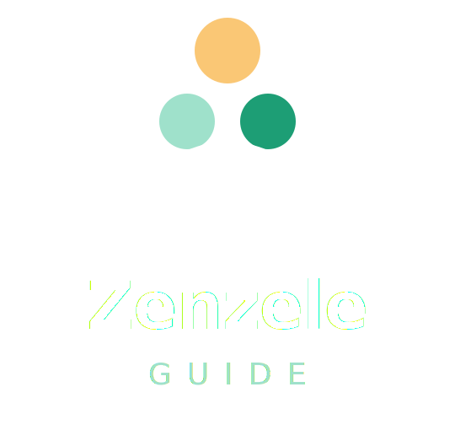
Business Plan 3.0
Do it yourself — but not alone.
South Africa's student guidance & opportunities ecosystem
zenzeleguide.co.za
Matric results · APS matching · Varsity guidance · Bursaries · Learnerships · Jobs · Accommodation

Contents

Vision

To become South Africa's most trusted student guidance and opportunity platform, helping learners move from Grade 10 to their first job through one connected ecosystem.
“Do it yourself — but not alone.”

Executive Summary

Zenzele Guide is a South African student guidance and opportunities platform that helps learners, students, graduates, employers, bursary providers, educational institutions, and accommodation providers connect through a single digital ecosystem.
Unlike traditional job boards or university directories, Zenzele Guide follows a student throughout their entire journey:
Grade 10 → Subject Selection → Matric → Funding → University → Graduate Employment
The platform combines ten connected services into one experience:
- Career guidance
- APS calculation
- University matching
- TVET matching
- NSFAS guidance
- Bursary matching
- Learnership opportunities
- Graduate opportunities
- Student accommodation
- Employer recruitment
The platform is free for students and monetised through partner services, advertising, sponsored opportunities, premium visibility packages, and subscriptions.

10  Connected modules | Grade 10→Job  Full journey | Free  For all students | 600k+  SA matrics / year

Problem Statement

South Africa's education and career ecosystem is fragmented. Students struggle to:
- Understand APS requirements
- Choose careers
- Compare institutions
- Access funding
- Find accommodation
- Discover learnerships
- Access graduate opportunities
Information is scattered across university websites, government portals, bursary websites, accommodation websites, and job boards. This creates confusion, poor decisions, and missed opportunities.

Solution

Zenzele Guide centralises the entire student journey. Users select where they are in their journey and receive personalised guidance. No account is required for basic guidance.
Optional accounts unlock:
- Saved recommendations
- Application tracking
- Deadline reminders
- WhatsApp alerts

Customer Segments

Primary Users — students (free)
Segment | Primary need
Grade 10 learners | Career exploration
Grade 11 learners | APS forecasting
Grade 12 learners | University matching
Gap year students | Alternative pathways
TVET applicants | Skills-based education
University applicants | Course discovery
NSFAS applicants | Funding support
Bursary seekers | Funding opportunities
Learnership seekers | Workplace experience
Graduates | Employment opportunities

Secondary Customers — the paying customers
Customer | Why they pay
Employers | Need applicants
Accommodation providers | Need tenants
Universities | Need applicants
Colleges | Need applicants
Bursary providers | Need qualified applicants

User Journey

The homepage asks one question: “Where are you in your journey?” Each option launches a dedicated workflow.
Entry point | Entry point
Grade 10 | University applicant
Grade 11 | NSFAS
Grade 12 | Bursary seeker
Gap year | Learnership seeker
TVET | Graduate

Platform Modules

Student Guidance Module
- APS calculator
- Career assessment
- University matching
- TVET matching
- Recommendation engine
Bursary Module
- Bursary search
- Eligibility matching
- Deadline tracking
- Application guides
NSFAS Module
- Eligibility checker
- Required documents
- Status guidance
- Appeals information
Learnership Module
- Learnership listings
- Industry matching
- Province filtering
Graduate Module
- Internship listings
- Graduate programmes
- Entry-level jobs
Accommodation Module
- Student housing listings
- University-based search
- Rent comparison
- Contact providers

Partner Portal

The Partner Portal serves employers, institutions, bursary providers, and accommodation providers.

Employer Portal
Workflow: Create account → Business verification → Post opportunity → Admin review → Publish
Opportunity types: jobs, learnerships, internships, graduate programmes.
Features:
- Manage listings
- Track views
- Featured listings
- Applicant analytics

Accommodation Portal
Workflow: Create account → Verify property → Create listing → Upload photos → Admin review → Publish
Features:
- Vacancy management
- Featured listings
- Lead tracking

Bursary Provider Portal
Workflow: Create account → Submit bursary → Requirements → Application process → Admin review → Publish
Features:
- Featured placement
- Analytics dashboard

Institution Portal
Workflow: Create account → Upload prospectus → Course information → Application dates → Admin review → Publish
Features:
- Featured institution pages
- Open day promotions
- Course advertising

Admin Portal

The Admin Portal controls the entire ecosystem.
Area | Manages
User management | Student accounts, partner accounts
Institution management | Universities, colleges, TVETs
Opportunity management | Jobs, learnerships, internships, bursaries
Accommodation management | Listings, verification, approvals
Content management | SEO pages, blogs, guides
Revenue dashboard | Ad, listing & subscription revenue
Analytics dashboard | Traffic, popular searches, user behaviour

Revenue Model

# | Revenue stream | Description
1 | Google AdSense | Ads served to students searching educational information
2 | Featured opportunities | Free / featured / premium listing tiers
3 | Accommodation listings | Monthly subscriptions and featured placements
4 | Institution promotion | Universities and colleges pay for enhanced visibility
5 | Bursary promotion | Sponsored bursaries and featured placement
6 | Premium student membership | R39–R49/month subscription

Premium Student Membership — R39–R49/month
- Saved recommendations
- Deadline reminders
- WhatsApp alerts
- Application tracker

Marketing Strategy

SEO — long-tail pages
- Wits APS requirements
- NSFAS application guide
- Engineering bursaries
- Learnership opportunities

Social media
- TikTok
- Instagram
- Facebook
- WhatsApp Channel

School partnerships
- Career guidance departments
- Career expos
- Student ambassadors

Technology Stack

Layer | Technology
Frontend | Next.js
Backend | Supabase
Database | PostgreSQL
AI engine | Claude API
Storage | Cloudflare R2
Hosting | Cloudflare Pages
Payments | PayFast
Email | Resend
Analytics | Google Analytics

Development Roadmap

Phase | Timeline | Launch | Goal
Phase 1 | Months 1–3 | APS calculator, university & TVET matching, NSFAS checker, bursary database | Product-market fit
Phase 2 | Months 4–6 | User accounts, saved profiles, WhatsApp alerts, opportunity database | Retention
Phase 3 | Months 6–12 | Employer, accommodation & bursary portals | Revenue generation
Phase 4 | Year 2 | Institution portal, premium membership, advanced analytics | Scale

Long-Term Vision

By Year 5, Zenzele Guide becomes South Africa's largest student opportunities ecosystem — one platform where learners can:
- Choose careers
- Find funding
- Apply to institutions
- Find accommodation
- Secure learnerships
- Launch careers
All from one trusted platform.

zenzeleguide.co.za · “Do it yourself — but not alone.”

