**MIT has got its very Own Ground Station!**

**(**Mr. Ankit Sharma**)**

MIT’s Astronomy club started to work on idea of building its very own ground station on around 1st of May,2017.

A meeting was officially called to discuss about the matter and a team was finalized to work for the same.

Our idea was to be capable of receiving satellite data as well as to work on cube sat building as soon as the Ground station becomes Active.

After many discussions and meeting we were forced to drop the idea due to lack of resources as well as support from all sides nevertheless we were asked to continue our research on a personal platform.

Researches went on individual basis, Students travelled to various location and tried to analyse various ground stations and their working.

Finally, on 27th of May, 2020, we were able to make our 1st ever satellite reception via a ground station setup based at Bharuch, Gujarat by our ex student Mr. Ankit Sharma.

Reception are as follows –   
Satellite pass,   
27-05-20   
Time 20:08-20:20,  
Location – Bharuch, Gujarat   
Ground Station Operator/Data Analyst – Er. Ankit Sharma

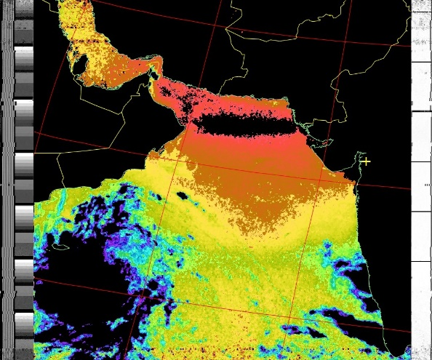NOAA 15 satellite reception. 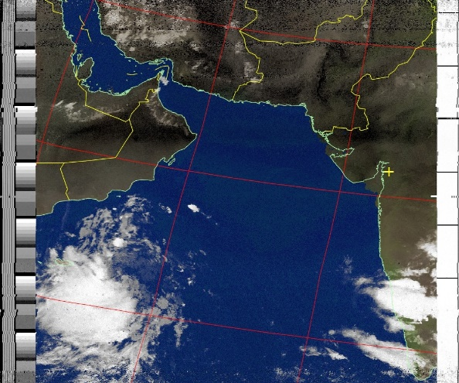It's a weather data.

