Part 1. Monte Carlo Integration

### Task 1:

Task One-One:

|  |  |  |
| --- | --- | --- |
| Round: | $$\overline{I}$$ | $$\overline{s}$$ |
| 1 | 2.399 | 0.007 |
| 2 | 2.391 | 0.007 |
| 3 | 2.398 | 0.007 |
| 4 | 2.396 | 0.007 |
| 5 | 2.397 | 0.007 |
| 6 | 2.391 | 0.007 |
| 7 | 2.400 | 0.007 |
| 8 | 2.393 | 0.007 |
| 9 | 2.389 | 0.007 |
| 10 | 2.392 | 0.007 |

Task One-Two:

lambda = 0.100

|  |  |  |
| --- | --- | --- |
| Round: | $$\overline{I}$$ | $$\overline{s}$$ |
| 1 | 0.401 | 0.007 |
| 2 | 0.400 | 0.007 |
| 3 | 0.399 | 0.007 |
| 4 | 0.395 | 0.007 |
| 5 | 0.396 | 0.007 |
| 6 | 0.399 | 0.007 |
| 7 | 0.398 | 0.007 |
| 8 | 0.393 | 0.007 |
| 9 | 0.398 | 0.007 |
| 10 | 0.399 | 0.007 |

lambda = 1.000

|  |  |  |
| --- | --- | --- |
| Round: | $$\overline{I}$$ | $$\overline{s}$$ |
| 1 | 0.398 | 0.001 |
| 2 | 0.399 | 0.001 |
| 3 | 0.398 | 0.001 |
| 4 | 0.398 | 0.001 |
| 5 | 0.396 | 0.001 |
| 6 | 0.399 | 0.001 |
| 7 | 0.398 | 0.001 |
| 8 | 0.397 | 0.001 |
| 9 | 0.397 | 0.001 |
| 10 | 0.399 | 0.001 |

lambda = 10.000

|  |  |  |
| --- | --- | --- |
| Round: | $$\overline{I}$$ | $$\overline{s}$$ |
| 1 | 0.442 | 0.106 |
| 2 | 0.337 | 0.019 |
| 3 | 0.349 | 0.019 |
| 4 | 0.362 | 0.027 |
| 5 | 0.398 | 0.058 |
| 6 | 0.400 | 0.076 |
| 7 | 0.361 | 0.027 |
| 8 | 0.359 | 0.038 |
| 9 | 0.357 | 0.021 |
| 10 | 0.362 | 0.023 |

A λ value of 1.0 has led to the estimator with best efficiency.

### Task 2:

Task Two-One:

|  |  |  |
| --- | --- | --- |
| Round: | $$\overline{I}$$ | $$\overline{s}$$ |
| 1 | 6.277 | 0.019 |
| 2 | 6.261 | 0.019 |
| 3 | 6.280 | 0.019 |
| 4 | 6.276 | 0.019 |
| 5 | 6.296 | 0.019 |
| 6 | 6.284 | 0.019 |
| 7 | 6.291 | 0.019 |
| 8 | 6.291 | 0.019 |
| 9 | 6.293 | 0.019 |
| 10 | 6.269 | 0.019 |

Task Two-Two:

|  |  |  |
| --- | --- | --- |
| Round: | $$\overline{I}$$ | $$\overline{s}$$ |
| 1 | 0.417 | 0.003 |
| 2 | 0.419 | 0.003 |
| 3 | 0.416 | 0.003 |
| 4 | 0.418 | 0.003 |
| 5 | 0.418 | 0.003 |
| 6 | 0.420 | 0.003 |
| 7 | 0.418 | 0.003 |
| 8 | 0.418 | 0.003 |
| 9 | 0.419 | 0.003 |
| 10 | 0.418 | 0.003 |

### Task Three:

P is approximately 11.076 ± 0.100, to get this I used 2620000 samples.

## Part 2. Simple Path Tracing

### **Task 1. Path Tracing Version 0.5**

## Sample image(64 samples):

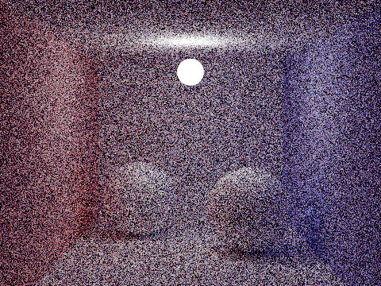

### **Task 2. Specular BRDFs**

## Sample image (64 samples):

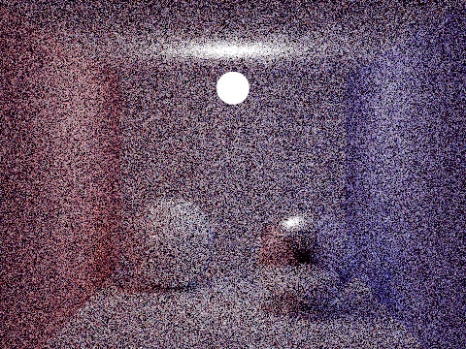

### **Task 3-1. Path Tracing with Next Event Estimation**

## Sample image (64 samples):

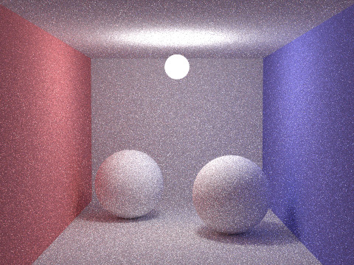

#### **Task 3-2. Fixing Specular Surfaces**

## Sample image (64 samples):

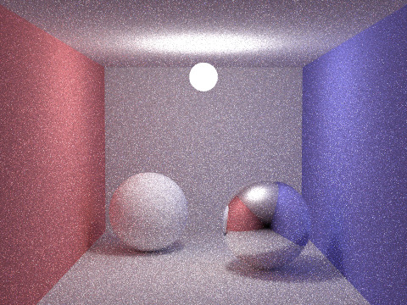

## Sample image (256 samples):

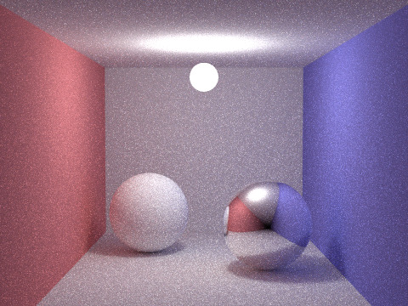

## Sample image (512 samples):

