سینا ملکی – مکتب ۱۱۲
1. What is database indexing?
Indexing improves database performance by minimizing the number of disc visits required to fulfill a query. It is a data structure technique used to locate and quickly access data in databases. Several database fields are used to generate indexes. The main key or candidate key of the table is duplicated in the first column, which is the Search key. To speed up data retrieval, the values are also kept in sorted order. It should be highlighted that sorting the data is not required. The second column is the Data Reference or Pointer which contains a set of pointers holding the address of the disk block where that particular key value can be found.
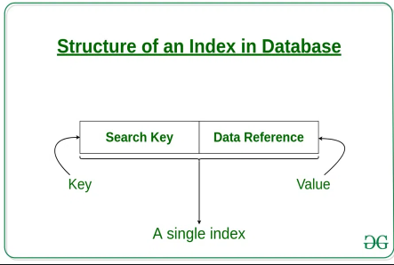

2- What kinds of SQL constraint are there? What is the meaning of them?
SQL constraints are used to specify rules for the data in a table.
Constraints are used to limit the type of data that can go into a table. This ensures the accuracy and reliability of the data in the table. If there is any violation between the constraint and the data action, the action is aborted.
Constraints can be column level or table level. Column level constraints apply to a column, and table level constraints apply to the whole table.
The following constraints are commonly used in SQL:
- NOT NULL - Ensures that a column cannot have a NULL value
- UNIQUE - Ensures that all values in a column are different
- PRIMARY KEY - A combination of a NOT NULL and UNIQUE. Uniquely identifies each row in a table
- FOREIGN KEY - Prevents actions that would destroy links between tables
- CHECK - Ensures that the values in a column satisfies a specific condition
- DEFAULT - Sets a default value for a column if no value is specified
- CREATE INDEX - Used to create and retrieve data from the database very quickly
3.What is a relationship in an RDBMS?
A database management system (DBMS) is a software system for creating and managing databases. A DBMS enables end users to create, protect, read, update and delete data in a database.
A Relation in a database management system (DBMS) organizes information into rows and columns. This organized arrangement makes a difference in information storing and recovering information proficiently. Relations permit us to query information utilizing SQL commands like SELECT, Update, Insert, and Delete. Henceforth, it becomes easier and more demanding to control and extract data from the database.
Relations are alluded to as tables within the database management system.

Sources:
https://www.geeksforgeeks.org/indexing-in-databases-set-1/
https://www.w3schools.com/sql/sql_constraints.asp#:~:text=Constraints%20can%20be%20column%20level,in%20a%20column%20are%20different
https://www.geeksforgeeks.org/what-is-relationship-set-in-dbms/

