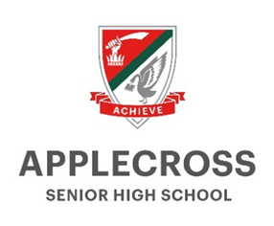 | Year 7 Humanities and Social Sciences  Student Program | Geography | Term 1 | 2026
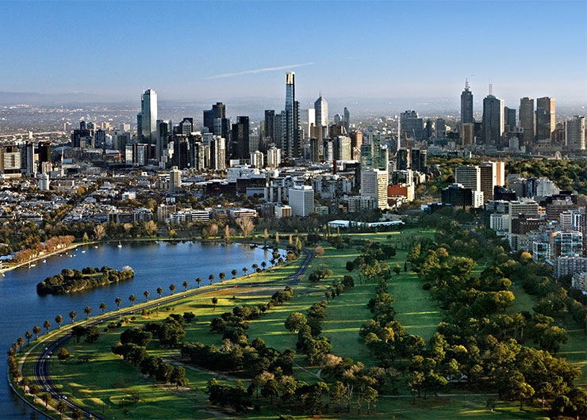 |  |  | 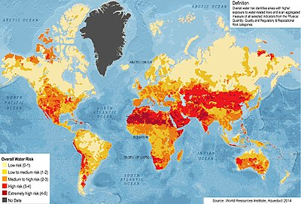 | 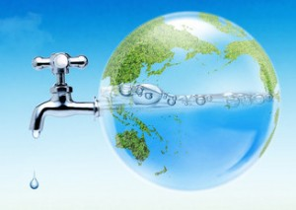 | 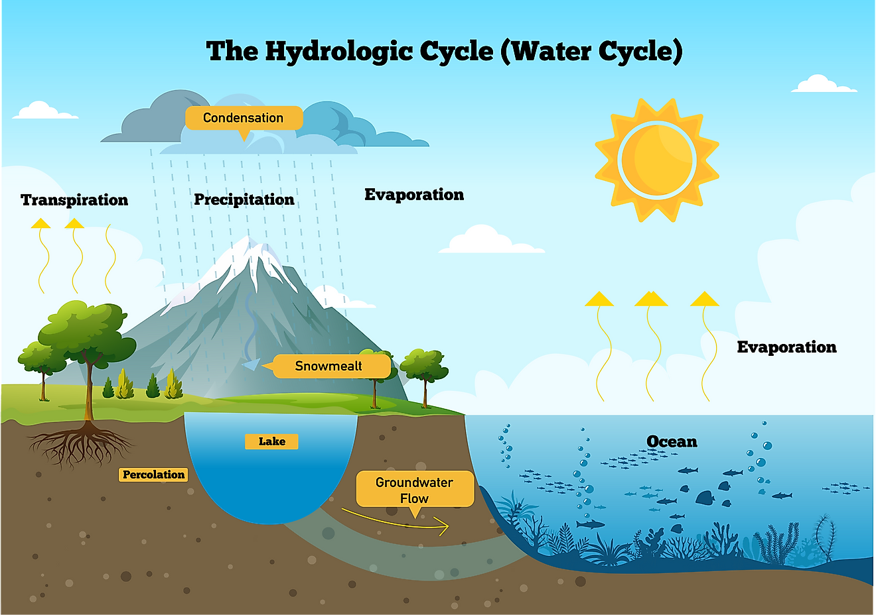
Geography: Water in Australia; Place and Liveability Duration: 9 Weeks

In the Year 7 syllabus for Geography, the concepts of place, space, environment, interconnection, sustainability and change continue to be developed as a way of thinking and provide students with the opportunity to inquire into the nature of water as a natural resource. The concept of place is expanded through students' investigation of the liveability of their own place. They apply this understanding to a wide range of places and environments at the full range of scales, from local to global, and in a range of locations.

Week | Learning intentions | Vocabulary | Support materials
1 | Year 7 ‘Big Days In’  Intro to HASS. Set up INB. |  | INB set-up documents
2 | Place and Liveability  Essential Question (EQ): What is geography?  - I can list and briefly describe the seven key concepts of Geography: place, space, environment, interconnection, sustainability, scale and change.  - I can identify different types of maps.  - I can annotate features on a map.  - I can describe what physical and political maps show.  EQ: What factors determine the ‘liveability’ of a place?  - I can define ‘place’ and ‘liveability’. | Geography  Place  Liveability | Textbook: Oxford Humanities and Social Sciences 7: Module 1.1, 1.6-1.7
3 | EQ: What factors determine the ‘liveability’ of a place?  - I can discuss the factors that influence the decisions people make about where to live and their perceptions of the liveability of places. For example:  - demographics, such as age, education, income and cultural background  - cultural and historical links to the land by Aboriginal and Torres Strait Islander peoples  - climate, infrastructure, access to healthcare, connection to family and friends  - air quality, tree canopy and parks.  - I can identify liveability features through the study of different maps.  - I can describe the influence of environmental quality on the liveability of places. For example:  - air and water quality  - proximity to oceans, rivers and open spaces. | Demographics  Climate | Text 3.1
4 | EQ: What factors determine the ‘liveability’ of a place?  - I can explain the influence of accessibility to services and facilities on the liveability of places. For example:  - services, such as education and healthcare  - infrastructure allowing access to clean water and sanitation  - ways to access services and facilities, such as the ability to walk or use public transport.  - I can carry out fieldwork to sketch and map location and accessibility of services listed above. For example:  - Desktop field work using Google Maps or Google EARTH, Streetview to search, map and measure how easy it is to access the services and environmental quality outlined in the EQ’s from student’s own home or school. | Accessibility  Infrastructure | Text 3.2-3.6 + 3A Skills in context p116
5 | EQ: How can liveability of places be improved?  - I can describe strategies used to enhance liveability of places for different groups in society. For example:  - global shift in urban development that incorporates green space for residents. Consider resources related to City of Fremantle ‘Future of Fremantle Place and Vision’.  - providing a range of accessible modifications and features for people living with a disability  - improving access to the National Broadband Network for people living in rural areas to allow for use of services, such as healthcare and banking.  - I can write an introductory extended response using TEEL paragraph structure. Suggested TEEL paragraph structure includes:  - Topic sentence (contains main idea)  - Explain  - Evidence / example  - Link (refer back or sum up main idea) |  | Text 3.8-3.11
6 | EQ: How can liveability of places be improved?  - I can describe the liveability of the City of Melville.  - I can work in groups to brainstorm and rank a range of strategies that would enhance liveability for young people in the local area.  - I can evaluate which strategy would best improve the liveability of the City of Melville.  Complete Common Assessment Task (CAT): Inquiry into liveability within the City of Melville |  | CAT Inquiry into liveability within the City of Melville
7 | Water in Australia  EQ: Why is water an important resource?  - I can classify environmental resources as either renewable or non-renewable.  - I can analyse rainfall data to determine how quantity and variability of Australia’s water resources have changed over time.  - I can describe how water is used in Australia. For example:  - I can explain how water is used as an environmental resource  - I can explain how water is used as an economic resource  - I can explain how water is used as a social resource  - I can explain how water is used as a cultural resource  - I can explain how water connects people  - I can describe the location, distribution and variability of Australia’s water sources. For example:  - the variability of seasons and longer-term climatic variations  - types of water sources, such as desalination, aquifer, river basins, dams and springs.  - I can interpret climate graphs and recognise how water resources may be impacted via variations in rainfall as shown in this data. | Renewable resources  Non-renewable resources  Evaporation  Precipitation  Climate | Text 2.9-2.13
8 | EQ: How can we minimise the impact of water scarcity?  - I can define water scarcity.  - I can identify the main causes of water scarcity. For example:  - physical factors, such as drought and economic factors, such as the way in which water is used as a resource.  - I can explain the social, environmental and economic impacts water scarcity can have on an area. For example:  - I can explain how water scarcity impacts peoples water usage in the home, in businesses and public infrastructure  - I can explain how water scarcity impacts plants, animals and humans  - I can explain how water scarcity impacts expenditure. | Water scarcity | Text 2.14-2.15
9 | EQ: How can we minimise the impact of water scarcity?  - I can describe how Australia is ensuring we have reliable supplies of safe water for use now and in the future. For example:  - recycling wastewater in Western Australia  - stormwater harvesting and reuse  - desalination in Western Australia  - reducing demand for water through water restrictions and public awareness campaigns. | Desalination  Recycling  Stormwater harvesting | CAT Test – Water in Australia  Text 2.16
Assessments:

Interactive Notebook (INB) | 2.5% | First review by end of Week 4
Common Assessment Task (CAT) 1: Inquiry into liveability within the City of Melville | 7.5% | Week 6
CAT 2 Test: Water in Australia | 15% | Week 9

