Smart Application tutorial

Introduction:
Smart Application is simple supervision software designed for smart relays controllers. It have been tested with millennium 3 (Crouzet) controllers using standard serial, Bluetooth, and Ethernet link (with XN05 extension module), and with Advantys OTB distributed I/O using Ethernet link.

IMPORTANT INFORMATIONS:
This development is realized totally outside of any professional activities and with no support of Crouzet ©. Crouzet© or developer can’t be responsible for any damages or miss-functioning that occur through the use of this free software witch is developed only under privates activities.

This document will teach you how to use this software and supervise M3 controllers through serial (or Bluetooth) and Ethernet link

Equipments required:
- 1 Millenium 3 controller (it must be extensible like XD10(S) 24 VDC or XD26(S) 24VDC for Ethernet use only)
- 1 Ethernet extension XN05 for Ethernet use only.
- 1 computer with Microsoft .Net framework©.
NOTE: .Net framework is downloadable here.
- 1 Millenium 3 Bluetooth key for Millenium 3 controllers (part number 88 970 104 0625) for Bluetooth use only.
- 1 serial link cable for millennium 3 controller for serial link use only.
- CLS M3 2.1.0 software or further versions.

Setup:
Launch Setup.exe and follow instructions. Once setup is complete, two shortcuts should have been created on your desktop, one for SmartConfig and one for SmartCommand

1. Creating a supervision configuration file 3
2. Frames Wizards 4
2.1 M3 SL Bloc Wizard. 5
2.2 TCP Modbus Wizard 9
3. Frame Window 12
3.1 Frame properties 13
3.2 Frame datas 15
4. Data Window 16
5. Screen Window 19
5.1 Screen Page 20
5.2 Designer 21
5.3 Control Options Page 23
Associating datas and controls 25
5.4 Item Script Page 28
6. Script 29
7. SmartCommand 32
7.1 Connection configuration 33
7.2 Runnig program 33
8.Finalize M3 Controller Supervision 34
9. Program Window 35
9.1 Timers Page 36
9.2 Loggers Page 36
9.3 Functions Page 36

1. Creating a supervision configuration file

Start the Smart Configuration (SmartConfig shortcut) software, the following screen appears.

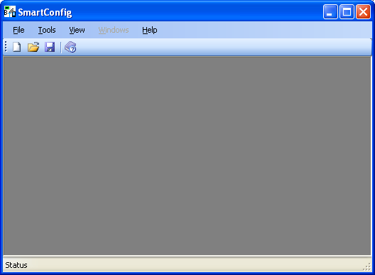

Once the software is started, press the “New” button  or “New” item in “File” menu.
4 new windows appear in configuration software.
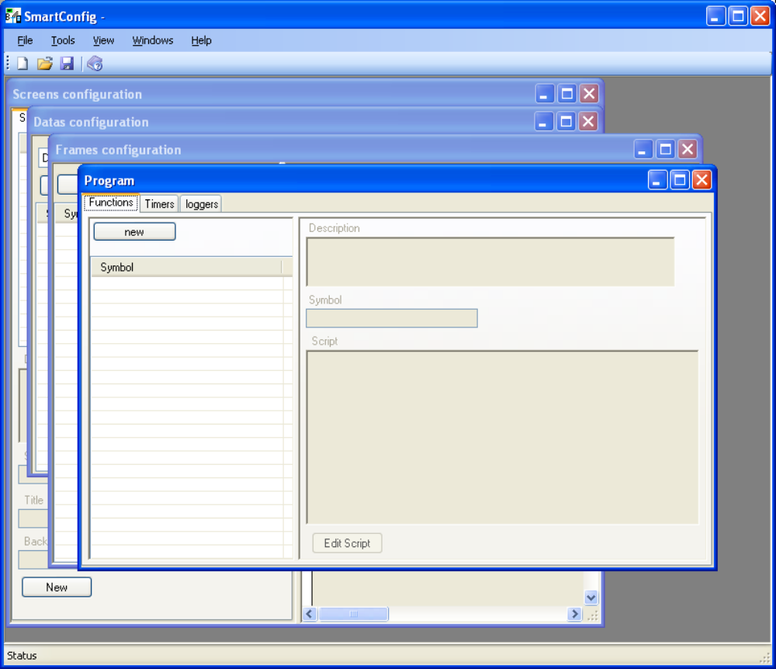

Before describing the purpose of each window, we will see how to use frame generator wizard.

2. Frames Wizards
Open “Tool” menu.
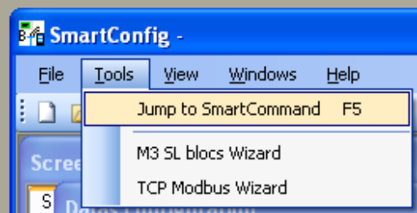

In this menu, you can find 3 commands:
- Jump to SmartCommand: it allows you to jump directly to SmartComand Application and test currently edited configuration file.
- M3 SL bloc Wizard: this wizard will help you to create exchanged frames for M3 SL BLOC supervision using serial link (or Bluetooth).
- TCP Modbus Wizard: this wizard will help you to create TCP/Modbus frame for M3 XN05 Ethernet supervision.

2.1 M3 SL Bloc Wizard.
If you want to use this software through Ethernet using XN05 extension module, jump to TCP Modbus Wizard

Open M3 SL Bloc Wizard. The following window appears. 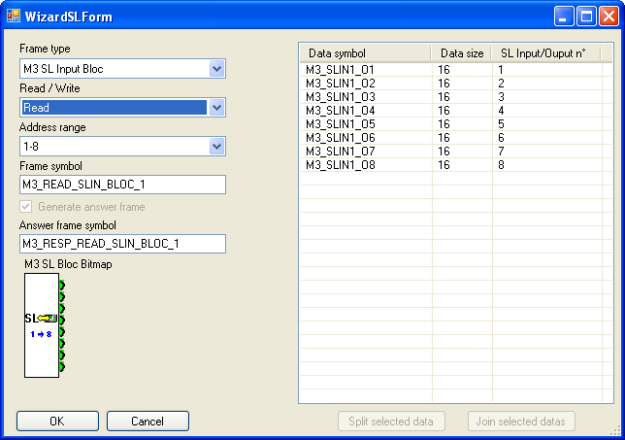

The left part of the window is used to configure frame for M3 SL Bloc:
- Frame Type: select if you want to use an input or an output SL Bloc. The corresponding bloc bitmap in CLSM3 software is updated according to current parameters.
- Read/Write: select if you want to create a frame for reading or writing selected SL Bloc
- Address Range: select the address range of SL Bloc according to your CLSM3 project configuration.
- Frame Symbol: Symbol of frame that will be created for sending read request on controller.
- Answer frame Symbol: Symbol of frame that will be created to receive read request answer.
Leave those parameters as they are and continue.

The right part of the window is the list of datas that will be used to store controller values. The list allows you to split each data to smaller size and at least create one data for each bit, quartet of byte for each SL Bloc I/O.
But see how it can be used concretely with Serial Example (SL Bloc).pm3 file.

Here is a screen shot of M3 Input (address 1-8) SL bloc wiring in sample file.
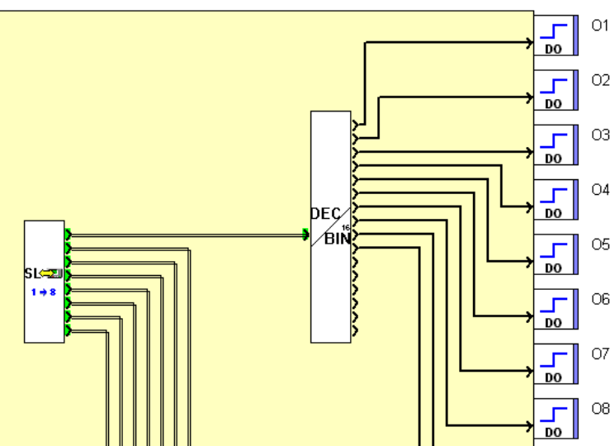.
The first bloc output is connected to a DEC/BIN bloc that allows us to use each bit to order controller outputs. So we want to use each bit of first SL Bloc output as independent data.

Click the first data named M3_SLIN1_O1 and then click “Split selected data”.
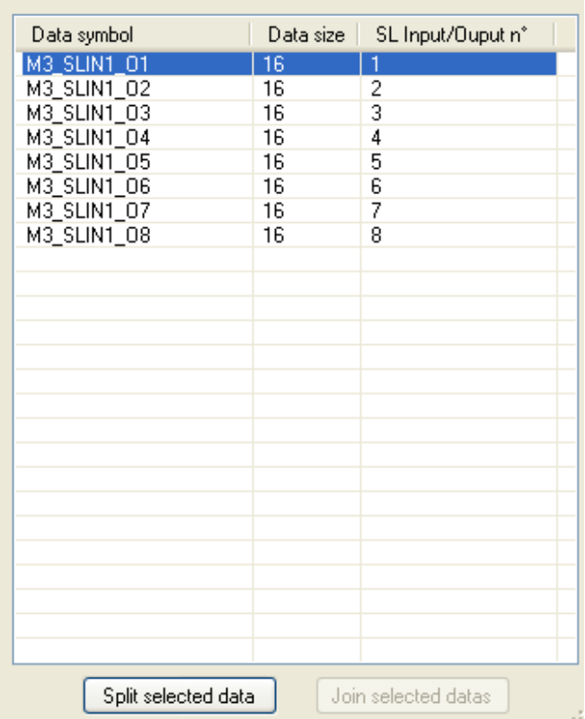

The data is splitted into two 8 bits datas witch are defined on the same output.
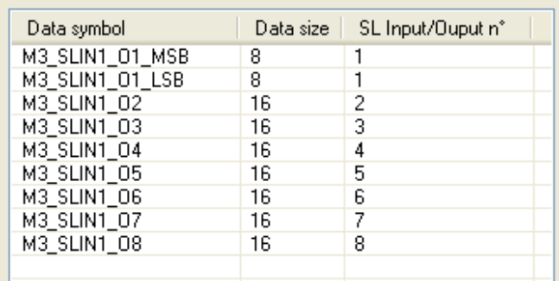
Each created data take a specific name according to it size and IO of SL Bloc.
Here, the two datas are named M3_SLIN1_O1_MSB (MSB for Most Significant Byte) and M3_SLIN1_O1_LSB (LSB for Less Significant Byte).
Select now M3_SLIN1_O1_LSB and click “Split” button (or press “s” on keyboard).
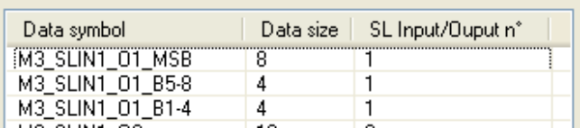
This time, the 8 bits data have been splitted into two 4 bits datas.
One more time, data name have change according to it size and IO:
- M3_SLIN1_O1_B5-8 for data beginning at fifth bit and finishing at eighth bit of SL bloc output.
- M3_SLIN1_O1_B1-4 for data beginning at first bit and finishing at fourth bit of SL bloc output.
Continue to split each data beginning by “M3_SLIN1_O1” in order to create one bit data per bit in SL bloc output as following.
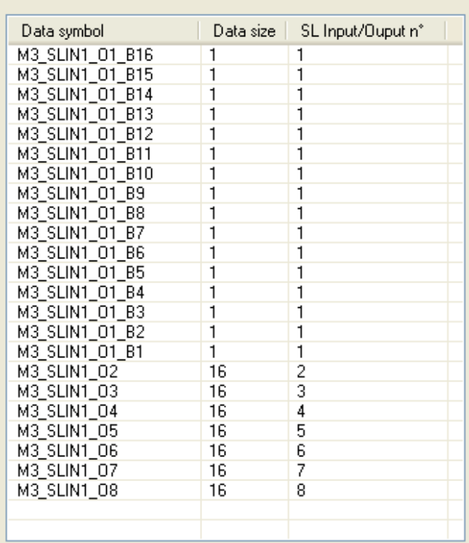

We have now sixteen 1 bit data for each bit in first SL Bloc output, and sevent 16 bits datas for other SL Bloc outputs. Frame is now ready to be created.
Press “OK” button.
Before seeing what have been created, we will create writing frame for the SL input bloc 1-8. Open one more time the M3 SL Bloc Wizard and modify only the field “Read/Write” using “Write” choice. Split the first output data into sixteen 1 bit datas as done previously and click OK and then go to Frame Window description.

2.2 TCP Modbus Wizard
Open TCP Modbus Wizard. The following window appears.
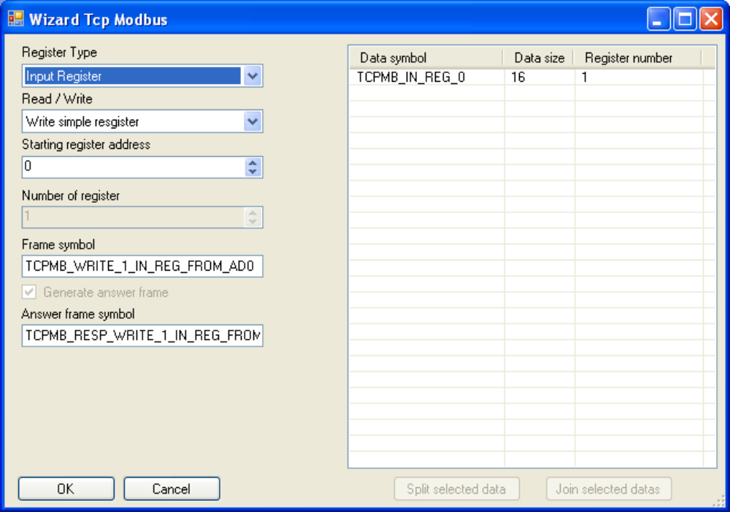
NOTE: the TCP modbus wizard have not been designed in order to be used only with Millenum 3 controllers but with any kind of controllers able to use this protocol.

The left part of the window is used to configure frame for TCP Modbus communication:
- Register Type: select if you want to use an input or an output register. It is mainly used to create data names according to register type. Note that outputs registers can only be read.
- Read/Write: select if you want to create a frame for reading or writing registers.
- Starting register address: select the start address of read/written registers.
- Number of registers: Only available for “Read holding registers” and “Write multiple registers” modbus orders.
- Frame Symbol: Symbol of frame that will be created for sending read request on controller.
- Answer frame Symbol: Symbol of frame that will be created to receive read request answer.

NOTE: M3 XN05 extension only support “Write simple register” and “Read Holding register” orders.

The right part of the window is the list of datas that will be used to store controller values. The list allows you to split each data to smaller size and at least create one data for each bit, quartet of byte for each register.
But see how it can be used concretely with Ethernet Example (XN05).pm3 file

Here is a screen shot of M3 Ethernet Input J1 (register address 12) wiring in sample file.
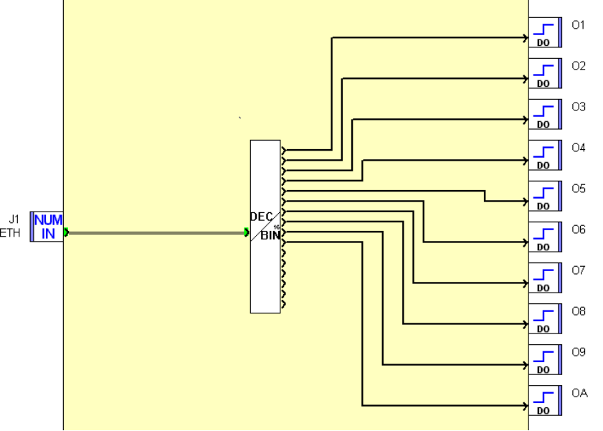
The bloc output is connected to a DEC/BIN bloc that allows us to use each bit to order controller outputs. So we want to use each bit of NUM_IN bloc output as independent data.
Select wizard parameters as following
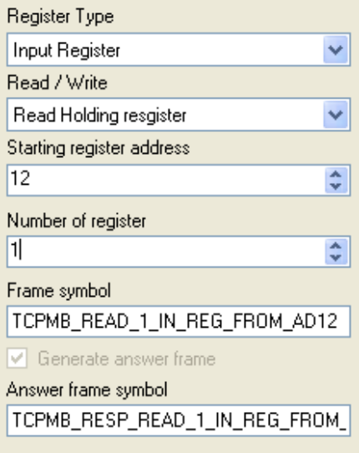

Click the first data named TCPMB_IN_REG_12 and then click “Split selected data”.
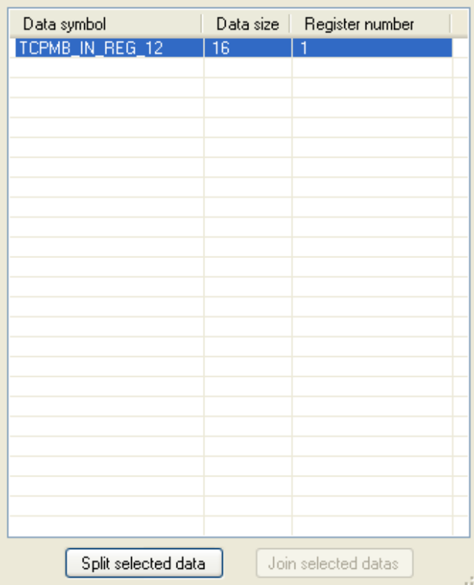
The data is splitted into two 8 bits datas witch are defined on the same register.
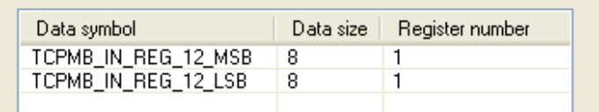
Each created data take a specific name according to it size and register address.
Here, the two datas are named TCPMB_IN_REG_12_MSB (MSB for Most Significant Byte) and TCPMB_IN_REG_12_LSB (LSB for Less Significant Byte).
Select now TCPMB_IN_REG_12_LSB and click “Split” button (or press “s” on keyboard).
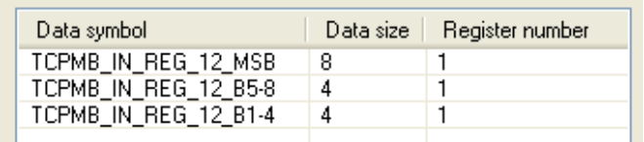
This time, the 8 bits data have been splitted into two 4 bits datas.
One more time, data name have change according to it size and IO:
- TCPMB_IN_REG_12_B5-8 for data beginning at fifth bit and finishing at eighth bit of SL bloc output.
- TCPMB_IN_REG_12_B1-4 for data beginning at first bit and finishing at fourth bit of SL bloc output.
Continue to split each data beginning by “TCPMB_IN_REG_12” in order to create one bit data per bit in SL bloc output as following.
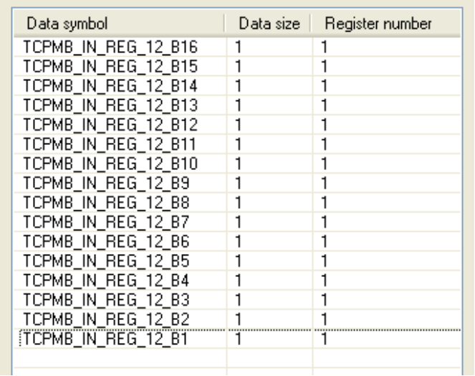
We have now sixteen 1 bit data for each bit in register. Frame is now ready to be created.
Press “OK” button.

Before seeing what have been created, we will create writing frame for the SL input bloc 1-8. Open one more time the TCP Modbus Wizard and modify only the field “Read/Write” using “Write simple register” choice. Split the register data into sixteen 1 bit datas as done previously and click OK and then continue tutorial.

3. Frame Window
Activate “Frame Configuration” window in SmartCommand software.
According to witch wizard you have use, you must have one of following result:

M3 SL Bloc Wizard:
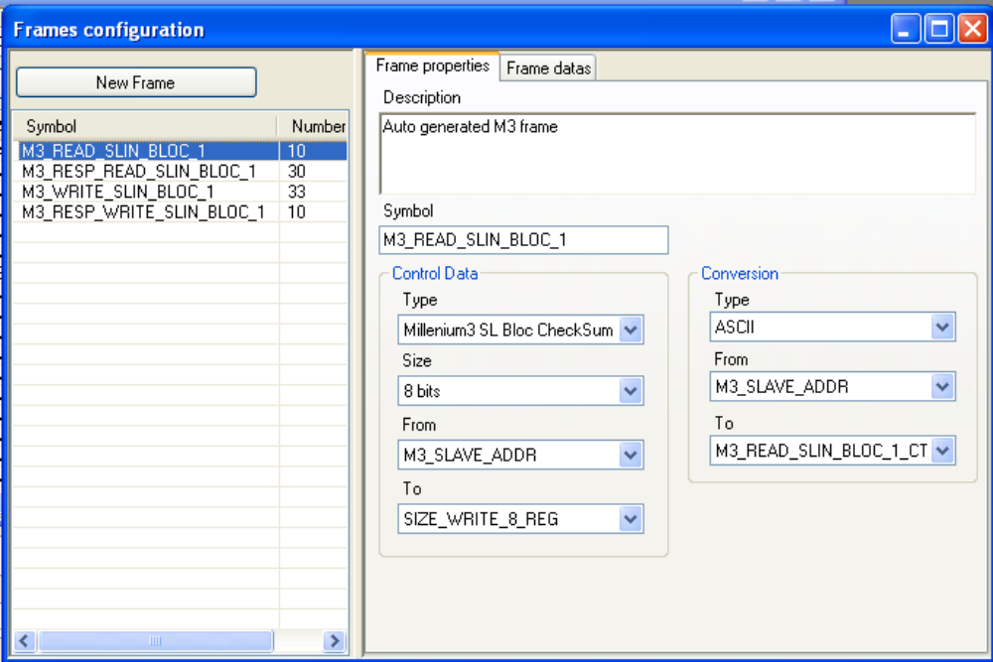
TCP Modbus Wizard:
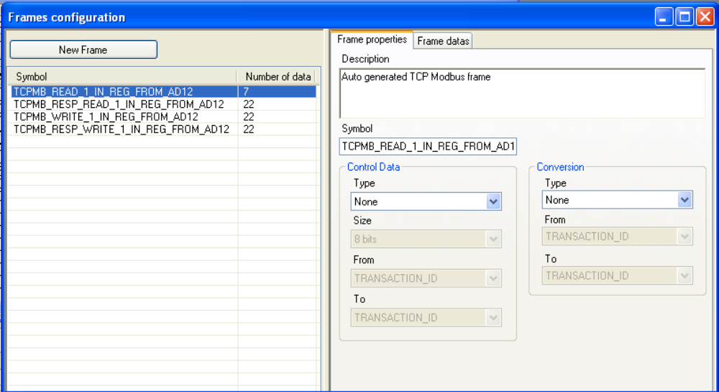

On the left side of window, you have the list of all existing frame, the one you have just created using wizards are here.

On the right part of the window, you have “Frame properties” and “Frame datas” pages.

3.1 Frame properties
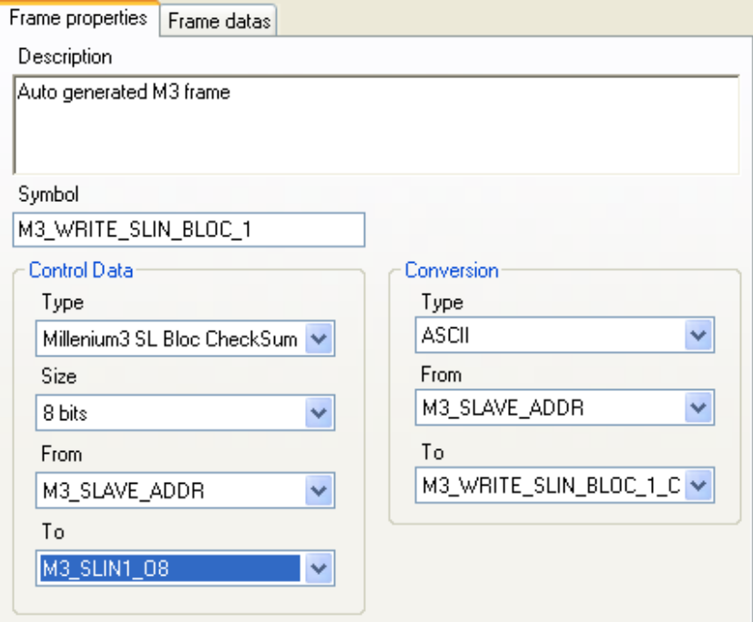
On this page you can find followings parameters:
- Description: description of frame
- Symbol: symbol of frame
- Control Data group:
As many communications protocols need a checksum or a CRC, you can define witch kind of control data is used with your message. When you select a control data different from none, a special data is automatically added to message, then you can move it to the right position. At the moment, the only allowed checksum is a M3 SL blocs checksum.
NOTE: if you want to use this software with controller witch need specific checksum or CRC, you can ask me to add it, provided that you gave me checksum or CRC algorithm and rules.
- Type: type of control data used in frame, available choices are none or M3SLBloc checksum.
- Size: size in bits of frame control data, it work as for standard data, but only 8, 16 and 32 bits sizes are authorized.
- From/To: some protocols build checksum on only a partial part of the frame, so here you can define the first and the last data that enter in checksum/CRC calculation. If selected data’s have a size inferior to 1 byte, the checksum/CRC calculation begin from the byte where is “From data” in final frame, and end at the byte where is “To data” in final frame.
- Conversion Group:
Many communications protocols use a conversion. As for Controls Data, you can define witch type of conversion you want to use, the beginning and the end of conversion.
- Type: At the moment, the only available conversion is ASCII (used for M3 SL blocs communication).
- From/To: It works as for Control data

3.2 Frame datas
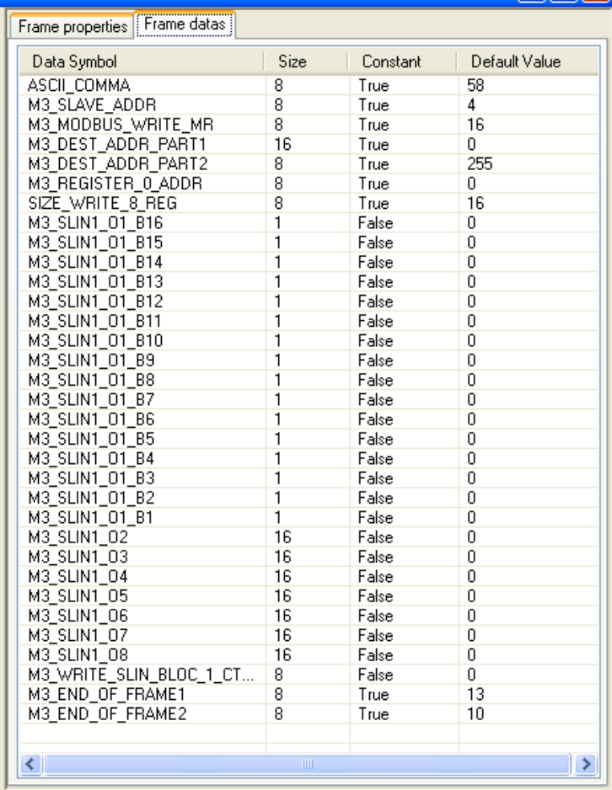
On this page you can find data list of currently selected frame. Here you can modify order using drag and drop in list.
WARNING: You should not modify frame which have been created by wizard since they have been tested and configured specially for M3 SL bloc or TCP modbus protocol. You can do it only if you know precisely how build protocols are.

4. Data Window
Activate “Data Configuration” window in SmartCommand software.
When the frame have been created using wizards, all datas used by frames have been created.
According to witch wizard you have use, you must have one of following result:

M3 SL Bloc Wizard:
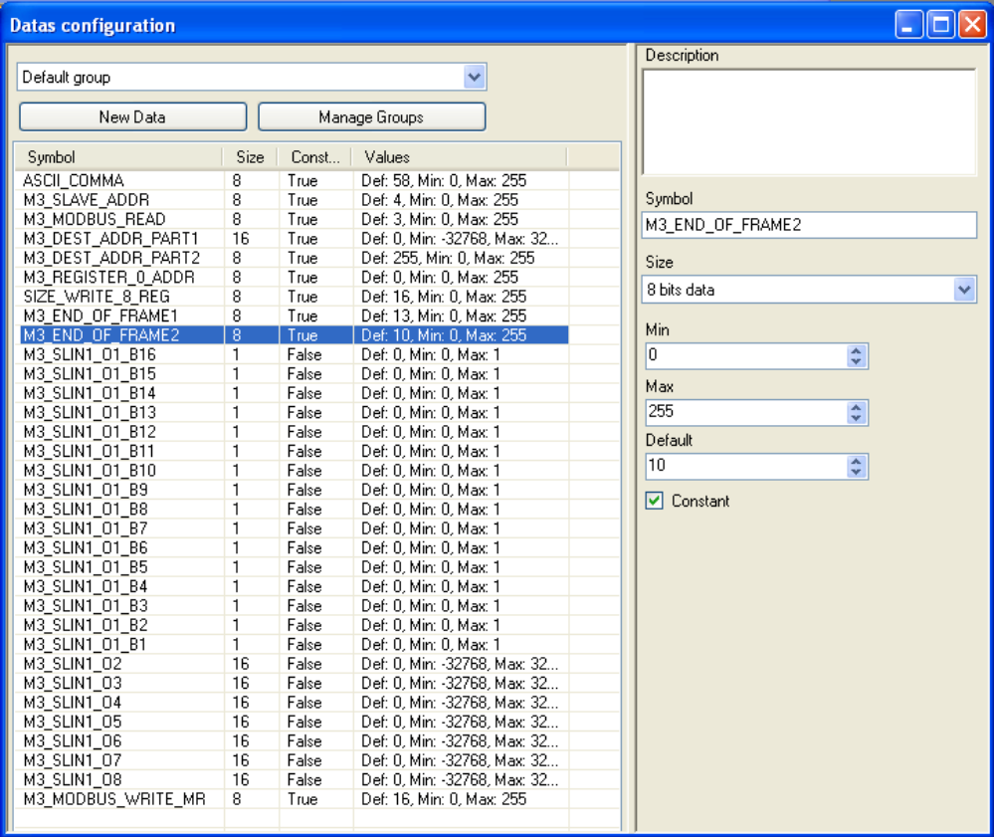
TCP Modbus Wizard:
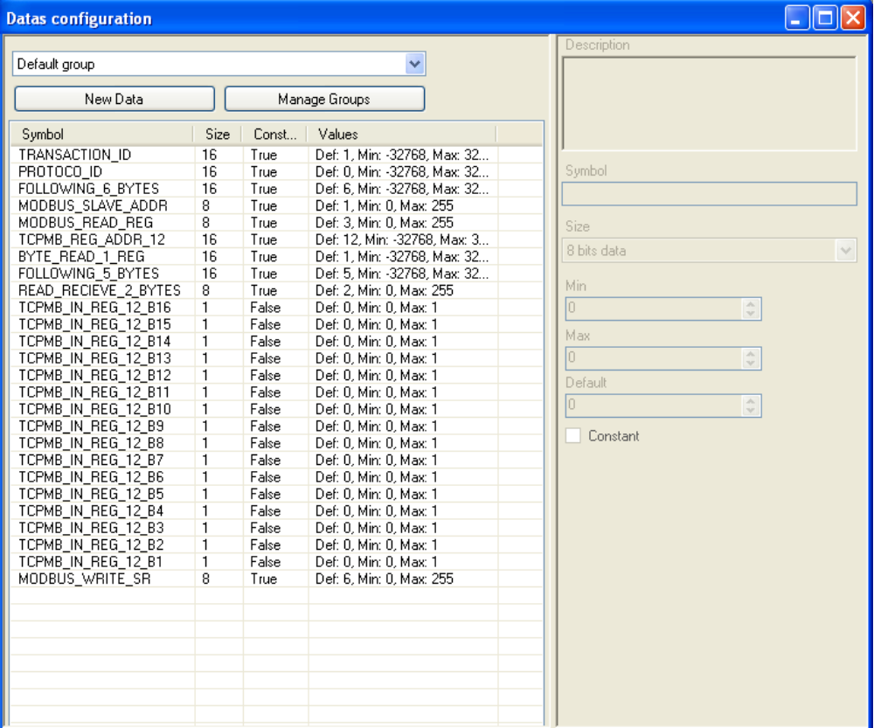
The left part of this window contains the list of all datas according to currently selected group.
Using the “Manage Groups” button, you can open a new window allowing you create new groups and then organize you data according to their purpose. I will not detail this part as it has no functional interest.
The data list displays all information’s about each data. Each parameter will be detailed with the right part of the window:
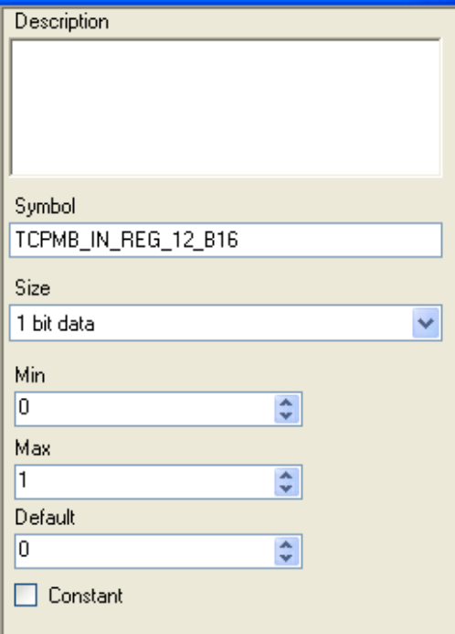
On the right part of window you can find followings parameters:
- Description: description of data
- Symbol: symbol of data
- Size: Size if data in bits
- Max: maximum value that can have the data. Range change according to data size.
- Min: minimum value that can have the data. Range change according to data size.
- Default: Default value of data when used (see SmartCommand)
- Constant: if this option is checked, the value will be used as a constant and will always have its default value.
NOTE: “Constant” parameter may be critical as it is used on frame reception. Each constant data are compared to receive value (and must be equal), unlike non constant datas witch are assigned to receive value.

There’s nothing more to do in this window since all data should not be modified.

5. Screen Window
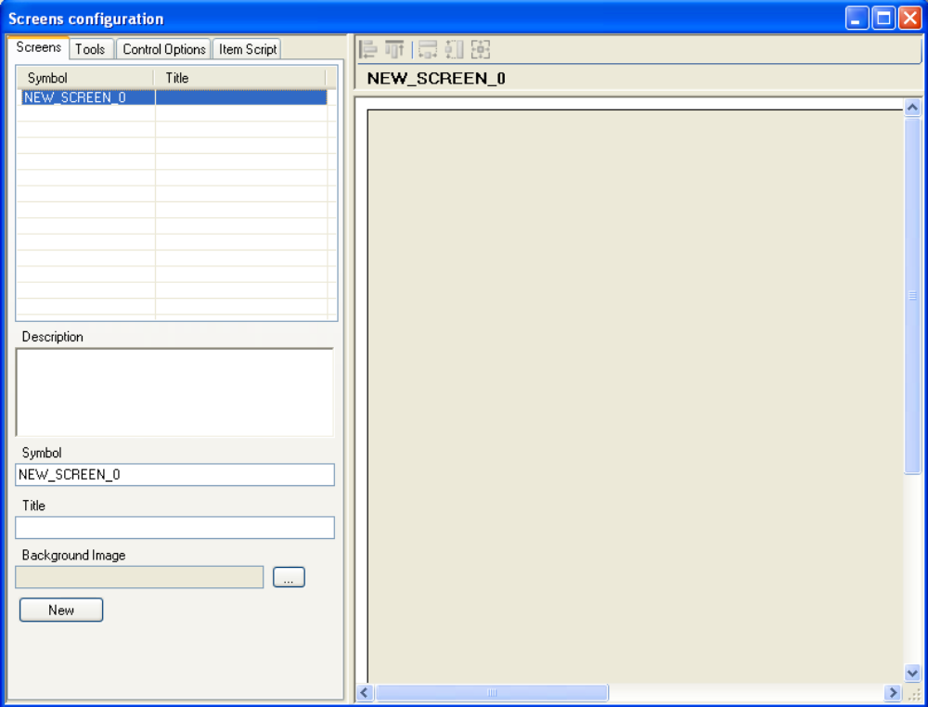
In this window, you can create and design appearance and behavior of displayed screens in SmartCommand software.

5.1 Screen Page
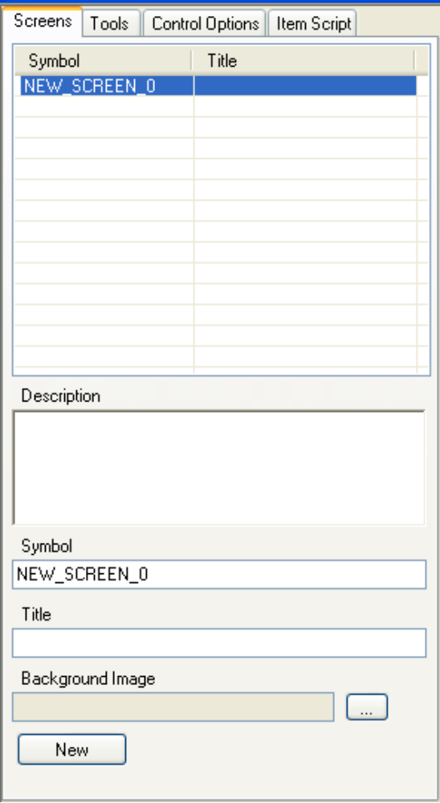

On the top part, you can find a list of all existing screens. Press the “New” button and then select the new screen in top list.
On bottom part you can find screen parameters.
- Description: description of screen
- Symbol: symbol of screen
- Title: Title that will have screen in SmartCommand application
- Background image: path to an image file that will be used as a background for screen.

Enter the Title “Millenium 3 Controller”, and then press the “…” button to browse an image file. In Application directory you will find usable image of a Millenium 3 controller. The path to application folder should be: System Disk letter… most often “C”\program Files\M3Tool\SmartApp\Examples. Select the file M3XD26S.bmp and then click in right part of the window to validate changes. The selected picture is now displayed in “Designer”.

5.2 Designer
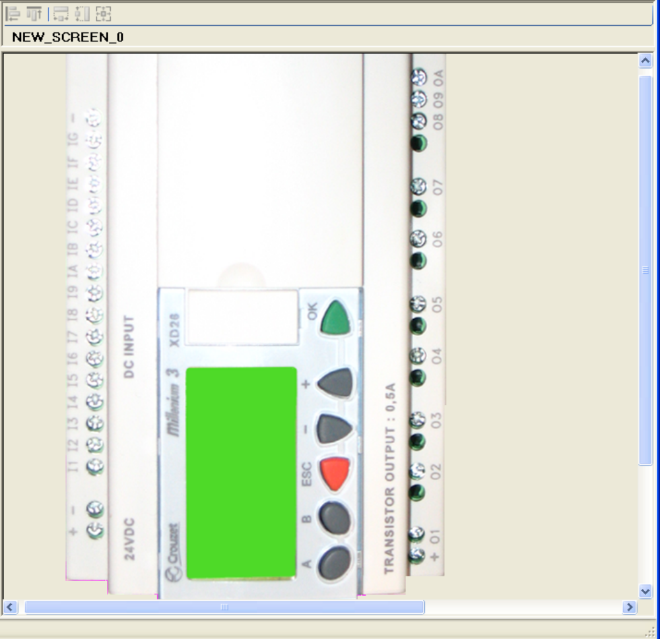

Here is the designer with the newly selected background image.
On the left side, select the “Tool” page.
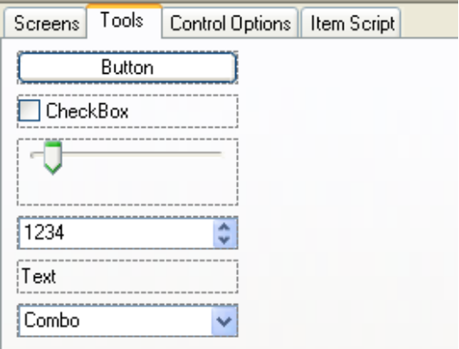
In this page you can find all available kind of controls that can be used in screens. You can drag and drop any of them in designer area.
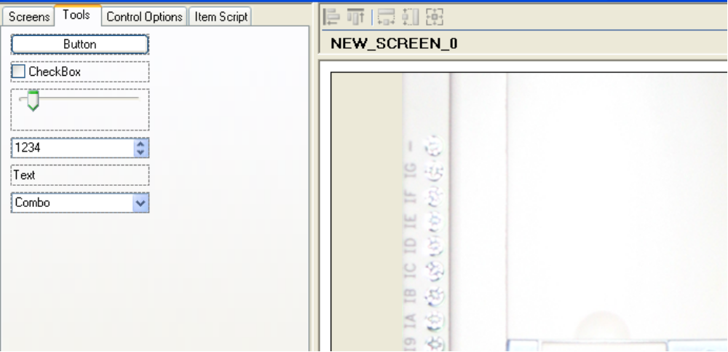
Once a control ha been added, you can move and resize it in designer area by selecting the item, and the using move button or selection squares.

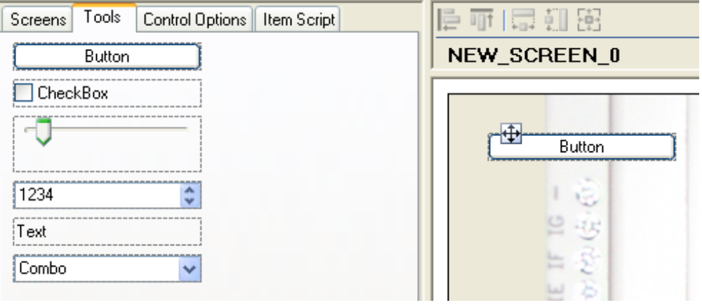
For current purpose, we will not use buttons controls, so select the one that you have dropped ans the press “Suppr” key to delete the button.
While frame configuration, we have build frame for reading and writing a register connected to controller outputs. So place a “CheckBox” control for each controller output in designer as following and select them all (using mouse square selection or shift and mouse click).
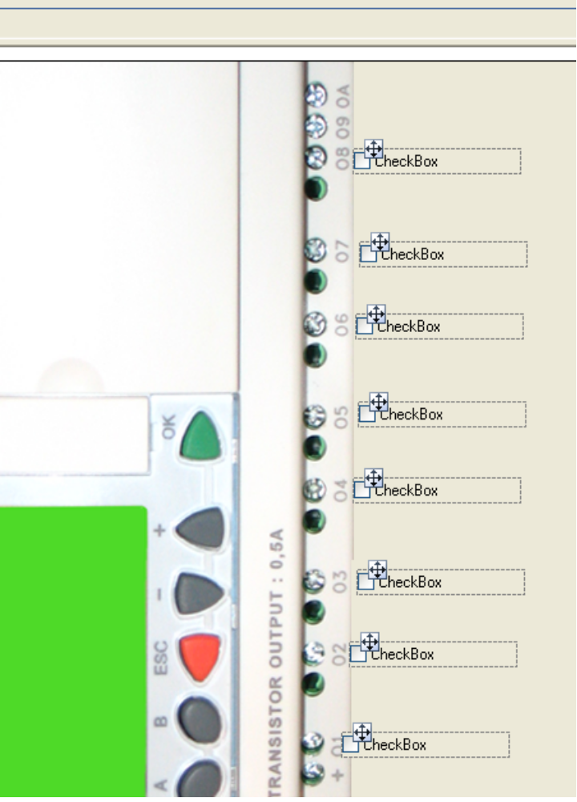
Now click the “Arrange left” button
All Item will be aligned on left. If you want you can also move them all using “move” button

Now, double click on the item in front of controller output 1. The “Control Option” page is displayed.

5.3 Control Options Page
On bottom part you can find screen parameters.
- Description: description of screen
- Symbol: symbol of screen
On bottom part you can find screen parameters.
- Description: description of screen
- Symbol: symbol of screen

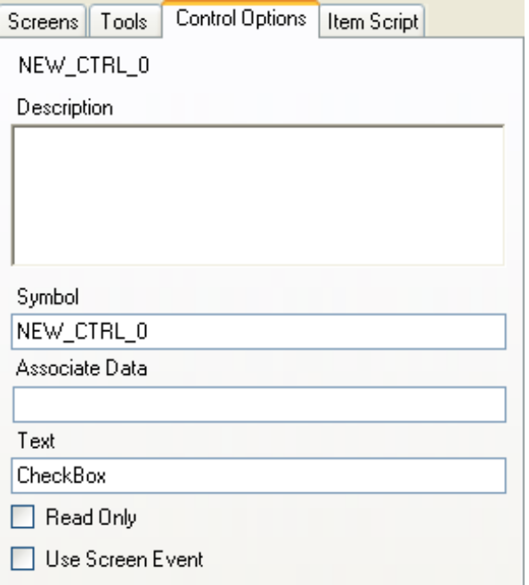
On this page you can find control parameters.
- Description: description of control
- Symbol: symbol of control
- Associate Data: Symbol of a data that will be used by control in Smart Command software. This property is one of the most important as it will decide the behavior of control according to data value.
- Text: The text displayed by the control
- Read Only: set if the control is a read only one (value could not be modified by human action)
- Use Screen Event:determine if the control raised the screen event and so, execute the script (see following chapter for more informations about script).

A this step you should change text according to controller outputs and active “Use screen event” properties of each control like in following screen shots.(Note, change made to a control are applied when you leave the control properties page, by clicking anywhere outside for example.
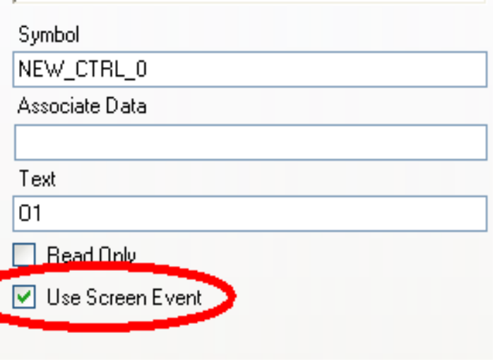
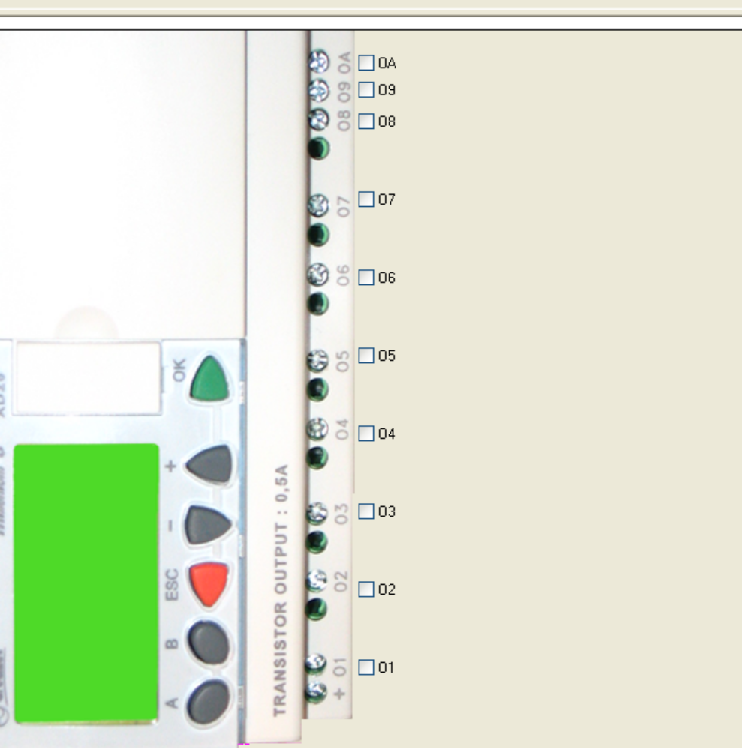

Associating datas and controls
This part is very important as it will set which values exchanged with remote controller will be displayed.
In our purpose, we would like each check box controlling one output of remote controller. When frames have been created, datas have been created for each bits of remote controller register connected to controllers outputs through a DEC/BIN bloc. So each data will correspond to controller outputs.
TCP modbus Wizard:
TCPMB_IN_REG_12_B1: Controller O1
TCPMB_IN_REG_12_B2: Controller O2
TCPMB_IN_REG_12_B3: Controller O3
TCPMB_IN_REG_12_B4: Controller O4
TCPMB_IN_REG_12_B5: Controller O5
TCPMB_IN_REG_12_B6: Controller O6
TCPMB_IN_REG_12_B7: Controller O7
TCPMB_IN_REG_12_B8: Controller O8
TCPMB_IN_REG_12_B9: Controller O9
TCPMB_IN_REG_12_B10: Controller OA
M3 SL Bloc Wizard:
M3_SLIN_O1_B1: Controller O1
M3_SLIN_O1_B2: Controller O2
M3_SLIN_O1_B3: Controller O3
M3_SLIN_O1_B4: Controller O4
M3_SLIN_O1_B5: Controller O5
M3_SLIN_O1_B6: Controller O6
M3_SLIN_O1_B7: Controller O7
M3_SLIN_O1_B8: Controller O8
M3_SLIN_O1_B9: Controller O9
M3_SLIN_O1_B10: Controller OA
Arrange “Data” and “Screen” windows as in following screen shot.
Select and drag the data named TCPMB_IN_REG_12_B1 (for TCP modbus) or M3_SLIN1_O1_B1 over the check box named “O1”
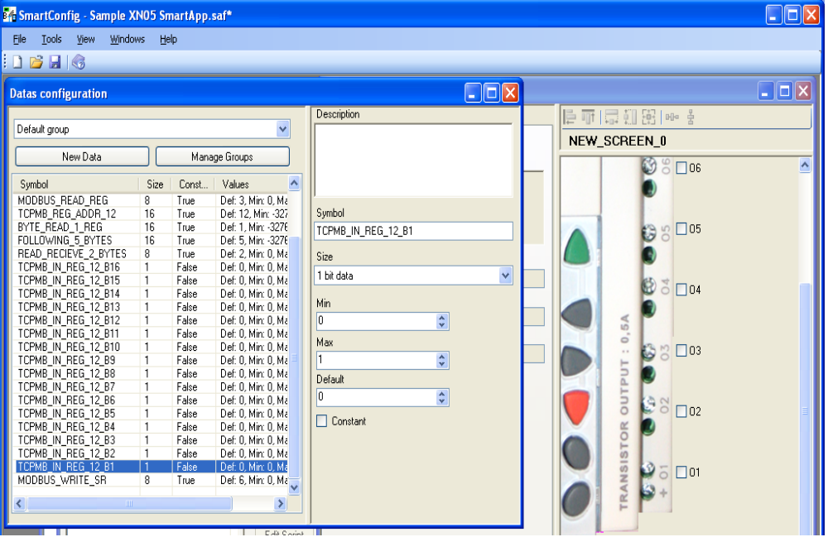
Once the mouse cursor hover the check box, drop become available. Release mouse button. A green light appear on top left of check box, data have been associated. Now value displayed by control will depend of data value, and data value will be modified by actions on control in Smart Command software.
Repeat this operation for each controller outputs with correspondence table given previously.
Save your file and go to next step.

5.4 Item Script Page
Active now the Item Script Page.
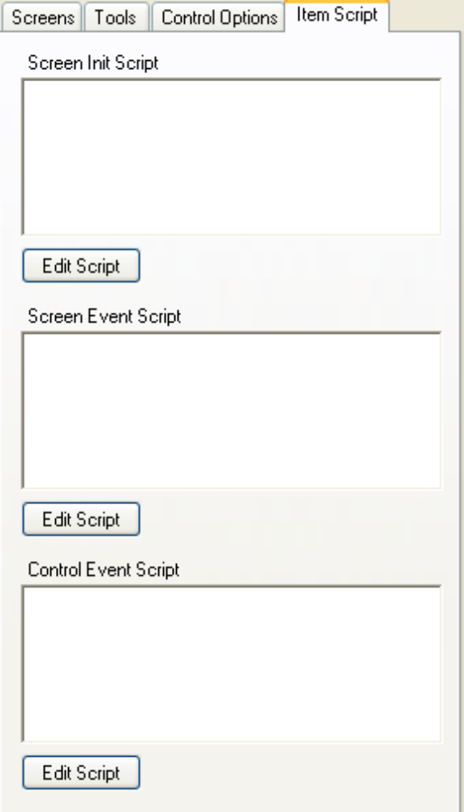
In this page, you can find 3 text box containing that will be executed by screen or control at different moment:
“Screen Init Script” : this script will be executed at startup of configuration file when used in Smart Command software. In this script, you should add all initialization that you will need for your application. In this tutorial we will need to initialize our data with values in remote controller. During at the beginning of the tutorial, we have used wizards and created frame for reading and writing remote registers.
Press the “Edit Script” button for “Init Script”.
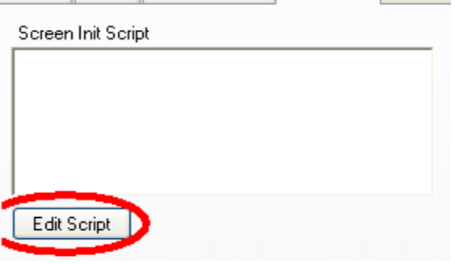

6. Script

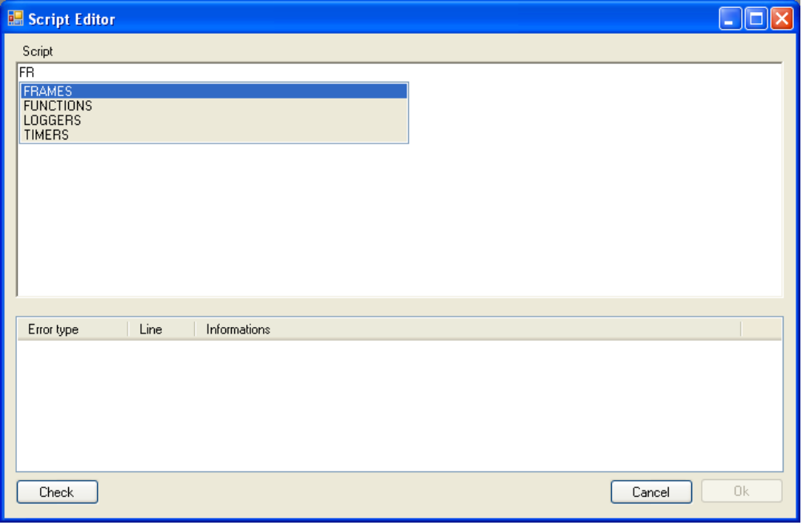
This window will help you to write script instructions using a contextual help giving you all available choices.
The top part of the window contain the script, and the bottom contains error window that you will have to used to verify your script consistency.

For the moment, script have not many abilities but in spite of this weakness, it is very easy to understand.
Most of time, a line can be decomposed in 3 elements separated by points.
1: the object type
2: the object symbol
3: and the object instruction

See an example with this line:
FRAMES . TCPMB_READ_1_IN_REG_FROM_AD12 . SEND()

In this line, the first element is “FRAMES”. It means that the line will execute a frame instruction.
The second element is the frame symbol “ TCPMB_READ_1_IN_REG_FROM_AD12”. It means that the instruction will be executed by the specified frame. (here, the frame have been generated using TCP/Modbus wizard.)
The last element is the instruction to execute followed by brackets. “SEND()”.
The whole line means that frame TCPMB_READ_1_IN_REG_FROM_AD12 will be send to connected remote controller on script execution.

Object Type:
- Frames:
  - Keyword: FRAMES
  - Description: Frames are “objects” exchanged with remote controller to read or write data into its registers.
- Functions:
  - Keyword: FUNCTIONS
  - Description: functions are objects containing only script and can be executed in others scripts. Functions should be used create a script that will be used as only one line in any other script. For example, you can create a function that send and receive many frames and used it in screens for all items executing the same action instead of re-write all the script for each items
- Loggers:
  - Keyword: LOGGERS
  - Description:Logger allow you to store data values in “.csv” files. These files can be used in other softwares like Excel© to extract values as graphics. More details about logger are given here.
- Timers
  - Keyword: TIMERS
  - Description: Timer are used to execute periodically a script. The most interesting use of these object is to execute periodically read instructions on remote controller in order to supervise specifics registers values (according to sent frames). More details about Timers are given here

Back to tutorial:
start writing “FRAMES” keyword in script editor. A List of choice appear.
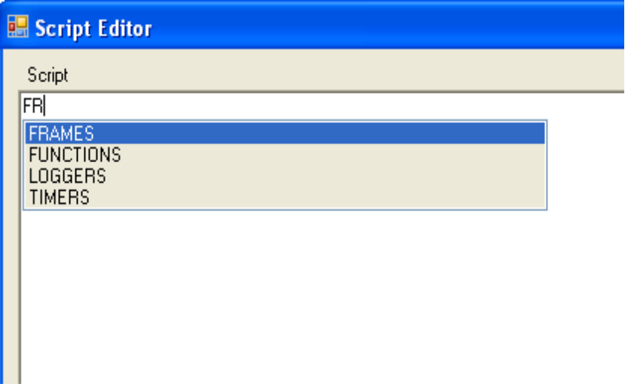
In this list you can find all kind of object available as see previously. By pressing the “Down Arrow” key on your keyboard, you will active the “Auto completion List”. Once the list is activated, you can change selected value using up and down arrow keys. Select FRAMES and then press enter.
The text “FRAMES” have been written in script editor. Now, add a point. On more time the list appear but with other choices.
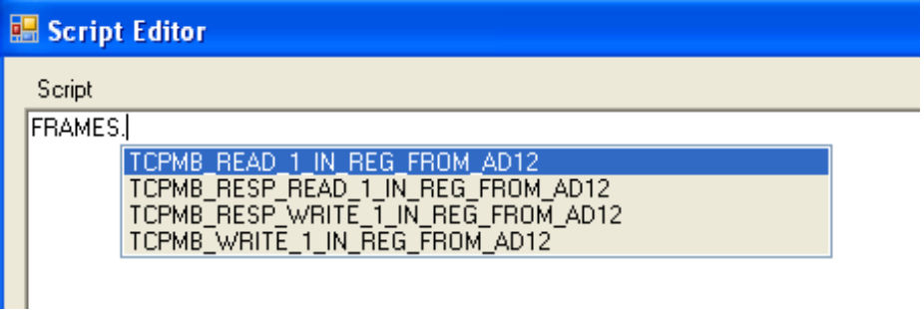
Here is the list of all frames crated using wizard (here is for TCP Modbus wizard). Whether for SL Bloc protocol or for TCP modbus protocol. A full exchanged between software an controller contains a request (read or write) and an answer corresponding to request. In our case we would like to read remote controller registers for initializations. So we will send one read frame request and receive one answer frame.
In script it would be written like that:
we first send the read request to controller
FRAMES.TCPMB_READ_1_IN_REG_FROM_AD12.SEND()
and then we wait and read controller answer.
FRAMES.TCPMB_RESP_READ_1_IN_REG_FROM_AD12.RECEIVE()

For M3 SL Bloc wizard, the script would be:
FRAMES.M3_READ_SLIN_BLOC_1.SEND()
FRAMES.M3_RESP_READ_SLIN_BLOC_1.RECEIVE()

Once the script is written, click “Check” button in bottom left, is there is no errors, the “OK” button become available.
Press OK button and then open the “Screen Event Script”.
This script will be executed when clicking in any check boxes that you have added to current screen (if “Use screen Event” attribute is set), and we want check boxes executing frames sens to write controller registers.
Using writing frames works in the same way as reading, we first send a write request, and then read the answer.
The script with TCP modbus wizard would be :
FRAMES.TCPMB_WRITE_1_IN_REG_FROM_AD12.SEND()
FRAMES.TCPMB_RESP_WRITE_1_IN_REG_FROM_AD12.RECEIVE()

For ML3 SL Bloc Wizard:
FRAMES.M3_WRITE_SLIN_BLOC_1.SEND()
FRAMES.M3_RESP_WRITE_SLIN_BLOC_1.RECEIVE()

Once scripts are written, save your file and use tool menu and then “Jup To Smart Command” (or F5 key) the program hides and then smart command launch and load automatically current file.

7. SmartCommand
The purpose of this software is to use created file to supervise remote controllers. The Smart Command software appear as following.

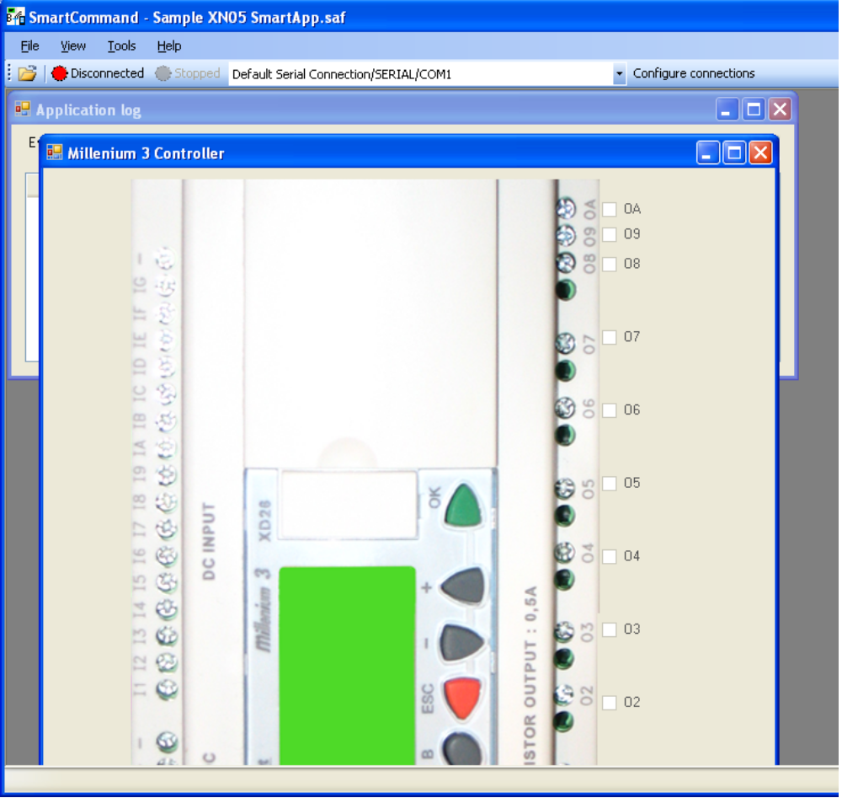

7.1 Connection configuration
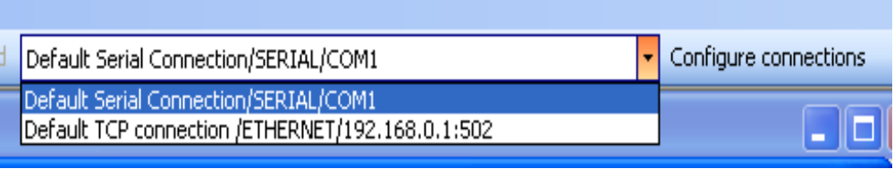
In tool bar, you can find connection drop list, and connections configuration button. By default, two different connection are configured.(see screen shot)

By pressing on “Configure connections” button, following window appear:

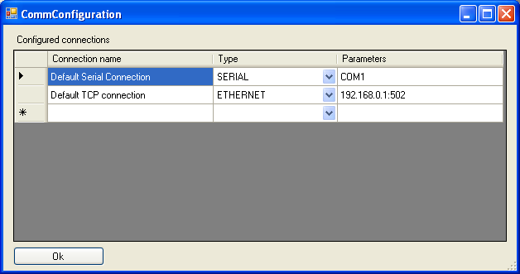
In order to use the file with tour remote controller, you should create a new or modify existing connections.
In the first column, you can enter a connection name, in second column, you must select connection type: Ethernet or Serial (use Serial for Bluetooth). In last column, you must enter connection parameters:
For Serral : the COM port (COMn where n is the number of valid serial)
For Ethernet: IP address of your remote controller , colon, TCP port number (502 for TCP Modbus Protocol).

Once you've added your connections, press OK button.
Note: Configured connection are automatically saved and are restored on next software startup.
The last connection used with a configuration file is saved on software exit and will be restored on next file opening. This behavior can be modified using option page.

7.2 Runnig program
Select you own connection in connection's drop list, and then press “Disconnected” button.
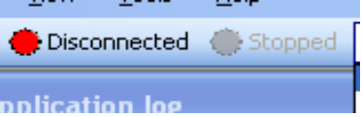
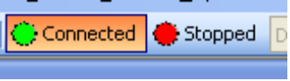
Once software is connected to remote controller, the button state changed, and the “Stopped” button becomes available.
Since the current loaded file is not started, nothing happens. When you press the “Stopped” button, it's state change and software execute initializations written in “Screens Init Script”
If automatic objects are configured like Timers and Loggers, they are also started (theses objects will be describe later).

Screen Item are now available. Since the controller have been started, all registry value should be null and so, all check boxes should be unchecked.

Click of any of them. The value is written on controller register by executing “Screen Event Script” if you use an non static relay controller you should have heard controller relays closing corresponding to output check box, if you use a static relay controller (such as XD10S or XD26S) you can see the outputs states on controller front panel. Test that each check box actuate corresponding controller output.

Summary:
In this first part, you have learn how to create frames, screens and configure them to read/write remote controller registers.
Theses actions can be executed periodically by software, and so it become able to refresh its state according to controller register values. See it in next chapter.

Stop your configuration and then

8.Finalize M3 Controller Supervision
Close Smart Command Software, “Smart Configuration” software reappear.
When supervising a remoter controller, the most interesting is reading values of controller outputs registers. As we have not created needed frames, active the wizards according to your current project type (SL Bloc or TCP Modbus). You can refer to Wizards section for help.
The frames parameters should be:
M3 SL Bloc:
Frame Type = M3 SL Output Bloc
Read/Write = Read (can't be modified)
Address range = 25-32
M3_SLOUT1_I1 register splitted into 16 one bit value. (as in wizard tutorial)

TCP Modbus:
Register Type = Output Register
Read/Write = Read Multiple Register.
Starting Address = 20
Number of register = 1
TCPMB_OUT_REG_20 register splitted into 16 one bit value. (as in wizard tutorial)
Now, needed frames are created, and we can add more values in screen, jump to screen window and add new check boxes for each controller discret inputs (I1 to IA). See following screen shot:
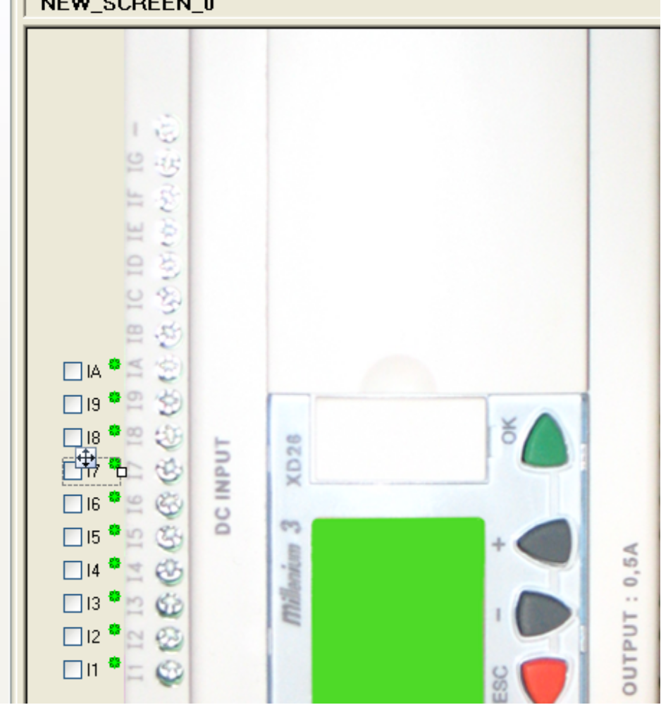
Here is assotiation table for controller inputs.
TCP modbus Wizard:
TCPMB_OUT_REG_20_B1: Controller I1
TCPMB_OUT_REG_20_B2: Controller I2
TCPMB_OUT_REG_20_B3: Controller I3
TCPMB_OUT_REG_20_B4: Controller I4
TCPMB_OUT_REG_20_B5: Controller I5
TCPMB_OUT_REG_20_B6: Controller I6
TCPMB_OUT_REG_20_B7: Controller I7
TCPMB_OUT_REG_20_B8: Controller I8
TCPMB_OUT_REG_20_B9: Controller I9
TCPMB_OUT_REG_20_B10: Controller IA
M3 SL Bloc Wizard:
M3_SLOUT_I1_B1: Controller I1
M3_SLOUT_I1_B2: Controller I2
M3_SLOUT_I1_B3: Controller I3
M3_SLOUT_I1_B4: Controller I4
M3_SLOUT_I1_B5: Controller I5
M3_SLOUT_I1_B6: Controller I6
M3_SLOUT_I1_B7: Controller I7
M3_SLOUT_I1_B8: Controller I8
M3_SLOUT_I1_B9: Controller I9
M3_SLOUT_I1_B10: Controller IA
Once you've finished with screen configuration, active « Program Window ».

9. Program Window
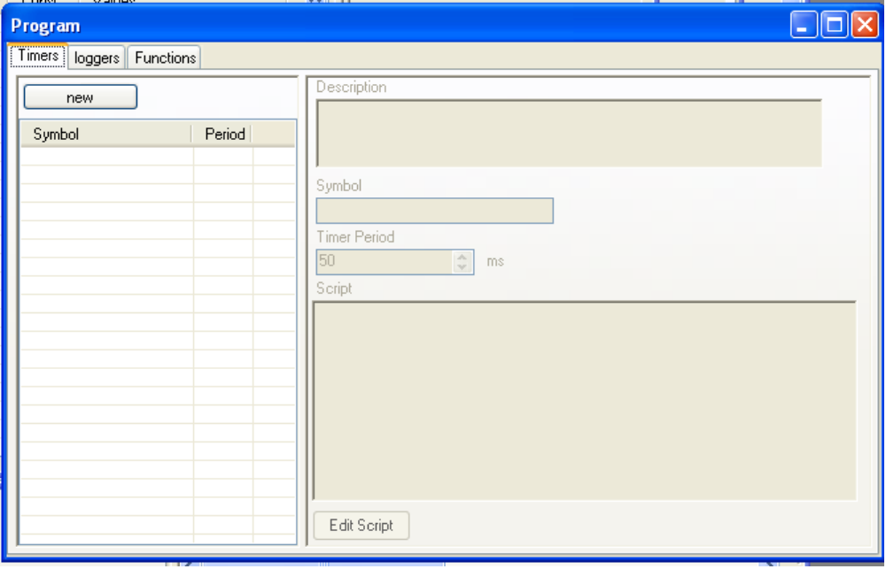
This window is decomposed in 3 pages, one for each kind of item.
The first page is the Timer Page:

9.1 Timers Page
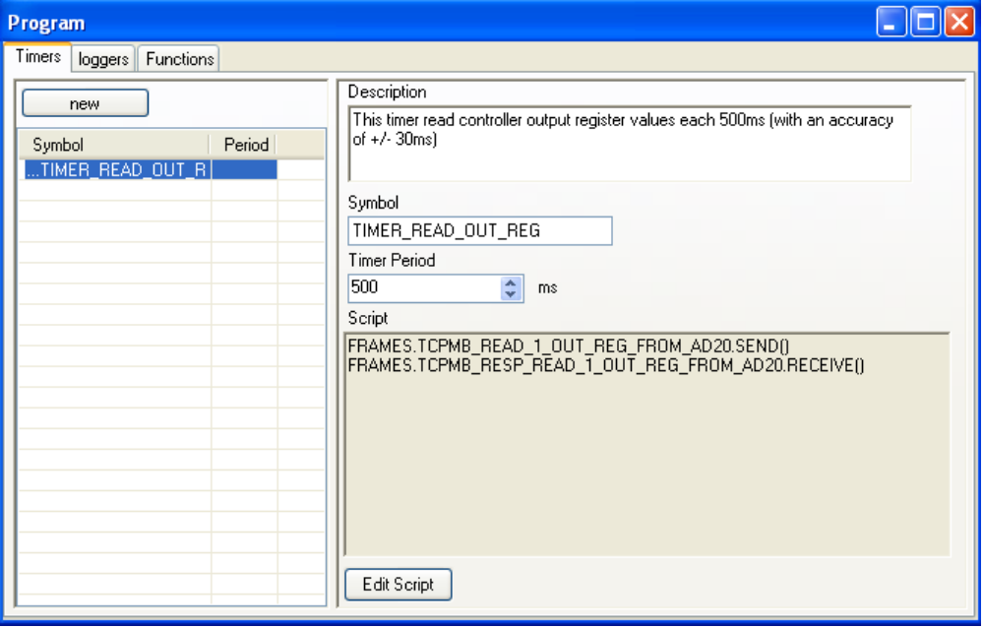
There is no many thing to explain here. Timers objects execute their script periodically according to their period (in ms).
Timers are stared or stopped when you press the « Start/Stop » button in Smart Command software. Then can also be started and stopped by script.
Script lines for starting or stopping timers ares:
TIMERS.[TIMER SYMBOL].START()
or TIMERS.[TIMER SYMBOL].STOP()
For our example, the script must read controller output register. So the script should be:
For M3 SL Bloc:
FRAMES.M3_READ_SLOUT_BLOC_1.SEND()
FRAMES.M3_RESP_READ_SLOUT_BLOC_1.RECEIVE()

For TCP Modbus:
FRAMES.TCPMB_READ_1_OUT_REG_FROM_AD20.SEND()
FRAMES.TCPMB_RESP_READ_1_OUT_REG_FROM_AD20.RECEIVE()

Do not forget to change timer perdio to 500ms (minimum timer period is 50 ms).

9.2 Loggers Page

9.3 Functions Page

