Commit Log:

Initial commit – 30/04/21

I made an initial commit on the 30th of April. This commit just had the base parts of the app, like the board with buttons that you could click on and it would give them a text value to display based on who’s turn it was to play. There was also alternating turns and the board was procedurally generated (generated using code) with a new class that was based on the button class.

Second commit – 05/05/21

I made a second commit on the 5th of May. This commit completed the Naughts and Crosses element of the project and fixed a bug that allowed players to choose a tile that was already selected.

Third commit – 19/05/21

The third commit was made on the 19th of May. This commit added images that would display instead of just regular text. The process of creating this version is also what started the idea that led to what ended up being the final version.

Fourth commit – 25/05/21

My fourth commit, on May 25th, is when I started to swerve away from AI. In this commit I started hosting the project website on GitHub Pages as well as started to create some branches for different aspects of the project. Such as the ‘main’ branch, which has pretty much everything, and the ‘gh-pages’ branch for anything to do with GitHub Pages. I also added a based that will allow for the user to customize the look of the icons

Fifth commit – 28/05/21

My fifth commit on 28th of May completed the basics of colour customization. It allowed the user to change the colours of the symbols to whatever they wanted. It used a very primitive system that, in retrospect, wasn’t very good and also looked fairly ugly.

Sixth commit – 16/06/21

My sixth commit marked the beginning of the end of this project’s development. After getting some user feedback I found that one of the biggest problem was that the colour customization system wasn’t very user friendly. To try and make it more user friendly I changed the input methods from typed in numbers to sliding bars. This allowed the user to have more graphical view of the system rather than it being based entirely on numbers

Seventh commit (Final Commit) – 19/06/21

I made the final commit on the 19th of July. This commit mostly responded to more user feedback. The problem that users were having now was that the colour customization options were hard to locate. To combat this I moved it to the main screen, positioning it to the right of the game board. Another problem was that the sliders did not update the colour info in real time, it wouldn’t update until the scroll bar had been let go. To fix this I added a timer that calls a subroutine every 50 milliseconds. This sub routine would perform all of the updates so that everything would be synchronized and in real-time. Another problem that I had to fix was that it was often quite hard to find specific colours, in particular brown was very hard to find. To fix this I added a set of 10 buttons above the sliders. These buttons each represented one of the following colours:

* White
* Black
* Red
* Green
* Blue
* Yellow
* Orange
* Pink
* Purple
* Brown

The buttons were all coloured to match their corresponding colours. Clicking on any of these buttons will set the RGB values of the sliders to the correct colour. For pink and orange it also sets the strength value to four because they were too dark and hard to distinguish from other similar colours, like purple and brown.

Release Log:

First release – 09/06/21

The first release contained the feature list in the commits from one to five. This build was release on the 9th of July. This was the version that I got user feedback on.

Second release – 19/06/21

The second release was the final release and had all of the final features listed in all the commits. This build was much more polished overall and is much easier to use than the previous version.

Gantt Chart:

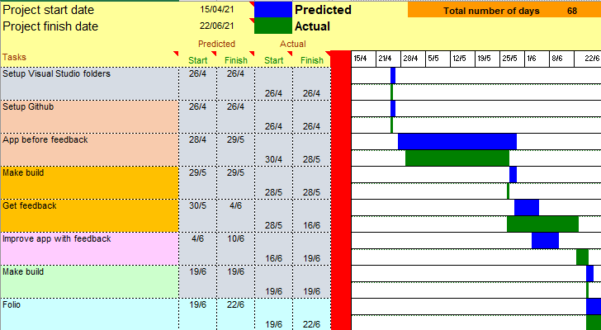

App Design: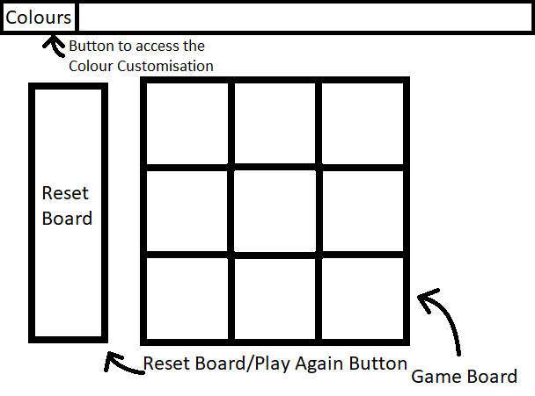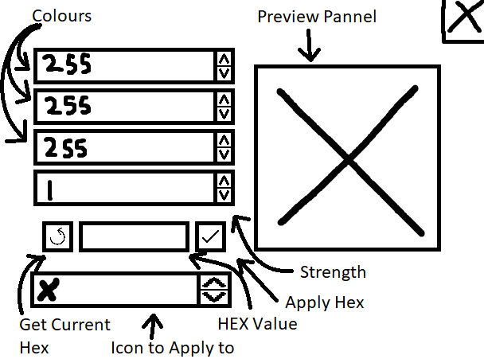

Flowcharts:

