**Seal Scan**

**Theory of Operation**

**Purpose**

The seal scan program was created to help automate the collection of serial numbers from the shipping vessel security seals. These seals have unique serial numbers represented on each seal as both human readable text as well as a barcode. The seal scan program generates a seal record showing the serial number of each seal used to secure the vessels entry and exit points. This seal record can then be sent to the customer for verification that the shipping vessel was properly sealed by verifying the serial numbers on the seals upon arrival at their facility.

**Operation**

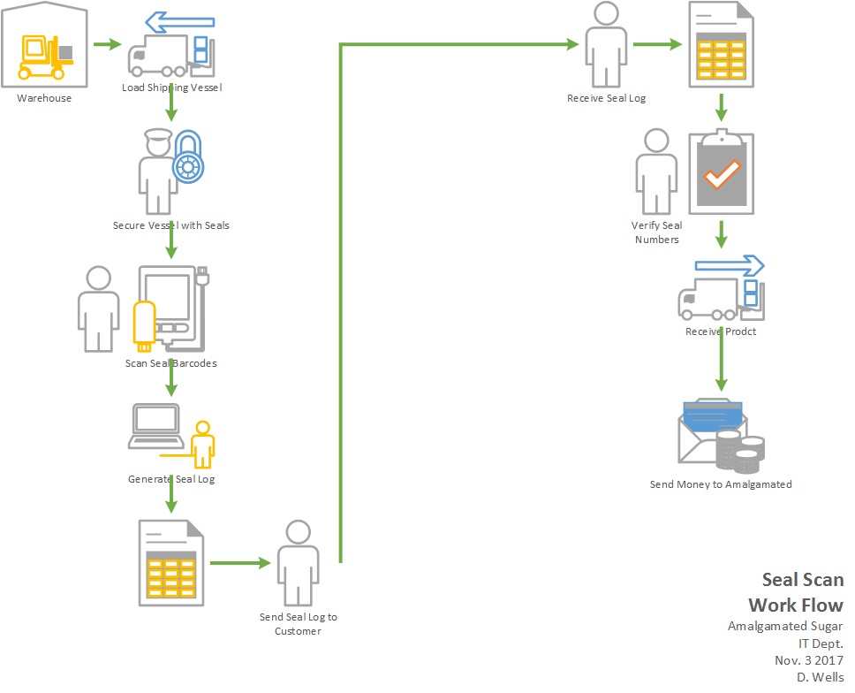

The Seal Scan program is designed to capture and print the numeric value of barcodes gathered with the Symbol MC3000 barcode scanner. The barcode values are gathered by scanning the serial numbers printed on the truck seals. Frequently referred to as truck seals but they are also used to seal the rail cars.

The Symbol MC3000 is a batch based barcode scanner. The user interface for the scanner contains two buttons, the plus button scans a barcode and adds the barcodes value to the scanners memory while the minus button scans a barcode and removes a previous entry with that value from the scanners memory.

The SealScan application runs in the background on the PC but it is not visible to the user unless they have plugged a CS3000 scanner to the PC via the USB port. When a scanner is plugged into the PC the operating system notifies SealScan that mobile storage device insertion event occurred. SealScan will interrogate the device to determine if it is a CS3000 scanner. If it is a valid scanner it will verify barcode data is present on the device. If barcode data is present, then the user interface will become visible and be presented to the user.

SealScan’s user interface contains to text fields for user input. The order number field is for the Amalgamated Sugar order number. This field must be numeric and contain 7 digits. The second field is for car number which represents the unique identifier for the rail car being sealed. There are no character type or length restrictions required. These cars come from so many different places and are owned by so many different companies that it would be impossible to have any sort of consistency around the value of this field. Therefore, no real error checking can be done on this field.

Once the user enters the Order Number and Car Number they can continue by pressing the “Generate Seal Report” button. This will copy the barcode data file to the PC. This file is then parsed, sorted and any duplicate values are removed. Cleaning up duplicate values at this point is for the benefit of the user. This allows them to scan the seal more than once should they forget if it was scanned or not. They can simply rescan the seal to ensure it was not missed.

Because there are so many different configurations for the rail cars and trucks there is no attempt made to organize the placement of the tags or match the scans to some sort of container layout. The values are sorted and displayed in numeric order.

After obtaining the barcode data from the scanner a copy of the original data file is stored on the PC in the c:\Temp directory. These files are generically named so they are over written when a new scan file is made available to the PC.

The values from the barcode file are added to a word document along with the Order Number, Car Number and the current date. The word document formatting comes from a document template stored in the program files folder for the application.

(c:\Program Files(x86)\The Amalgamated Sugar Co\SealScan\MasterLayout.docx)

The document template contains the master layout for the seal record report. The application searches the document for keywords to identify the proper location to insert the user supplied data. The document contains a table this three columns wide with seventeen rows. This allows for up to 51 barcodes. The Mini Cassia template was adjusted to hold 23 rows for a total of 69 barcode values.

The template should be adjusted for each facility to reflect the facilities address and if applicable the appropriate company log. The Atlanta facility template contains the NSM logo.

The completed copy of each seal record shipping report is saved on the local PC for future reference. Over time these can accumulate and should be deleted by the user.

**Seal Scan Application**

The application itself consists of five small classes.

The first class is for the user interface form. The Form1 class registers the application to monitor for storage device insertion events so the presence of the scanner can be detected. It also covers the basic user interface events.

The DriveDetector class contains the code for interacting with the scanner when it is connected via the USB port. It also has the code used to confirm a detected removable drive is the barcode scanner and not some other device such as a thumb drive.

The DocClass class contains the codes for interacting with the word document template. This includes things such as copying the files and editing a copy of the file to add the user information.

The scanner class is used to read and sanitize the barcode data from the scanner.

SealScan was written in C# using Visual Studio 2015. The solution contains a second project. This is a setup project used to create the MSI for application deployment and packaging.

**Programming Sheet**

Currently a programming sheet is required to program the scanner to our required configuration. Because the scanner only has two buttons for a user interface there is no way to enter type configuration information, therefore, the barcode scanner is used to scan in programming codes. These codes are used to set the scanners configuration. Because the seals are printed with such a low quality barcode the scanner is programmed to only read barcodes that exactly match the type found on the seals.

**Seals**

The seals are constructed for one-time use. To remove the seals their cable must be cut. This effectively destroys the seals so they can’t be used to re-seal the vessel.

Each seal contains a unique serial number which is displayed as both – human readable text and a barcode. The print quality of the barcodes is very poor, and they can be difficult for the scanner to read.

The barcode format is Interleaved 2of5 and they are 8 digits long with a leading zero.

**Components**

SealScan Application

Symbol MC3000 Barcode Scanner (Serial Batch Version)

PC with Seal Scan installed

USB Cable

Cable Seals with barcoded serial numbers

Scanner Configuration Sheet

Word Document Template (MasterLayout.docx)

**Future Updates**

Enhancement - Add version information to user interface.

This will aid in any future troubleshooting to ensure the PC is running the expected version of software.

Enhancement – add ability to transfer configuration file to the scanner when the device is detected.

This will eliminate the need for the scanner programming sheet and prevent the users from making modifications to the scanner sheet or changes to the scanner. It will also help with maintenance and configuration management as the configuration parameters can be deployed centrally to the PC and will then be copied to the scanner.