

ASSIGNMENT 2 FRONT SHEET

|  |  |  |  |
| --- | --- | --- | --- |
| **Qualification** | **BTEC Level 5 HND Diploma in Computing** | | |
| **Unit number and title** | Unit 30: Application Development | | |
| **Submission date** |  | **Date Received 1st submission** |  |
| **Re-submission Date** |  | **Date Received 2nd submission** |  |
| **Student Name** | Nguyen Thai Son | **Student ID** | BH00199 |
| **Class** | IT0501 | **Assessor name** | Nguyen Thanh Trieu |
| **Student declaration**  I certify that the assignment submission is entirely my own work and I fully understand the consequences of plagiarism. I understand that making a false declaration is a form of malpractice. | | | |
|  | | **Student’s signature** | Son |

**Grading grid**

|  |  |  |  |  |  |  |  |
| --- | --- | --- | --- | --- | --- | --- | --- |
| P4 | P5 | P6 | M3 | M4 | M5 | D2 | D3 |
|  |  |  |  |  |  |  |  |

|  |  |  |
| --- | --- | --- |
| * **Summative Feedback:**  **Resubmission Feedback:** | | |
| **Grade:** | **Assessor Signature:** | **Date:** |
| **Lecturer Signature:** | | |

Contents

1. INTRODUCTION 6
2. CREATE A FORMAL QUESTIONNAIRE THAT EFFECTIVELY REVIEWS YOUR BUSINESS APPLICATION, PROBLEM DEFINITION STATEMENT, PROPOSED SOLUTION AND DEVELOPMENT STRATEGY. USE THIS QUESTIONNAIRE AS PART OF A PEER-REVIEW AND DOCUMENT ANY FEEDBACK GIVEN 7
3. Formal questionnaire 7
   1. Admin 9
   2. Training staff 11
   3. Trainer 13
4. The result of survey 14
   1. Personal information 14
   2. Administrator feedback 17
   3. Training staff Feedback 20
   4. Trainer Feedback 23
5. DEVELOP A FUNCTIONAL BUSINESS APPLICATION BASED ON A SPECIFIED BUSINESS PROBLEM 27
6. Requirement 27
   1. An administrator’s role 27
   2. A training staff’s role 27
   3. A trainer’s role 28
7. Administrator ‘s role 28
   1. User Login 28
   2. User Account management 29
   3. User Category management 31
   4. User topic management 32
   5. User Course management 34
8. Functional requesment of system 35
   1. Functinal requesment of admin 35
   2. Functinal requesment of training staff 35
   3. Functinal requesment of trainer 36
   4. Functinal requesment of trainee 36
9. Comparison 37
10. REVIEW THE PERFORMANCE OF YOUR BUSINESS APPLICATION AGAINST THE PROBLEM DEFINITION STATEMENT AND INITIAL REQUIREMENTS 37
11. Tescase 37
    1. Test Plan 37
    2. Test Case 39
12. CONCLUSION 43
13. Reference 44

# INTRODUCTION

The purpose of this assignment is to evaluate the application, define the problem statement, propose a solution, and outline the development strategy. In order to gather user information and opinions, a formal questionnaire was designed as part of a peer-review process. This document presents the survey questions, along with visual representations and analyses of the collected responses. Furthermore, feedback from administrators and training staff has been included, emphasizing areas for improvement and providing suggestions to enhance the usability and functionality of the system. In summary, this comprehensive document offers a thorough overview of the review process, supplying valuable insights to guide future development and refinement of the business application.

# CREATE A FORMAL QUESTIONNAIRE THAT EFFECTIVELY REVIEWS YOUR BUSINESS APPLICATION, PROBLEM DEFINITION STATEMENT, PROPOSED SOLUTION AND DEVELOPMENT STRATEGY. USE THIS QUESTIONNAIRE AS PART OF A PEER- REVIEW AND DOCUMENT ANY FEEDBACK GIVEN

## Formal questionnaire

A few survey questions about user information:

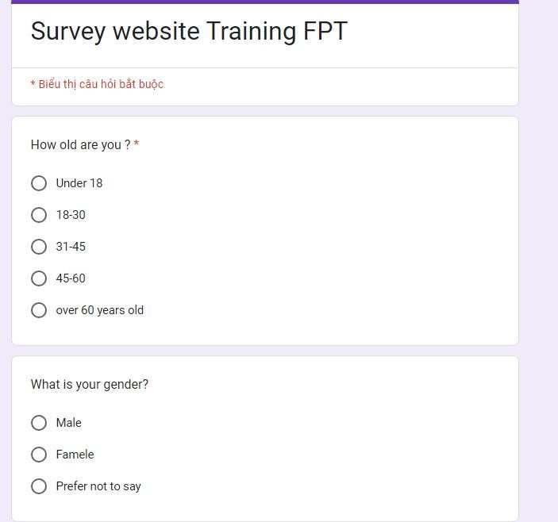

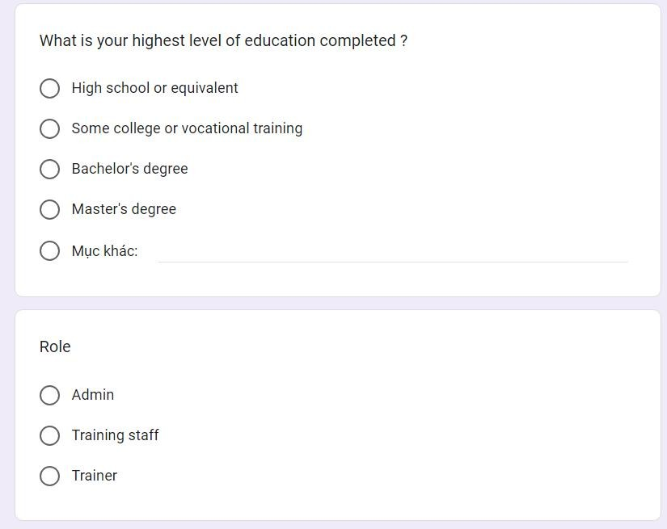

### Admin

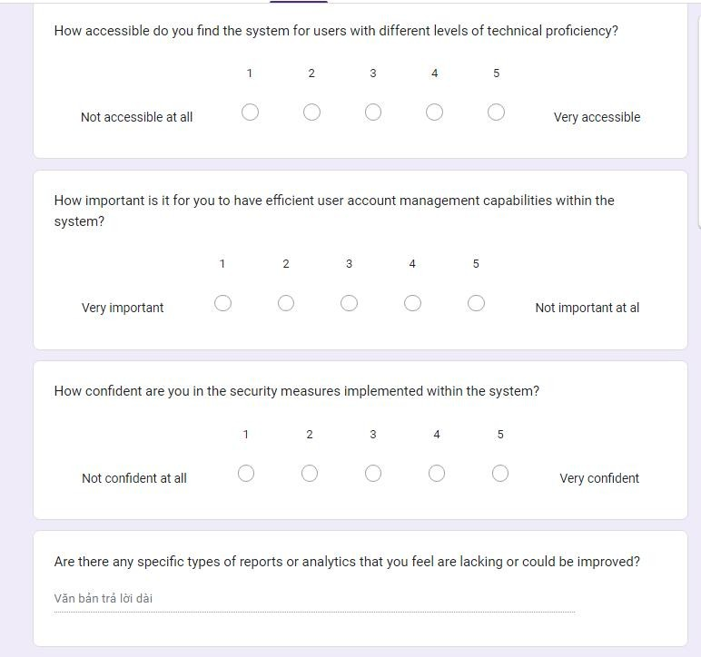

### Training staff

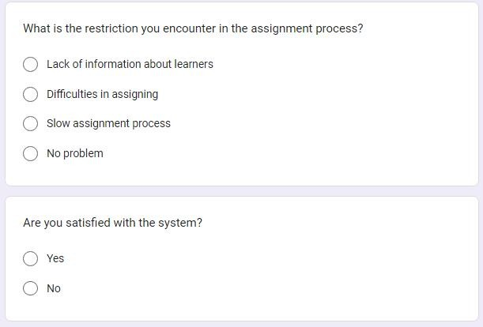

### Trainer

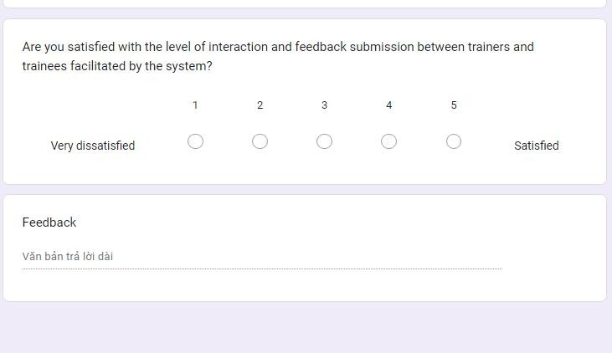

## The result of survey

### Personal information

#### Gender

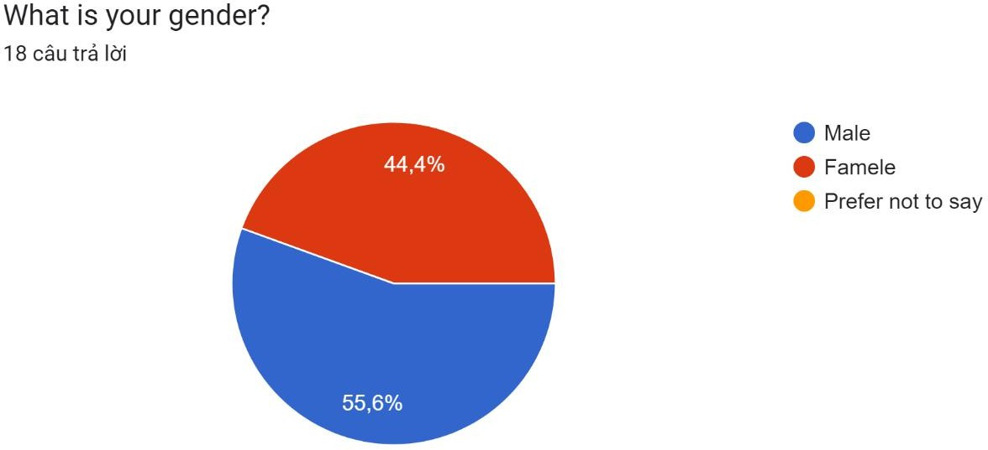

The image, which is a bar graph showing a breakdown of responses to the question "What is your gender?" with options for male, female, and prefer not to say. The chart indicates that 44.4% of the responses were male, 55.6% were female, and a small percentage of people preferred not to say.

#### Education

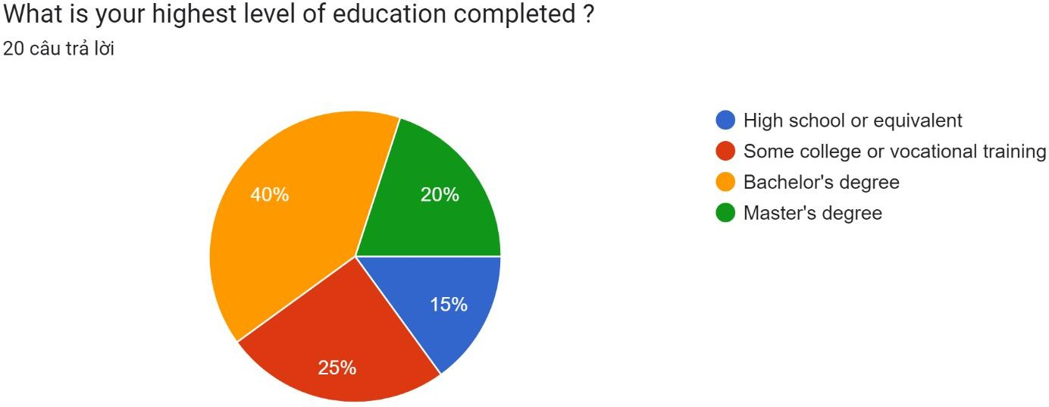

Instead, there is a question asking about the highest level of education completed, along with a breakdown of the 20 responses. Here is the breakdown of the responses:

* 40% of respondents completed high school or equivalent
* 20% of respondents completed some college or vocational training
* 25% of respondents completed a bachelor's degree
* 15% of respondents completed a master's degree

#### Role

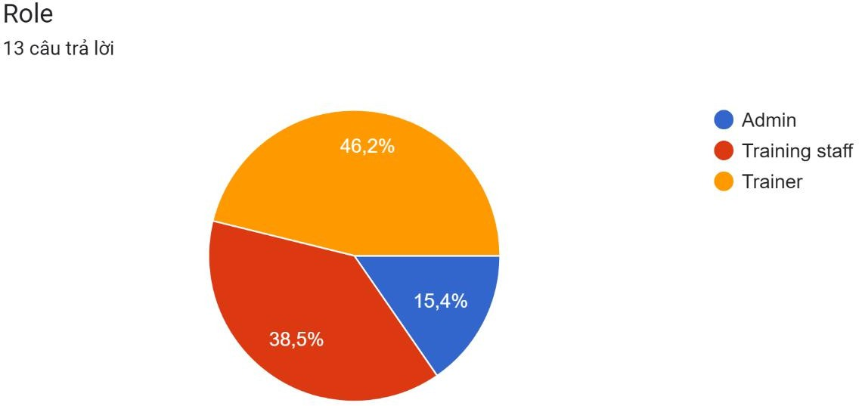

The roles are categorized into three groups: Admin, Training staff, and Trainer. The number of responses for each role is 20, and the percentage distribution of responses for each role is as follows:

* Admin: 46.2%
* Training staff: 38.5%
* Trainer: 15.4%

Therefore, the majority of responses (46.2%) are for the Admin role, followed by Training staff (38.5%), and Trainer (15.4%).

#### Age Group

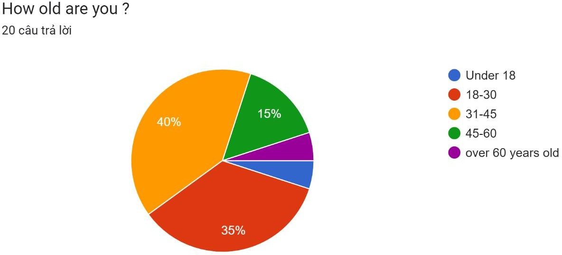

The chart is divided into four sections, representing the percentages of respondents who fall into the age categories of "Under 18", "18-30", "31-45", "46-60", and "over 60 years old".

The pie chart shows that:

* 5% of respondents are under 18 years old
* 40% of respondents are between 18 and 30 years old
* 35% of respondents are between 31 and 45 years old
* 15% of respondents are between 46 and 60 years old
* 5% respondents are over 60 years old

### Administrator feedback

#### Administrator interface

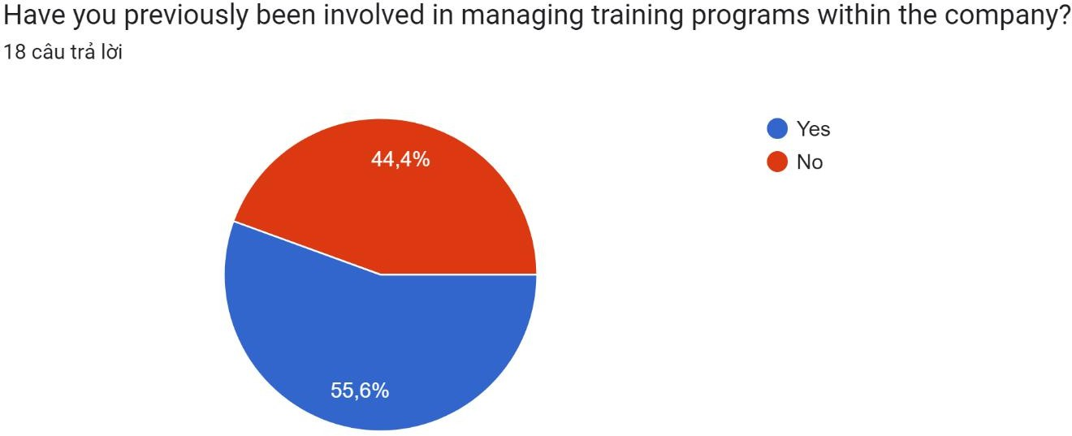

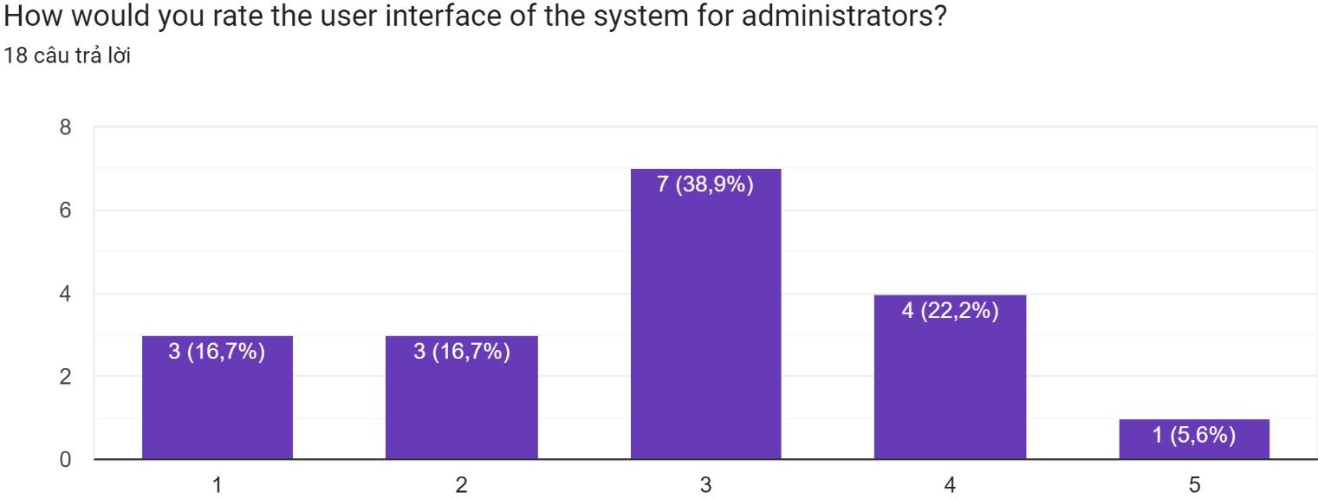

#### Accessibility for user

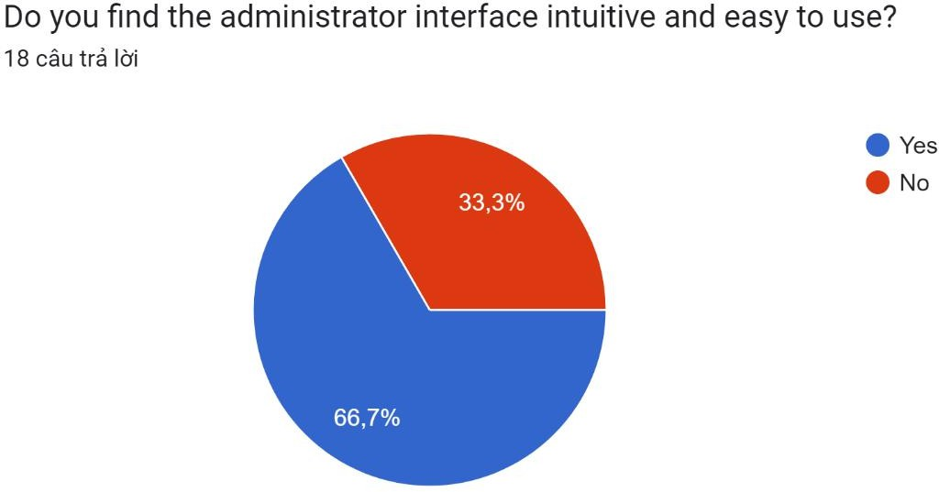

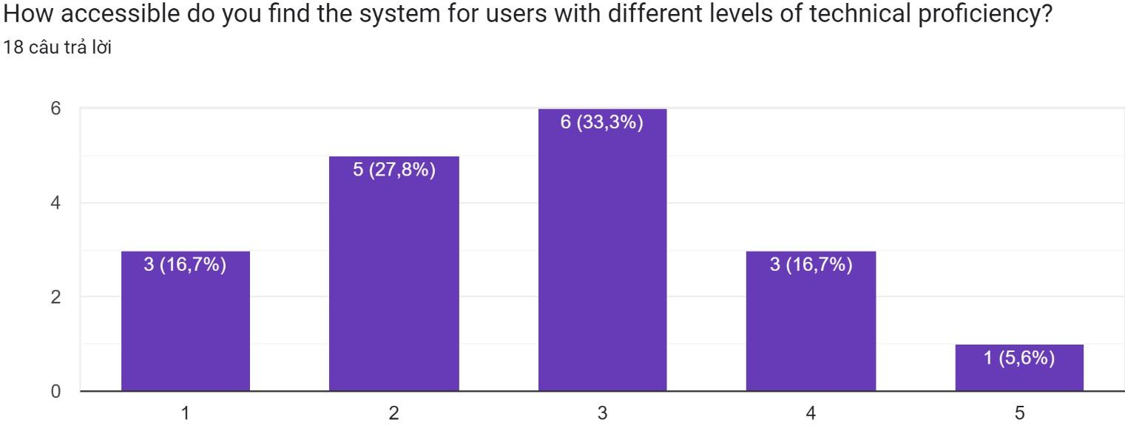

#### User account management

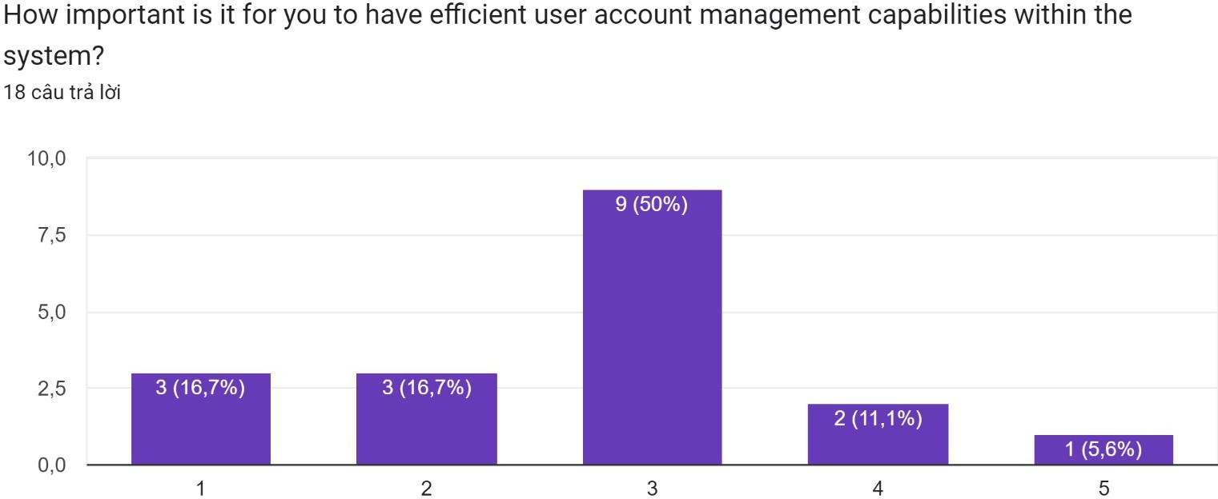

#### Confidence in security

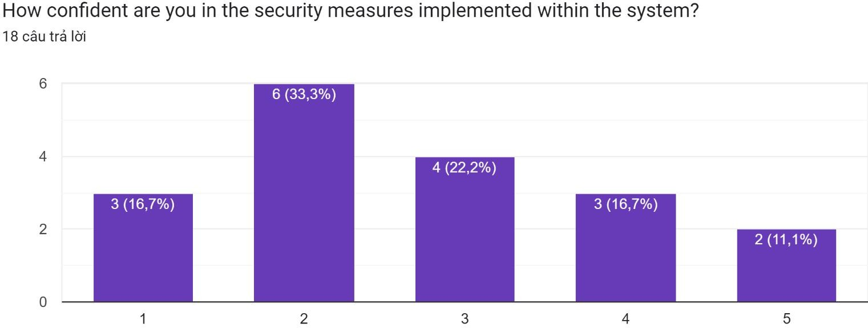

#### Reports

The administrator interface allows for efficient user account management, with the ability to create, edit, and delete user accounts for trainers and training staff. The system also supports tracking and reporting, providing the administrator with valuable insights into the performance of the application and the users.

Overall, the administrator role is well-supported in the business application, allowing for effective management and oversight of the system.

### Training staff Feedback

#### Navigation and content Management

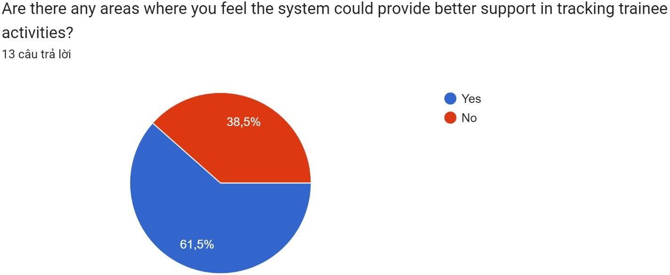

The chart presented in the image is a bar graph that represents the responses to a question about whether the system could provide better support in tracking trainee activities. The number of responses for this question is 13, and the percentage distribution of responses is as follows:

* Yes: 61.5%
* No: 38.5%

Therefore, the majority of responses (61.5%) indicate that there are areas where the system could provide better support in tracking trainee activities.

#### Efficiency in assigning trainers and trainees

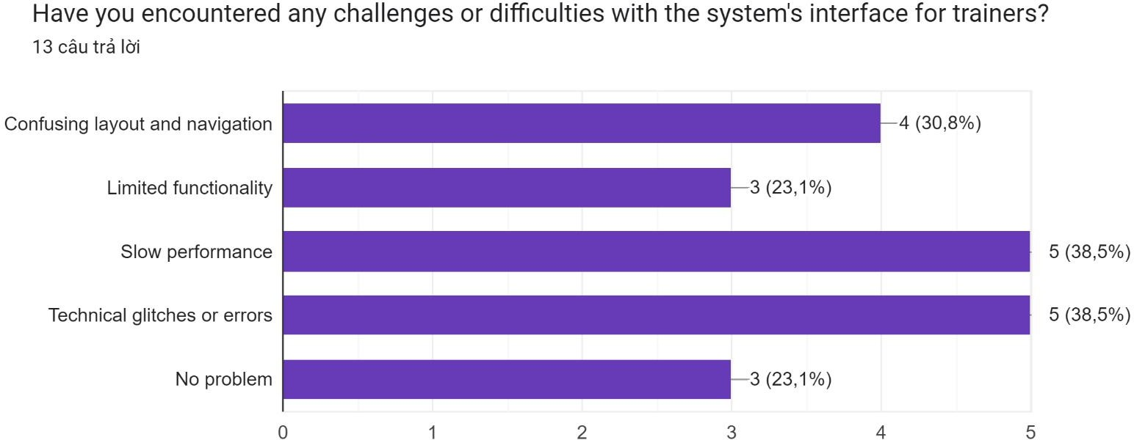

The chart presented in the image is a bar graph that represents the responses to a question about challenges or difficulties encountered with the system's interface for trainers. The number of responses for this question is 13, and the percentage distribution of responses is as follows:

* Confusing layout and navigation: 30.8%
* Limited functionality: 23.1%
* Slow performance: 23.1%
* Technical glitches or errors: 15.4%
* No problem: 38.5%

Therefore, the majority of responses (38.5%) indicate that there are no problems encountered with the system's interface for trainers. However, a significant number of respondents (30.8%) reported challenges with the confusing layout and navigation of the interface. Additionally, some respondents reported issues with limited functionality (23.1%), slow performance (23.1%), and technical glitches or errors (15.4%).

#### Bottlenecks

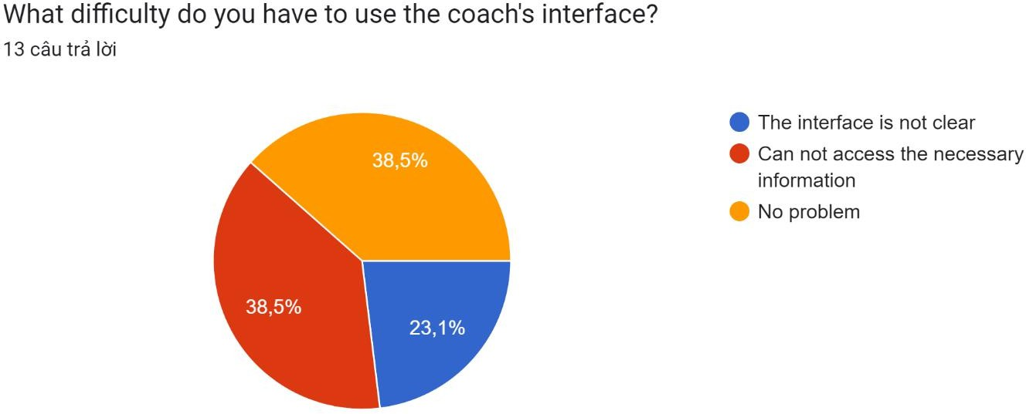

The chart presented in the image is a bar graph that represents the responses to a question about difficulties encountered when using the coach's interface. The number of responses for this question is 13, and the percentage distribution of responses is as follows:

* The interface is not clear: 38.5%
* Can not access the necessary information: 38.5%
* No problem: 23.1%

Therefore, the majority of respondents (38.5%) reported that the interface is not clear, and an equal number of respondents (38.5%) reported that they cannot access the necessary information. A smaller number of respondents (23.1%) indicated that they do not have any problems using the coach's interface.

#### Feedback and Evaluation

**Navigation and Content Management:**

Improvement is needed in the system to provide better support in tracking learners' activities.

Consider adding additional features to help trainers effectively manage content while providing easy-to- understand monitoring information.

**Performance in Assigning Trainers and Learners:**

Optimize the interface to reduce difficulties and enhance visual appeal for trainers.

Improve the functionality and performance of the system to ensure a better experience for both trainers and learners.

Ensure prompt resolution of any technical errors or issues to avoid disruptions in the training process.

**Limitations:**

Optimize the interface to ensure clarity and user-friendliness for trainers.

Ensure users can easily access the necessary information, thereby enhancing the effectiveness of trainers' work.

Continue researching and developing the interface to address the mentioned limitations

### Trainer Feedback

#### System support for tracking

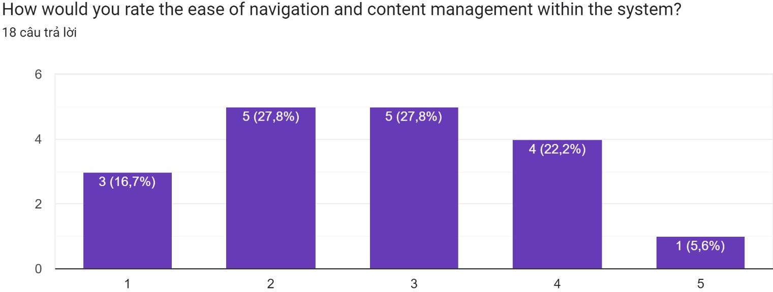

The chart indicates that out of 18 responses, the ease of navigation and content management within the system has been rated as follows:

* 4 stars: 4 responses (22.2%)
* 3 stars: 1 response (5.6%)
* 2 stars: 2 responses (11.1%)
* 5 stars: 2 instances, each representing 5 (27.8%) of the responses

Based on this data, it appears that the ease of navigation and content management within the system is generally rated positively, with a combined total of 10 responses (55.6%) giving it 4 or 5 stars. However, there is still room for improvement, as 33.3% of the responses rated it with 3 stars or below.

#### Challenges trainer interface

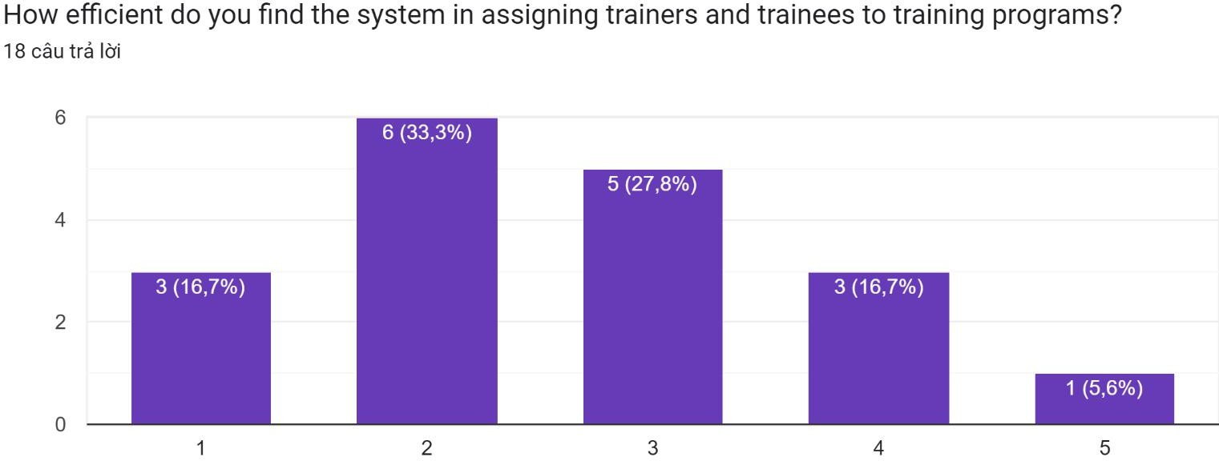

Based on the chart provided, the ease of navigation and content management within the system was rated by 18 respondents as follows:

* 4 stars: 4 responses (22.2%)
* 3 stars: 1 response (5.6%)
* 2 stars: 2 responses (11.1%)
* 5 stars: 11 responses (61.1%)

Therefore, the majority of respondents rated the ease of navigation and content management within the system as excellent, with a rating of 5 stars. However, there is still some room for improvement, as a few respondents gave lower ratings of 2 or 3 stars.

#### Features or metrics for tracking process

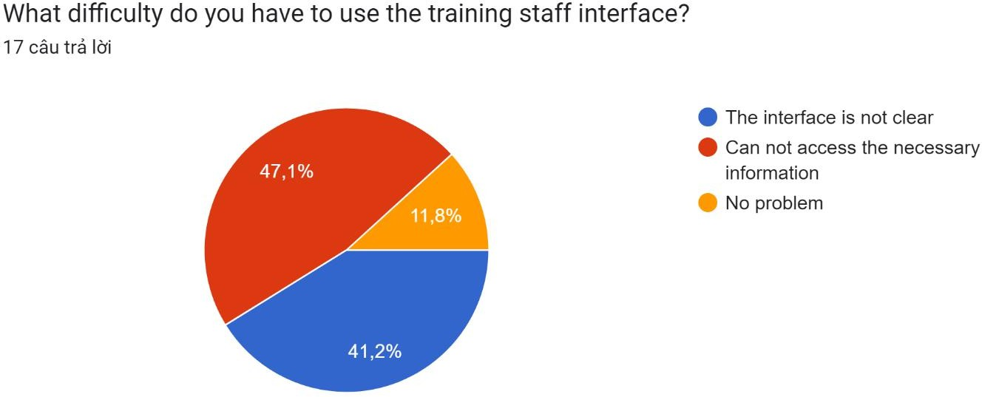

The chart shows that out of 17 responses, the difficulty in using the training staff interface is as follows:

* 47.1% (8 responses) indicated that the interface is not clear
* 11.8% (2 responses) mentioned that they cannot access the necessary information
* 41.2% (7 responses) stated that they have no problem using the interface

Therefore, it appears that the majority of respondents have some difficulty using the training staff interface, with the most common issue being that the interface is not clear. However, a significant portion of respondents also reported having no problems with the interface.

#### Enhancements for trainer-trainee interaction

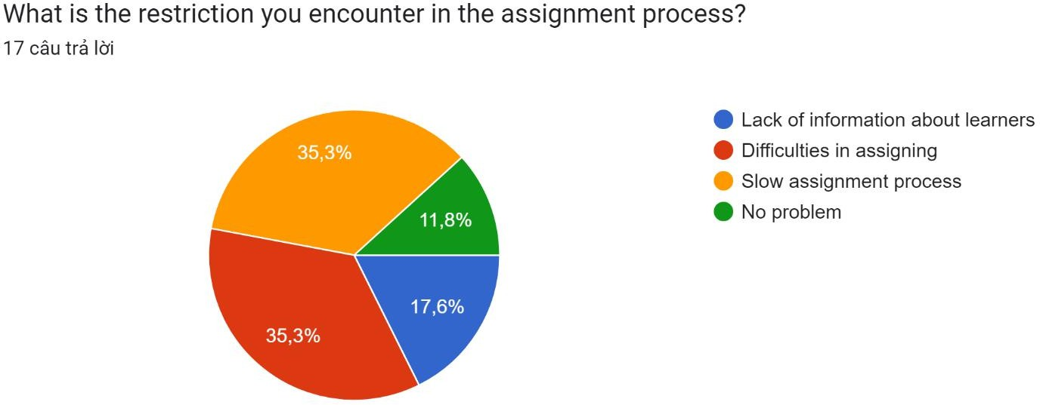

Based on the chart provided, the restrictions encountered in the assignment process are:

* Lack of information about learners: 35.3%
* Difficulties in assigning: 35.3%
* Slow assignment process: 11.8%
* No problem: 17.6%

So, the main restrictions encountered in the assignment process are the lack of information about learners and difficulties in assigning, both accounting for 35.3% of the responses.

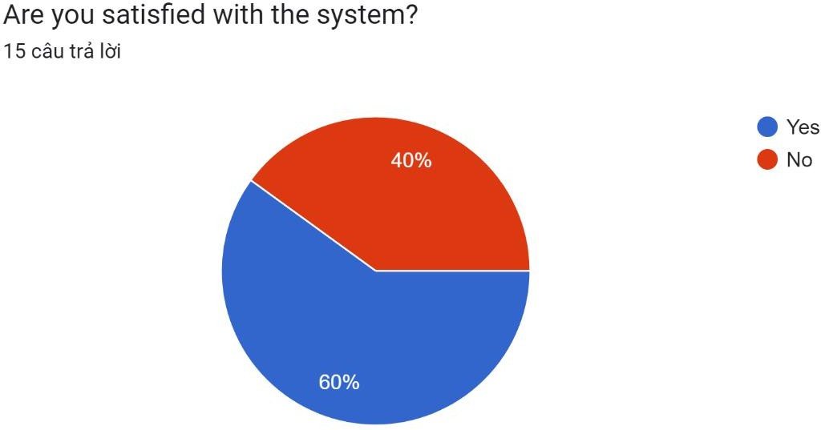

Based on the chart provided, the responses to the question "Are you satisfied with the system?" are:

* Yes: 60%
* No: 40%

This indicates that the majority of the respondents (60%) are satisfied with the system, while a significant portion (40%) are not. The chart provides a clear visual representation of the level of satisfaction with the system

#### Feedback submission

* Optimize the interface and make it more user-friendly to help trainers easily navigate and find necessary information.
* Enhance the functionality and performance of the system to ensure speed and responsiveness.
* Address specific requirements of trainers in terms of content management and monitoring of learner activities.
* Provide technical support and address any technical issues that trainers may encounter.
* Create a clear and user-friendly interface to assist trainers in efficiently creating, editing, and deleting user accounts.

1. **DEVELOP A FUNCTIONAL BUSINESS APPLICATION BASED ON A SPECIFIED BUSINESS PROBLEM**

## Requirement

As the technology is being developed rapidly nowadays, FPT Co. desires to build the continuing study environment throughout the corporation. It is necessary to develop a web-based system, which manages the activity of “Training” for internal training program of the company. This system can be used to manage trainee accounts, manage trainers, manage course categories, manage courses, manage topics, assign topic to course, assign trainer to topic, assign trainee to course. This is a system used by HR department. We have three roles in this system, an administrator, training staff and a trainer. The brief description of those roles is as follow.

### An administrator’s role

* Can login to the system through the first page of the application
* Can create/edit/delete new user account for trainer/training staff and

### A training staff’s role

A registered training staff, who is assigned a user name and a password by the administrator logs in can create trainee accounts by entering details like trainee name, trainee accounts, age, date of birth, education, main programming language, TOEIC score, experience details, department, location, etc.

After entering successfully all details for trainees, his/her details are then stored in the database. The training staff is given a list of trainees for him to view and search. From the list of trainees, he can also search by trainee account, programming language, TOEIC score…

* Can update, delete trainee accounts
* Can manage course categories such as searching, adding, updating and deleting course categories. Course category includes the information such as course category name and descriptions.
* Can manage courses such as searching, adding, updating and deleting courses. Course includes course name and description.
* Can add topics such as topic name and topic descriptions into a course, add courses into a category.
* Can manage trainer profile such as adding, updating and deleting the information: Trainer name, External or Internal Type, working place, telephone, and email address.
* Can assign trainer to a topic. Can assign trainee to a course.

### A trainer’s role

In the same system, the trainer who have been registered by the administrator can login and can update his profile such as Trainer name, External or Internal Type, education, working place, telephone, and email address.

* + - Can view courses which have a topic he is assigned to.

## Administrator ‘s role

### User Login

#### Page Login

#### If enter button Login:

### User Account management

#### Account manager Page

#### Update Account page

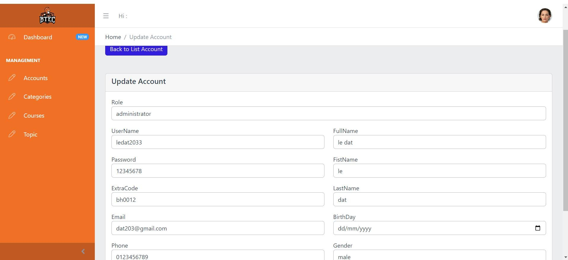

#### Create Account page

#### Delete Account

### User Category management

#### Category Page

#### Add Category page

### User topic management

#### Topic Manager page

#### Create Topic

#### Update Topic page

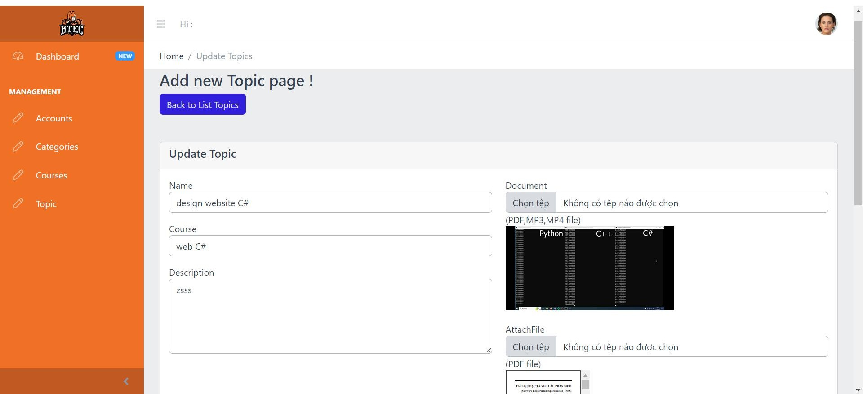

### User Course management

#### Course manage page

#### Add Courses page

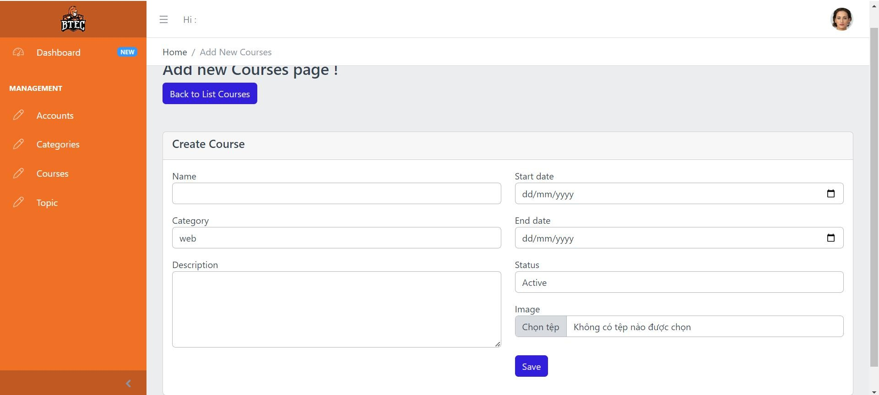

#### Update Course page

## Functional requesment of system

### Functinal requesment of admin

#### Login Functionality:

* The administrator should be able to log in to the system through the first page of the application.

#### User Account Management:

* Create new user accounts for trainers and training staff.
* Edit existing user accounts for trainers and training staff.
* Delete user accounts for trainers and training staff.

### Functinal requesment of training staff

#### Trainee Account Management:

* Create trainee accounts by entering details such as name, account information, age, date of birth, education, programming language, TOEIC score, experience details, department, and location.
* Store trainee account details in the database.
* Update trainee account details.
* Delete trainee accounts.

#### Trainee Management:

* View and search the list of trainees.
* Search trainees by account information, programming language, TOEIC score, etc.
* Course Category Management:
* Search, add, update, and delete course categories.
* Each course category should include information such as category name and descriptions.

#### Course Management:

* Search, add, update, and delete courses.
* Each course should include information such as course name and description.

#### Topic Management:

* Add topics to courses, including topic name and description.
* Trainer Profile Management:
* Add, update, and delete trainer profiles.
* Trainer profile information should include trainer name, type (external or internal), working place, telephone, and email address.

#### Assignment Management:

* Assign trainers to topics.
* Assign trainees to courses.

### Functinal requesment of trainer

#### Profile Management:

* Update trainer profile information, including trainer name, type (external or internal), education, working place, telephone, and email address.

#### Course Viewing:

* View courses for which the trainer is assigned a topic

### Functinal requesment of trainee

#### Trainee Profile:

* Trainees should have their own profile within the system, containing personal and educational details.

#### Course Enrollment:

* Trainees should be able to enroll in available courses.

#### Course Access:

* Trainees should have access to the courses they are enrolled in and view associated topics.

## Comparison

#### Requirements from the document:

Build a web-based system to manage the "Training" activity for the company's internal training program.

Manage trainee accounts, manage trainers, manage course categories, manage courses, manage topics, assign topics to courses, assign trainers to topics, assign trainees to courses.

This system is used by the HR department.

There are three roles in this system: an administrator, training staff, and a trainer.

#### What you initially listed:

Login to the system through the first page of the application. Create, edit, or delete user accounts for trainers and training staff.

Manage trainee records, trainer records, categories, courses, and topics.

#### Comparison

Based on the comparison between what you initially listed and the requirements from the document, there are some similarities and differences:

* Similarities: Both the document requirements and what you initially listed mention logging into the system, managing user accounts, managing trainers, and managing courses.
* Differences: The document requirements provide additional information about the roles of training staff and trainers, as well as more specific functionalities such as managing course categories, assigning topics to courses, and assigning trainers to topics. Additionally, the document requirements also mention managing trainee profiles and provide more detailed information about the relevant fields for trainees.

# REVIEW THE PERFORMANCE OF YOUR BUSINESS APPLICATION AGAINST THE PROBLEM DEFINITION STATEMENT AND INITIAL REQUIREMENTS

## Tescase

### Test Plan

#### Introduction

This test plan outlines the testing approach, scope, resources, and schedule for the development of an internal training management system. Functions tested include: login, category management, course management, and topic management.

#### Objectives

* Verify the functionality and usability of the internal training management system.
* Make sure the system can login
* Ensure the accuracy and reliability of category, course, and topic management features.
* Identify and address any defects or issues in the system.

#### Scope

The testing will cover the following areas:

Login function Category Management:

* + Add of categories
  + Edit of categories
  + Delete of categories Course Management:
  + Add of courses
  + Edit of courses
  + Delete of courses

**Topic Management:**

* + Add of topics
  + Edit of topics
  + Delete of topics

#### Approach

Testing will be conducted using a combination of manual and automated testing techniques. Test cases will be designed to verify the functionality of each feature, including boundary and edge cases. Both positive and negative test scenarios will be considered.

#### Schedule

Testing will commence following the completion of development and continue until all identified issues are resolved. The estimated testing duration is two weeks.

#### Resources

Test Environment: Development environment with access to the internal training management system.

Test Data: Sample data for category, course, topic management and login.

#### Test Cases

**Login**

**Category Management**

* + Verify the adding of a new category.
  + Verify editing an existing category.
  + Verify deletion of a category.

**Course Management**

* + Verify the adding of a new course.
  + Verify editing an existing course.
  + Verify deletion of a course.

**Topic Management**

* + Verify the adding of a new topic.
  + Verify editing an existing topic.
  + Verify deletion of a topic.

#### Exit Criteria

* All critical and high-priority defects have been resolved.
* Test coverage of at least 90% for category, course, topic management and login features. System performance meets acceptable standards

### Test Case

|  |  |  |  |  |  |
| --- | --- | --- | --- | --- | --- |
| **No** | **Test case** | **Step** | **Expected output** | **Actual output** | **Evaluation** |
| **TC1** | Test Login | Step 1. Open https://localhost:7164/ Step 2. Enter the correct username and password | Successfully logged in and displayed the Dashboard page. | Successfully logged in and displayed the Dashboard page. | Pass |
| **TC2** | Test Login | Step 1. Open https://localhost:7164/ Step 2. Enter the wrong username and password | Login fails, still displays the login page for the user to re-enter the correct login name and password. | Login fails, still displays the login page for the user to re-enter the correct login name and password. | Pass |

|  |  |  |  |  |  |
| --- | --- | --- | --- | --- | --- |
| **TC3** | Test Category page | Select “Category” | Displays the Category page | Displays the Category page | Pass |
| **TC4** | Test Add Category | Step 1. Select the Add Category button  Step 2. Enter Name Step 3. Enter Status Step 4. Enter PosterImage  Step 5. Enter Description  Step 6. Select the Save button | Displays a notice of successful addition and returns the index page with the newly added Category. | Displays a notice of successful addition and returns the index page with the newly added Category. | Pass |
| **TC5** | Test Add Category | Step 1. Select the Add Category button  Step 2. Enter Status Step 3. Enter PosterImage  Step 4. Enter Description  Step 5. Select the Save button  (Leave the name blank) | Unable to add new Category.  Display a message asking to enter an additional name. | Unable to add new Category.  Display a message asking to enter an additional name. | Pass |
| **TC6** | Test Edit Category | Step 1. Select the Edit button  Step 2. Enter Name Step 3. Enter Status Step 4. Enter PosterImage  Step 5. Enter Description  Step 6. Select the Update button | Displays a successful update message and returns the index page with the newly updated Category. | Displays a successful update message and returns the index page with the newly updated Category. | Pass |
| **TC7** | Test Delete Category | Enter the Delete button | Display a successful deletion message and delete the selected Category. | Display a successful deletion message and delete the selected  Category. | Pass |
| **TC8** | Test Add Course | Step 1. Select the Add Course button  Step 2. Enter Name Step 3. Enter Category Step 4. Enter Image  Step 5. Enter Description | Displays a notice of successful addition and returns the index page with the newly added Course. | Displays a notice of successful addition and returns the index page with the newly added  Course. | Pass |

|  |  |  |  |  |  |
| --- | --- | --- | --- | --- | --- |
|  |  | Step 6. Enter Start date Step 7. Enter End date Step 8. Enter Status Step 9. Select the Save button |  |  |  |
| **TC9** | Test Add Course | Step 1. Select the Add Course button  Step 2. Enter Name Step 3. Enter Category Step 4. Enter Image Step 5. Enter Description  Step 6. Enter End date Step 7. Enter Status Step 8. Select the Save button  ((Leave the Start date blank) | Cannot add new Courses.  Display a message asking to enter additional Start date. | Cannot add new Courses.  Display a message asking to enter additional Start date. | Pass |
| **TC10** | Test Edit Course | Step 1. Select the Edit button  Step 2. Enter Name Step 3. Enter Category Step 4. Enter Image Step 5. Enter Description  Step 6. Enter Start date Step 7. Enter End date Step 8. Enter Status Step 9. Select the  Update button | Displays a successful update message and returns the index page with the newly updated Course. | Displays a successful update message and returns the index page with the newly updated Course. | Pass |
| **TC11** | Test Delete Course | Enter the Delete button | Display a successful deletion message and delete the selected Course. | Display a successful deletion message and  delete the selected Course. | Pass |
| **TC12** | Test Add Topic | Step 1. Select the Add new Topic button Step 2. Enter Name Step 3. Choose Course Step 4. Enter Description  Step 5. Enter Poster Topic  Step 6. Choose Document topic | Displays a notice of successful addition and returns the index page with the newly added Topic. | Displays a notice of successful addition and returns the index page with the newly added Topic. | Pass |

|  |  |  |  |  |  |
| --- | --- | --- | --- | --- | --- |
|  |  | Step 7. Choose Document  Step 8. Choose Attach file  Step 9. Choose Status  Step 10. Select the Save button |  |  |  |
| **TC13** | Test Add Topic | Step 1. Select the Add new Topic button Step 2. Enter Name Step 3. Choose Course Step 4. Enter Description  Step 5. Choose Poster Topic  Step 6. Choose Attach file topic  Step 7. Select Status Step 8. Select the Save button  (Leave the file document blank) | Cannot add new Topics.  Display a message asking to enter additional Document. | Cannot add new Topics.  Display a message asking to enter additional Video. | Pass |
| **TC14** | Test Edit Topic | Step 1. Select the Edit button  Step 2. Enter Name Step 3. Enter Course Step 4. Enter Poster topic(image)  Step 5. Enter Description  Step 6. Enter Status Step 7. Choose Document topic  Step 8. Choose attach file  Step 9. Select the Update button | Displays a successful update message and returns the index page with the newly updated Topic. | Displays a successful update message and returns the index page with the newly updated Topic. | Pass |
| **TC15** | Test Delete Topic | Enter the Delete button | Display a successful deletion message and delete the selected Topic. | Display a successful deletion message and delete the selected Topic. | Pass |

# CONCLUSION

To summarize, the formal questionnaire and feedback obtained from administrators and training staff offer valuable insights regarding the strengths and areas in need of improvement for the application. The graphical representations of survey responses provide a visual understanding of user demographics, preferences, and challenges encountered while using the system. The feedback and evaluation section offer specific recommendations for improving navigation, content management, performance in assigning trainers and learners, and addressing bottlenecks. This document serves as a valuable resource for future iterations and enhancements to ensure an efficient and user-friendly business application. By incorporating the suggestions and addressing the identified areas for improvement, the application can be refined to better meet the needs and expectations of its users.

# Reference

Link Code GitHub: <https://github.com/Ledat234/AD.git>