AgriStream IoT
Azure architecture, implementation, and evidence
Student ST10538419. Module CLDV7112. Public site https://st10538419.azurewebsites.net. Resource group rg-st10538419-cldv7112 in UAE North, on the Azure for Students subscription. This document explains each Azure service, why it was chosen, how the code uses it, and what was observed on 6 November 2026.

1. What the brief asked for
AgriStream IoT takes soil readings and drone images for commercial farms. The brief asks for an MVC site, a relational user store, blob and table storage, exactly four Azure Functions, a heavy-traffic test, monitoring, and an autoscale rule. The table below is the map from that brief to the running system.
Brief item | Where it is proved
App Service at studentnumber.azurewebsites.net | Web app st10538419, host st10538419.azurewebsites.net. GET /health returns Healthy.
Relational accounts: username, password, role | Azure SQL database ST10538419_CLDV7112_Practicium. Table UserAccounts. Password stored as a PBKDF2-SHA256 hash.
Blob storage for drone images | Container drone-images. Private. Upload from the farmer and agronomist pages.
Table storage for telemetry and logs | Tables sensorreadings, environmentallogs, irrigationcommands, and imageaudits.
Four functions only | DroneImageAuditFunction, GetTelemetryFunction, PostIrrigationFunction, ProcessIrrigationFunction.
Heavy traffic | scripts/load-test.sh, 20 workers, about 12 minutes, 6 November 2026.
Monitoring | Application Insights st10538419-insights, plus Azure Monitor metrics on the plan and the web app.
Autoscale | The load ran while the plan was S1. The plan is now B1 with one worker. B1 cannot autoscale, so the rule is not left in place. Section 11 explains that choice.

2. Architecture
The browser talks only to the MVC site. The site does not call the Azure Storage SDK or the SQL client from a controller. Controllers call application services. Infrastructure owns Entity Framework Core and the Azure clients. The four functions are a second host on the same App Service plan. They share the storage account and the SQL database, and they share a secret header so a stranger cannot call the HTTP functions.
Browser
-> st10538419 (ASP.NET Core MVC, Linux, .NET 10)
-> Application services
-> Azure SQL users and the device registry
-> Blob container drone-images
-> HTTP functions telemetry and irrigation intake
-> st10538419-functions
DroneImageAuditFunction blob trigger -> table imageaudits
GetTelemetryFunction HTTP GET -> table sensorreadings
PostIrrigationFunction HTTP POST -> table irrigationcommands
-> queue irrigation-commands
ProcessIrrigationFunction queue trigger -> Azure SQL Devices
-> Application Insights and Log Analytics
Domain has no reference to Entity Framework or ASP.NET. Application defines the ports. Infrastructure implements them. Program.cs is the only composition root. Production refuses to start if the SQL connection, any of the four storage connection strings, or the Application Insights connection string is empty.

3. Design decisions

One resource group, one plan, one region
Everything sits in rg-st10538419-cldv7112. The student subscription allows UAE North, Switzerland North, Central India, Brazil South, and Austria East. South Africa North is blocked by policy. UAE North is the nearest allowed region, so infra/main.bicep defaults to uaenorth and rejects any other value with an @allowed list.
Linux App Service has no Free tier. B1 is the cheapest plan that stays online. The Function App shares that plan. A Consumption plan would not start in this region. Azure SQL is Basic, 2 GB. Storage is Standard_LRS. One Log Analytics workspace and one Application Insights component receive both the web app and the functions. A second copy of any of these would spend the student credit without satisfying an extra brief item.

Stateless web and functions
A later request can land on another worker. The farmer's dashboard is not kept in server memory. Each dashboard load calls GetTelemetryFunction, which reads the latest rows from sensorreadings. A drone image is not written to the web server disk. It goes to the drone-images container, so the blob trigger sees it no matter which worker accepted the upload. The HTTP irrigation function and the queue function do not share memory. The hand-off is the irrigationcommands table plus the irrigation-commands queue.

LRS for this workload
The storage account is Standard_LRS: three synchronous copies in one data centre. That matches a high volume of sensor readings and drone images on a student subscription. A harvest archive that cannot be measured again would want geo-redundant storage, and that would be a second storage account. One account cannot be both. The theory note in docs/theory.md records that distinction.

Triggers in code, not binding attributes for the data
Each function declares only its trigger. Reads and writes go through IFarmTables, IWorkQueue, and IDeviceService. That is the same job as an input or output binding, kept in the application layer so the rule can be unit-tested without the Azure SDK.

4. The resource group
Signed in to the Azure portal as ST10538419@rcconnect.edu.za. The group contains nine resources, all in UAE North: the Log Analytics workspace, the web app, the Function App, Application Insights, the App Service plan, the SQL server, the storage account, and the SQL database (the master database on the server is the system database Azure creates with the server).
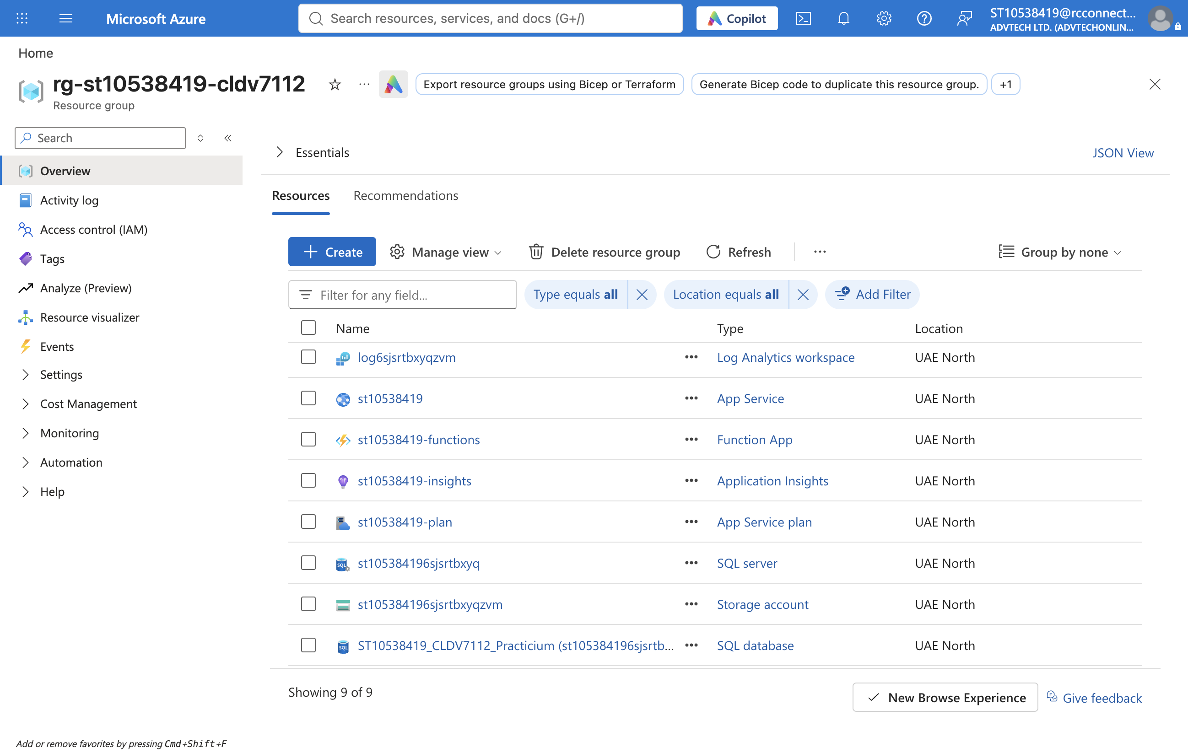
Figure 1. Resource group rg-st10538419-cldv7112, overview, 6 November 2026.

5. App Service
The MVC site is the Linux web app st10538419. HTTPS only. Stack DOTNETCORE|10.0. Always On is on, so the worker is not spun down between requests. FTPS is disabled. Minimum TLS is 1.2. The plan is st10538419-plan, SKU B1, one worker.
App settings, set by Bicep and never committed, point the site at SQL, the four storage services, Application Insights, and the Function App base URL. The shared secret is an app setting on both hosts. GET /health checks the database through the EF Core health check and returned Healthy during this capture.
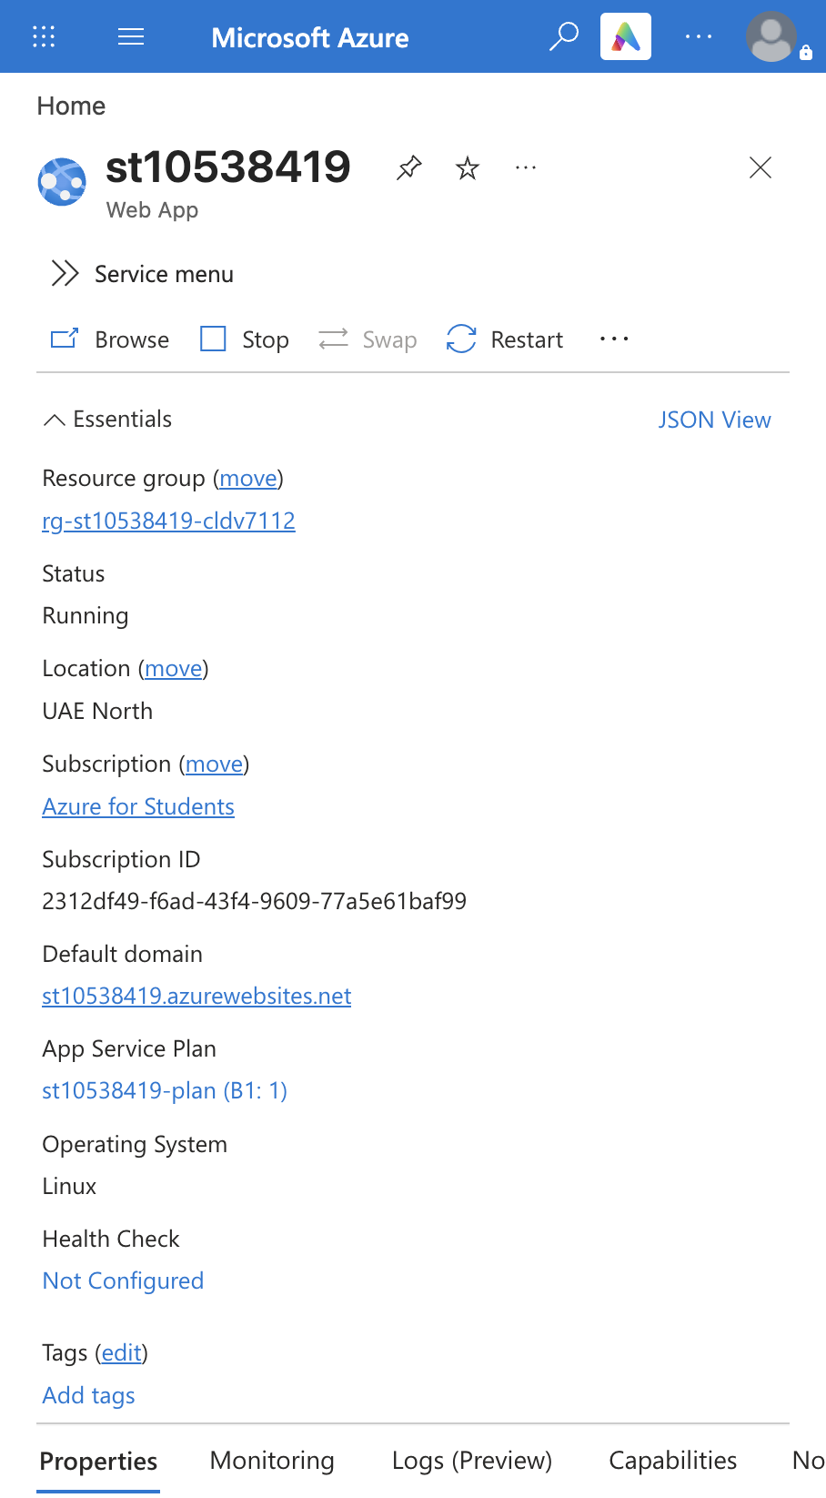
Figure 2. Web app st10538419. Status Running, UAE North, default host st10538419.azurewebsites.net, plan B1.

Figure 3. GET /health on the public site.
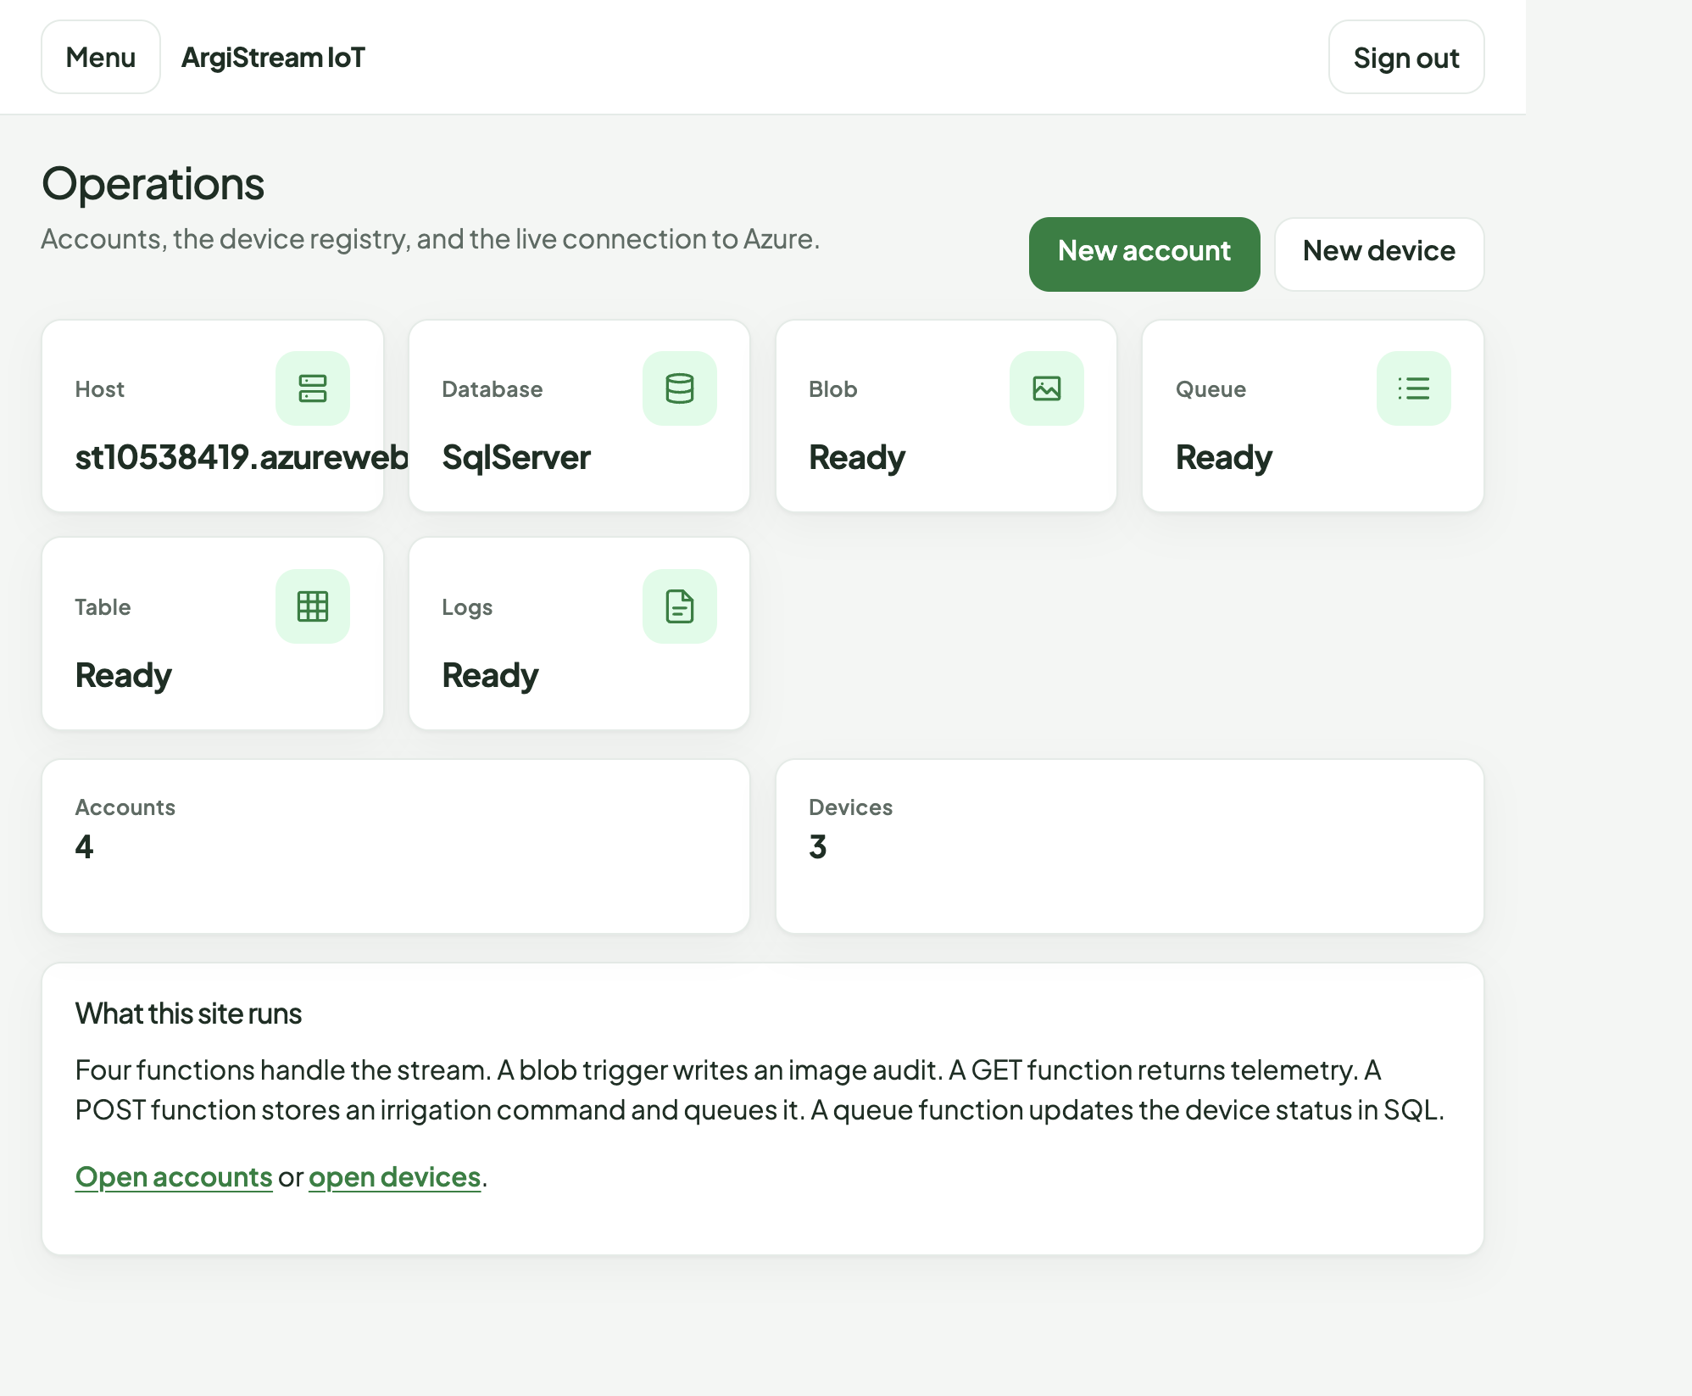
Figure 4. Admin operations page on the live site. Database provider SqlServer. Blob, queue, table, and logs all Ready.
The hosting card is read in the web project from configuration, not from a hardcoded string:
public HostingStatusViewModel Read(HttpRequest request) => new()
{
Host = request.Host.Value ?? "local",
DatabaseProvider = database.Value.Provider,
BlobReady = storage.Value.BlobConfigured,
QueueReady = storage.Value.QueueConfigured,
TableReady = storage.Value.TableConfigured,
LogsReady = !string.IsNullOrWhiteSpace(
configuration["APPLICATIONINSIGHTS_CONNECTION_STRING"])
};

6. Azure SQL
Server st105384196sjsrtbxyq.database.windows.net. Database ST10538419_CLDV7112_Practicium, SKU Basic, status Online, collation SQL_Latin1_General_CP1_CI_AS. TLS 1.2 minimum. A firewall rule named AllowAzureServices lets the App Service and the Function App reach the server. The admin password is generated at deploy time and kept in infra/.deploy.env, which is gitignored.
Two tables matter. UserAccounts stores the username, a password hash, and the role Farmer, Agronomist, or Admin. The username is unique. Devices is the master registry the queue function updates: name, field, and operational status Idle, Irrigating, or NeedsAttention. Local development uses SQLite. Production calls MigrateAsync on startup, then seeds the three tester accounts and the North pivot device if they are missing.
The password is never stored or shown. PasswordHasher uses PBKDF2-SHA256, 100,000 iterations, a random 16-byte salt, and a fixed-time compare.
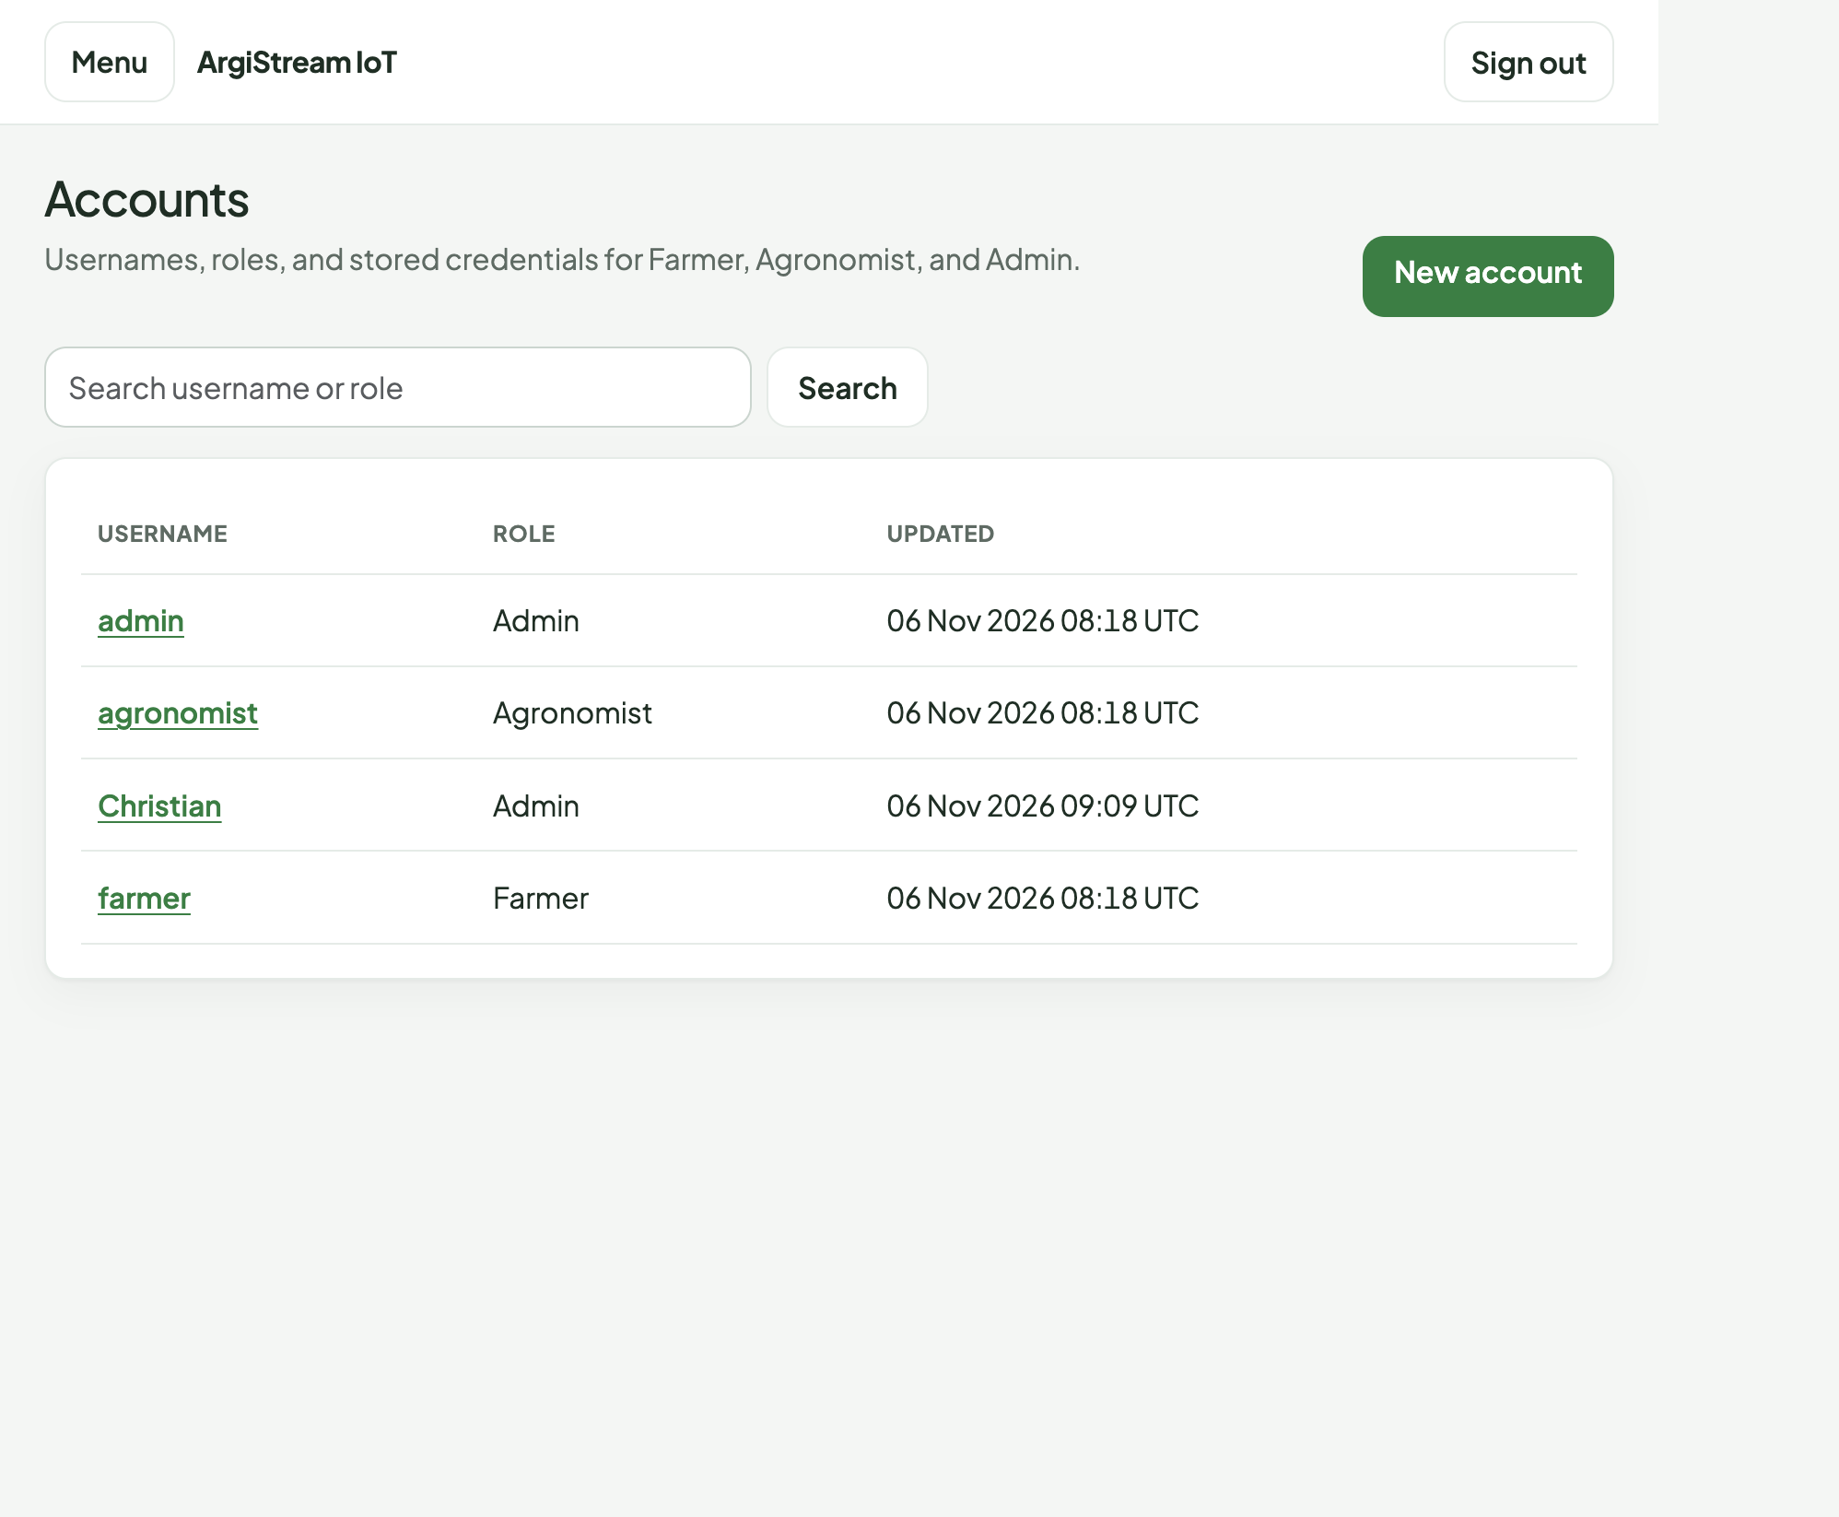
Figure 5. Accounts read from Azure SQL through the MVC site. Roles Farmer, Agronomist, and Admin.
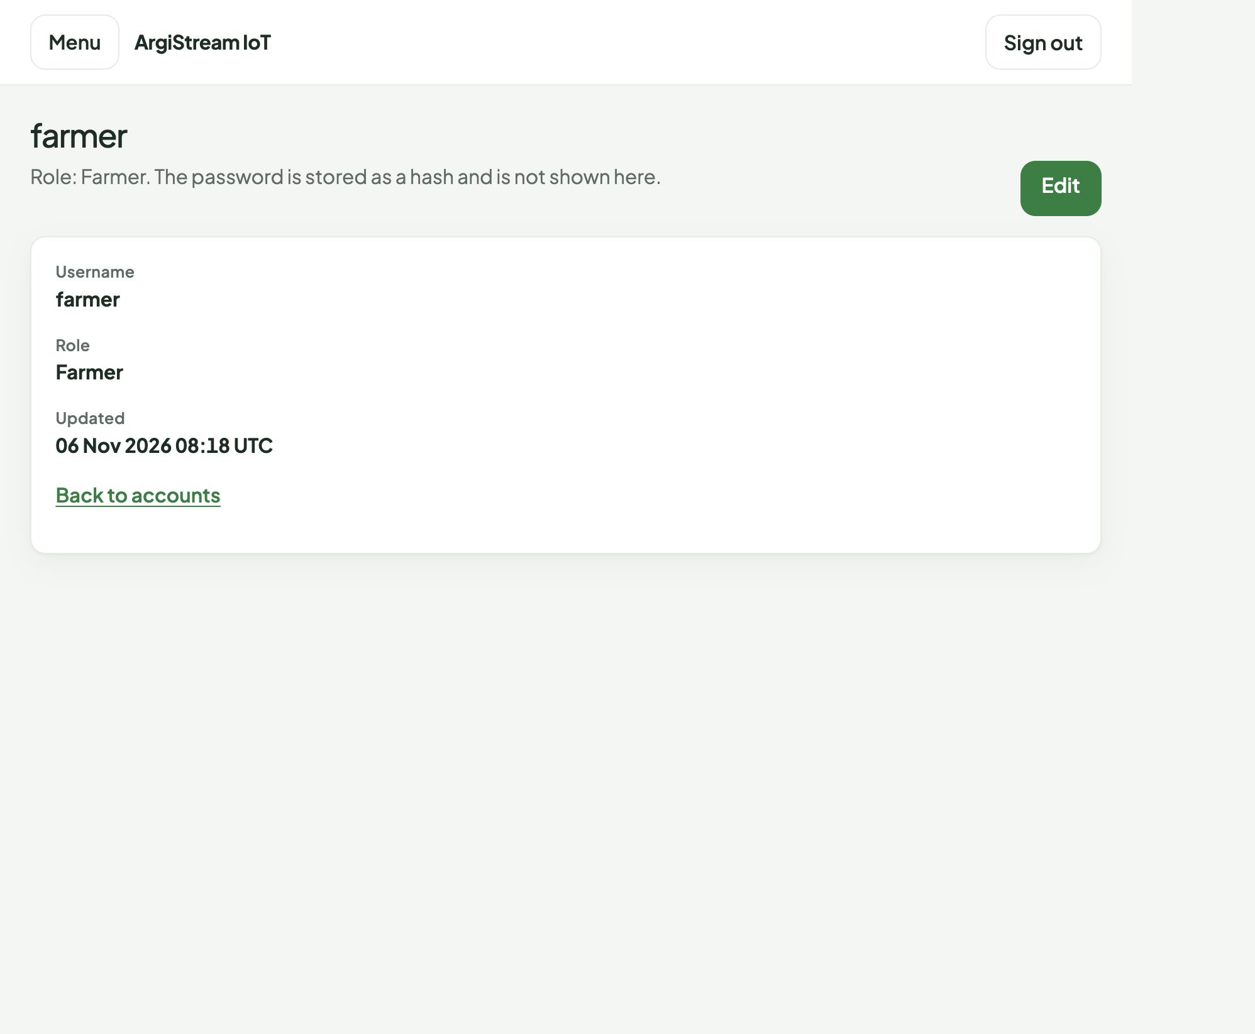
Figure 6. The farmer record. The page states that the password is stored as a hash and is not shown.
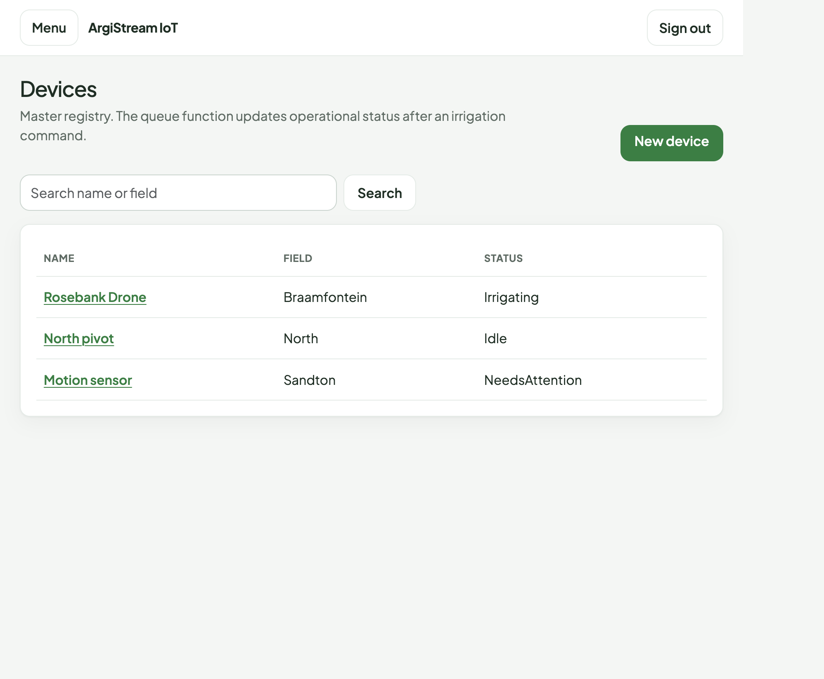
Figure 7. Device registry in Azure SQL before the capture in section 9. Status is the column the queue function is responsible for.
Portal path if a marker wants the database blade itself: Azure portal, resource group rg-st10538419-cldv7112, SQL database ST10538419_CLDV7112_Practicium. Do not open the connection string blade in a screenshot.

7. Storage account
Storage account st105384196sjsrtbxyqzvm, kind StorageV2, SKU Standard_LRS, TLS 1.2, public blob access disabled, HTTPS only. CloudBootstrap creates the containers and tables on startup when the connection strings are present.
- Blob container drone-images. Private. Drone uploads. Names are a GUID plus .jpg, .jpeg, .png, or .webp. Maximum 8 MB.
- Blob containers azure-webjobs-hosts and azure-webjobs-secrets. Created by the Functions host.
- Queue irrigation-commands. Irrigation hand-off from the HTTP function to the queue function.
- Tables sensorreadings, environmentallogs, irrigationcommands, imageaudits.
- File share practicum. Present because the foundation registers a file-share port. The brief's media path is the blob container, not the share.
At the time of the capture the drone-images container held the uploaded images, sensorreadings held North and South moisture and temperature rows, environmentallogs held humidity and wind, and imageaudits held a Received row for each uploaded blob. Those rows are what the pages in section 9 render.
Portal path: storage account st105384196sjsrtbxyqzvm, then Containers (drone-images), Tables, and Queues (irrigation-commands). Do not open Access keys.

8. The four functions
Function App st10538419-functions. Linux, .NET isolated worker, runtime 4.x, same B1 plan, HTTPS only. AzureWebJobsStorage is the storage account, which is what the blob and queue triggers use. The list from the Function App, confirmed with the Azure CLI, is exactly these four. There is no fifth function.
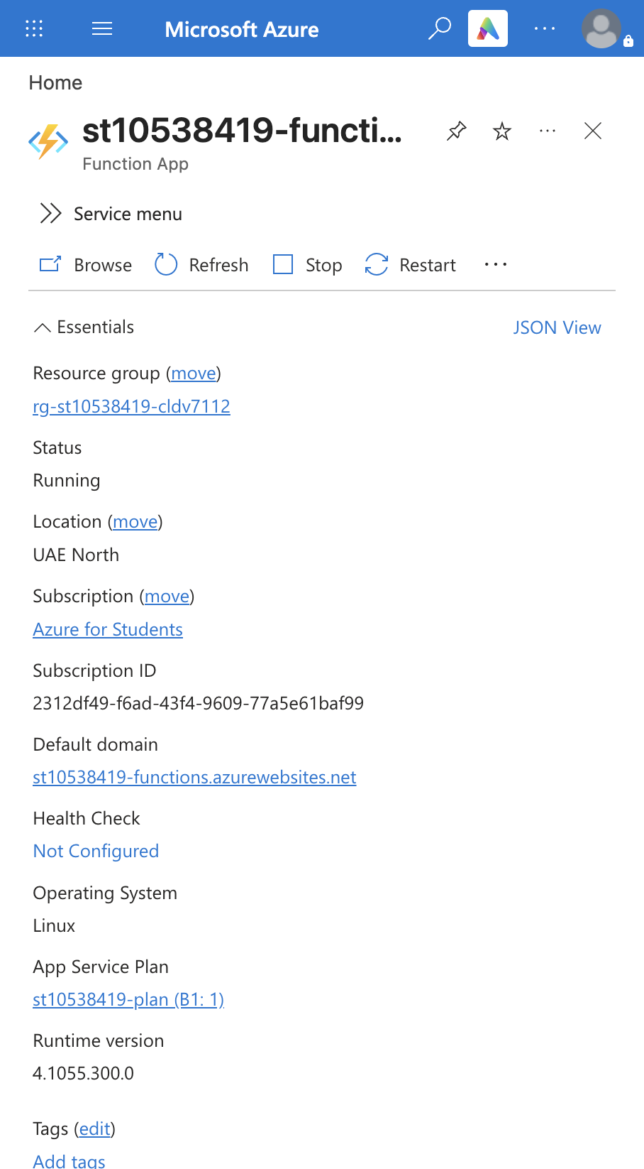
Figure 8. Function App st10538419-functions. Running, UAE North, host st10538419-functions.azurewebsites.net, plan B1, Functions runtime 4.x.

8.1 Blob trigger — DroneImageAuditFunction
Trigger: a new blob in drone-images. The function logs the name and size, then ImageAuditProcessor upserts a row in imageaudits with status Received. It does not poll.
[Function(nameof(DroneImageAuditFunction))]
public async Task Run(
[BlobTrigger("drone-images/{name}", Connection = "AzureWebJobsStorage")] Stream blob,
string name,
CancellationToken cancellationToken)
{
var size = blob.CanSeek ? blob.Length : 0;
await audits.RecordAsync(name, size, cancellationToken);
}
Application Insights, 6 November 2026 at 11:11:07 UTC, while the farmer page uploaded a test image: "Drone image b2c31c2a43844a2284b3e1db50e46ac6.jpg uploaded. Size 17133 bytes." The function execution succeeded. The agronomist gallery in Figure 12 shows that image with status Received.

8.2 HTTP GET — GetTelemetryFunction
Route GET /api/telemetry. The MVC dashboard calls it with the header X-ArgiStream-Key. The function rejects a bad key with HTTP 401. On success it reads sensorreadings through ITelemetryQuery and returns the latest twelve rows, optionally filtered by field. Opening the farmer dashboard is the call. Figure 10 shows the three readings that came back, and the hosting card still says SqlServer.
[Function(nameof(GetTelemetryFunction))]
public async Task<HttpResponseData> Run(
[HttpTrigger(AuthorizationLevel.Anonymous, "get", Route = "telemetry")] HttpRequestData request,
CancellationToken cancellationToken)
{
if (!FunctionResponses.Authorized(request, configuration))
return await FunctionResponses.Json(request, HttpStatusCode.Unauthorized, ...);
var readings = await telemetry.LatestAsync(field, cancellationToken);
return await FunctionResponses.Json(request, HttpStatusCode.OK, readings);
}
Application Insights recorded GetTelemetryFunction HTTP 200 while that dashboard was open, including a call at 11:11:07 UTC with a duration of about 121 ms.

8.3 HTTP POST — PostIrrigationFunction
Route POST /api/irrigation. The body is a device id and a command type, either irrigate or sensor-alert. IrrigationIntake checks the command, loads the device from Azure SQL, writes a Pending row to irrigationcommands, then puts the same payload on the irrigation-commands queue. The table write happens before the queue send, so a crash after the table write still leaves a record of the command.
await tables.UpsertAsync(CloudResources.IrrigationCommands, deviceId, commandId,
new Dictionary<string, string>
{
["Status"] = "Pending",
["CommandType"] = commandType,
...
}, cancellationToken);
await queue.SendAsync(CloudResources.IrrigationQueue, message, cancellationToken);
During this capture the farmer button posted device id 44e3a51e-a42d-4cfd-a484-d4ea94ac6be7 (North pivot). The function answered "Device and command type are required." That message is the function's own validation, so the call did reach PostIrrigationFunction. A JSON call to the same route with that device id and command type irrigate returned HTTP 200 and a command id. The irrigationcommands table then held two Pending irrigate rows, recorded at 11:12:54 UTC and 11:12:56 UTC. Application Insights shows those executions succeeding, one of them after a SQL read of the Devices row.

8.4 Queue trigger — ProcessIrrigationFunction
Trigger: a message on irrigation-commands. IrrigationProcessor reads the message, sets the device to Irrigating for an irrigate command or NeedsAttention for a sensor alert, and rewrites the table row as Processed. The function host was observed polling that queue about once a minute. At the moment the devices page in Figure 13 was taken, North pivot was still Idle, so the queue function had not yet committed the status change for the commands written at 11:12 UTC. Rosebank Drone was already Irrigating and Motion sensor was already NeedsAttention from earlier commands.
[Function(nameof(ProcessIrrigationFunction))]
public async Task Run(
[QueueTrigger(CloudResources.IrrigationQueue, Connection = "AzureWebJobsStorage")] string message,
CancellationToken cancellationToken)
{
var outcome = await processor.ProcessAsync(message, cancellationToken);
}

9. The live site while the functions ran
These pages were captured against https://st10538419.azurewebsites.net on 6 November 2026, in the same session as the Application Insights rows above. The farmer dashboard load is the GET. The upload is the blob trigger. The agronomist page reads environmentallogs from table storage and the device list from Azure SQL.
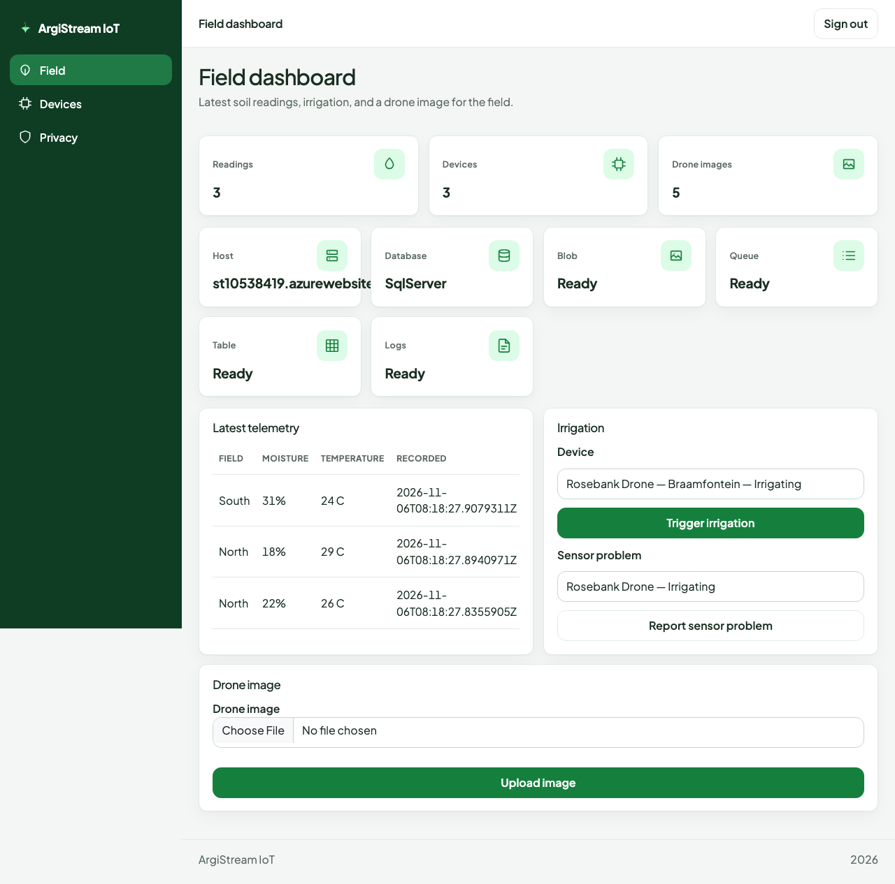
Figure 10. Farmer dashboard immediately after GetTelemetryFunction. Three soil readings, three devices, blob and table Ready, database SqlServer.
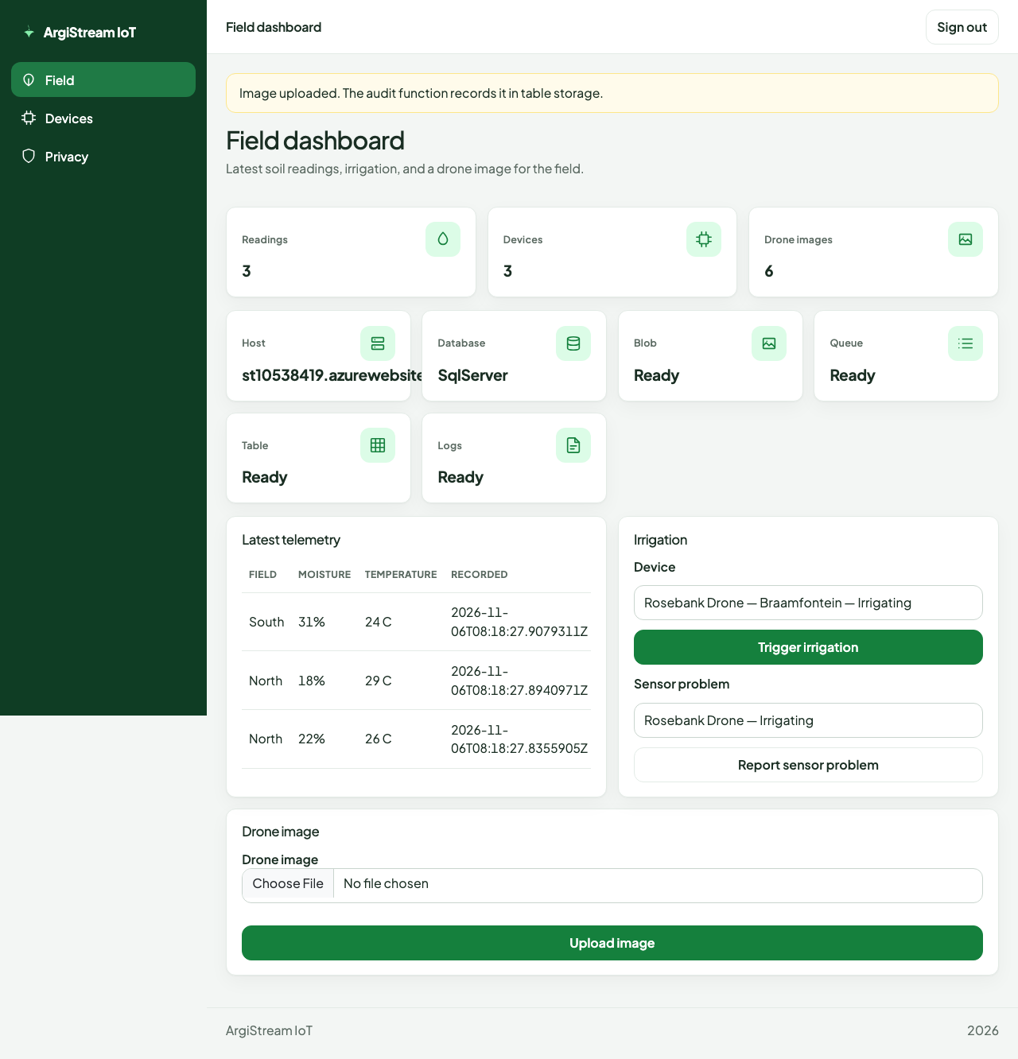
Figure 11. After the upload. The page says the audit function records the image in table storage. The drone-image count moved from 5 to 6.
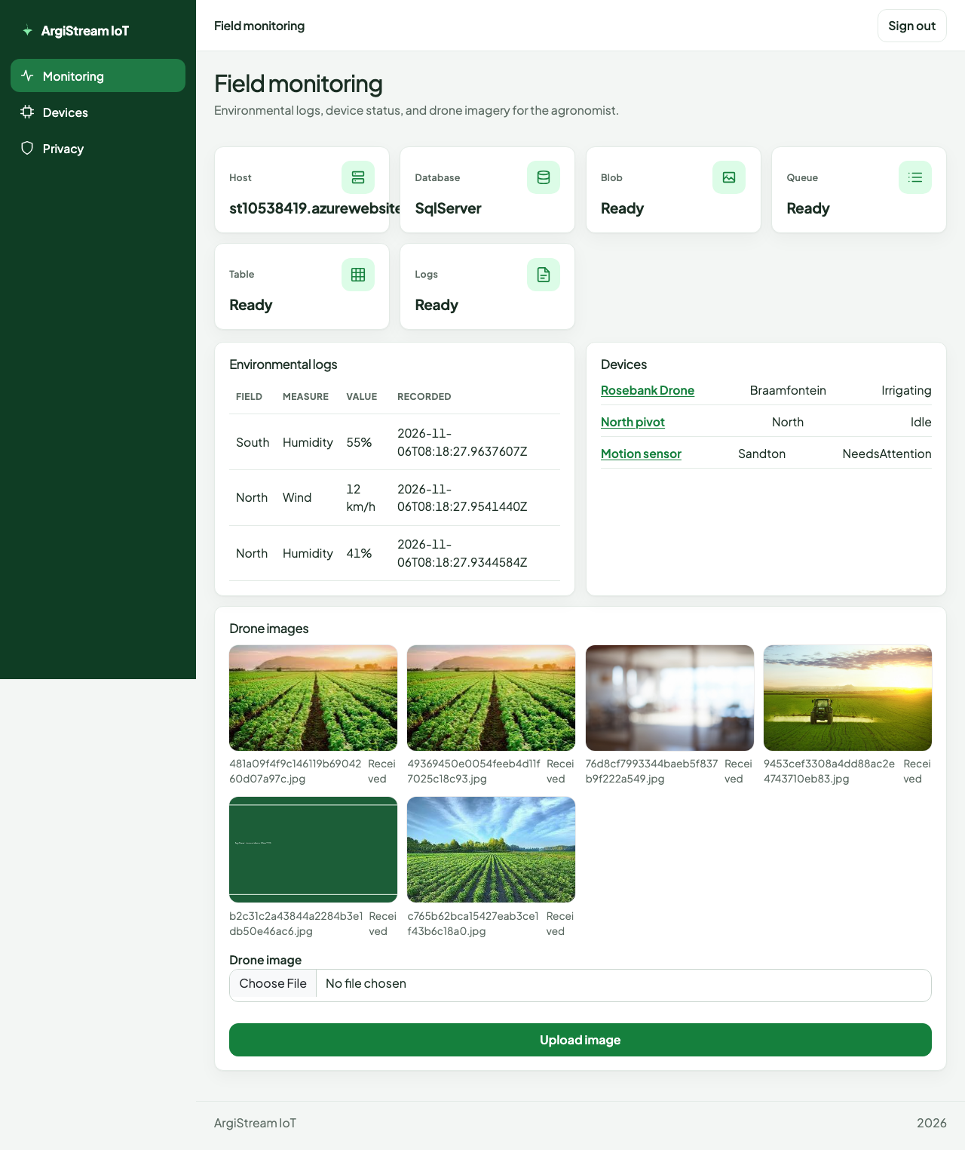
Figure 12. Agronomist monitoring. Environmental logs from table storage, device status from Azure SQL, and the drone gallery including the image just audited.
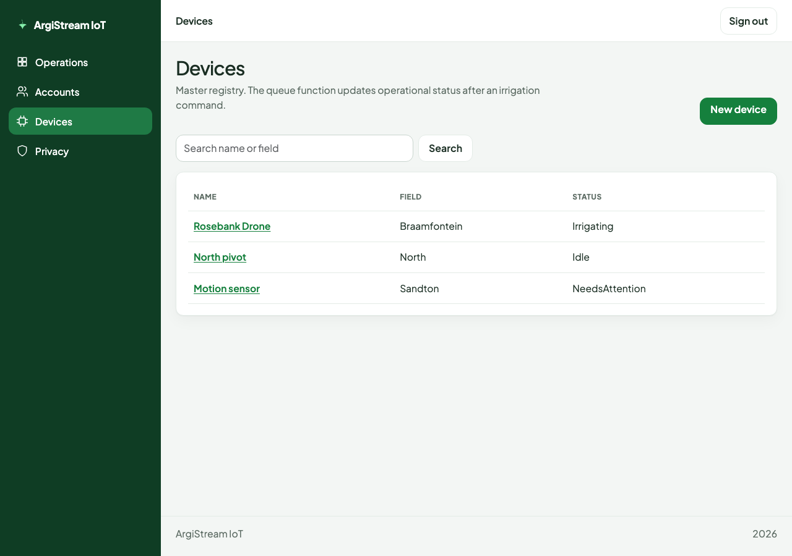
Figure 13. Device registry after the irrigation commands were accepted. North pivot was still Idle at this instant. See section 8.4.

10. Automated tests
The test project does not call Azure. That is deliberate. Service rules are checked with in-memory fakes, and one persistence test uses SQLite so the SQL mapping can be proved without the student database. dotnet test on 6 November 2026 reported 17 passed, 0 failed.
- UserAccountServiceTests. Blank username, short password, unknown role, and duplicate username are rejected. The seeded password verifies, and a wrong password does not. This is the rule behind the Azure SQL accounts.
- DeviceServiceTests. Blank name and an unknown status are rejected. Set status updates a device and fails when the device is missing. This is the rule ProcessIrrigationFunction uses when it writes the SQL registry.
- IrrigationIntakeTests. An unknown command writes nothing. A valid irrigate writes the table row as Pending before the queue message. A sensor alert ends as NeedsAttention and the table row becomes Processed.
- FarmPersistenceTests. SQLite round-trip for a user account and for a device search.
- StorageRegistrationTests. Empty connection strings register the unconfigured stores. A blob connection string registers the Azure blob store. Production without storage throws, which is why the live hosting card cannot show Off.
Passed UserAccountServiceTests 5
Passed DeviceServiceTests 4
Passed IrrigationIntakeTests 3
Passed FarmPersistenceTests 2
Passed StorageRegistrationTests 3
Total 17 passed, 0 failed

11. Load test, monitoring, and autoscale

How the load was generated
scripts/load-test.sh sends 20 concurrent workers. Each worker requests /health and /Account/Login, then the wave repeats until 720 seconds have elapsed. Azure autoscale evaluates CPU over about five minutes, so a short burst does not move the instance count. The script was run on 6 November 2026 against https://st10538419.azurewebsites.net.
The script's own tally was 20,520 requests, 20,518 successes, and 2 failures. Both failures were connection timeouts. Azure Monitor on the web app shows the same burst: requests climb from a handful per minute to between about 1,200 and 2,000 per minute from 08:32 to 08:44 UTC, about 20,500 requests in that window. One HTTP 5xx was counted, at 08:32. Average response time during the burst stayed under one second.

What Azure Monitor recorded
The chart below is drawn from Azure Monitor metric queries run on 6 November 2026. The bars are the web app Requests metric. The line is CpuPercentage on the App Service plan st10538419-plan. The dashed line is 20 percent, the threshold the scale-out rule used. At 08:33 UTC the plan CPU average was 80.5 percent, which is the peak the README records for the loaded minute. CPU was also high in the minutes just before the request burst. The request counts are what identify the load test itself.
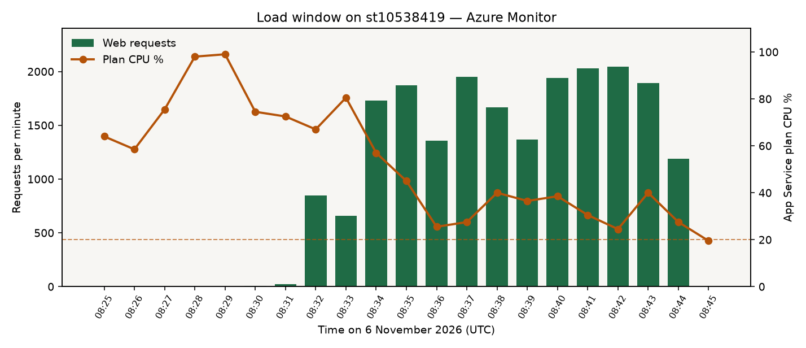
Figure 14. Azure Monitor during the load window. Requests per minute on the web app, CPU percent on the plan.
Application Insights component st10538419-insights is workspace-based (Log Analytics workspace log6sjsrtbxyqzvm, ingestion mode LogAnalytics). The operations page on the live site shows Logs Ready, which means the web app has the Application Insights connection string. Function executions cited in section 8 were read from this component.
Portal path for the same chart: App Service plan st10538419-plan, Metrics, metric CPU Percentage, and web app st10538419, metric Requests. Set the time range to 6 November 2026, 08:25 to 08:50 UTC. Application Insights, st10538419-insights, then Failures or Performance, same time range, shows the request trace. A live metrics blade opened later in the day will not show this burst, because the default range is the last hour.

Autoscale, and why the rule is not left on
The load ran while the plan was S1 with two workers. S1 can autoscale. The rule used during that run was minimum 1, maximum 2, scale out when CPU is above 20 percent. The site stayed up. Two of 20,520 requests timed out. That is the reliability result.
B1 cannot autoscale. Leaving a scale-out rule in place would put the more expensive plan back and spend the student credit. After the evidence was recorded, the rule was removed and the plan was returned to B1 with one worker. On 6 November 2026, az monitor autoscale list for this resource group returned no autoscale settings, and the plan SKU was B1 with capacity 1. The site is still online at the public URL, which is the point of that choice.
Portal path: App Service plan st10538419-plan, Scale out. It should show manual scale, one instance, and no autoscale rule. Scale up shows the B1 SKU.

12. How to repeat the check
- Portal: resource group rg-st10538419-cldv7112. Sign in with the student account that owns the Azure for Students subscription.
- Site: https://st10538419.azurewebsites.net. The sign-in page lists the farmer, agronomist, and admin tester accounts.
- Farmer, Field dashboard: this call is GetTelemetryFunction. Trigger irrigation calls PostIrrigationFunction. Upload image calls the blob trigger.
- Agronomist, Field monitoring: environmental logs and the drone gallery.
- Admin, Operations: the hosting card must show SqlServer, and Blob, Queue, Table, and Logs as Ready.
- Health: https://st10538419.azurewebsites.net/health
- Tests, from the repository: dotnet test ST10538419_CLDV7112_Practicium.slnx
- Load, only if the credit can afford it: ./scripts/load-test.sh https://st10538419.azurewebsites.net
Do not screenshot a connection string, an access key, or the SQL password. The hosting card, the resource list, the function executions, and the pages above are the evidence.

