MINISTRY OF EDUCATION OF THE REPUBLIC OF BELARUS

EDUCATIONAL INSTITUTION

«BREST STATE TECHNICAL UNIVERSITY»

Department of IIT

Laboratory work №2

For the first semester

Topic: «Familiarization with the environment of Visual Studio»

Completed by the 1st year student of

Faculty of Electronic Information Systems

the group AC-57f Chernookiy I.V.

Checked by Khatskevich M.V.

Brest 2019

**Laboratory work № 2**

**« Familiarization with the environment of Visual Studio »**

**Goal:** explore the visual Studio environment, understand the basic principles of the compiler and write a simple working program.

**Equipment:** Personal Computer

**Task**

1. Create a project

In order to create a project go to the program Visual Studio in the upper left corner:

File – Create – Project

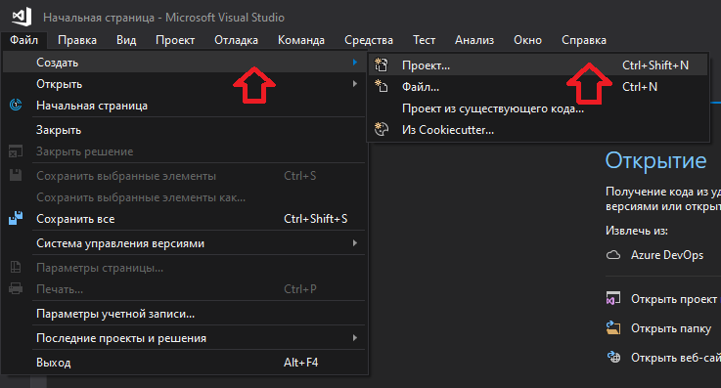

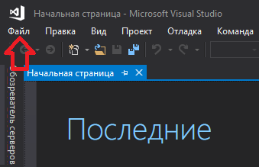

1. Сreating a graphical user interface

Having previously installed the necessary components, we choose: Visual C++ and Windows console application. Then set the place where our project will be saved and change the name if necessary.

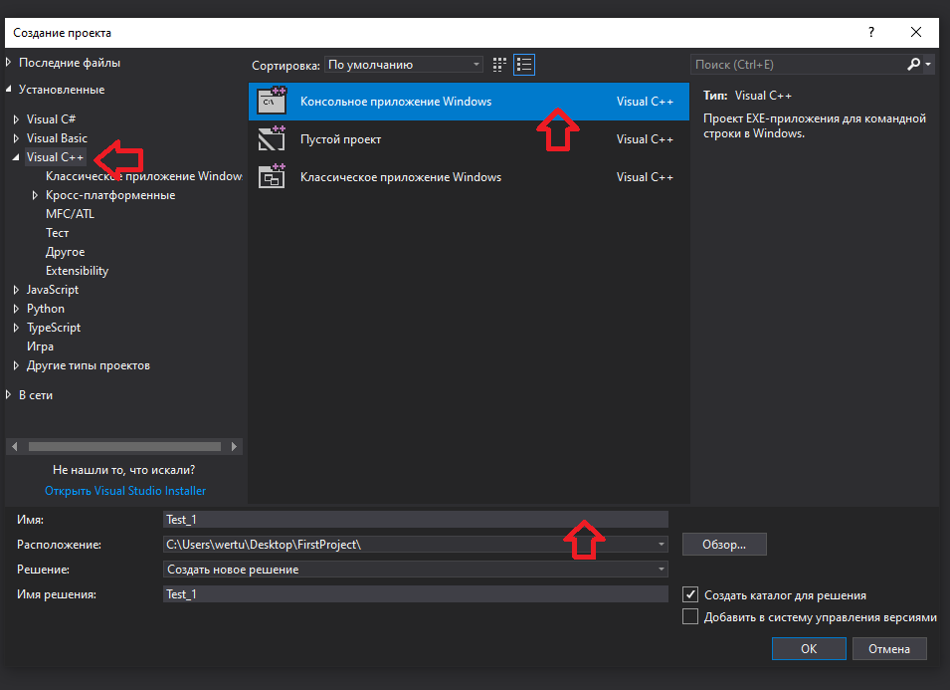

1. Сreating a C++ workspace

Right-click on the resource fowl and create a C++ file with the extension .cpp.

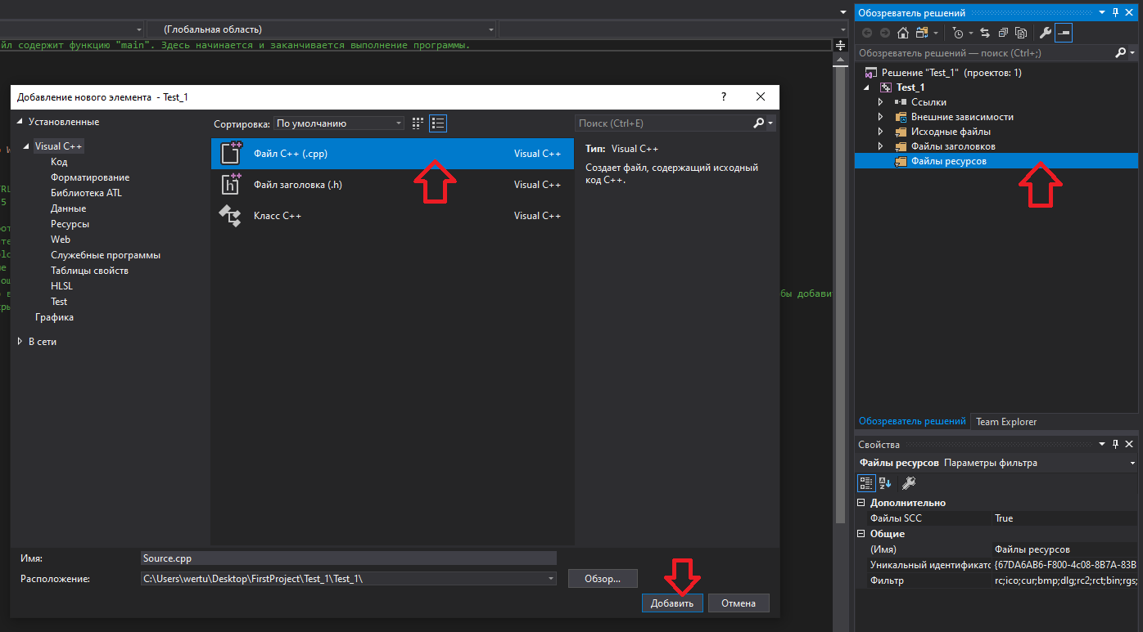

1. Let's write a simple program to check the operation of the program

Аfter debugging in debug and release mode, we got:

#include <iostream>

using namespace std;

int main()

{

cout << "I kill all Sunday oh this lab!" << endl;

system("pause");

return 0;

}

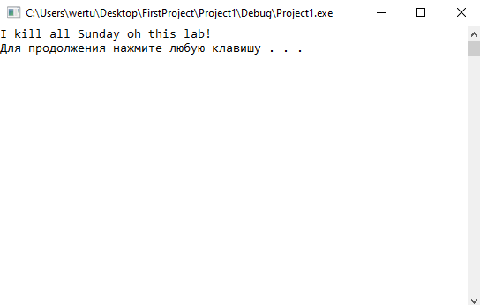

1. Сonfigurations Debug and Release

The main difference is in the purpose: Debug configuration is intended for compilation at the stage of development and debugging of the program, and Release - for building the program and its subsequent use by program users.

1. Compilation

Compilation (programming) -conversion by the compiler of the source code of a program written in a high-level language into a machine language, a language close to the machine, or an object module.

Types of compilation:

Batch. Compile multiple source modules in a single job.

Linewise. Machine code is generated and then executed for each completed grammatical construction of the language. Externally perceived as an interpretation, but the device has a different.

Conditional. Compilation, in which the translated text depends on the conditions specified in the source program by the compiler directives. (A striking example is the work of the C language preprocessor and its derivatives.) So, depending on the value of a certain constant, a certain specified part of the source code of the program is broadcast or not broadcast.

1. Breakpoint

Breakpoint is a deliberate interruption of program execution, in which the debugger is called (at the same time, the program itself can use breakpoints for its own needs). After going to the debugger, the programmer can examine the state of the program (logs, memory, processor registers, stack, etc.) to determine whether the program behaves correctly. Unlike a full stop, with a stop, after running in the debugger, the program can be terminated or continued from the same place where the stop occurred.

**Conclusion:** I acquainted with the basic principles of visual Studio. Also launched program in two kinds of compiler debug and release. Compilation - conversion by the compiler of the source code of a program written in a high-level language into a machine language, a language close to the machine, or an object module. Moreover got acquainted with the types of compilers.