MINISTRY OF EDUCATION OF THE REPUBLIC OF BELARUS

EDUCATIONAL INSTITUTION

«BREST STATE TECHNICAL UNIVERSITY»

Department of IIT

**Laboratory work №4**

**For the first semester**

**Topic: «Math functions in C»**

Completed by the 1st year student of

Faculty of Electronic Information Systems

the group AC-57f Chernookiy I.V.

Checked by Khatskevich M.V.

Brest 2019

**Laboratory work №4**

**«Math functions in C»**

**Goal:** To find out how math lib in C lang works. Then how to use them for solving difficult problems.

**1.** Please dial the code of the program. Compiling and running the program. The result of program execution write into report.

**#include** <stdio.h>

**#include** <conio.h>

**#include** <math.h>

**int** **main**()

{

**float** num = 9.25;

clrscr();

**printf**("Sqrt of %f : ", num);

**printf**("%f\n", **sqrt**(num));

**printf**("Ceil of %f : ", num);

**printf**("%f\n", **ceil**(num));

**printf**("Power of %f : ", num);

**printf**("%f\n", **pow**(num,num));

**return** 0;

**_getch**();

}

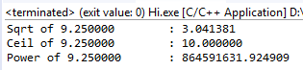

**2.** Please dial the code of the program. Compiling and running th

e program. The result of program execution write into report.

**#include** <stdio.h>

**#include** <conio.h>

**#include** <math.h>

**int** **main** ()

{

**float** a,b,c,p,s;

**printf**("\na="); **scanf_S**("%f",&a);

**printf**("\nb="); **scanf_S**("%f",&b);

**printf**("\nc="); **scanf_S**("%f",&c);

p=(a+b+c)/2;

s=**sqrt**(p*(p-a)*(p-b)*(p-c));

**printf**("\The area of a triangle=%.3f", s) ;

**_getch**();

**return** 0;

}

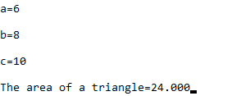

**3.** How to write this function in the C programming language ? Write a program that finds the result of this function. Compiling and running the program. The result of program execution write into report.

Var-7.

**#include** <stdio.h>

**#include** <conio.h>

**#include** <math.h>

**int** **main** ()

{

**float** d;

**int** x,y;

**printf**("Set x= "); **scanf_s**("%d", &x);

**printf**("Set y= "); **scanf_s**("%d", &y);

d= **pow**(x,3)+**sin**(**pow**(x,3)+**pow**(y,3))+**log**(y)/(**pow**(x,3)+1)\***pow**(**pow**(y,3),1/3)*1.5* **pow**(10,-5)

**printf**("\Result=%.11f", d)

**_getch**();

**return** 0;

}

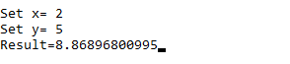

**Conclusion:** familiarized with the basic functions of the library <math.h> and write a simple program that solve equation that consist of many functions.

