MINISTRY OF EDUCATION OF THE REPUBLIC OF BELARUS

EDUCATIONAL INSTITUTION

«BREST STATE TECHNICAL UNIVERSITY»

Department of IIT

**Laboratory work №9**

**For the second semester**

**Topic: «Characters and Strings»**

Completed by the 1st year student of

Faculty of Electronic Information Systems

the group AC-57f Chernookiy I.V.

Checked by Khatskevich M.V.

Brest 2019

**Laboratory work №9**

**Topic: «Characters and Strings»**

**Goal:** to learn main operations with strings and characters.

**Task 1.**

#include <iostream>

#include <cctype>

using namespace std;

int main()

{

char input;

cout << "Please Enter Any Character:" << endl;

cin >> input;

cout << "The character entered is " << input << endl << endl;

cout << "The ASCII code for " << input << " is " << int(input) << endl;

if (isalpha(input))

{

cout << "The character is a letter" << endl;

if (islower(input))

cout << "The letter is lower case" << endl;

if (isupper(input))

cout << "The letter is upper case" << endl;

}

else if (isdigit(input))

cout << "The character you entered is a digit" << endl;

else

cout << "The character entered is not a letter nor a digit"

<< endl;

return 0;

}

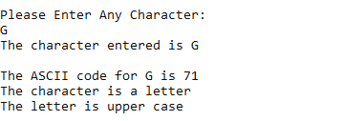

**Task 2.**

#include <iostream>

#include <cstring>

using namespace std;

int main()

{

int week, total, dollars;

float average;

char choice;

cout << showpoint << fixed << setprecision(2);

do

{

total = 0;

for (week = 1; week <= 4; week++)

{

cout << "How much (to the nearest dollar) did you"

<< " spend on food during week " << week << " ?:" << endl;

cin >> dollars;

total = total + dollars;

}

average = total / 4.0;

cout << "Your weekly food bill over the chosen month is $"

<< average << endl << endl;

do

{

cout << "Would you like to find the average for " << "another month?";

cout << endl << "Enter Y or N" << endl;

cin >> choice;

} while (toupper(choice) != 'Y' && toupper(choice) != 'N');

} while (toupper(choice) == 'Y');

return 0;

}

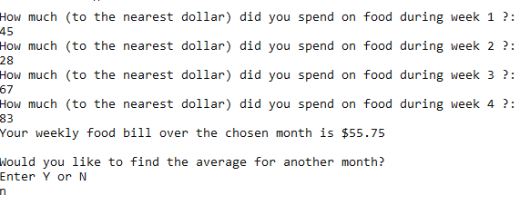

**Task 3.**

#include <iostream>

#include <cstring>

using namespace std;

int main()

{

char line[50];

int length, count = 0;

cout << "Enter a sentence of no more than 49 characters:\n";

cin.getline(line, 50);

length = strlen(line);

cout << "The sentence entered read backwards is:\n";

for (count = length - 1; count >= 0; count--)

{

cout << line[count];

}

cout << endl;

return 0;

}

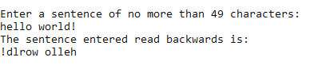

**Task 4.**#include <iostream>

#include <string>

using namespace std;

int main()

{

string text;

cout << "Input string:\n";

getline(cin, text, '\n');

int i = 0;

int strl = text.length();

for (int k = 0; k < strl; k++)

if (text[k] == ' ')

i++;

cout << "Amount of whitespaces - " << i;

getchar();

return 0;

}

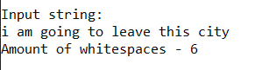

**Conclusion:** understand the main principles of working with string and characters.

