MINISTRY OF EDUCATION OF THE REPUBLIC OF BELARUS

EDUCATIONAL INSTITUTION

«BREST STATE TECHNICAL UNIVERSITY»

Department of IIT

Laboratory work №1

For the first semester

Topic: « A categorized list of Windows CMD commands»

Completed by the 1st year student of

Faculty of Electronic Information Systems

the group AC-57f Chernookiy I.V.

Checked by Khatskevich M.V.

Brest 2019

**Laboratory work № 1**

**«A categorized list of Windows CMD commands»**

**Goal:** So we are going to learn how to use Command-line interface, namely, cmd in Windows. This lesson will help us to understand how text user interface work, and how can it speed up such processes as renaming or making any types of files.

**Equipment:** Personal Computer

**Task**

1. 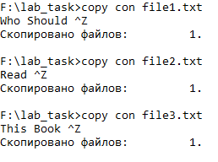Copy from the console (accept user input)
   1. create a file R:\file1.txt
   2. Enter the text in the file: Who Should
   3. Close the file.
   4. create a file R:\file2.txt
   5. Enter the text in the file:Read
   6. Close the file.
   7. create a file R:\file3.txt
   8. Enter the text in the file:This Book
   9. Close the file.
2. Make Directory TASK1

C:\Users\wertu\OneDrive\Изображения\Screenshots\Снимок экрана (3).png

1. Copy (file1.txt, file2.txt, file3.txt) to TASK1\

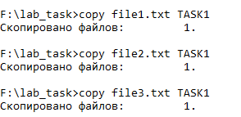

1. Make several folders (TASK2, TASK3, TASK4) with one command

C:\Users\wertu\OneDrive\Изображения\Screenshots\4.png

1. Copy from a different folder/directory (TASK1\file1.txt copy to folder TASK2\)

C:\Users\wertu\OneDrive\Изображения\Screenshots\5.png

1. Copy all the files into the current directory R:\TASK1\ to the directory R:\TASK3\) with one command. Displays directory of files and directories stored on disk

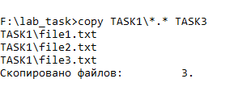

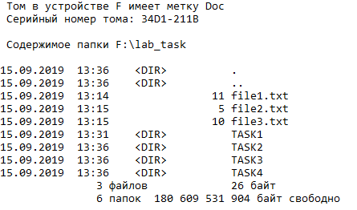

1. Combine files (file1.txt, file2.txt, file3.txt) in file4.txt

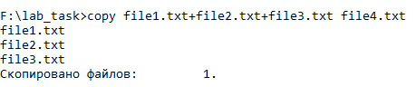

1. Display the contents of a text file (R:\file4.txt)

C:\Users\wertu\OneDrive\Изображения\Screenshots\9.png

1. Copy R:\file4.txt to R:\TASK1\file5.txt

C:\Users\wertu\OneDrive\Изображения\Screenshots\10.png

1. Compare two files (R:\file4.txt and R:\TASK1\file5.txt)

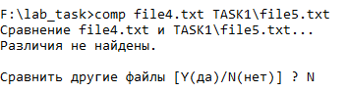

1. Search for "Book" in R:\file4.txt Displays directory of files and directories stored on disk

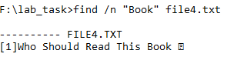

1. Search for "My" OR "Book" in the files R:\file1.txt or R:\file4.txt

C:\Users\wertu\OneDrive\Изображения\Screenshots\12.png

1. Move all files from one folder (R:\TASK1) to another (R:\TASK4)

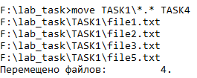

1. Rename R:\TASK4\file1.txt as R:\TASK4\MyFile1.txt

C:\Users\wertu\OneDrive\Изображения\Screenshots\14.png

1. Graphical display of folder structure (C:\)

C:\Users\wertu\OneDrive\Изображения\Screenshots\15.png

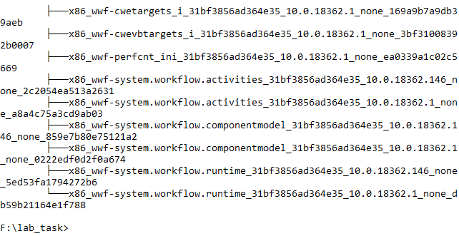

1. Output file (R:\file1.txt) into a new file (R:\file5.txt)

C:\Users\wertu\OneDrive\Изображения\Screenshots\16.png

1. Display a search path for executable files (C:\)

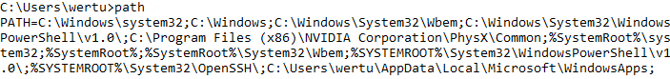

1. Display the current Date and Time

C:\Users\wertu\OneDrive\Изображения\Screenshots\18.png

C:\Users\wertu\OneDrive\Изображения\Screenshots\18(1).png

1. Display or set the date

C:\Users\wertu\OneDrive\Изображения\Screenshots\19.png

1. Display Online Help

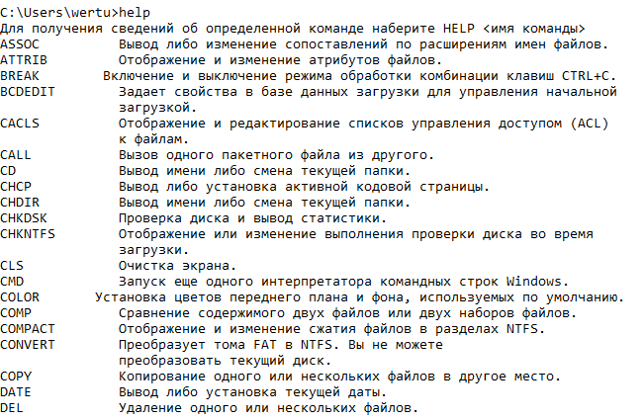

1. Display version information

C:\Users\wertu\OneDrive\Изображения\Screenshots\21.png

1. Display the current UserName and domain

C:\Users\wertu\OneDrive\Изображения\Screenshots\Снимок экрана (31).png

1. Display a disk label

C:\Users\wertu\OneDrive\Изображения\Screenshots\23.png

1. Delete all files
   1. Delete R:\file5.txt

C:\Users\wertu\OneDrive\Изображения\Screenshots\24.png

* 1. create a files R:\fileAB.txt, R:\fileAAB.txt , R:\fileAaAb.txt

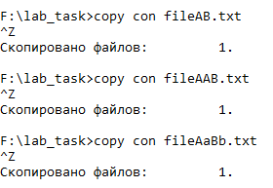

* 1. create a files R:\afileA.txt, R:\AAfileAA.txt , R:\aAAfileAaA.txt

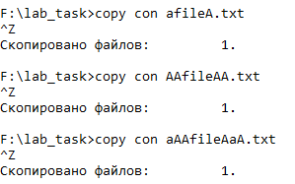

* 1. Delete all files that start with the letter a

C:\Users\wertu\OneDrive\Изображения\Screenshots\24(d).png

* 1. Delete all files that end with the letter B

C:\Users\wertu\OneDrive\Изображения\Screenshots\24(e).png

* 1. Delete all files with a .doc extension:

C:\Users\wertu\OneDrive\Изображения\Screenshots\24(f).png

1. Create a files R:\file11.txt, R:\file12.txt , R:\file12.txt

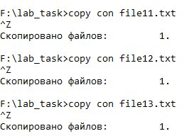

* 1. C:\Users\wertu\OneDrive\Изображения\Screenshots\25(a).pngRename R:\file11.txt as R:\file111.txt
  2. C:\Users\wertu\OneDrive\Изображения\Screenshots\25(b).pngChange the (final) extension of every file (R:\file11.txt, R:\file12.txt , R:\file12.txt) to *.doc

1. Removes a directory R:\TASK1.

C:\Users\wertu\OneDrive\Изображения\Screenshots\26.png

1. Сlear the Hidden and System attributes for the R:\file1.txt file

R Read-only (1)

H Hidden (2)

A Archive (32)

S System

C:\Users\wertu\OneDrive\Изображения\Screenshots\27.png

1. 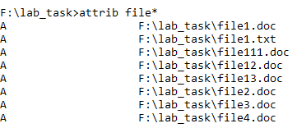Use wildcards (? and *) with the filename parameter to display or change the attributes for a group of files.
2. Display the attributes for a directory/folder.

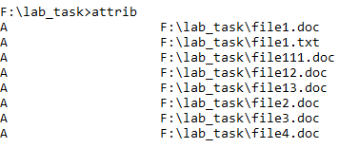

1. Change the attributes for a directory/folder.

C:\Users\wertu\OneDrive\Изображения\Screenshots\30.png

1. Change Directory
   1. C:\Users\wertu\OneDrive\Изображения\Screenshots\31(a).pngChange to the parent directory
   2. C:\Users\wertu\OneDrive\Изображения\Screenshots\31(b).pngChange to the ROOT directory
   3. C:\Users\wertu\OneDrive\Изображения\Screenshots\31(c).pngDisplay the current directory in the specified drive

**Conclusion:** I got acquainted with such text interface as command line (cmd). I studied the basic commands and learned how to apply them in practice. Nowadays not every user knows what the command line is and how to use it. However, cmd can greatly simplify and speed up the work with some elements of the system.