MINISTRY OF EDUCATION OF THE REPUBLIC OF BELARUS

EDUCATIONAL INSTITUTION

«BREST STATE TECHNICAL UNIVERSITY»

Department of IIT

**Laboratory work №11**

**For the second semester**

**Topic: «Pointers»**

Completed by the 1st year student of

Faculty of Electronic Information Systems

the group AC-57f Chernookiy I.V.

Checked by Khatskevich M.V.

Brest 2019

**Laboratory work №11**

**Topic: «Pointers»**

**Goal:** To learn the main properties of the pointers.

**Task 1.**

#include <iostream>

using namespace std;

int **main**()

{

int length;

int width;

int area;

int *lengthPtr;

int *widthPtr;

cout << "Please input the length of the rectangle" << endl;

cin >> length;

cout << "Please input the width of the rectangle" << endl;

cin >> width;

lengthPtr = &length;

widthPtr = &width;

area = *lengthPtr * *widthPtr;

cout << "The area is " << area << endl;

if (*lengthPtr > *widthPtr)

cout << "The length is greater than the width" << endl;

else if (*lengthPtr < *widthPtr)

cout << "The width is greater than the length" << endl;

else

cout << "The width and length are the same" << endl;

return 0;

}

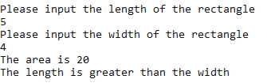

**Task 2.**

#include <iostream>

using namespace std;

const int MAXNAME = 10;

int **main**()

{

int pos;

char * name;

int * one;

int * two;

int * three;

int result;

one = new int;

two = new int;

three = new int;

name = new char;

cout << "Enter your last name with exactly 10 characters." << endl;

cout << "If your name has < 10 characters, repeat last letter. " << endl

<< "Blanks at the end do not count." << endl;

for (pos = 0; pos < MAXNAME; pos++)

cin >> *(name+pos);

cout << "Hi ";

for (pos = 0; pos < MAXNAME; pos++)

cout << *(name+pos);

cout << endl << "Enter three integer numbers separated by blanks" << endl;

cin >> *one >> *two >> *three ;

cout << " The three numbers are ";

cout << *one << " "<< *two << " " << *three << endl;

result = *one + *two + *three;

cout << "The sum of the three values is " << result << endl;

delete one;

delete two;

delete three;// Fill in code to deallocate one, two, three and name

return 0;

**}**

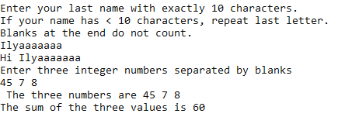

**Task 3.**

#include <iostream>

#include <iomanip>

using namespace std;

int **main**()

{

float *monthSales;

float total = 0;

float average;

int numOfSales;

int count;

cout << "How many monthly sales will be processed? ";

cin >> numOfSales;

monthSales = new float[numOfSales];

if (monthSales==nullptr)

{

cout << "Error allocating memory!\n";

return 1;

}

cout << "Enter the sales below\n";

for (count = 0; count < numOfSales; count++)

{

cout << "Sales for Month number "<< count+1 << ":";

cin >> monthSales[count];

}

for (count = 0; count < numOfSales; count++)

{

total = total + monthSales[count];

}

average = total / numOfSales;

cout << "Average Monthly sale is $" << average << endl;

delete[] monthSales;

return 0;

}

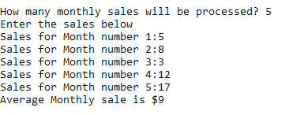

**Task 4.**

#include <iostream>

int **main**()

{

int size;

int idnum;

std::cout << "Size of array: ";

std::cin >> size;

int *array = new int[size-1];

for (int counter = 0; counter < size; counter++)

{

std::cout << std::endl << "Array element:" << counter+1 << " is ";

std::cin >> array[counter];

}

std::cout << std::endl << "Enter your id ";

std::cin >> idnum;

int found = 0;

for (int counter = 0; counter < size; counter++)

{

if (idnum == array[counter])

{

found = 1;

break;

}

}

if (found)

std::cout << "Your id is in the list. Welcome" << std::endl;

else

std::cout << "Your id is not in the list" << std::endl;

return 0;

}

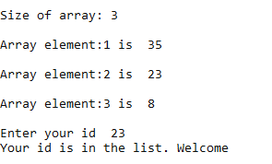

**Conclusion:** learn the basicprinciples of pointers and learn how to use them is practice.

