MINISTRY OF EDUCATION OF THE REPUBLIC OF BELARUS

EDUCATIONAL INSTITUTION

«BREST STATE TECHNICAL UNIVERSITY»

Department of IIT

**Laboratory work №12**

**For the second semester**

**Topic: «Structures»**

Completed by the 1st year student of

Faculty of Electronic Information Systems

the group AC-57f Chernookiy I.V.

Checked by Khatskevich M.V.

Brest 2019

**Laboratory work №12**

**Topic: «Structures»**

**Goal:** To learn the main properties of the structures and try to use them in practice.

**Task 1.**

#include <iostream>

#include <iomanip>

using namespace std;

struct rectangle

{

float length;

float width;

float area;

float perimeter;

};

int main()

{

rectangle box;

cout << "Enter the length of a rectangle: ";

cin >> box.length;

cout << "Enter the width of a rectangle: ";

cin >> box.width;

cout << endl << endl;

box.area = box.length * box.width;

box.perimeter = 2 * (box.length + box.width);

cout << fixed << showpoint << setprecision(2);

cout << " Area: " << box.area << endl;

cout << " Perimeter: " << box.perimeter << endl;

return 0;

}

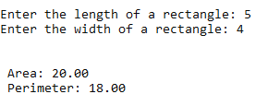

**Task 2.**

#include <iostream>

#include <iomanip>

#include <string.h>

using namespace std;

struct taxPayer

{

long socialSecNum;

char name[25];

float taxRate;

float income;

float taxes;

};

int main()

{

taxPayer citizen1;

strcpy_s(citizen1.name, "Tim McGuiness");

citizen1.socialSecNum = 255871234;

citizen1.taxRate = 0.35;

taxPayer citizen2;

strcpy_s(citizen2.name, "John Kane");

citizen2.socialSecNum = 278990582;

citizen2.taxRate = 0.29;

cout << fixed << showpoint << setprecision(2);

cout << "Please input the yearly income for Tim McGuiness: ";

cin >> citizen1.income;

citizen1.taxes = citizen1.income * citizen1.taxRate;

cout << endl << "Name: " << citizen1.name << endl;

cout << "Social Security Number: " << citizen1.socialSecNum << endl;

cout << "Taxes due for this year: $" << citizen1.taxes << endl << endl;

cout << "Please input the yearly income for John Kane: ";

cin >> citizen2.income;

citizen2.taxes = citizen2.income * citizen2.taxRate;

cout << endl << "Name: " << citizen2.name << endl;

cout << "Social Security Number: " << citizen2.socialSecNum << endl;

cout << "Taxes due for this year: $" << citizen2.taxes << endl << endl;

return 0;

}

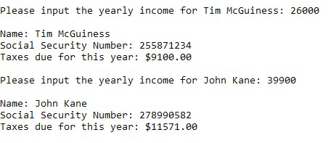

**Task 3.**

#include <iostream>

#include <iomanip>

using namespace std;

struct taxPayer

{

float taxRate;

float income;

float taxes;

};

int main()

{

taxPayer citizens[5];

cout << fixed << showpoint << setprecision(2);

cout << "Please enter the annual income and tax rate for 5 tax payers: ";

cout << endl << endl << endl;

for (int count = 0; count < 5; count++)

{

cout << "Enter this year's income for tax payer " << (count + 1);

cout << ": ";

cin >> citizens[count].income;

cout << "Enter the tax rate for tax payer " << (count + 1);

cout << ": ";

cin >> citizens[count].taxRate;

citizens[count].taxes = citizens[count].taxRate * citizens[count].income;

cout << endl;

}

cout << "Taxes due for this year: " << endl << endl;

for (int index = 0; index < 5; index++)

{

cout << "Tax Payer " << (index + 1) << ": " << "$ "

<< citizens[index].taxes << endl;

}

return 0;

}

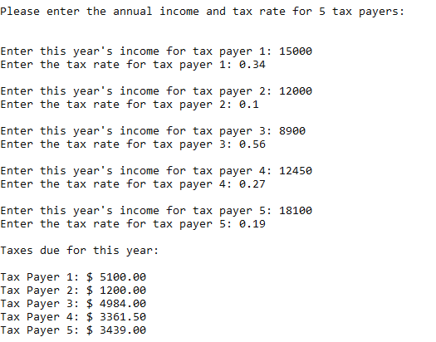

**Task 4.**

#include <iostream>

#include <iomanip>

using namespace std;

struct dimensions

{

float length;

float width;

};

struct rectangle

{

float area;

float perimeter;

dimensions sizes;

};

int main()

{

rectangle box;

cout << "Enter the length of a rectangle: ";

cin >> box.sizes.length;

cout << "Enter the width of a rectangle: ";

cin >> box.sizes.width;

cout << endl << endl;

box.area = box.sizes.length * box.sizes.width;

box.perimeter = 2 * (box.sizes.length + box.sizes.width);

std::cout << "The area of the rectangle is " << box.area << endl;

std::cout << "The perimeter of the rectangle is " << box.perimeter

<< endl;

return 0;

}

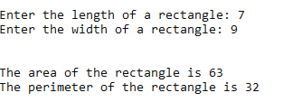

**Task 5.**

#include <iostream>

#include <iomanip>

struct MonthReport

{

int totalArrived;

int totalDeparted;

int greatestNumber;

int leastNumber;

};

int main()

{

std::cout << "Write info as needed, watch your screen :" << std::endl;

MonthReport airport[12];

for (int counter = 1; counter <= 12; counter++)

{

std::cout << "Total arrived in " << counter << " month: ";

std::cin >> airport[counter].totalArrived;

std::cout << "Total departed in " << counter << " month: ";

std::cin >> airport[counter].totalDeparted;

std::cout << "Greatest number of planes in one day in " << counter << " month: ";

std::cin >> airport[counter].greatestNumber;

std::cout << "Least number of planes in one day in " << counter << " month: ";

std::cin >> airport[counter].leastNumber;

std::cout << std::endl;

}

int anuallyArrived = 0, anuallyDeparted = 0, greatestNumber, greatestMonth, leastNumber, leastMonth;

greatestNumber = airport[1].totalArrived + airport[1].totalDeparted;

greatestMonth = 1;

leastNumber = airport[1].totalArrived + airport[1].totalDeparted;

leastMonth = 1;

for (int counter = 1; counter <= 12; counter++)

{

anuallyArrived += airport[counter].totalArrived;

anuallyDeparted += airport[counter].totalDeparted;

if ((airport[counter].greatestNumber) > greatestNumber)

{

greatestNumber = airport[counter].greatestNumber;

greatestMonth = counter;

}

if ((airport[counter].leastNumber) < leastNumber)

{

leastNumber = airport[counter].leastNumber;

leastMonth = counter;

}

}

std::cout << "Greatest number of planes is: " << greatestNumber << " in " << greatestMonth << " month" << std::endl;

std::cout << "Least number of planes is: " << leastNumber << " in " << leastMonth << " month" << std::endl;

std::cout << std::fixed << std::showpoint << std::setprecision(2);

std::cout << "Total planes arrived: " << anuallyArrived << ". Total planes departed: " << anuallyDeparted << "." << std::endl;

std::cout << "Average planes arrived per month: " << anuallyArrived / 12 << ". Average planes departed per month: " << anuallyDeparted / 12 << "." << std::endl;

}

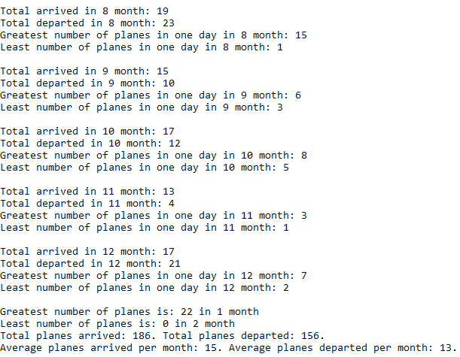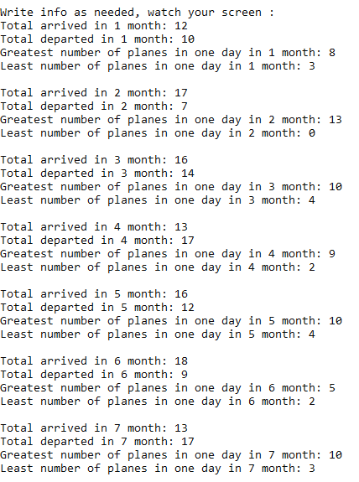

**Conclusion:** learn how to work with structures.