MINISTRY OF EDUCATION OF THE REPUBLIC OF BELARUS

EDUCATIONAL INSTITUTION

«BREST STATE TECHNICAL UNIVERSITY»

Department of IIT

**Laboratory work №13**

**For the second semester**

**Topic: «Files»**

Completed by the 1st year student of

Faculty of Electronic Information Systems

the group AC-57f Chernookiy I.V.

Checked by Khatskevich M.V.

Brest 2019

**Laboratory work №13**

**Topic: «Files»**

**Goal:** To learn the main properties of the files.

**Task 1.**

#include <stdio.h>

int **main**()

{

FILE *fp;

fp = fopen("С:\1.txt", "wt");

fprintf(fp, "This is testing for fprintf...\n");

fputs("This is testing for fputs...\n", fp);

fclose(fp);

}

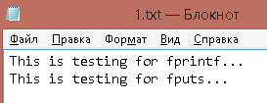

**Task 2**.

#include <stdio.h>

int **main**()

{

FILE *fp;

char buff[100];

fp = fopen("C:\\1.txt", "r");

fscanf(fp, "%s", buff);

printf("1 : %s\n", buff );

fgets(buff, 255, (FILE*)fp);

printf("2: %s\n", buff );

fgets(buff, 255, (FILE*)fp);

printf("3: %s\n", buff );

fclose(fp);

}

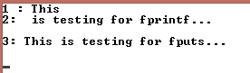

**Task 3.**

#include <stdio.h>

#include <string.h>

typedef struct student

{

char name[20];

int k;

}

student;

void vvod (FILE *fp,student list[], int size);

void output (FILE *fp,student list[], int size);

int main()

{

FILE *fp;

student list[10];

fp = fopen("F:\\1.txt", "wt");

vvod(fp,list,10);

fclose(fp); }

void vvod (FILE *fp,student list[], int size)

{

int i;

for (i=0;i<size;i++)

{

printf("\nN:");

scanf("%d",&list[i].k);

fflush(stdin);

printf("Name:");

gets(list[i].name);

fprintf(fp, "%d\n",list[i].k);

fprintf(fp, "%s\n",list[i].name);

}

}

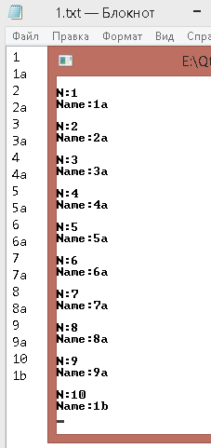

**Task 4.**

#include <stdio.h>

#include <string.h>

typedef struct student {

char name[20];

int k;

}student;

void vvod (FILE *fp,student list[], int size);

void output (FILE *fp);

int main()

{

int i;

FILE *fp;

student list[10];

fp = fopen("F:\\1.txt", "wt");

vvod(fp,list,10);

fclose(fp);

fp = fopen("F:\\1.txt", "r");

output(fp);

fclose(fp);

}

void vvod (FILE *fp,student list[], int size)

{

int i;

for (i=0;i<size;i++)

{

printf("\nN:");

scanf("%d",&list[i].k);

fflush(stdin);

printf("Name:");

gets(list[i].name);

fprintf(fp, "%d\n",list[i].k);

fprintf(fp, "%s\n",list[i].name);

}

}

void output (FILE *fp)

{

int i=1;

student list[10];

printf("\n=============================\n");

while (!feof(fp))

{

fscanf(fp, "%d",&list[i].k);

printf("N:%d\t",list[i].k);

fscanf(fp, "%s", list[i].name);

printf("Name:%s\n",list[i].name);

}

}

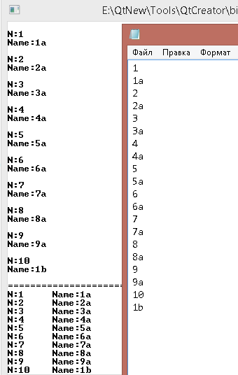

**Task 5.**

#include <string.h>

#include <iostream>

int main()

{

int min;

int array[8];

for (int counter = 0; counter < 8; counter++)

{

std::cout << "Input " << counter+1 << " element in the array: ";

std::cin >> array[counter];

}

min = array[0];

for (int counter = 0; counter < 8; counter++)

{

if (array[counter]<min) min = array[counter];

}

FILE *myfile;

myfile = fopen("F:\\file.txt", "wt");

fprintf(myfile, "%d", min);

fclose(myfile);

}

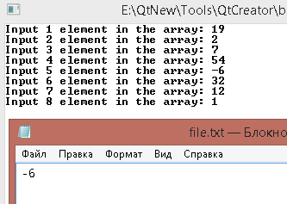

**Task 6.**

#include <iostream>

#include <fstream>

#include <string.h>

int main()

{

std::string name = "Time is a great teacher but unfortunately it kills all its pupils";

std::ofstream myfile("F:\\file.txt");

myfile << name;

myfile.close();

}

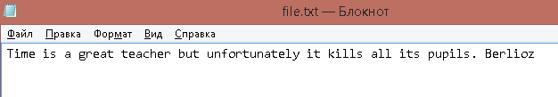

**Conclusion:** I learned how to implement file-input\output.