MINISTRY OF EDUCATION OF THE REPUBLIC OF BELARUS

EDUCATIONAL INSTITUTION

«BREST STATE TECHNICAL UNIVERSITY»

Department of IIT

**Laboratory work №5**

**For the first semester**

**Topic: «Conditional Statements»**

Completed by the 1st year student of

Faculty of Electronic Information Systems

the group AC-57f Chernookiy I.V.

Checked by Khatskevich M.V.

Brest 2019

**Laboratory work №5**

**«Conditional Statements»**

**Goal:** Our main goal in this work is to learn how conditional statements **if** or **switch {case…}** are working.

**Task 1.**

#include <stdio.h>

#include <stdlib.h>

int main( )

{

int num1,

num2 = 5;

printf( "Please enter an integer\n" );

scanf_s("%d", &num1);

printf("num1 = %d and num2 = %d ",num1,num2);

if (num1==num2)

printf("Hey, that's a coincidence!\n");

if (num1 != num2)

printf("The values are not the same\n");

system("PAUSE");

return 0;

}

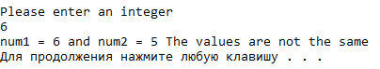

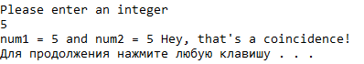

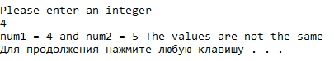

**Task 2.**

#include <stdio.h>

#include <stdlib.h>

int main()

{

float average;

printf( "Input your average:\n");

scanf_s("%f",&average);

if (average > =60)

printf("You Pass\n");

if (average < 60)

printf("You Fail\n");

system("PAUSE");

return 0;

}

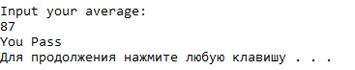

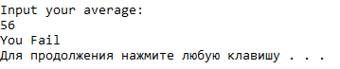

**Task 3.**

#include <stdio.h>

#include<stdlib.h>

int main()

{

char year;

float gpa;

printf("What year student are you ?\n");

printf("Enter 1 (freshman), 2 (sophomore), 3 (junior), or 4 (senior)\n");

scanf_s("%c",&year);

printf("Now enter your GPA\n");

scanf_s("%f",&gpa);

if (gpa >= 2.0 && year == '4')

printf("It is time to graduate soon\n");

else if (year != '4'|| gpa <2.0)

printf("You need more schooling\n");

system("PAUSE");

return 0;

}

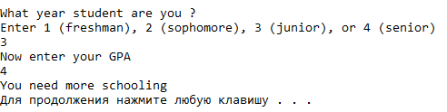

**Task 4.**

#include <stdio.h>

#include <stdlib.h>

int main()

{

char grade;

printf ("What grade did you earn in Programming I ?\n");

scanf_s("%c", &grade);

switch( grade )

{

case 'A': printf("an A - excellent work !\n");

break;

case 'B': printf("you got a B - good job\n");

break;

case 'C': printf("earning a C is satisfactory\n");

break;

case 'D': printf("while D is passing, there is a problem\n");

break;

case 'F': printf("you failed - better luck next time\n");

break;

default: printf("You did not enter an A, B, C, D, or F\n");

}

system ("PAUSE");

return 0;

}

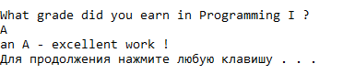

**Task 5.**

Write a program that prompts the user for the number of shirts required and then computes the total price. Make sure the program accepts only nonnegative input. (5-10 (10%), 11-20 (15%), 21-30 (20%), 31 or more (25%)).

#include <stdio.h>

#include <stdlib.h>

int main()

{

int quantity;

printf("How many shirts would you like ?\n");

scanf_s("%d", &quantity);

if (quantity >= 5 && quantity <= 10)

printf("\The cost per shirt is %.2f$ and the total cost is %.2f$\n", 12 * 0.9, quantity * 10.8);

else if (quantity >= 11 && quantity <= 20)

printf("\The cost per shirt is %.2f$ and the total cost is %.2f$\n", 12 * 0.85, quantity * 10.2);

else if (quantity >= 21 && quantity <= 30)

printf("\The cost per shirt is %.2f$ and the total cost is %.2f$\n", 12 * 0.8, quantity * 9.6);

else if (quantity >= 31)

printf("\The cost per shirt is %.2f$ and the total cost is %d$\n", 12 * 0.75, quantity * 9);

else if (quantity > 0 && quantity < 5 )

printf("\The cost per shirt is $12 and the total cost is %d$\n", quantity * 12);

else if (quantity == 0)

printf("\The cost per shirt is $12 and the total cost is %d$\n", quantity * 0);

else if (quantity <0)

printf("Invalid Input: Please enter a nonnegative integer\n");

system("PAUSE");

return 0;

}

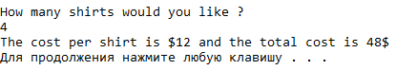

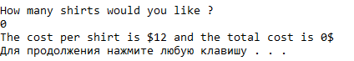

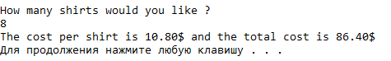

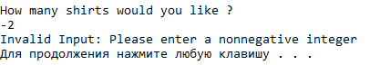

**Conclusion:** Conditional statements are required elements in programming languages. Learned to use if / else statement and the switch statement. Study logical operators and relational operators.