MINISTRY OF EDUCATION OF THE REPUBLIC OF BELARUS

EDUCATIONAL INSTITUTION

«BREST STATE TECHNICAL UNIVERSITY»

Department of IIT

**Laboratory work №6**

**For the first semester**

**Topic: «Looping Statements»**

Completed by the 1st year student of

Faculty of Electronic Information Systems

the group AC-57f Chernookiy I.V.

Checked by Khatskevich M.V.

Brest 2019

**Laboratory work №6**

**Topic: «Looping Statements»**

**Goal:** our main goal in this work is to learn how looping statements **for, while** or **do … while** are working.

**Task 1.**

#include <stdio.h>

#include<stdlib.h>

int main()

{

int num = 5;

int numFac = 1;

while (num > 0)

{

numFac = numFac * num;

num--;

}

printf(" 5! = %d\n ", numFac);

system("PAUSE");

return 0;

}

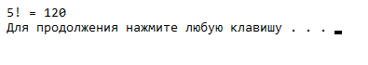

**Task 2.**

#include <stdio.h>

#include <stdlib.h>

const int NUMBEROFTESTS = 5;

int main()

{

int score; // the individual score read in

float total = 0.0; // the total of the scores

float average; // the average of the scores

int test = 1; // counter that controls the loop

while (test <= NUMBEROFTESTS) // Note that test is 1 the first time

// the expression is tested

{

printf("Enter your score on test : %d ", test);

scanf_s("%d", &score);

total = total + score;

test++;

}

average = total / NUMBEROFTESTS;

printf("Your average based on %d test scores is %f\n", NUMBEROFTESTS, average);

system("PAUSE");

return 0;

}

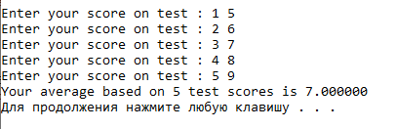

**Task 3.**

#include <stdio.h>

#include <stdlib.h>

int main()

{

int score; // the individual score read in

float total = 0.0; // the total of the scores

float average; // the average of the scores

int test = 1; // counter that controls the loop

printf("Enter your score on test %d (or -1 to exit):", test);

scanf_s("%d", &score); // Read the 1st score

while (score != -1) // While we have not entered the sentinel

// (ending) value, do the loop

{

total = total + score;

test++;

printf("Enter your score on test (or -1 to exit) %d : ", test);

scanf_s("%d", &score); // Read the next score

}

if (test > 1) // If test = 1, no scores were entered

{

average = total / (test - 1);

printf("Your average based on %d test scores is %f ", (test - 1), average);

}

system("PAUSE");

return 0;

}

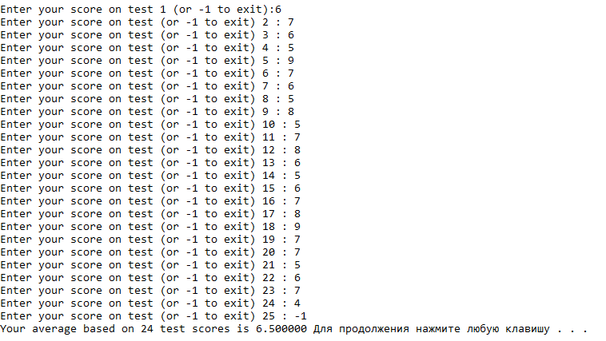

**Task 4.**

#include <stdio.h>

#include <stdlib.h>

int main()

{

int value;

int total = 0;

int number;

float mean;

printf("Please enter a positive integer\n");

scanf_s("%d", &value);

if (value > 0)

{

for (number = 1; number <= value; number++)

{

total = total + number;

} // curly braces are optional since

// there is only one statement

mean = (float)(total) / value;

printf("The mean average of the first %d positive integers is %f ", value, mean);

}

else

printf("Invalid input - integer must be positive");

system("PAUSE");

return 0;

}



**Task 5.**

#include <stdio.h>

#include <stdlib.h>

int main()

{

int numStudents;

float numHours, total, average;

int count1 = 0, count2 = 0; // these are the counters for the loops

printf("This program will find the average number of hours a day\n");

printf(" that each given student spent programming over a long weekend\n");

printf("How many students are there ?");

scanf_s("%d", &numStudents);

for (count1 = 1; count1 <= numStudents; count1++)

{

total = 0;

for (count2 = 1; count2 <= 3; count2++)

{

printf("Please enter the number of hours worked by student %d on day %d\t", count1, count2);

fflush(stdin);

scanf_s("%f", &numHours);

total = total + numHours;

}

average = total; /// 3;

printf("\n");

printf("The average number of hours per day spent programming student %d is %f\n", count1, average);

}

system("PAUSE");

return 0;

}

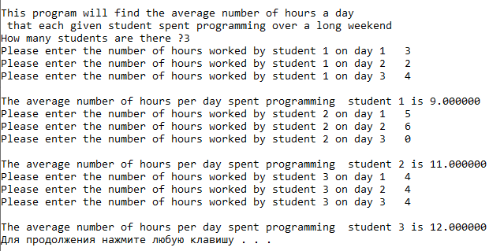

**Individual Tasks**

**Task 1.**

#include <stdio.h>

int main()

{

char letter = 'a';

while (letter != 'x')

{

printf("Please enter a letter: ");

scanf_s("%c", &letter);

printf("The letter you entered is: %c \n ", letter);

}

return 0;

}



**Task 2.**

#include <stdio.h>

#include <stdlib.h>

int main()

{

int month = 1;

float total = 0;

printf("Enter the total rainfall for month \n");

printf("Enter -1 when you are finished\n");

int rain;

scanf_s("%d", &rain);

while (rain != -1)

{

total = total + rain;

month++;

printf("Enter the total rainfall in inches for month %d\n", month);

printf("Enter -1 when you are finished\n");

scanf_s("%d", &rain);

}

if (month == 1)

printf("No data has been entered");

else

printf("The total rainfall for the %d months is %f ", month - 1, total);

system("PAUSE");

return 0;

}

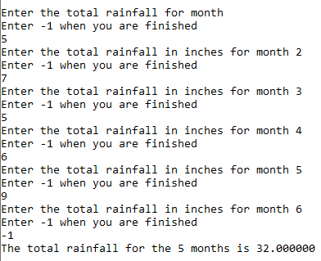

Task 3.

#include <stdio.h>

#include <stdlib.h>

#include <stdio.h>

int main()

{

int number;

float cost;

char beverage;

int validBeverage;

do

{

printf("Hot Beverage Menu\n\n");

printf("A: Coffee $1.00\n");

printf("B: Tea $ .75\n");

printf("C: Hot Chocolate $1.25\n");

printf("D: Cappuccino $2.50\n\n\n");

printf("Enter the beverage A,B,C, or D you desire\n");

printf("Enter E to exit the program\n\n");

scanf_s("%c", &beverage);

switch (beverage)

{

case 'a':

case 'A':

case 'b':

case 'B':

case 'c':

case 'C':

case 'd':

case 'D': validBeverage = true;

break;

default: validBeverage = false;

}

if (validBeverage == true)

{

printf("How many cups would you like?\n");

scanf_s("%d", &number);

}

switch(beverage)

{

case 'a':

case 'A':

cost = number * 1.0;

printf("The total cost is $ %f\n", cost);

break;

case 'c':

case 'C':

cost = number * 1.25;

printf("The total cost is $ %f\n", cost);

break;

case 'b':

case 'B':

cost = number * .75;

printf("The total cost is $ %f\n", cost);

break;

case 'd':

case 'D':

cost = number * 2.5;

printf("The total cost is $ %f\n", cost);

break;

case 'e':

case 'E': printf(" Please come again\n");

break;

default:

printf("You entered invalid latter, try again please\n");

}

} while (beverage == 'e' || beverage == 'E');

system("PAUSE");

return 0;

}

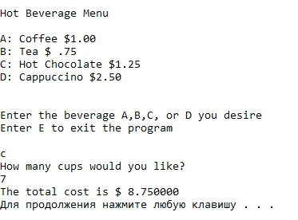

Task 4.

#include <stdio.h>

#include <stdlib.h>

int main()

{

int a, b;

int c = 0;

int k = 0;

float result;

printf("Please enter first number: ");

scanf_s("%d", &a);

printf("Please enter second number: ");

scanf_s("%d", &b);

for (; a <= b; a++) {

c += a;

k++;

}

result = c / k;

printf("result = %f\n", result);

system("PAUSE");

return 0;

}

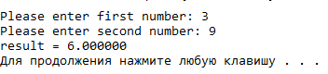

Task 5.

#include <stdio.h>

int main()

{

printf("Please input the time of fall in seconds:");

int time;

scanf_s("%d", &time);

printf("Please input the height of the bridge in meters:");

int height;

scanf_s("%d", &height);

printf("Time Falling (seconds) Distance Fallen (meters)\n");

float dist_fall;

for (int i = 1; i <= time; i++)

{

dist_fall = 0.5 * 9.8 * i * i;

printf("Current time: %d ; Distance traveled: %.02f \n", i, dist_fall);

}

if ((int)dist_fall > height)

{

printf("Warning-Bad Data: The distance fallen exceeds the height of the bridge");

}

return 0;

}

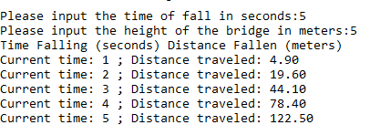

**Conclusion:** looping statements are required elements in programming languages.

