MINISTRY OF EDUCATION OF THE REPUBLIC OF BELARUS

EDUCATIONAL INSTITUTION

«BREST STATE TECHNICAL UNIVERSITY»

Department of IIT

**Laboratory work №3**

**For the third semester**

**Topic: «Python conditional statements and loop.**

**Python math»**

Completed by the 2st year student of

Faculty of Electronic Information Systems

the group AC-57f Chernookiy I.V.

Checked by Khatskevich M.V.

Brest 2020

**Laboratory work №3**

**Topic: «Python conditional statements and loop. Python math»**

**Variant 1**

**Goal:** to learn the main principles of Python statements and loop, and syntax of Python math.

**Task 1. (Python conditional statements and loop)**

nl=[]

for x in range(1500, 2701):

if (x%7==0) and (x%5==0):

nl.append(str(x))

print (','.join(nl))



result_str="";

for row in range(0,7):

for column in range(0,7):

if (column == 1 or (row == 6 and column != 0 and column < 6)):

result_str=result_str+"*"

else:

result_str=result_str+" "

result_str=result_str+"\n"

print(result_str);

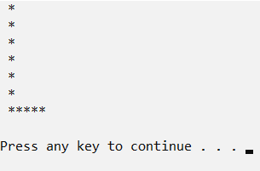

year = int(input("Input a year: "))

if (year % 400 == 0):

leap_year = True

elif (year % 100 == 0):

leap_year = False

elif (year % 4 == 0):

leap_year = True

else:

leap_year = False

month = int(input("Input a month [1-12]: "))

if month in (1, 3, 5, 7, 8, 10, 12):

month_length = 31

elif month == 2:

if leap_year:

month_length = 29

else:

month_length = 28

else:

month_length = 30

day = int(input("Input a day [1-31]: "))

if day < month_length:

day += 1

else:

day = 1

if month == 12:

month = 1

year += 1

else:

month += 1

print("The next date is [yyyy-mm-dd] %d-%d-%d." % (year, month, day))

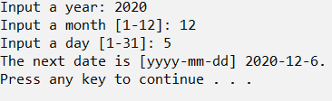

**Task 2. (Python math)**

pi=22/7

degree = float(input("Input degrees: "))

radian = degree*(pi/180)

print(radian)

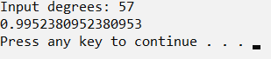

def sieve_of_Eratosthenes(num):

limitn = num+1

not_prime_num = set()

prime_nums = []

for i in range(2, limitn):

if i in not_prime_num:

continue

for f in range(i*2, limitn, i):

not_prime_num.add(f)

prime_nums.append(i)

return prime_nums

print(sieve_of_Eratosthenes(100));



import decimal

context = decimal.getcontext()

value = decimal.Decimal(1) / decimal.Decimal(17)

print("1/17 = ",value)

context.prec = 4

print("Precision: ",4)

context.rounding = getattr(decimal, 'ROUND_CEILING')

value = decimal.Decimal(1) / decimal.Decimal(17)

print("Round upwards towards infinity: ",value)

context.rounding = getattr(decimal, 'ROUND_FLOOR')

value = decimal.Decimal(1) / decimal.Decimal(17)

print("Round down towards negative infinity: ",value)

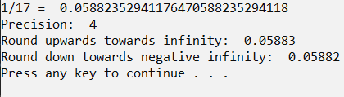

#https://gist.github.com/cartr/6513044

# Define the data

data = set()

count = int(input("Enter the number of data points: "))

for i in range(count):

x=float(input("X"+str(i+1)+": "))

y=float(input("Y"+str(i+1)+": "))

data.add((x,y))

# Find the average x and y

avgx = 0.0

avgy = 0.0

for i in data:

avgx += i[0]/len(data)

avgy += i[1]/len(data)

# Find the sums

totalxx = 0

totalxy = 0

for i in data:

totalxx += (i[0]-avgx)**2

totalxy += (i[0]-avgx)*(i[1]-avgy)

# Slope/intercept form

m = totalxy/totalxx

b = avgy-m*avgx

print("Best fit line:")

print("y = "+str(m)+"x + "+str(b))

x = float(input("Enter a value to calculate: "))

print("y = "+str(m*x+b))

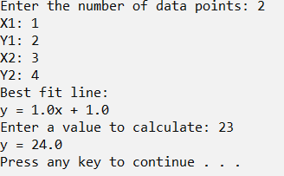

**Conclusion:** learn the Python statements and loop, and syntax of Python math, solve some problems that help us to represent the main principles of looping and using math statements.