Microsoft Word Essential
To create a new document in Word: Press the Office button in the top left corner of the
application -> Press New
To set the page orientation, margin and paper size: File -> Page Setup.
To save a document: Press the Save icon on the ribbon or Press the Office button
->Select Save->Provide a file name->Press Save
To automatically select all text: Press Select from the Home tab’s editing group.
To copy, cut or paste selected text or image: Press the Paste button from the Home
tab’s clipboard group.
To format the text (style, type, size, color etc): Press the Text object from the Home
tab’s font group.
To change the paragraph setting (single spacing, double spacing, centered text, justified
text): Press the paragraph object from the Home tab’s paragraph group.
Lesson 1: Basic Word
Objective: In this lesson, you would learn how to deal with:
a) Paragraphing
b) Numbering
c) Manipulating font
d) Header and Footer
e) Footnote
- Create a new file in MS Word. Save the file as 1.doc
- Open the Word Practice 1.doc file.
Type the following text : enter the text. Save the file.
- Highlight the title: Tips of Writing. Change the font to Arial, size 18. To do this, select Format -> Font. OR, you could change the font size and type from the task bar.
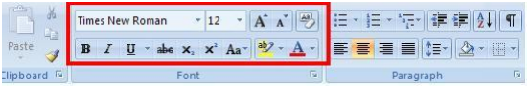
- Centralize your title. To do this, click the Center button on the tab’s paragraph group. Quick button:
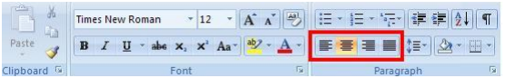
- Justified the body text. (Highlight the body text, click the Justify button).
- Bold the first sentence in each paragraph.
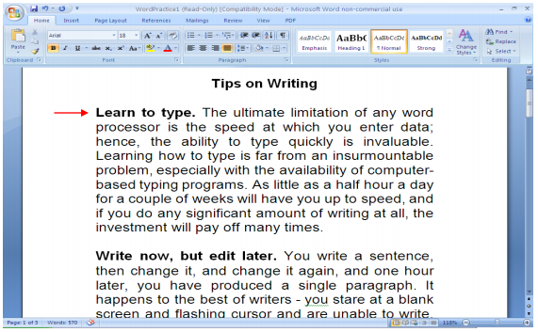
- Assign number to each paragraph. To do this, Press the Bullets object from the Home
tab’s paragraph group. Press [Enter] after each bulleted entry; Word will automatically
drop to the next bullet. OR, right click -> Numbering.
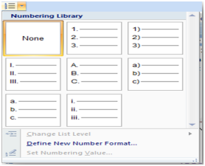
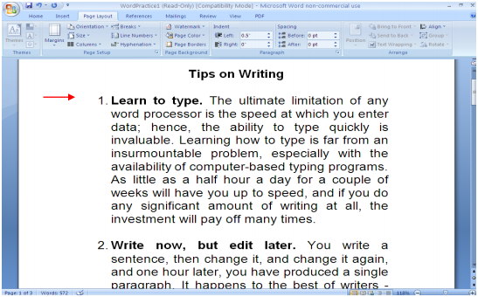

- Now, for each paragraph, place you cursor at the beginning of the second sentence.
Press Enter. Increase the paragraph indentation until it is aligned vertically with the first
sentence. To do this, click the Numbering button to deselect it. Then, click the Increase
Indentation button to indent your text.

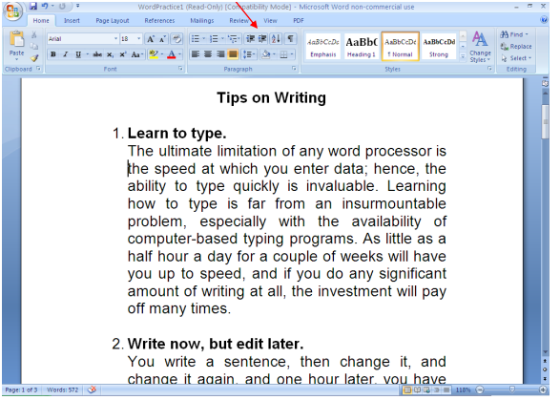
- Now you need to insert a Header text. To do this, from the menu bar, Insert -> Header.
Now, you can choose the header design (e.g.: blank, annual etc), then type “CMPF124
Word Exercise” at the header section. Inserting Footer also required the same steps.
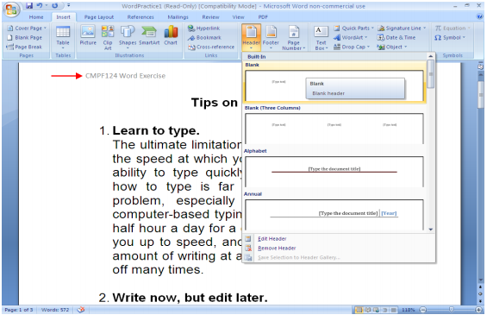
- Now, you need to set the paragraph for 1.5 spacing. To do this, select the body text, and
click the dialog launcher button in the tab’s paragraph group. 
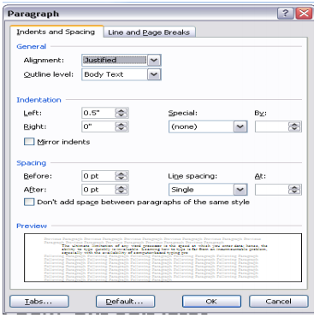
- Now, you want to add a footnote. You want to explain the meaning of the word
program. Look at item no 1, second sentences. To do this, click on the References tab’s
in the ribbon -> Insert Footnote.
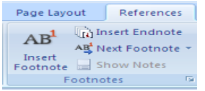
- Type the following sentence: A computer program (often simply called a program) is an
example of computer software that prescribes the actions ("computations") that are to
be carried out by a computer.
- Highlight the sentence and change the font size to 8.
