Microsoft Word Essential
Lesson 2: Newsletter
Objectives: In this lesson, you will learn how to work with:
a) Word Art
b) Column
c) Image
- Create a new file in MS Word. Save the file as 2.doc
- Open the Word Practice 1.doc file.
Type the following text : enter the text. Save the file.
- At the top of the page:
- Insert a Word Art text, and type the title as: Tips on buying a PC (To get to Word
Art, from the menu bar, click on the Insert tab’s in the ribbon.
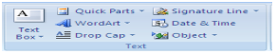
- Choose the appropriate font for your title.
- Centralize your title.
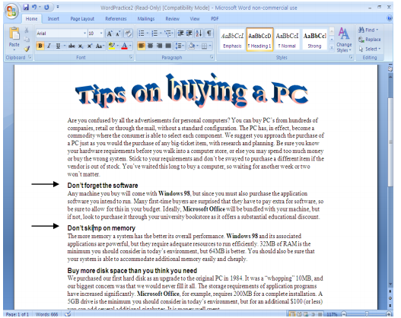
- Next, BOLD all the subtitles.
- Justify the body text (you need to select the body text first. Then, go to paragraph tab’s
group. Click justified button).
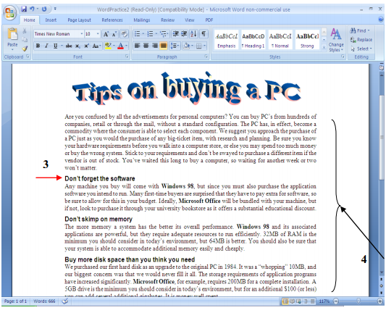
- To create text column, select ALL the body text ONLY (meaning leave the title alone !!! ), then from the menu bar, select Page Layout -> Columns. Under the Preset section,
choose Two.
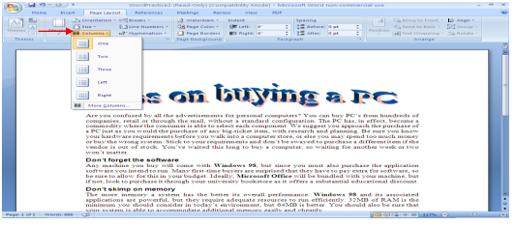
Now your document should look like this.
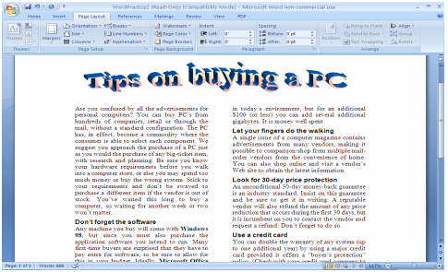
- Place your cursor at the middle of the page. Now, you want to insert a picture. From the
menu bar, Insert -> Picture -> Clip Art.
- Select any picture that you are interested in. Insert the picture into your word document
by clicking it.
- Now, you need to edit the picture (in terms of its position and size). In order to do that,
you need to change the Picture layout setting first. Click on the Format tab to format
picture.
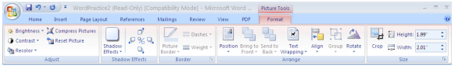
- Under Text Wrapping, select Tight wrapping style
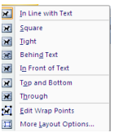
- Now, enlarge the picture. Your final product should look like this:
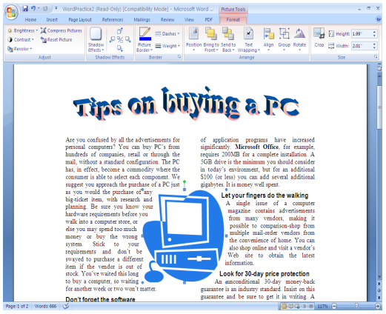

Lesson 3: Working with table.
Objectives: In this lesson you will learn how to work with:
a) Table
b) Cell manipulation
- Open a new word document file.
- To add a table, go to the insert tab of the ribbon, and select “insert table” (Drag the
mouse to select the size of table you want).
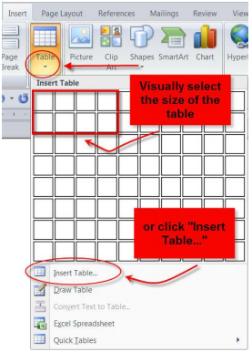
- To edit a table’s style, select it and a new tab will appear on the ribbon
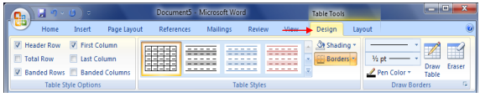
- You can also modify the structure of a table by using the “layout” tab.
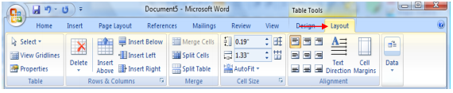
- Next, you want to combine two or more cells to become one single cell. To merge cells, select the desired cells, and then right click. From the pull down menu, choose Merge Cells.
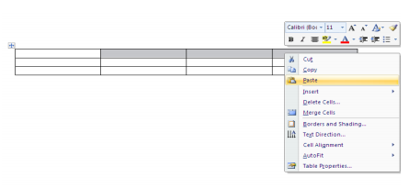
- Fill in the table as the following. You are also required to merge the first two row (as indicated by the figure below):
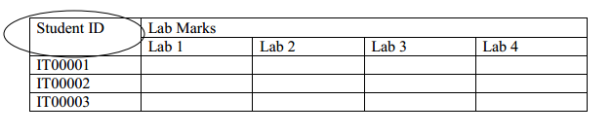
- Next, Bold the title “Lab Marks” and all the subtitle “Lab 1”, “Lab 2”, “Lab 3” and “Lab 4”. Centralize all those titles. Centralize the Student ID column as well.
- To centralize a cell (horizontally and vertically), highlight and right click the cell, from the pull down menu, choose Cell Alignment -> desired setting.

Lesson 4: Working with shape.
Objectives: In this lesson, you will learn how to work with:
a) Basic shape
b) Shape grouping
- Open a new word document
- Click the Insert tab.
- Click the Shapes button. Choose shape. Drawing tools will be appeared when you finish
drawing your shape. In the drawing tools. You can format your shape and design it
nicely.
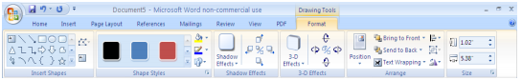
- Right click and choose ‘Add text’. Type “The recipe to success” in the text box
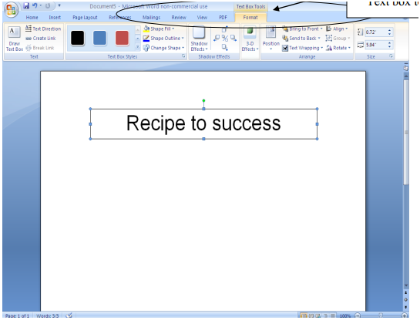
- Now, create another four boxes like the following (containing the word: Self
Motivations, Positive Attitude, Hardworking, Perseverance). To make the outline of the
box disappear, right click the text box, select Format Auto Shape. Under the Colors and
Lines tab, choose No Line option.
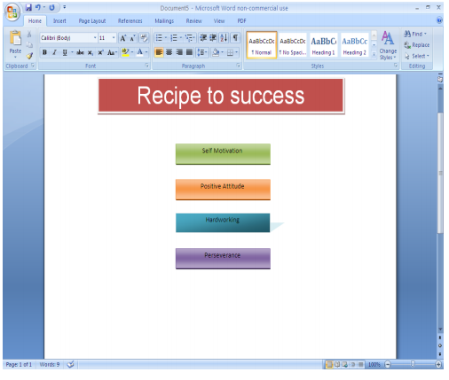
- Now, from the drawing toolbar, click on the AutoShapes botton -> Block
Arrows and choose your desired arrow style.
- Place the arrow between the first and the second box.
- Repeat the steps until you have the following diagram (tips: you could just copy and
paste the arrow):
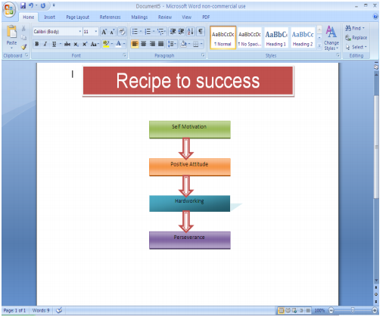
- . One of the concern issues is that if you want to position the diagram, you need to move
each of the objects one by one, which could lead to time consuming. What you can do is
to group all the objects in the diagram. In order to do this, hold the SHIFT key and click
on each of the object.
- Once you are done, point your cursor to the selection until a cross symbol appear. Right
click. From the pull down menu, choose Grouping -> Group. (You could ungroup or
regroup using the similar steps).
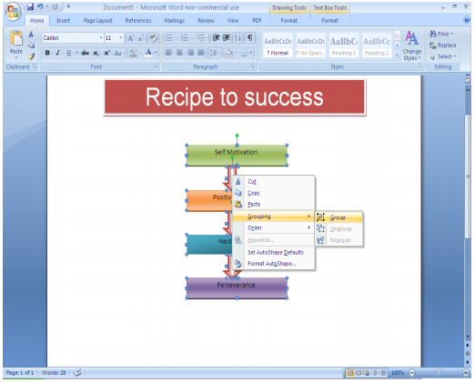
- Now if you move one object, the rest of the objects will follow.

