Microsoft Word
In this tutorial, you will learn how to:
a. use style
b. edit style
c. applying header and footer per section
d. using caption and cross reference
e. create table of content
Lesson 5: Using Style
1. OpenWord Practice 5.doc
2. Now, you want to apply heading style for the each of the main title/ subtitles. To do this,
a. Put your cursor at the beginning of the title, OR highlight the sentence where you want
to apply the style.
b. Select the heading style that you want from the Style pull down menu.
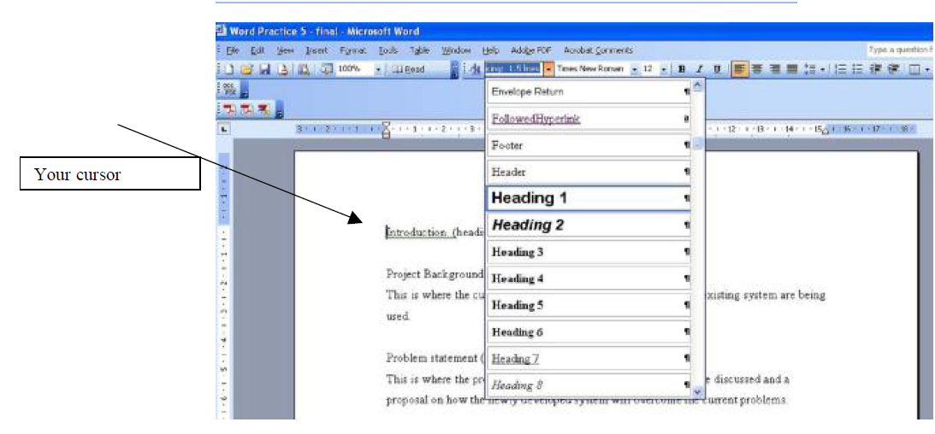
3. Now, apply the appropriate heading to the practice document. Once you are done, delete the
wording inside the bracket.
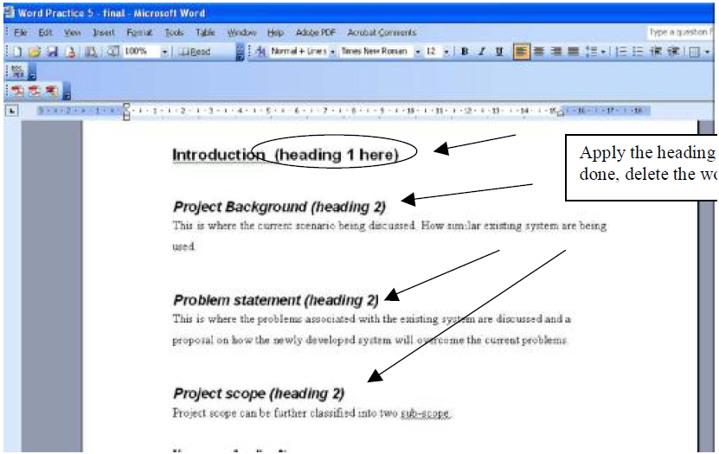
4. Now, we want to modify the style of each heading. We want to number each of them, as well
as changing the font size and font style (bold/italic/underline). To do this
a. From the menu bar, Format -> Styles and Formatting..
b. Select Heading 1, click on the down arrow and select Modify.
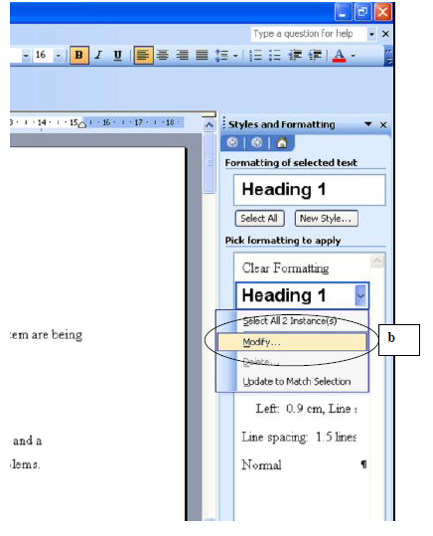
c. A Modify Style dialog box appears. To change the font or other formatting style,
click the Format button. For Heading 1, we want to apply numbering, so select
Numbering from the list.
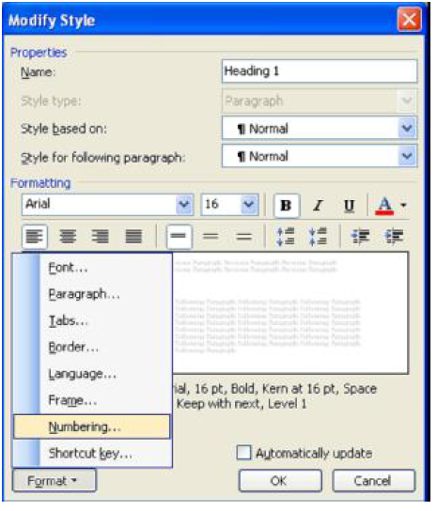
d. A Bullet and Numbering dialog box appear. Under the Outline Numbered tab,
select the option as illustrated from the following screen.
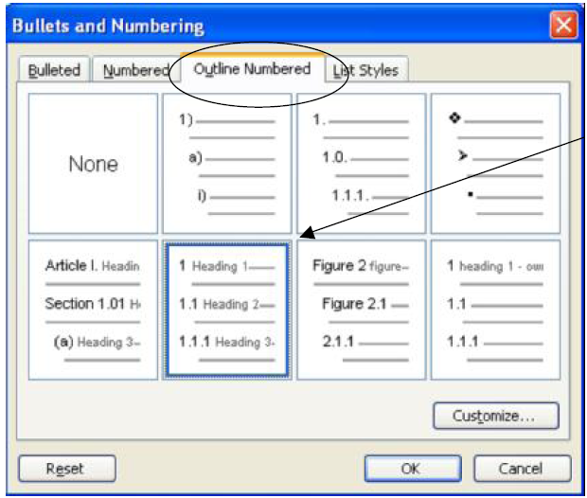
Click OK, and then, another OK button.
5. Now, change the formatting style for Heading 2 (font style).
a. Repeat step 4(a) and 4(b).
b. Click on the Italic icon to deselect it (we do not want Heading 2 to be italized). And
then change the font size to 12. Click the OK button.
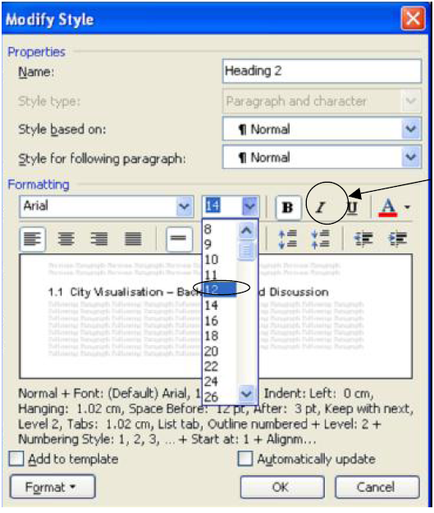
6. Now change the formatting style for Heading 3 font to Arial of size 12.
Lesson 6: Header and Footer (section)
1. Place your cursor just before the second chapter.
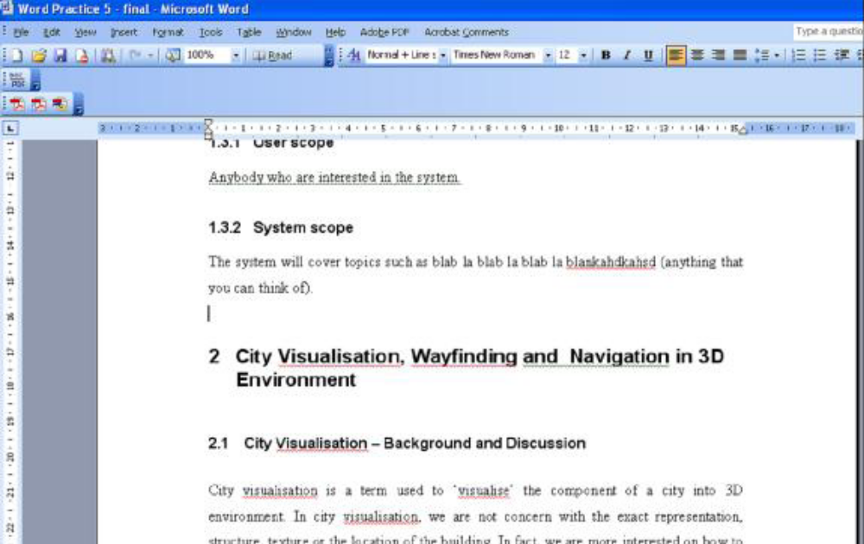
2. From the menu bar, Insert -> Break..
3. A Break dialog box appears. Choose Next page and click the OK button. (this is the most
important step)
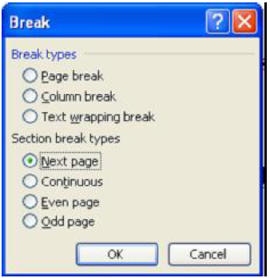
4. Put your cursor at the beginning of the file i.e. at the top of the first page (or Ctrl + Home).
From the menu bar, select View -> Header and Footer.
5. Write “Chapter 1: Introduction” for the header section. Change the font to Arial, size 8, and right
justified.
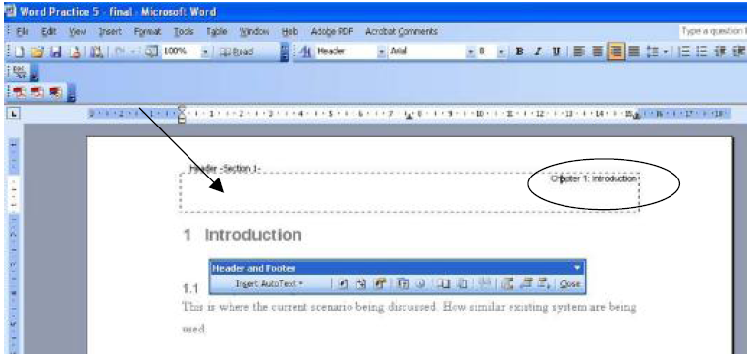
6. For the footer, insert page number by clicking the Insert Page Number icon. Change the font
to Arial, size 8 and right justified. Click the Close button.
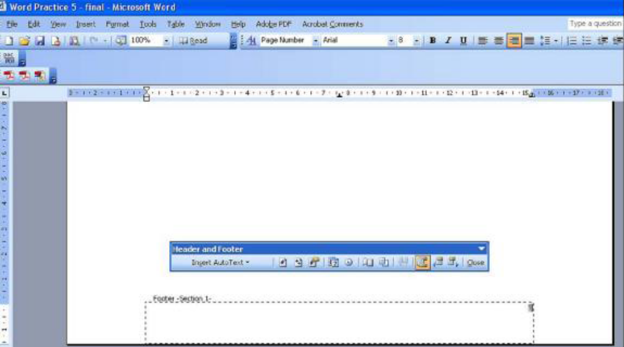
7. Now place the cursor at the beginning of chapter 2. As you can see, the header for chapter 2 is
currently similar to the header of chapter 1. This happen as the same header will be repeated for
every page in the document.
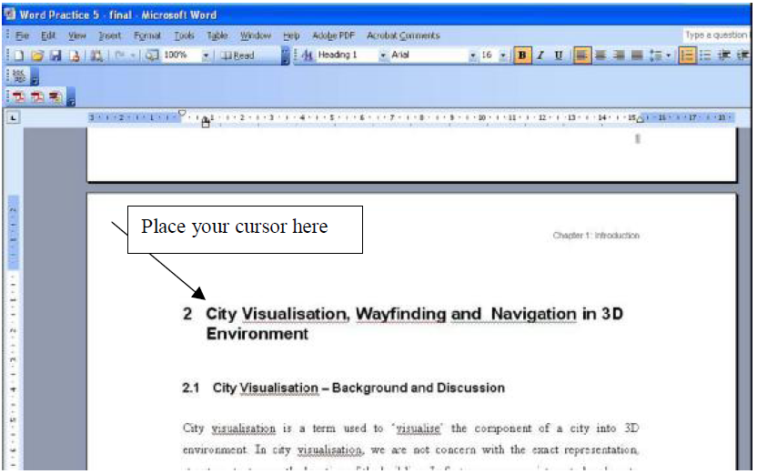
8.To change the header, select View -> Header and Footer. In your header area, you will see a
note indicating that the header is the same as the previous one and the icon “ Link to previous”
is selected (in MsWord 2000, the icon name is “Same as previous”). Deselect the icon.
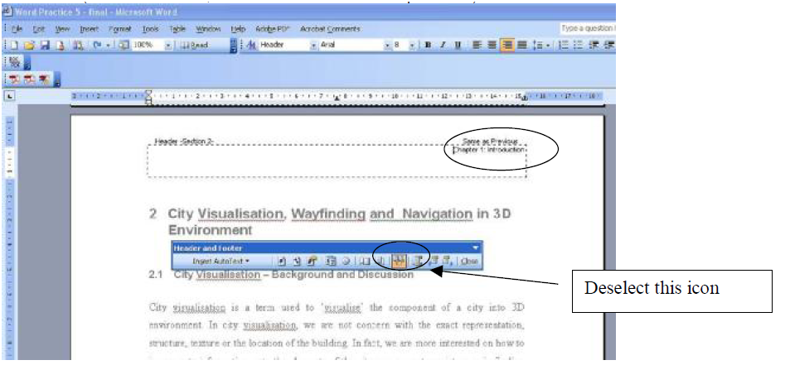
10. Now, you can have different header for each chapter. Note: this effect will only viable if you
choose the Next Page section break. (step 3)

Lesson 7 : Inserting Caption (figure, table etc.)
1. Place your cursor just below the image.
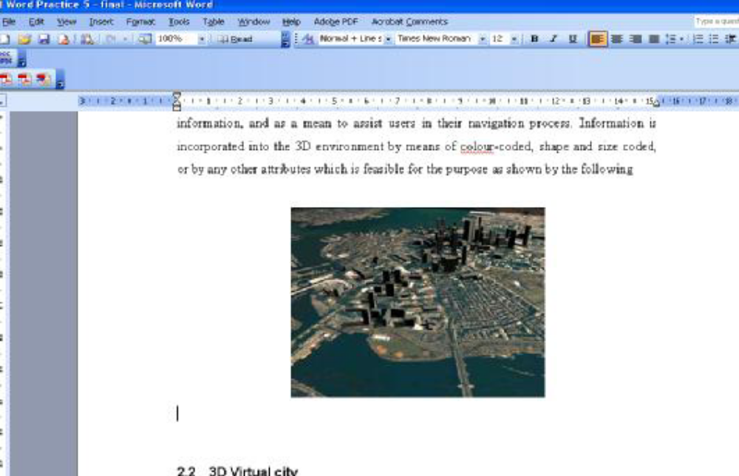
2. From the menu bar, Insert -> Reference -> Caption.
3. A Caption dialog box appears, Select Figure from the Label pull down list. Click OK.
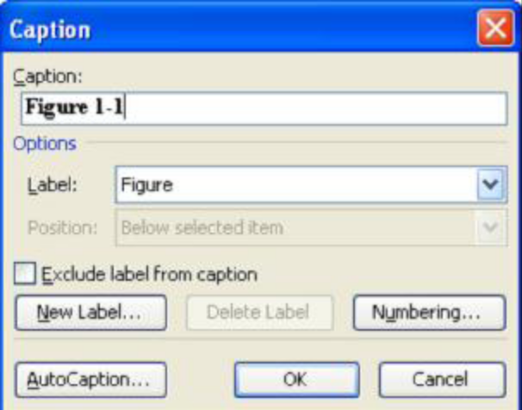
4. Write “City View” next to the Figure number. (Center the text by clicking the center
button)
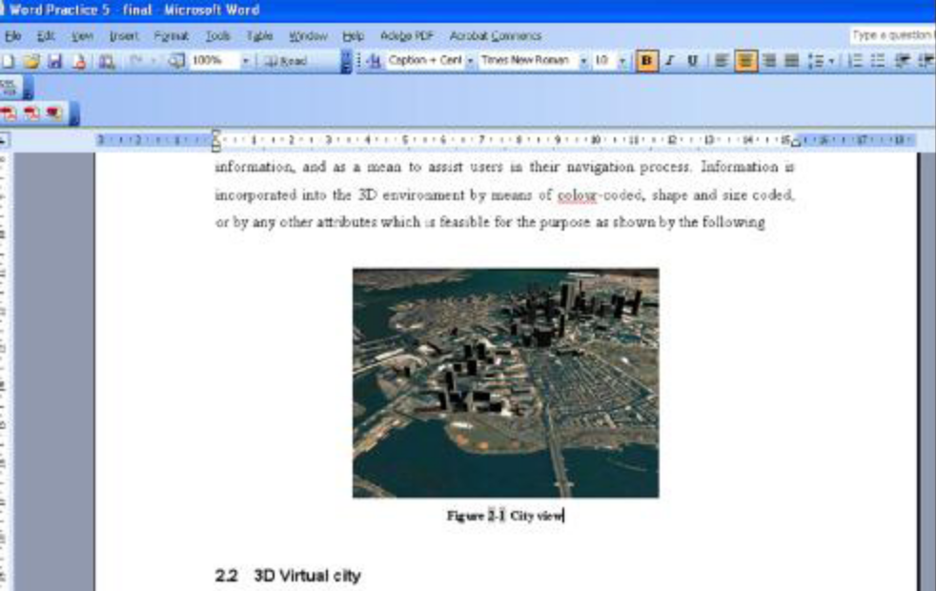
5. Now, we want to create a cross reference text (i.e. text referring) to the figure that we just
inserted. To do this, place your cursor at the text body (as shown in the following)
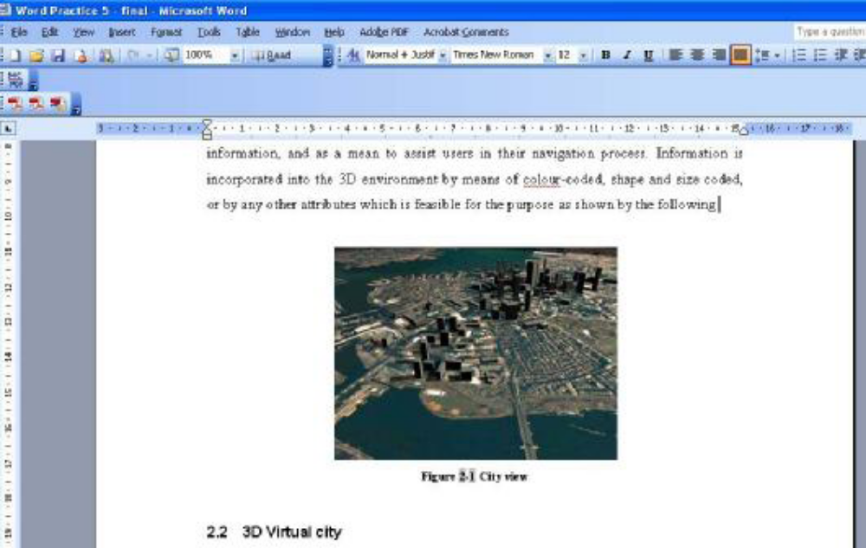
6. From the menu bar, Insert -> Reference -> Cross Reference
7. A Cross-referenced dialog box appears.
• From the Reference Type list choose Figure
• From the Insert reference to list. Choose Only label and number (you can experiment the
effect by choosing different option from the list).
• Under For which caption list, select the figure we want to cross referent.
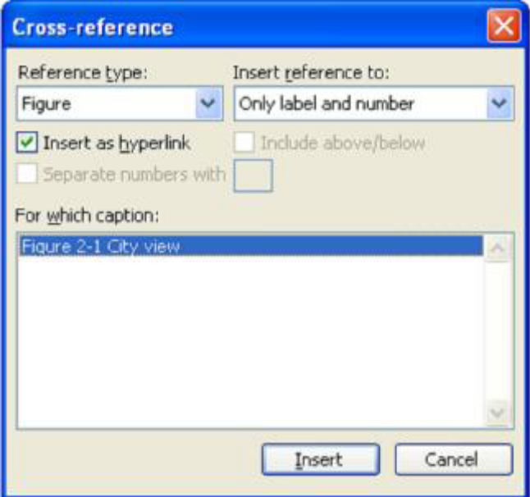
8. Click Insert, and then Click OK.
9. You now have a text, which refer to the figure.
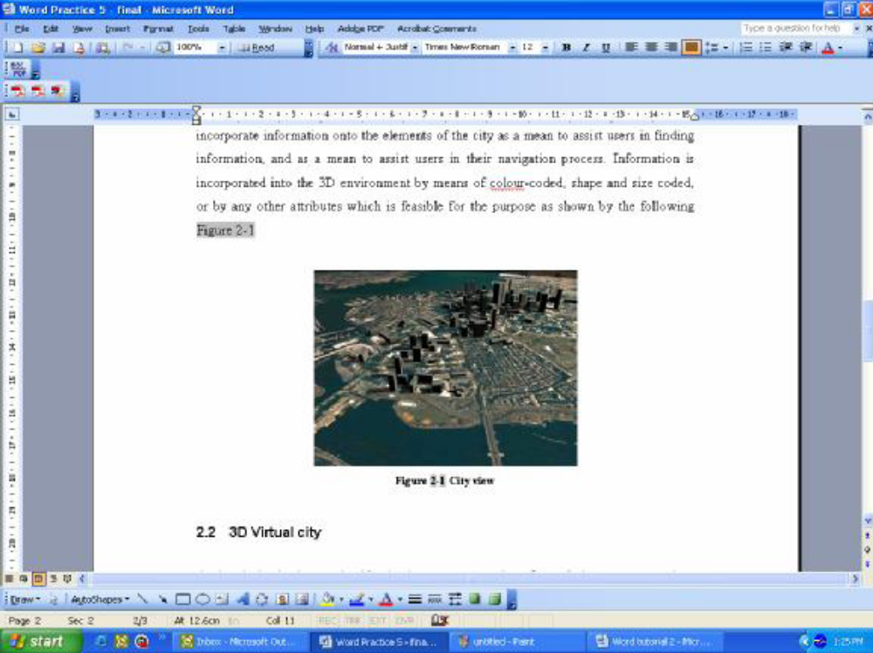
10. Caption and cross reference functions in Microsoft Words are used for easy update. If you
insert a new figure in the middle or at the beginning of the document, the figure number and its
corresponding reference for each image will be automatically updated (you need
To right click at the cross reference text, and select Update field, OR, the changes will
automatically take place when you reopen as saved document).

Lesson 8: Table of content and Table of Figure
- Place the cursor after the last sentence or at the end of the document.
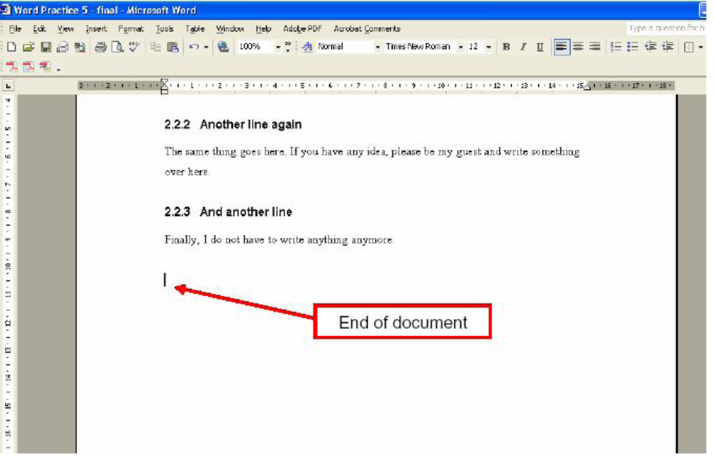
2. From the menu bar, Insert -> Break -> Next page
3. Repeat the steps in Lesson 6 (8) & (9). Delete the header text (we do not want to have
any header in Table of Content page)
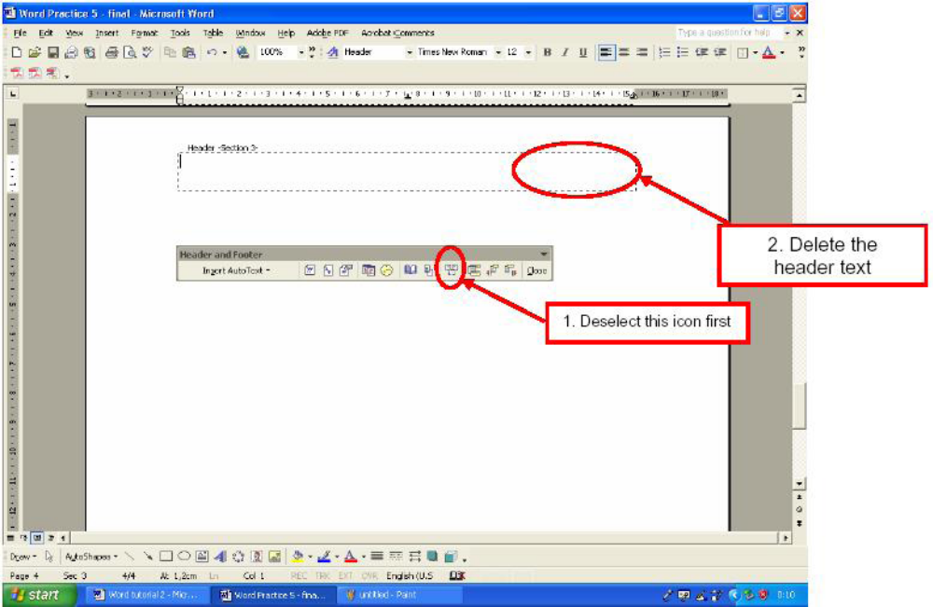
4. Apply the same steps to delete the number in footer (Table of Content usually has no
page number)
5. Write “Table of Content” at the beginning of the page, and place the cursor just below
the text.
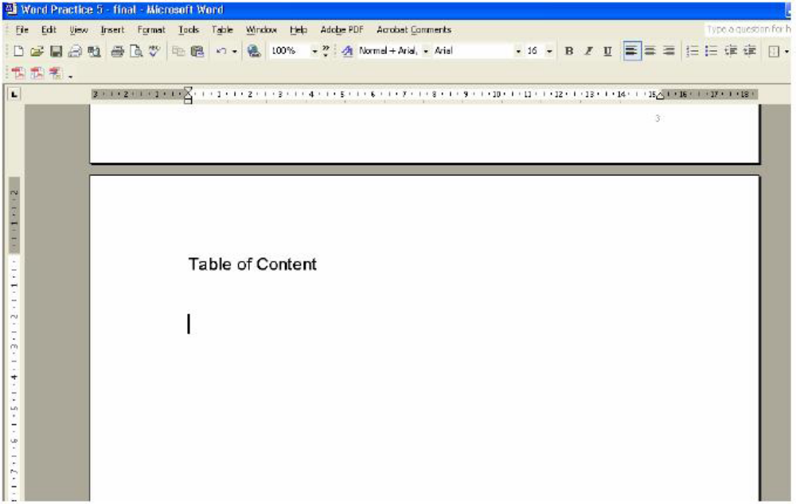
6. From the menu bar, Insert -> Reference -> Index and Tables
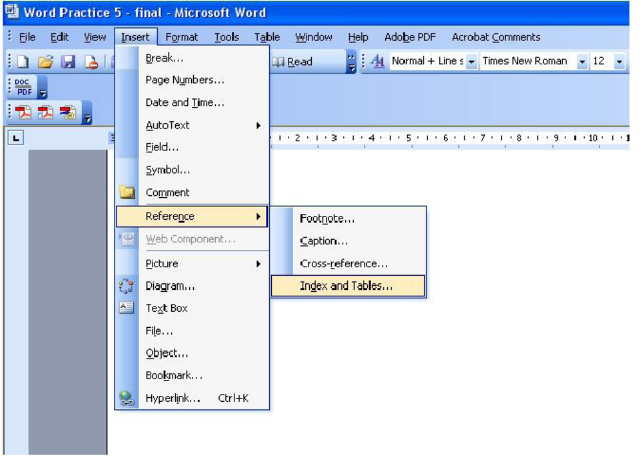
7. An Index and Tables dialog box appears. Select the Table of Contents tab. Set the
Show levels to 3 (meaning we want to display up to three level heading: heading 1,
Heading 2 and Heading 3). You could experiment by changing the value of Show
levels to 2, and observe the result on the Print Preview pane. You could also change
the template (the way your Table of Content will be displayed) by selecting your desired
choice from the Formats and Tab leader pull down list. Click the OK button.
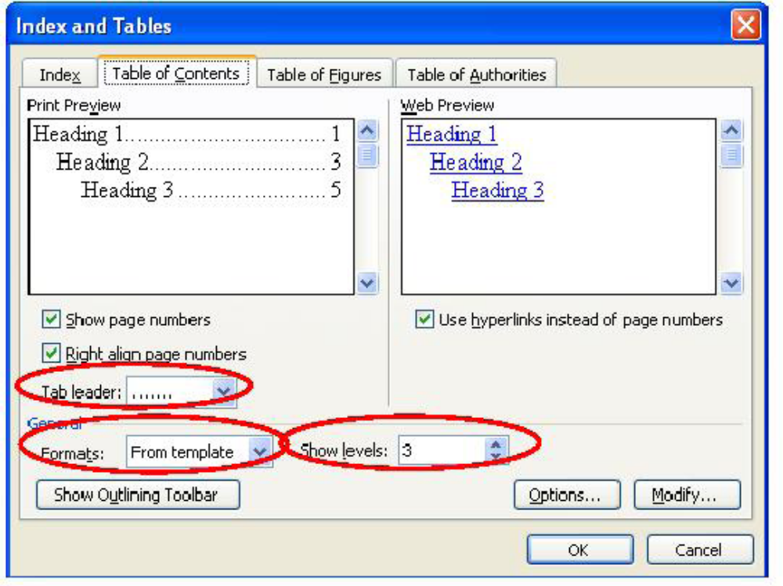
8. The table of content is automatically added. You could view the final result of the
exercise in WordPractice5_final.pdf
Test your skill: You are required to create a Table of Figure, as shown below:
