Lab 5: Microsoft Excel Tutorial (PART 1)

Excel Worksheet

Microsoft Excel works as account ledger. An Excel Workbook (1) could have multiple Worksheets
(2). A cell in Excel is referred by its Column and Row naming style (displayed in the name box). A
heavy border around a cell indicates that it is an active cell (3). Any entry made at this point is
made into the active cell, and any commands that are executed affect the contents of the active
cell. The active cell can be changed by clicking a different cell, or using the arrow keys. An active cell reference is displayed on the name box (4).
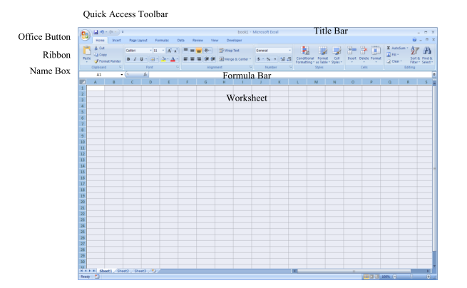
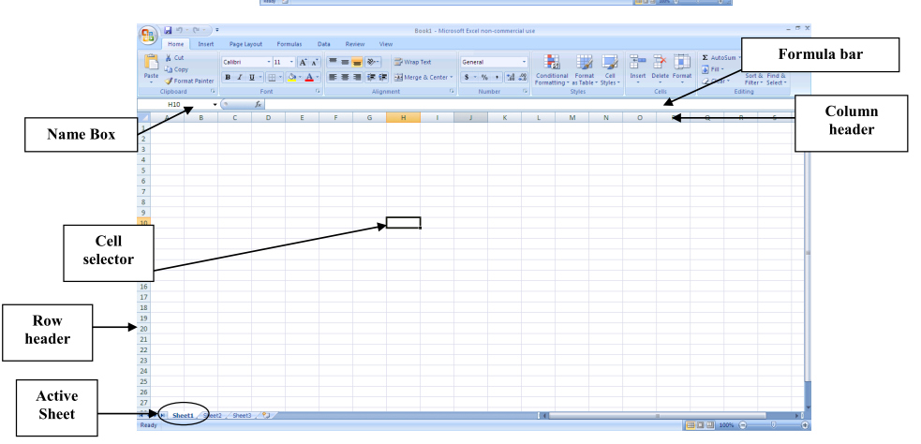
Lesson 1: Basic
- Open file ExcePractice.xls . To rename a worksheet, Right click at Sheet 1, choose Rename. Type Exercise 1
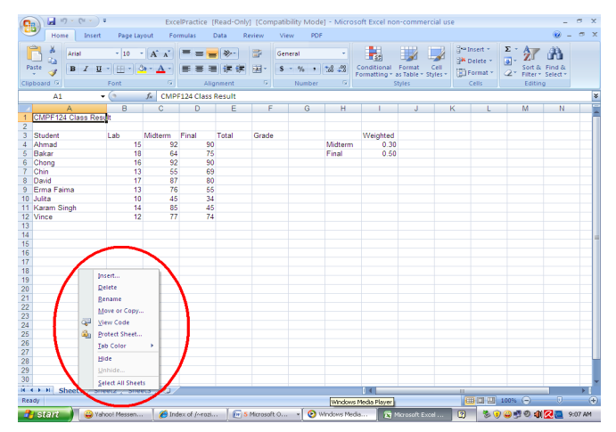
- Now, you need to add two more columns. To do this, right click at column D, choose Insert.
You have a new column inserted. Write “Midterm Percentage” as the table heading. Repeat
the step to insert a new column just next to Final, and name it as “Final Percentage”.

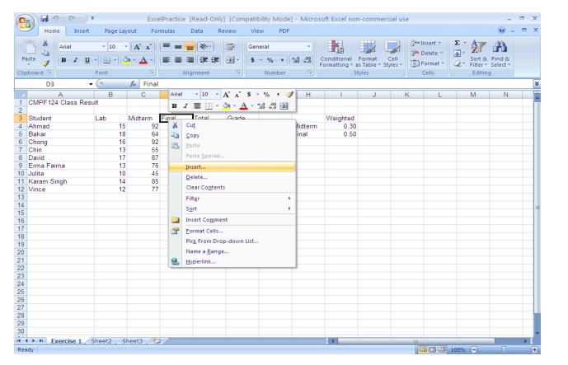
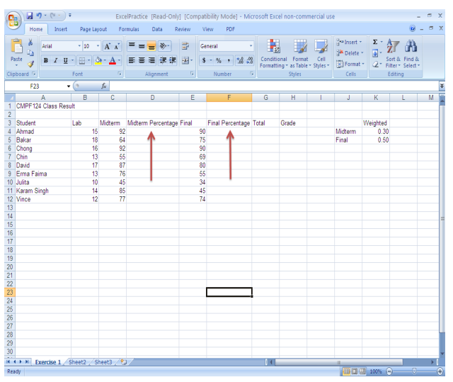
- Now, you need to calculate the average, the lowest and the highest score for the lab, midterm and final. Write the word “Average” at cell A16, the word “Highest” at cell A17, and the word “Lowest” at cell A18.
- Now, before you can do any of the calculations, you should change the cell format accordingly (in this case, number). To do this, highlight cell B4 -> G18, right click and choose Format Cells.
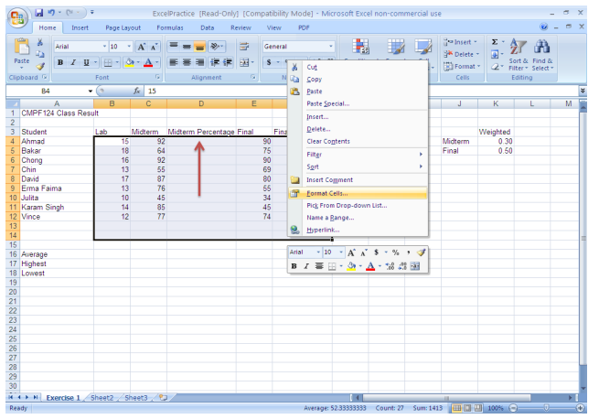
- A Format Cell dialog box appears. From the Category list, select Number. Set the
Decimal places to 2. Click the OK button.
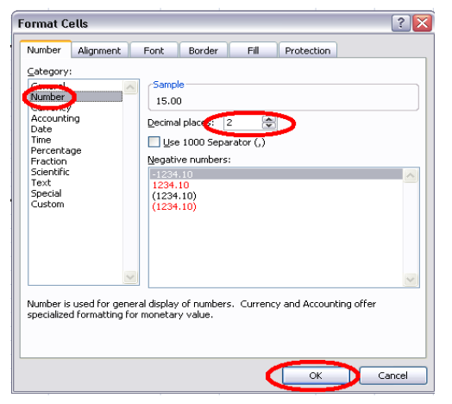
- Now, you should have all your numbers within the selected area to be in 2 decimals
format.
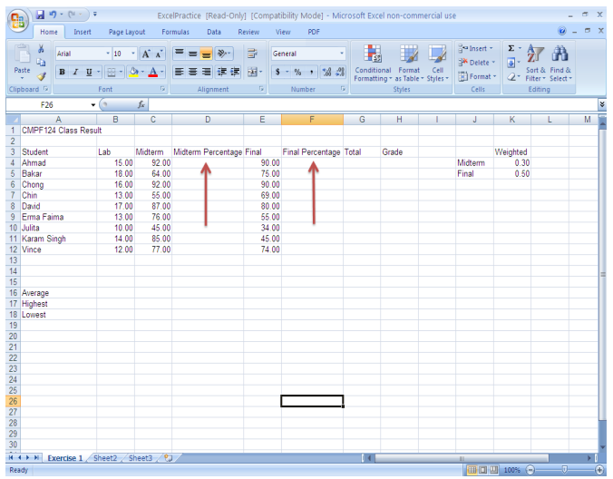

Lesson 2: Using formula

- Now that you have all the facts and figure ready, it is time for you to do some calculation.

- The first few things that you want to calculate is the average, lowest and highest mark for
each assessment.

- To calculate the average for lab marks, click on cell B16. Next, click on the Insert
Function icon.
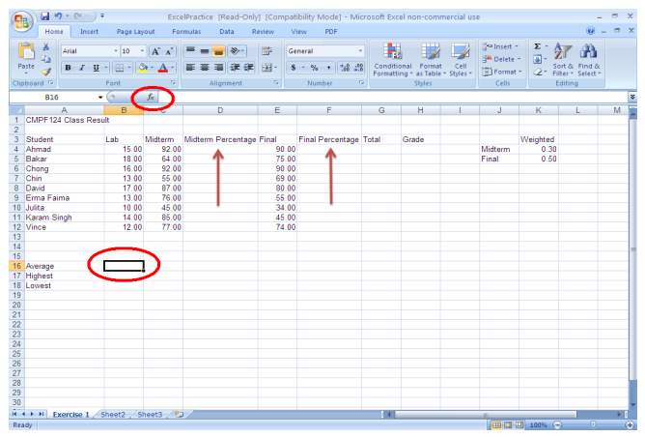
- An Insert Function dialog box appears. From the category list, select Statistical.
Select AVERAGE from the Select a function: list. Click the OK button
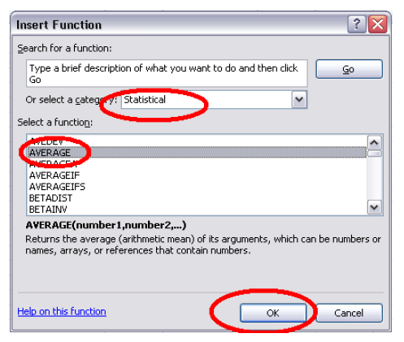
- Next, a Function Arguments dialog box would appear. Under the AVERAGE section,
make sure that text field Number 1 is highlighted.
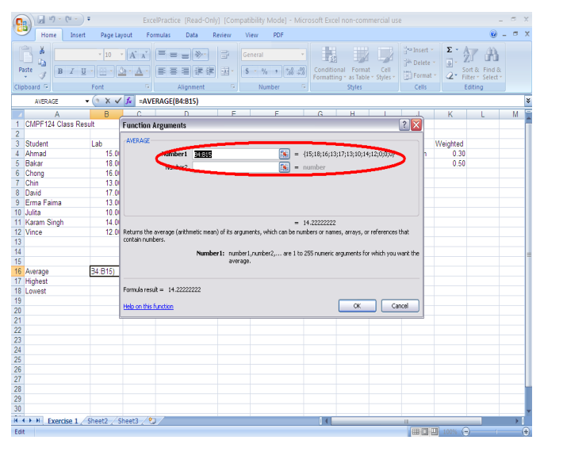
- Now, using your mouse, select cells B4 – B12 (we want to calculate the average for lab
marks remember!!). Click the OK button. You will now have the average automatically
calculated on cell B16.
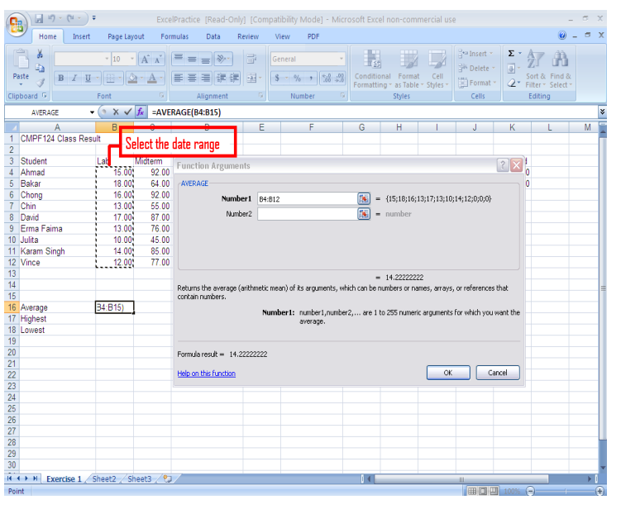
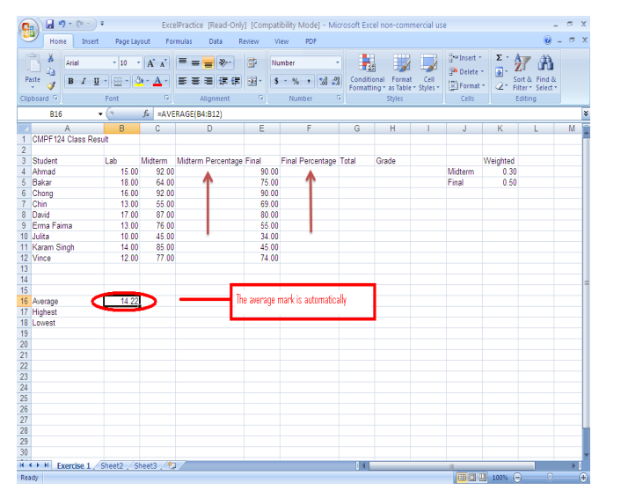
- Now, repeat the same steps to find the lowest and highest marks for lab. Your results
should similar to the following:
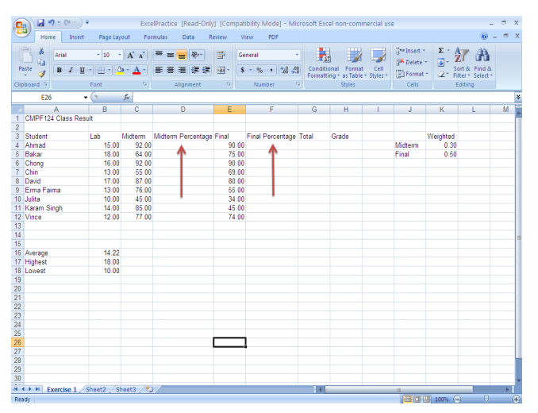
- Now, you should find out the average, highest and lowest mark for midterm and final as well.
There are two ways of doing this, either you repeat the similar steps, or you just copy paste
the cell. When you copy a cell that contains a formula, you are actually copying the formula,
not the value. When you paste a formula, Excel will work out the corresponding cell to come
out with the new result. Now, highlight cell B16 (source range), right click, and select Copy.
Next, select cell C16 (destination range), right click, select Paste. An average is automatically calculated for C16. Now click on cell B16 again, observe that the formula is=AVERAGE (B4:B12). Next, click on cell C16. Observe that the formula this time is =AVERAGE (C4:C12). Excel automatically adjusts the corresponding cells whenever a formula is copied and paste (this is called relative reference).
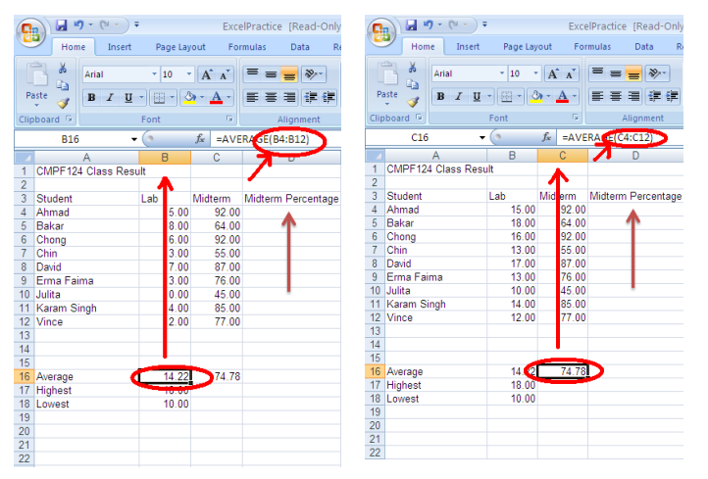
- Now, find the highest and lowest marks for Midterm, as well as the average, highest and
lowest marks for Final. Your result should be like this:
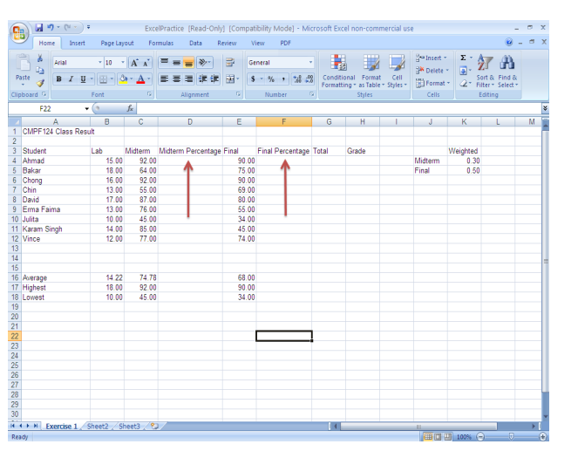
- Next, you want to calculate the equivalent percentage for midterm. The weight age for midterm is 30% of the total percentage. Take Ahmad score for a while. The formula to calculate the equivalent percentage for Ahmad’s midterm would be: C4 * $K$4 (C4 is the Ahmad midterm mark, while $K$4 refers to cell K4 which contain the weight age). The dollar sign ($) here refers to absolute reference, meaning, we would want to refer to THIS PARTICULAR cell only, even when we copy paste the formula.

- Therefore, to calculate the midterm percentage for Ahmad, select cell D4 (destination cell). At the formula bar, write =C4*$K$4, then press ENTER. The equivalent percentage is automatically calculated. (all function/calculation in Excel starts with the sign = ).
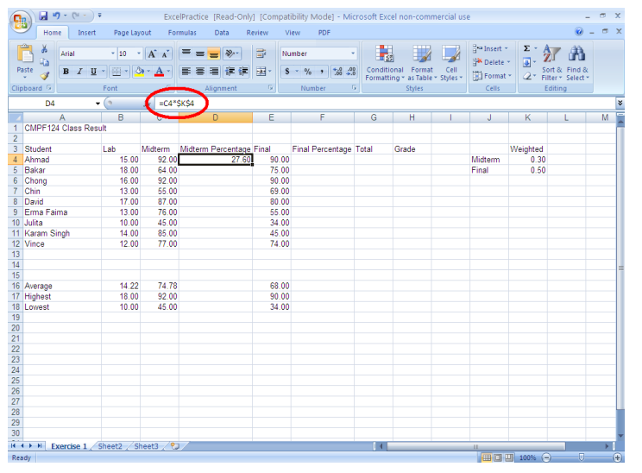
- Now, copy cell D4, and paste to cells D5 – D12.Observe how the midterm percentage for each student is automatically calculated.

- If you select cell D4, you will see the formula is C4*$K$4, meaning that Excel will take Ahmad’s midterm mark (C4), and multiply it with the midterm weightage (cell K4). Now if you select cell D6, you will see the formula is C6*$k$4, meaning that Excel will take Chong’s midterm mark (C6) and multiply it with the midterm weightage (cell K4). Observe that eventhough the midterm mark for each student would come from different cell, the weightage for midterm will come from the same cell (K4). That is why you use the dollar sign ($) to indicate absolute reference (meaning you want to refer to THIS PARTICULAR cell in every formula).

- Now, using the same steps, calculate the equivalent final percentage for each student.
You result should look similar to the following:
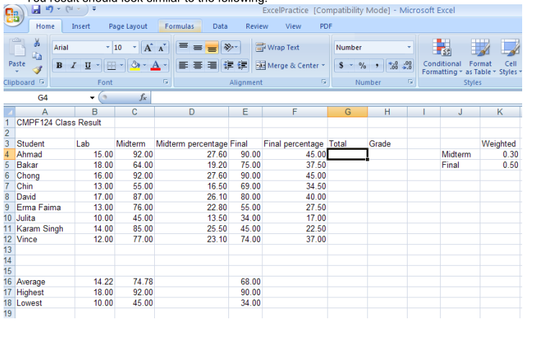
- Now, we want to calculate the total mark for each student. Take Ahmad for example. The formula to calculate the total marks for Ahmad would be B4+D4+F4. Your task is to calculate the total marks for each student. The result should look similar to the following:
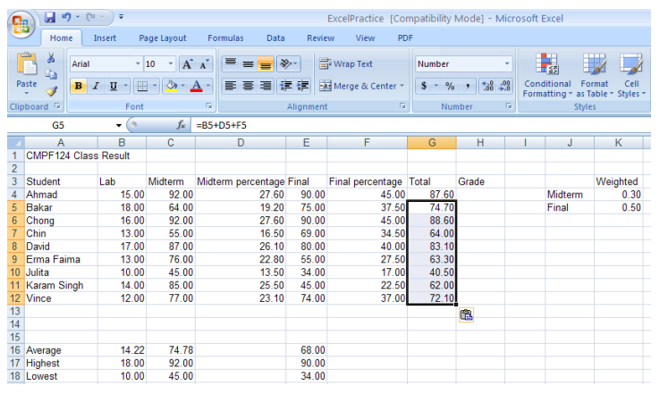
- Now, you want to add a grade lookup table. Please enter the following data into cells J8 –K12.
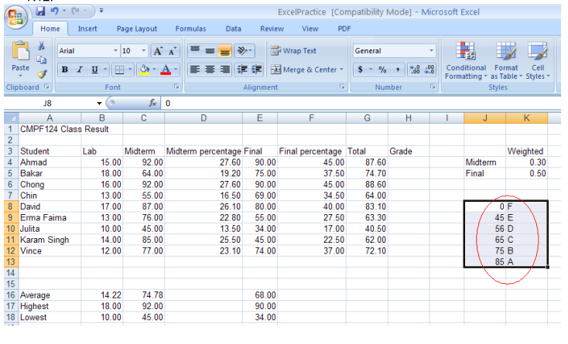
- Next, you want to determine the grade for each student. In this exercise, you are going to learn how to use VLOOKUP function. To use VLOOKUP function, your grade table must be sorted in ascending order. Observe that those who get between 0 – 44 will get F; those who get between 45 – 54 will get E and so on.

- Let’s start with Ahmad. Select cell H4. Click on the Insert Function icon.

- An Insert Function dialog box appears. Select Lookup and Reference from the category list. Select VLOOKUP from the function list. Click the OK button.

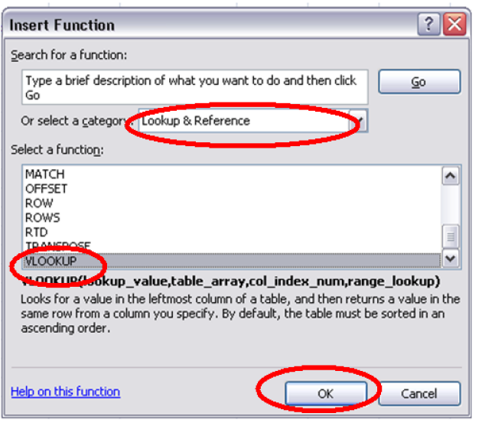
- A Function Arguments dialog box will appear.

a. For the Lookup_value field, select cell G4. This is the cell where the value we want to look
up (compare).
b. For the Table_array field, highlight grade table you created just now, i.e. J8 – K13. Add
dollar sign to make it as absolute reference. This is the table where the Excel will refer when
assigning lookup value.
c. For Col_index_num field, type in 2. This value 2 refers to the second column, where the
matching value will be returned.
d. Click the OK button.
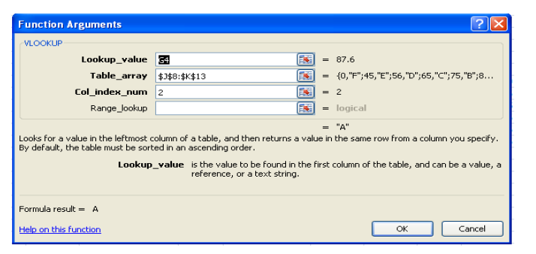
- You will see that Ahmad has just scored an A. Copy and paste the formula to determine
each student’s grade. The result should look similar to the following:
