Lab 5: Microsoft Excel Tutorial (PART 2)

- Now, you are going to learn how to do Conditional Formatting. Highlight cell H4 – H12. Click on the Conditional Formatting in the Home tabs -> New Rule.
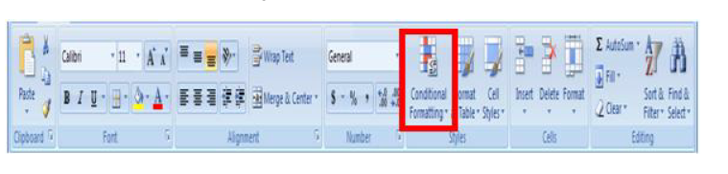
- A Conditional Formatting dialog box will appear. In the Select a Rule Type, choose format only cells that contain; another dialog box will appear. Make sure you fill each field with the following values, and click the Format button. Set the font color to red, then click the OK button.
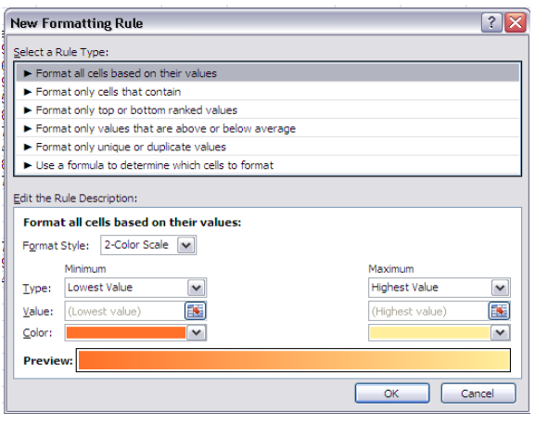
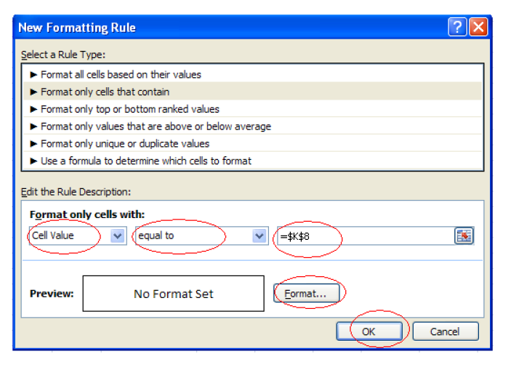
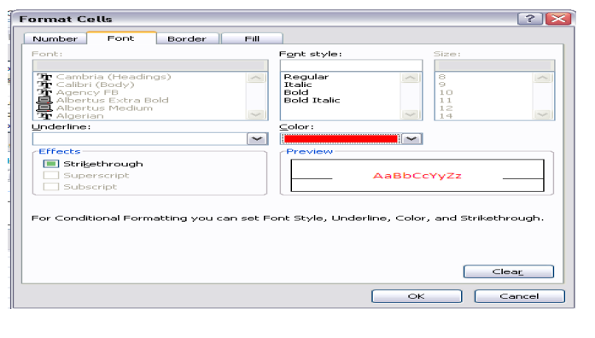
- You will see that grade F has changed color to red.
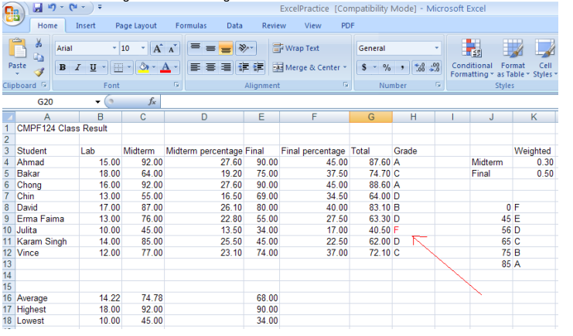
- Now, you will learn how to count how many students in each letter grade. To do this, first you need to insert the following values into cell J16 – J21.
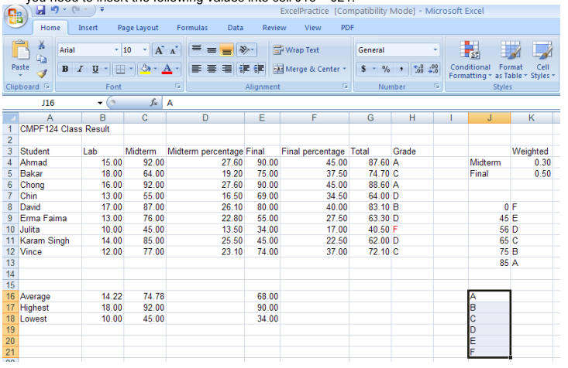
- Select cell K16. Click on the Insert Function icon. An Insert Function dialog box will appear. Choose Statistical from the category list. Choose COUNTIF from the function list. Click the OK button.
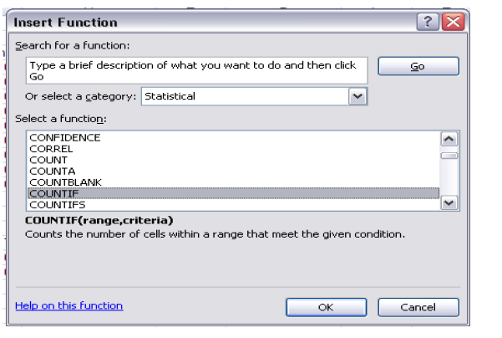
- A Function Arguments dialog box appears. For Range text field, select H4 – H12 (i.e. the grades for each student). For Criteria text field, select cell J16 (i.e. A). Here, what you are doing is you want to count “How many A’s within the grade obtain by this class”. Click the OK button. You will see the value 2 appear in cell K16 indicating there are two A’s within the selected range.
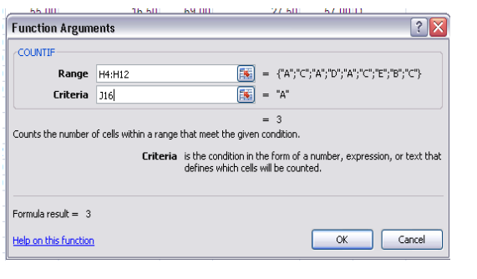
- Repeat the same steps to count the number of B, C, D, E and F within the class range.
The result should look similar to the following:
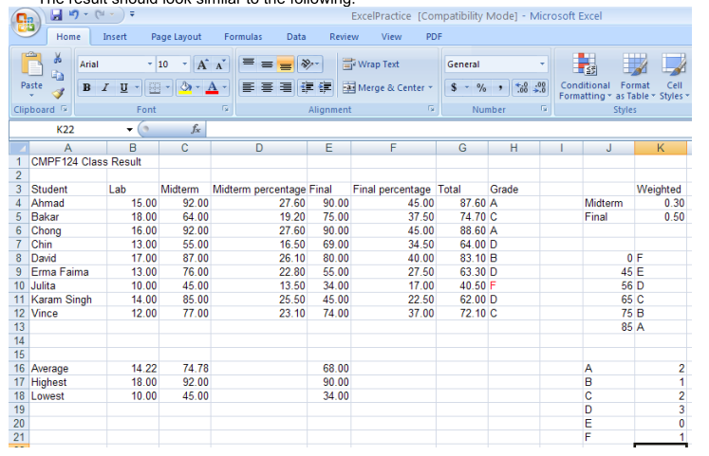
- Now, you could add border to the tables. To do this, select the area, then right click,
choose Format Cell.
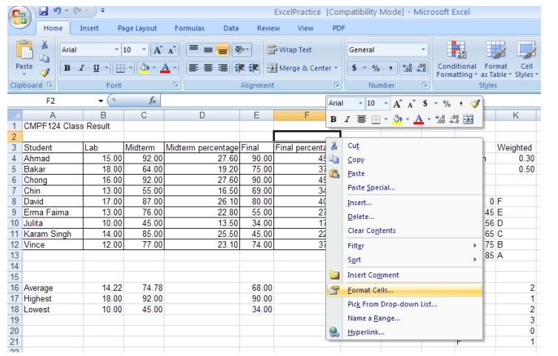
- A Format Cells dialog box appears. From the Border tab, make sure you select both the
Outline and Inside button. You should also select a pattern from the Line Style. Click the OK button.
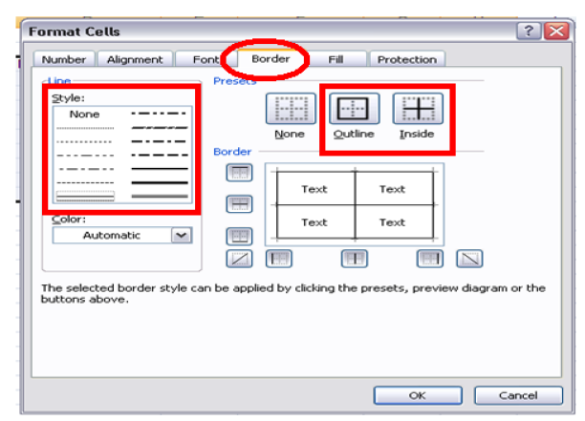
- You could also apply background color to a cell. To do this, select the cell, right click and choose the Format Cells option.

- A Format Cells dialog box appears. From the Fill tab, select the colour of you
choice. Click the OK button.
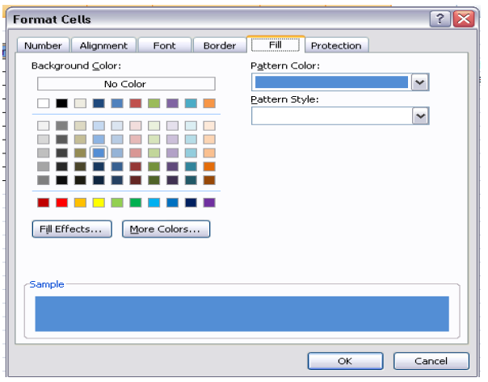

Lesson 3: Working with Chart

- Click the Insert Tab at the top of the Excel screen. When you do you’ll see that one of the Groups in the Insert Tab/Ribbon is Charts.
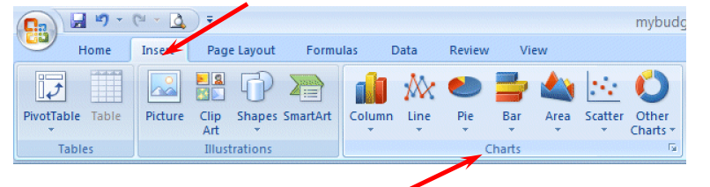
- Under the Data Range tab, highlight the Data range text field. Using your mouse,
highlight cell J16 – K21.
- For our first chart, we’ll use a Column Chart. Move your cursor over Column and an image like the one on the right will appear.
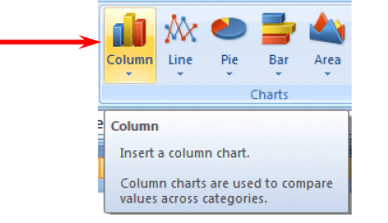
- Click the Column button and you’ll see an image like the one on the left. As you can see there all kinds of Column Charts. We’ll begin with a simple two dimension 2-D Column chart. You’ll be able to change this later, if you desire – to another Column Chart of one of the other selections.

- Click on the 2-D Column chart indicated by the arrow on the left.

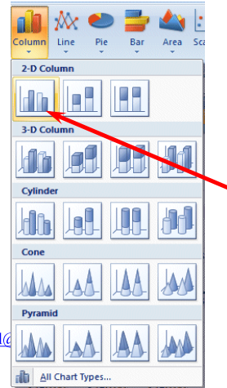
As soon as you click, because you highlighted your data, an image similar to the one below will appear. Don’t worry that the Chart is covering your data – we’ll take care of that in a minute. Notice that when we highlighted cells J16 to K21 this created the X-Axis labels (A, B, etc.).
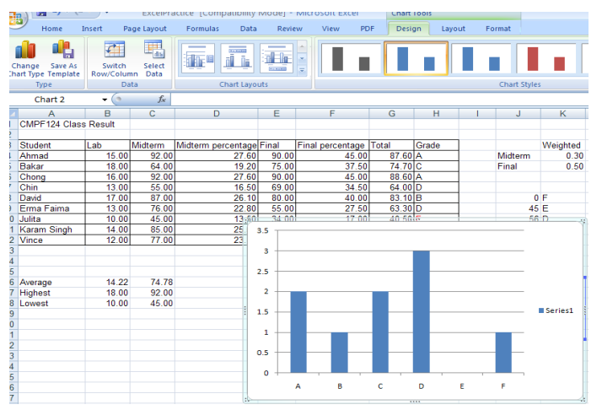
- Now, let’s move our chart to a page of its own – so it will be easier to work with and not cover our data. Click anywhere on your chart and you will notice that a new Tab appears at the top of your Excel screen – Chart Tools. Click the Chart tools Tab and the Chart Tools Tab/Ribbon will appear like the image below.
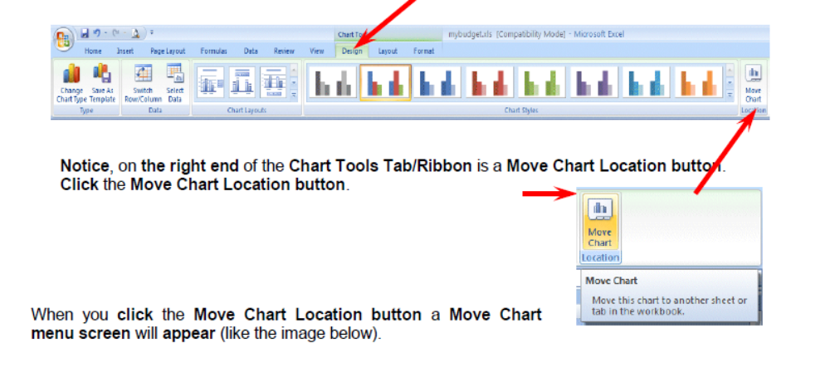
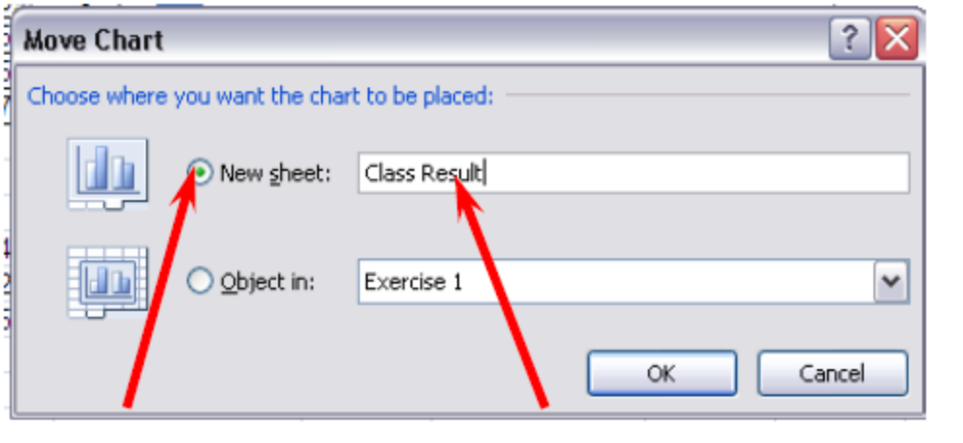
7. Click on the small circle to the left of New Sheet and change Chart 1 to Class Result – as indicated above. Then click the OK button.

8. Look at the bottom left of your Excel screen. You will see a new Tab – Class Result Chart! Your data is on Sheet 1. We’ll rename it when we have finished working with our chart.

9. You should be on your Class Result Chart Tab. If not, click this tab. Your chart should now fill the Excel screen. Click in one of the outside corners of your chart.
To add chart title, legend, etc: Chart Tools -> Layout
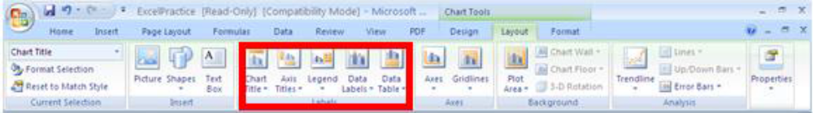
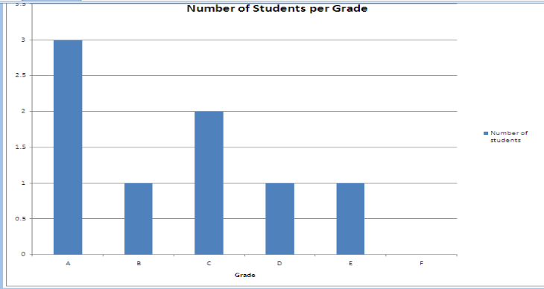
Experiment this:
Now try change the lab mark for Julita from 10 to 15, press Enter. Observe how the change is also reflected in the graph and the number of students per grade table. You can experiment this by changing the mark (mark ok.. not the percentage) for any student that you like. What is the conclusion that you can make from this observation?

