Inventory System It.1 12.11.17

# Use/Inspect

Inventory will look like in the picture down below. (Note not final design) 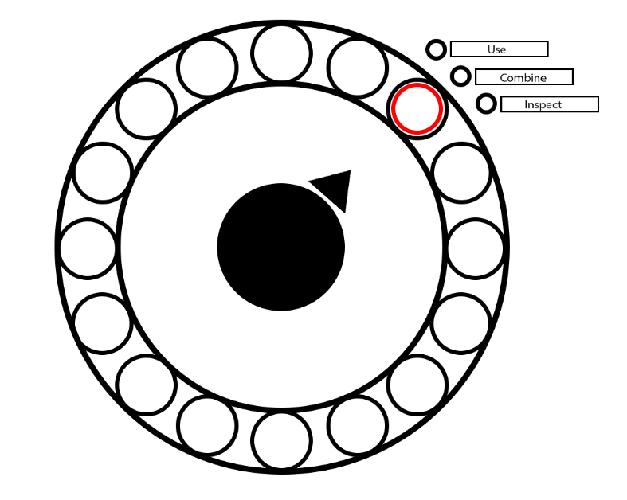

The middle point shows what item you are selecting, the arrow turns with the movement of the left control stick.

The small circles in the big circle are the item placeholders. If you pick up items there icons will be depicted in these circles.

If you select one of those circles with the a button on the controller it opens a sub menu on the side of that circle. The options will be use/combine/inspect.

Selecting use will trigger a event or show a short custom text. Depending on item.

If inspect is selected it will show a short custom text which depends on the selected item.

Combining Items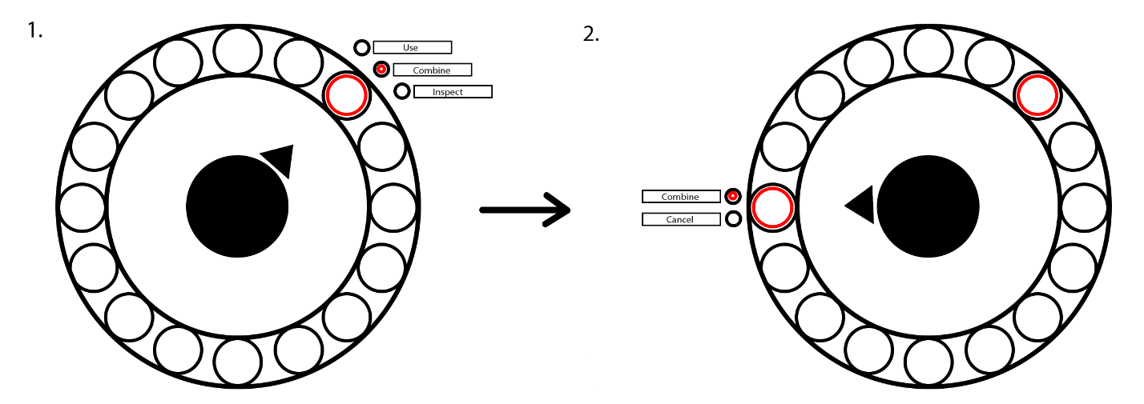

When combining is selected, you can select another item (while the other item you want to combine stays selected) to combine with the already selected item. If the items are able to combine, it will show a short custom text that it was successful. If the items are not able to combine it will show a custom text that they are not.

**Combining Items (More than two)**

There are some items that can be combined with more than one other item. The popup menu on the side of the selected item should always show a third option called select while combining.

So when you first select an item it says use/combine/inspect after starting combining items every other selected item apart from the first one shows select/combine/cancel.

# Inventory

It would be perfect if the inventory would be easily modifiable. For exmp the amount of items slot. And sprites used for everything.

When text is shown it should popup centered over the inventory. Text over a blurred out block/sprite or solid color.