**Sunny Devgan**

**C052045**

**Screen shots**

**Schematic diagram**

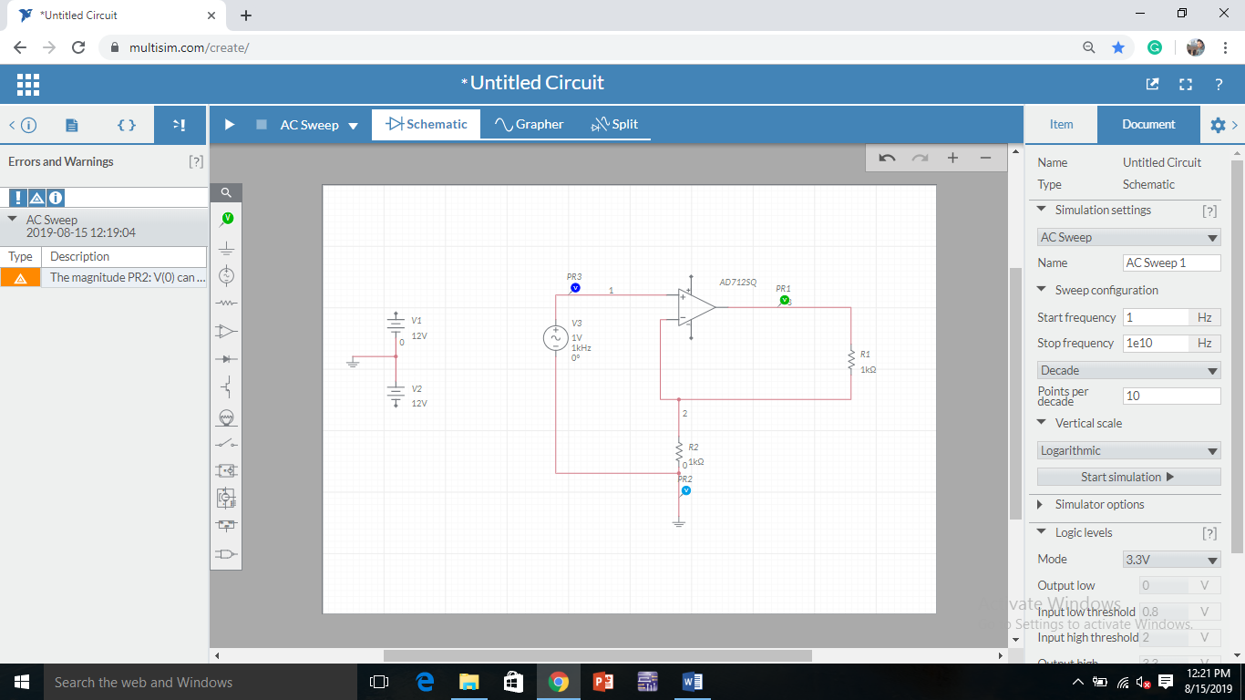

**Bode plot**

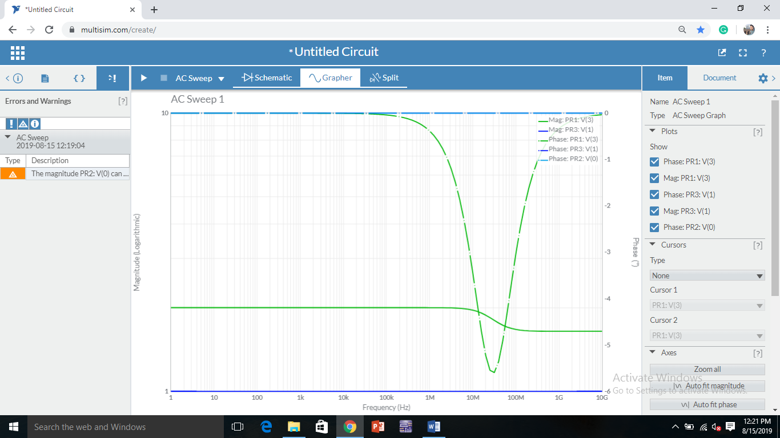

**Input and output waveform**

