**TECHNO INTERNATIONAL NEW TOWN**

GOT SECOND POSITION IN MODEL CONTEST OF TELECAST2024(13/03/2024) ORGANISED BY RADIO PHYSICS DEPARTMENT OF CALCAUTTA UNIVERSITY.

The model or the project we presented was smart streetlight. First, we had to register ourselves in telecast’24 program and then we had to send our idea to the organizing committee through email. Then we got selected and got a chance to present our project. After the judges marked our project and other teachers, students came to see our project and had to showcase our project. After the exhibition, the result was declared and then we got to know we got second position in the exhibition.

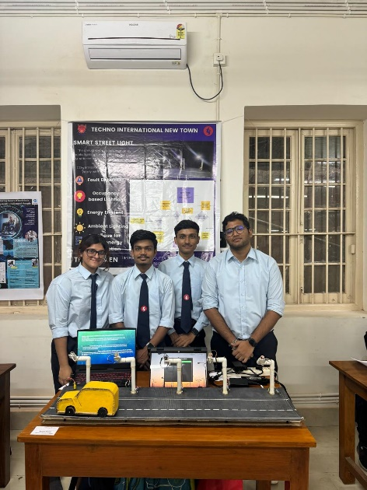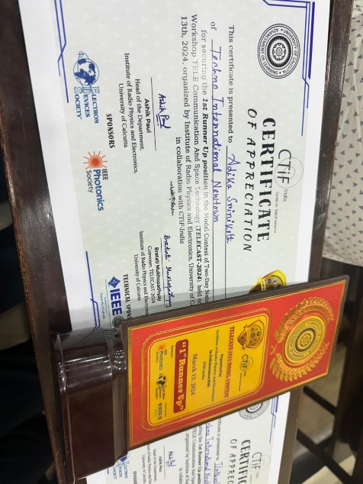

GOT THRID POSITION IN SPARKHACK IN CONVOLUTION 9.0(16/03/2024) ORGANISED BY ELECTRICAL DEPARTMENT OF JADAVPUR UNIVERSITY.

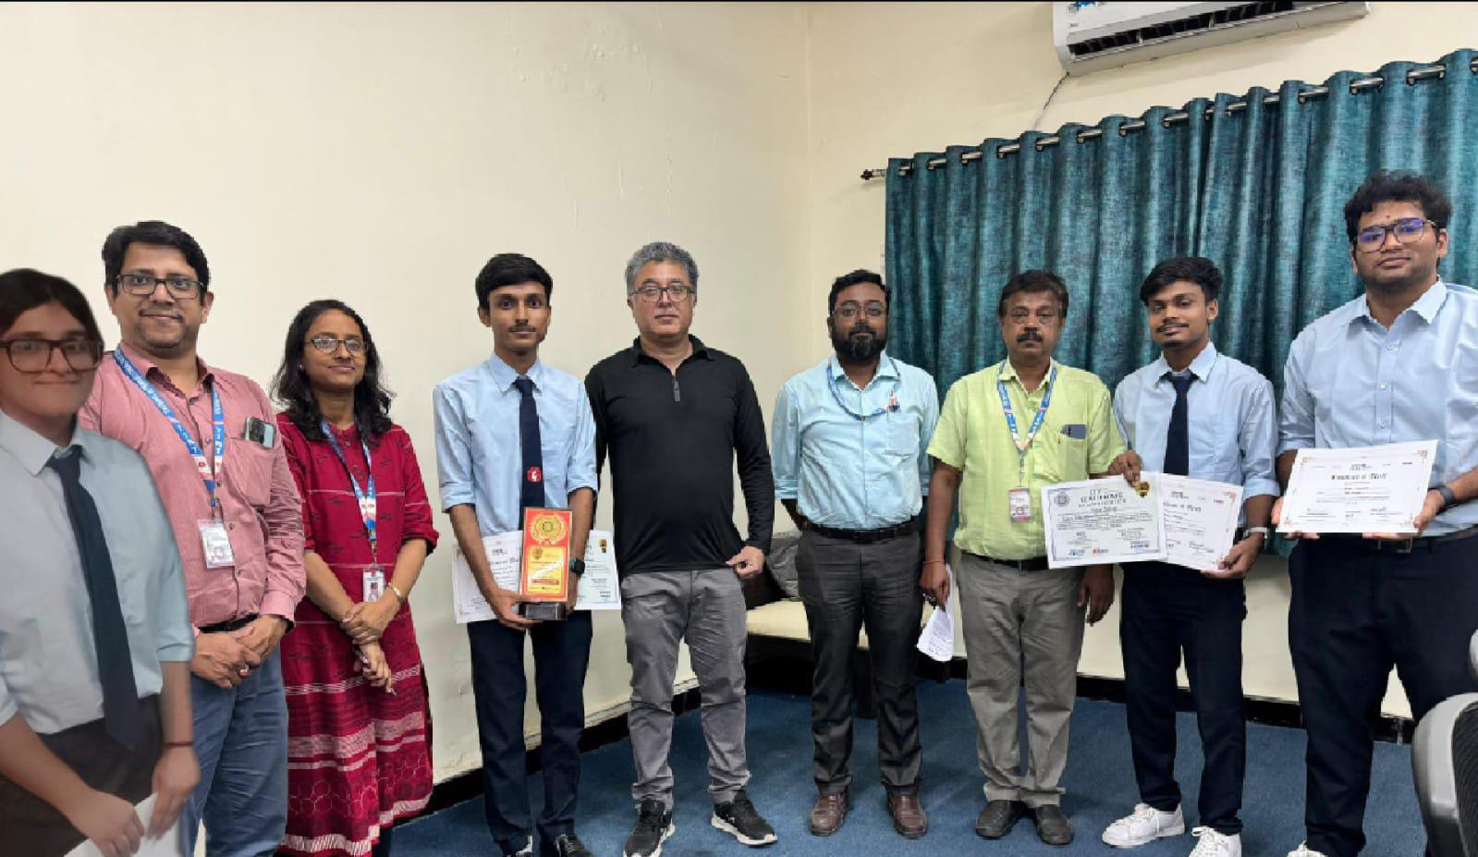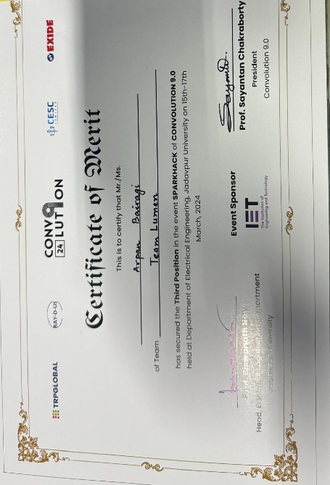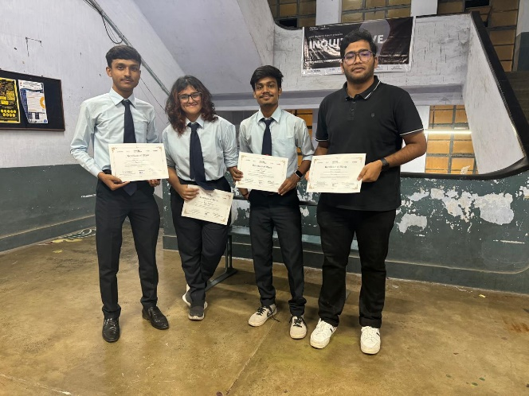The model or the project we presented was smart streetlight. First, we had to register ourselves in convolution 9.0 and then we had to send our idea to the organizing committee through email. Then we got selected and got a chance to present our project in a google meet where a judge was selecting top 10 projects which will be showcased in Jadavpur university. We got selected in the top 10 projects which will be showcased in jadavpur university. In jadavpur university we showcased our project to the judge panel who marked our project, after seeing the top 10 project ideas the judges marked them and declared the result next day. During the final day of the program we got our result in

which we secured 3rd position in sparkhack hackathon.