***1 美国人吃快餐频率***

***The chart below shows how frequently people in the USA ate in fast food restaurants between 2003 and 2013.***

[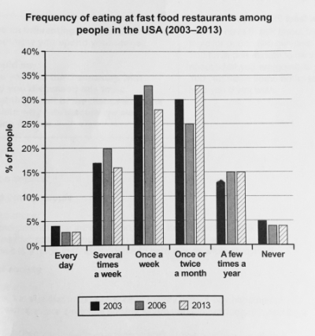](https://ielts-simon.com/.a/6a0120a5bb05d8970c022ad3b0bd16200b-pi)

(Source: Cambridge IELTS 12)

The bar chart illustrates the frequency with which Americans ate in fast food establishments from 2003 to 2013.

It is clear that the majority of Americans ate in fast food restaurants between once a week and once a month in all three years. We can also see a shift towards eating in these restaurants less frequently by the end of the 10-year period.

In each of the years shown on the chart, close to 60% of people in the US ate in fast food restaurants between once and four times a month/on a monthly basis. Roughly 15 to 20% of Americans reported eating in fast food outlets several times per week, while 3 to 4% of people ate in these outlets daily. At the other end of the scale, around 4% of people avoided fast food restaurants completely.

Between 2006 and 2013, the total proportion of Americans who ate in fast food establishments either once a week or several times a week fell by almost 10%. At the same time, there was an increase of around 8% in the ‘once or twice a month’ category. In other words, the weekly fast food habit that was common in 2003 and 2006 became a monthly or twice monthly habit in 2013.

(206 words)

***2 急诊***

***The chart below shows figures for attendances at hospital emergency care departments in Northern Ireland by age group in December 2016 and December 2017.***

**Attendances at emergency care departments per 1000-population**

[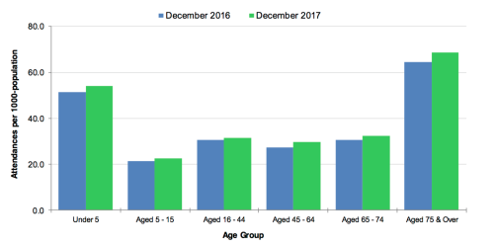](https://ielts-simon.com/.a/6a0120a5bb05d8970c0224e034e5b6200d-pi)

(Source: [health-ni.gov.uk](https://www.health-ni.gov.uk/sites/default/files/publications/health/hs-niwts-ecwt-q3-17-18.pdf))

The bar chart compares the number of visits made by people in six age categories to hospital emergency wards in Northern Ireland in the December of 2016 and 2017.

It is clear that elderly people and the youngest children were the most frequent visitors to A&E (accident and emergency) departments. Also, there was a slight increase in the rate of emergency care attendances among all six age groups from December 2016 to December 2017.

Looking first at the older age groups, roughly 65 people, per 1000 population, aged 75 and over attended A&E wards in December 2016, and this rose to almost 70 attendances per 1000-population one year later. Interestingly, those aged 65 to 74 were less than half as likely to require emergency treatment, with around 30 attendances per 1000-population in both months.

At the other end of the age scale, the figures for A&E visits by under-5s rose marginally from around 50 to approximately 52 per 1000-population over the one-year period. Children aged 5 to 15 made the fewest visits, at just over 20 per 1000-population in both months. Finally, there was almost no difference in the figures for emergency care attendances among people aged 16 to 44, 45 to 64 and 65 to 74.

(217 words)

Mm

***3 新西兰游客消费***

***The graph below shows the average daily spend of three categories of international visitor to New Zealand from 1997 to 2017....***

[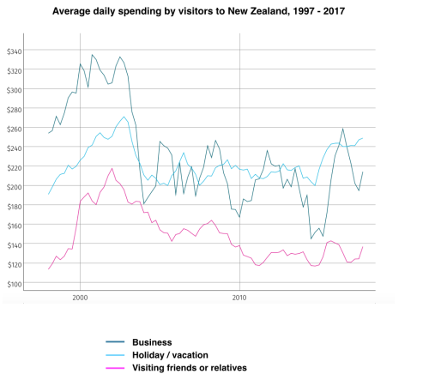](https://ielts-simon.com/.a/6a0120a5bb05d8970c01bb09f38090970d-pi)

The line graph compares three types of traveller to New Zealand between 1997 and 2017 in terms of their average daily expenditure.

It is noticeable that spending by these international visitors was at its highest between the years 2000 and 2003. Overall, business travellers spent the most per day, while people visiting friends or relatives spent the least.

In 1997, business visitors to New Zealand spent an average of almost $260 per day, while holidaymakers spent around $190 and people visiting friends or relatives spent less than $120. Over the following five years, spending by all three types of traveller increased dramatically, to peaks of around $330, $270 and $220. However, visitor spending suddenly fell again between 2003 and 2005.

From 2005 to 2015, the daily expenditure of business travellers and tourists fluctuated around the $200 mark, whereas people visiting relations or friends spent roughly 60 to 80 dollars less per day. By 2017, daily spending had risen to approximately $250, $210 and $140 respectively for vacationers, business people and those visiting loved ones.

(174 words)

***4 欧洲国家垃圾处理***

***The chart below compares levels of recycling, as well as some less environmentally friendly forms of waste management, in fifteen European countries.***

***[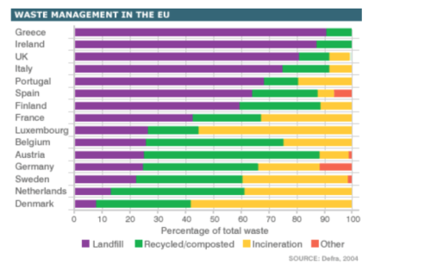](https://ielts-simon.com/.a/6a0120a5bb05d8970c01b7c93acd43970b-pi)***

mm  
The bar chart shows the percentage of waste that is recycled, put into landfill or incinerated in various EU countries.

If we look at the fifteen EU countries as a whole, it is clear that more waste goes to landfill sites than to any other refuse management facility. In fact, while around half of the countries put the majority of their waste into landfill sites, only two countries recycle at least 50% of the waste that they produce.

Austria and Belgium are the most environmentally friendly of the fifteen countries, recycling around 60% and 50% of their waste respectively. Germany, Sweden and Belgium also appear to have effective recycling programmes, resulting in roughly 40% of waste being processed in this way in each country.

Other EU countries recycle far less. Greece, Ireland and the UK, for example, only recycle around 10% of refuse, and put between 80 and 90 per cent of their waste into landfill. Finally, while most non-recycled waste in the EU area goes to landfill, four countries, namely Luxembourg, Sweden, the Netherlands and Denmark, incinerate more waste than they bury.

(184 words)

***5 美国公众旅游***

***The charts below show reasons for travel and the main issues for the travelling public in the US in 2009.***

[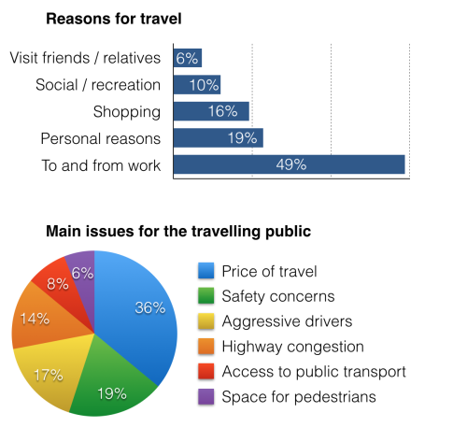](https://ielts-simon.com/.a/6a0120a5bb05d8970c01bb09c103af970d-pi)

...  
The bar chart and pie chart give information about why US residents travelled and what travel problems they experienced in the year 2009.

It is clear that the principal reason why Americans travelled in 2009 was to commute to and from work. In the same year, the primary concern of Americans, with regard to the trips they made, was the cost of travelling.

Looking more closely at the bar chart, we can see that 49% of the trips made by Americans in 2009 were for the purpose of commuting. By contrast, only 6% of trips were visits to friends or relatives, and one in ten trips were for social or recreation reasons. Shopping was cited as the reason for 16% of all travel, while unspecific ‘personal reasons’ accounted for the remaining 19%.

According to the pie chart, price was the key consideration for 36% of American travellers. Almost one in five people cited safety as their foremost travel concern, while aggressive driving and highway congestion were the main issues for 17% and 14% of the travelling public. Finally, a total of 14% of those surveyed thought that access to public transport or space for pedestrians were the most important travel issues.

(201 words)

***6 小学生面临的教育问题***

***The table below gives information about the problems faced by children in two primary schools in 2005 and 2015.***

[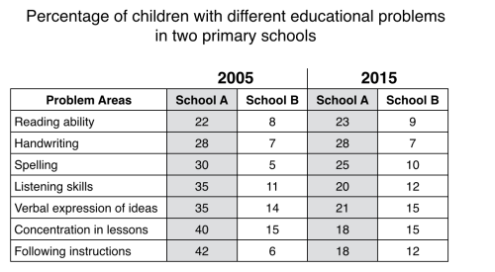](https://ielts-simon.com/.a/6a0120a5bb05d8970c01bb09a5d459970d-pi)

The table compares two primary schools in terms of the proportions of their pupils who experienced seven different educational problems in the years 2005 and 2015.

It is noticeable that school A had higher proportions of children with all seven educational difficulties in both years. However, while school A managed to reduce the incidence of most of the problems between 2005 and 2015, school B saw an overall rise in the percentage of children who were struggling.

In 2005, 42% of school A’s pupils found it difficult to follow instructions, whereas only 6% of pupils in school B experienced this problem. Similarly, between 30 and 40 per cent of children attending school A had problems in the areas of spelling, listening, verbal expression and concentration in lessons, while the equivalent figures for school B stood at between 5 and 15 per cent.

In 2015, the difference between the two schools was less pronounced. Notably, the proportion of children who struggled to follow instructions fell by 24% in school A, and this school also saw falls of 22%, 15%, 14% and 5% in the figures for children who had problems with concentration, listening, verbal expression and spelling. In school B, however, the proportion of children who struggled with spelling and following instructions doubled, to 10% and 12% respectively, and there was almost no change in the incidence of listening, verbal or concentration problems.

(232 words)

***7 英国不同景点的访客量***

***The chart below shows the results of a survey of people who visited four types of tourist attraction in Britain in the year 1999.  
...***

[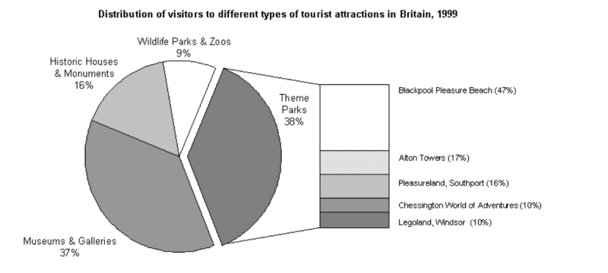](https://ielts-simon.com/.a/6a0120a5bb05d8970c01b8d255ae3d970c-pi)

...  
The pie chart compares figures for visitors to four categories of tourist attraction and to five different theme parks in Britain in 1999.

It is clear that theme parks and museums / galleries were the two most popular types of tourist attraction in that year. Blackpool Pleasure Beach received by far the highest proportion of visitors in the theme park sector.

Looking at the information in more detail, we can see that 38% of the surveyed visitors went to a theme park, and 37% of them went to a museum or gallery. By contrast, historic houses and monuments were visited by only 16% of the sample, while wildlife parks and zoos were the least popular of the four types of tourist attraction, with only 9% of visitors.

In the theme park sector, almost half of the people surveyed (47%) had been to Blackpool Pleasure Beach. Alton Towers was the second most popular amusement park, with 17% of the sample, followed by Pleasureland in Southport, with 16%. Finally, Chessington World of Adventures and Legoland Windsor had each welcomed 10% of the surveyed visitors.

(181 words)

***8 三公司垃圾生产量***

***The graph below shows the amounts of waste produced by three companies over a period of 15 years.***

[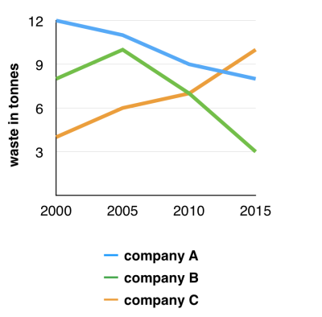](https://ielts-simon.com/.a/6a0120a5bb05d8970c01b8d23cdabf970c-pi)

At the start of this 15-year period, the waste production of company B was approximately 8.5 tonnes, rising significantly during the next five years to a peak of 11 tonnes

before dropping dramatically in the final decade to nearly one third of its initial figure (around 3 tonnes).

After that, the final decade witnessed a dramatic decline in the figure

At the start of this 15-year period, the waste production of company B was approximately 8.5 tonnes. There was a significant rise during the next five years to a peak of 11 tonnes, followed by a less considerable growth between 2005 and 2010, which reached

The line graph compares three companies in terms of their waste output between the years 2000 and 2015.

It is clear that there were significant changes in the amounts of waste produced by all three companies shown on the graph. While companies A and B saw waste output fall over the 15-year period, the amount of waste produced by company C increased considerably.

In 2000, company A produced 12 tonnes of waste, while companies B and C produced around 8 tonnes and 4 tonnes of waste material respectively. Over the following 5 years, the waste output of companies B and C rose by around 2 tonnes, but the figure for company A fell by approximately 1 tonne.

From 2005 to 2015, company A cut waste production by roughly 3 tonnes, and company B reduced its waste by around 7 tonnes. By contrast, company C saw an increase in waste production of approximately 4 tonnes over the same 10-year period. By 2015, company C’s waste output had risen to 10 tonnes, while the respective amounts of waste from companies A and B had dropped to 8 tonnes and only 3 tonnes.

(192 words)

***9 英国父母和孩子的运动参与情况***

***The first chart below gives information about the money spent by British parents on their children’s sports between 2008 and 2014. The second chart shows the number of children who participated in three sports in Britain over the same time period.***

[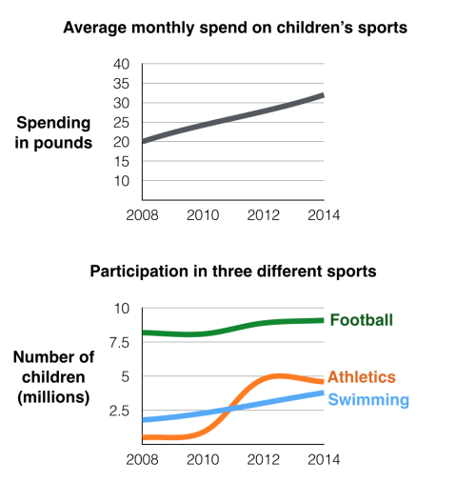](https://ielts-simon.com/.a/6a0120a5bb05d8970c01b8d21fd291970c-pi)

The line graphs show the average monthly amount that parents in Britain spent on their children’s sporting activities and the number of British children who took part in three different sports from 2008 to 2014.

It is clear that parents spent more money each year on their children’s participation in sports over the six-year period. In terms of the number of children taking part, football was significantly more popular than athletics and swimming.

In 2008, British parents spent an average of around £20 per month on their children’s sporting activities. Parents’ spending on children’s sports increased gradually over the following six years, and by 2014 the average monthly amount had risen to just over £30.

Looking at participation numbers, in 2008 approximately 8 million British children played football, while only 2 million children were enrolled in swimming clubs and less than 1 million practised athletics. The figures for football participation remained relatively stable over the following 6 years. By contrast, participation in swimming almost doubled, to nearly 4 million children, and there was a near fivefold increase in the number of children doing athletics.

(185 words)

***10 酒店客户的满意度***

***The charts below show the results of a questionnaire that asked visitors to the Parkway Hotel how they rated the hotel's customer service. The same questionnaire was given to 100 guests in the years 2005 and 2010.***

[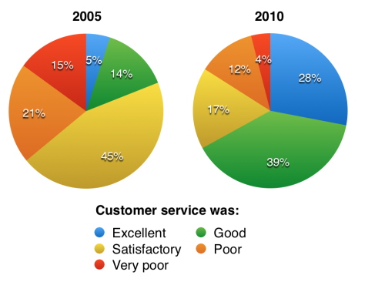](https://ielts-simon.com/.a/6a0120a5bb05d8970c01b7c882e02f970b-pi)

The pie charts compare visitors’ responses to a survey about customer service at the Parkway Hotel in 2005 and in 2010.

It is clear that overall customer satisfaction increased considerably from 2005 to 2010. While most hotel guests rated customer service as satisfactory or poor in 2005, a clear majority described the hotel’s service as good or excellent in 2010.

Looking at the positive responses first, in 2005 only 5% of the hotel’s visitors rated its customer service as excellent, but this figure rose to 28% in 2010. Furthermore, while only 14% of guests described customer service in the hotel as good in 2005, almost three times as many people gave this rating five years later.

With regard to negative feedback, the proportion of guests who considered the hotel’s customer service to be poor fell from 21% in 2005 to only 12% in 2010. Similarly, the proportion of people who thought customer service was very poor dropped from 15% to only 4% over the 5-year period. Finally, a fall in the number of ‘satisfactory’ ratings in 2010 reflects the fact that more people gave positive responses to the survey in that year.

(193 words)

***11 不同区域的用水量***

***The pie charts below compare water usage in San Diego, California and the rest of the world.***  
mm

[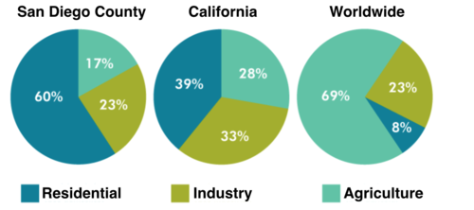](https://ielts-simon.com/.a/6a0120a5bb05d8970c01b8d1f45a5b970c-pi)

mm  
The pie charts give information about the water used for residential, industrial and agricultural purposes in San Diego County, California, and the world as a whole.

It is noticeable that more water is consumed by homes than by industry or agriculture in the two American regions. By contrast, agriculture accounts for the vast majority of water used worldwide.

In San Diego County and California State, residential water consumption accounts for 60% and 39% of total water usage. By contrast, a mere 8% of the water used globally goes to homes. The opposite trend can be seen when we look at water consumption for agriculture. This accounts for a massive 69% of global water use, but only 17% and 28% of water usage in San Diego and California respectively.

Such dramatic differences are not seen when we compare the figures for industrial water use. The same proportion of water (23%) is used by industry in San Diego and worldwide, while the figure for California is 10% higher, at 33%.

(168 words)

***12 英国学生互联网使用和游戏时间***

***The chart below shows the amount of time that 10 to 15-year-olds spend chatting on the Internet and playing on games consoles on an average school day in the UK.***  
...

[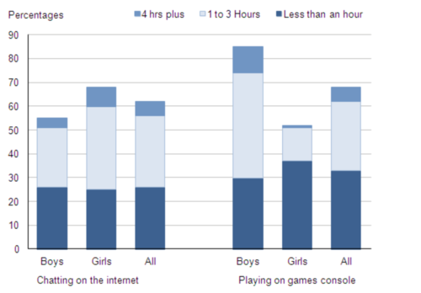](https://ielts-simon.com/.a/6a0120a5bb05d8970c01bb08c994f0970d-pi)

...

Overall, console gaming is more popular than online chatting, with distinct trends seen for boys and girls. Also noticeably, the most common length of time spent on each activity is 1 to 3 hours.

The bar chart compares the time spent by 10 to 15-year-olds in the UK on two activities, namely chatting online and playing computer games.

Overall, we can see that playing computer games is marginally more popular than chatting on the Internet. However, completely different trends can be seen if we look at the specific figures for boys and girls.

Boys aged between 10 and 15 clearly favour playing on games consoles over chatting online. According to the chart, while 85% of boys play computer games every day, only 55% chat online daily. Furthermore, the majority of boys play on their consoles for more than one hour each day, and 10% do this activity for four hours or more.

By contrast, girls prefer chatting online. Close to 70% of 10 to 15-year-old girls engage in online conversation each day, compared to about 50% of this cohort who play computer games. Of the girls who do play on consoles, most of them play for less than an hour, whereas most girls who chat online do so for more than one hour, and nearly 10% chat for four hours or more.

(188 words)

***13 不同方式的电话时长***

***The chart below shows the total number of minutes (in billions) of telephone calls in the UK, divided into three categories, from 1995-2002.***

[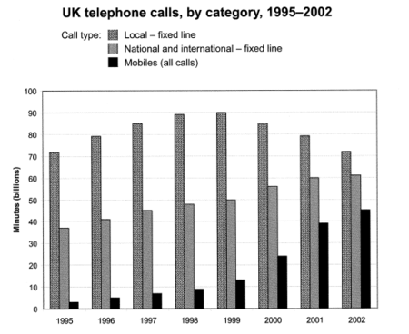](https://ielts-simon.com/.a/6a0120a5bb05d8970c01bb08aef750970d-pi)

The bar chart compares the amount of time spent by people in the UK on three different types of phone call between 1995 and 2002.

It is clear that calls made via local, fixed lines were the most popular type, in terms of overall usage, throughout the period shown. The lowest figures on the chart are for mobile calls, but this category also saw the most dramatic increase in user minutes.

In 1995, people in the UK used fixed lines for a total of just over 70 billion minutes for local calls, and about half of that amount of time for national or international calls. By contrast, mobile phones were only used for around 4 billion minutes. Over the following four years, the figures for all three types of phone call increased steadily.

By 1999, the amount of time spent on local calls using landlines had reached a peak at 90 billion minutes. Subsequently, the figure for this category fell, but the rise in the other two types of phone call continued. In 2002, the number of minutes of national / international landline calls passed 60 billion, while the figure for mobiles rose to around 45 billion minutes.

(197 words)

***14 英国男女独居情况***

***The bar chart below shows the proportions of English men and women of different ages who were living alone in 2011. The pie chart compares the numbers of bedrooms in these one-person households.  
...***

**Living alone in England by age and gender, 2011**

[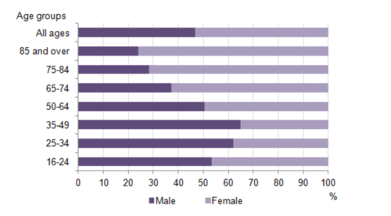](https://ielts-simon.com/.a/6a0120a5bb05d8970c01bb089bc2d3970d-pi)

**Number of bedrooms in one-person households (England, 2011)**

[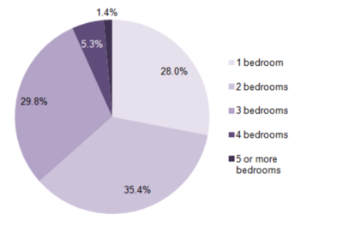](https://ielts-simon.com/.a/6a0120a5bb05d8970c01b8d1813290970c-pi)

The two charts give information about single-occupant households in England in the year 2011. The bar chart compares figures for occupants' age and gender, and the pie chart shows data about the number of bedrooms in these homes.

Overall, females made up a higher proportion of people living alone than males, and this difference is particularly noticeable in the older age categories. We can also see that the most common number of bedrooms in a single-occupant home was two.

A significant majority of the people aged 65 or over who were living alone in England in 2011 were female. Women made up around 72% of single occupants aged 75 to 84, and 76% of those aged 85 or over. By contrast, among younger adults the figures for males were higher. For example, in the 35-49 age category, men accounted for nearly 65% of people living alone.

In the same year, 35.4% of one-person households in England had two bedrooms, while one-bedroom and three-bedroom homes accounted for 28% and 29.8% of the total. Under 7% of single-occupant homes had four or more bedrooms.

(189 words)

***15 咖啡和香蕉的销售额***

***The tables below give information about sales of Fairtrade*-labelled coffee and bananas in 1999 and 2004 in five European countries.***

[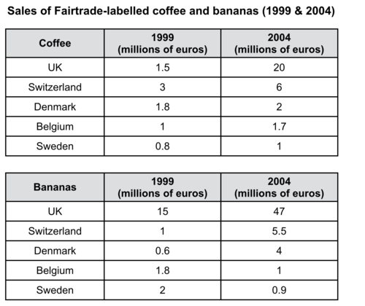](https://ielts-simon.com/.a/6a0120a5bb05d8970c01bb0884691e970d-pi)

*Fairtrade: a category of products for which farmers from developing countries have been paid an officially agreed fair price.

The tables show the amount of money spent on Fairtrade coffee and bananas in two separate years in the UK, Switzerland, Denmark, Belgium and Sweden.

It is clear that sales of Fairtrade coffee rose in all five European countries from 1999 to 2004, but sales of Fairtrade bananas only went up in three out of the five countries. Overall, the UK saw by far the highest levels of spending on the two products.

In 1999, Switzerland had the highest sales of Fairtrade coffee, at €3 million, while revenue from Fairtrade bananas was highest in the UK, at €15 million. By 2004, however, sales of Fairtrade coffee in the UK had risen to €20 million, and this was over three times higher than Switzerland’s sales figure for Fairtrade coffee in that year. The year 2004 also saw dramatic increases in the money spent on Fairtrade bananas in the UK and Switzerland, with revenues rising by €32 million and €4.5 million respectively.

Sales of the two Fairtrade products were far lower in Denmark, Belgium and Sweden. Small increases in sales of Fairtrade coffee can be seen, but revenue remained at €2 million or below in all three countries in both years. Finally, it is noticeable that the money spent on Fairtrade bananas actually fell in Belgium and Sweden.

(216 words)

***16 法国和印度人口结构对比***

***The charts below compare the age structure of the populations of France and India in 1984.***  
mm

[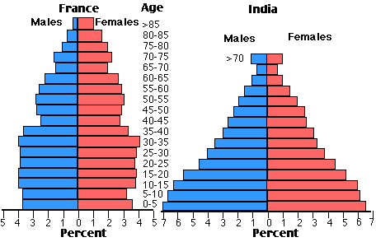](https://ielts-simon.com/.a/6a0120a5bb05d8970c01b7c7a4106c970b-pi)

mm  
The two charts compare the populations of France and India in terms of age distribution by gender in the year 1984.

It is clear that the population of India was younger than that of France in 1984, with a noticeably larger proportion of people aged under 20. France, on the other hand, had a significantly larger percentage of elderly inhabitants.

In India, close to 14% of people were aged 5 or under, and each five-year age bracket above this contained an increasingly smaller proportion of the population. France’s population, by contrast, was more evenly distributed across the age ranges, with similar figures (around 7% to 8% of all people) for each five-year cohort between the ages of 0 and 40. Somewhere between 10% and 15% of all French people were aged 70 or older, but the equivalent figure for India was only 2%.

Looking more closely at gender, there was a noticeably higher proportion of French women than men in every cohort from age 50 upwards. For example, almost 3% of French 70- to 75-year-olds were women, while just under 2% were men. No significant gender differences can be seen on the Indian population chart.

(199 words)

***17 六国垃圾生产量***

***The table below shows the amount of waste production (in millions of tonnes) in six different countries over a twenty-year period.***

[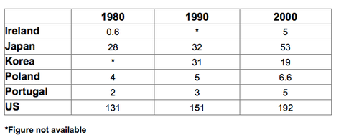](https://ielts-simon.com/.a/6a0120a5bb05d8970c01b7c7018323970b-pi)

In 1980, the waste production stood at 131 million tonnes in America, nearly five times the figure of Japan. Both countries saw considerable growths in their waste output, increasing to 192 and 53 million tonnes respectively. In contrast, Korea, a country where no initial figure was available and the 1990 figure reached almost the same level as Japan’s, managed to cut its waste output by 12 million tonnes between 1990 and 2000.

The chart compares the amounts of waste that were produced in six countries in the years 1980, 1990 and 2000.

In each of these years, the US produced more waste than Ireland, Japan, Korea, Poland and Portugal combined. It is also noticeable that Korea was the only country that managed to reduce its waste output by the year 2000.

Between 1980 and 2000, waste production in the US rose from 131 to 192 million tonnes, and rising trends were also seen in Japan, Poland and Portugal. Japan’s waste output increased from 28 to 53 million tonnes, while Poland and Portugal saw waste totals increase from 4 to 6.6 and from 2 to 5 million tonnes respectively.

The trends for Ireland and Korea were noticeably different from those described above. In Ireland, waste production increased more than eightfold, from only 0.6 million tonnes in 1980 to 5 million tonnes in 2000. Korea, by contrast, cut its waste output by 12 million tonnes between 1990 and 2000.

(165 words)

The line chart presents an illustration of how the number of three kinds of crime in England and Wales changed over a 35-year period (1970-2005).

The table presents a comparison of School A and School B in terms of the percentages of pupils who faced seven educational problems in 2005 and 2015.

The bar chart presents an illustration of how the total amount of time British people spent on making three types of telephone calls over a 8-year period (1995-2002).

The bar chart presents a comparison of five UK age groups in terms of the proportion of their expenditure on three categories in the year 2014.

***18 学校年度开支变化***

***The three pie charts below show the changes in annual spending by a particular UK school in 1981, 1991 and 2001.***

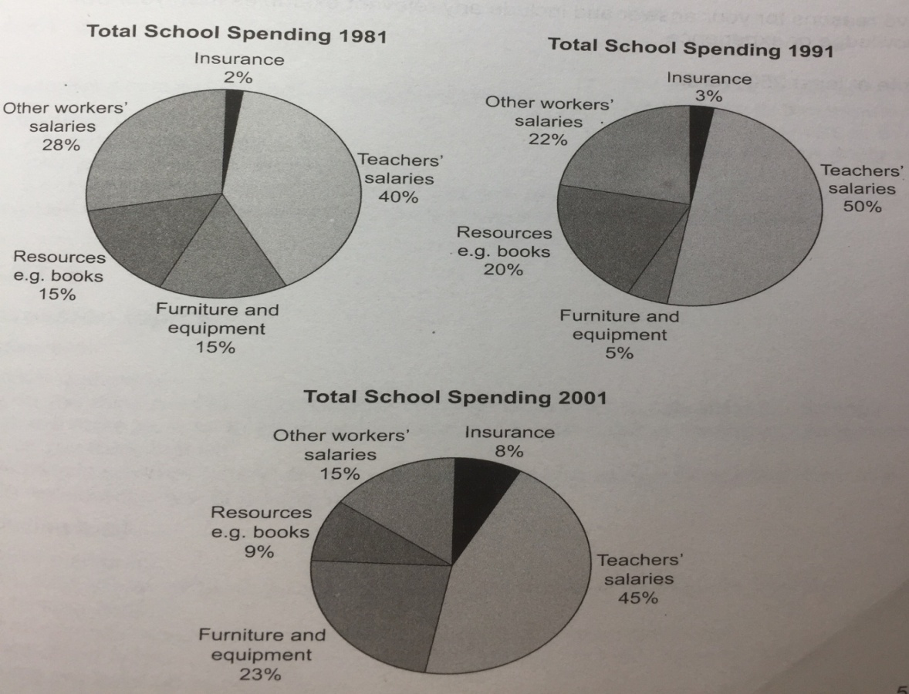

The pie charts compare the expenditure of a school in the UK in three different years over a 20-year period.

It is clear that teachers’ salaries made up the largest proportion of the school’s spending in all three years (1981, 1991 and 2001). By contrast, insurance was the smallest cost in each year.

In 1981, 40% of the school’s budget went on teachers’ salaries. This figure rose to 50% in 1991, but fell again by 5% in 2001. The proportion of spending on other workers’ wages fell steadily over the 20-year period, from 28% of the budget in 1981 to only 15% in 2001.

Expenditure on insurance stood at only 2% of the total in 1981, but reached 8% in 2001. Finally, the percentages for resources and furniture/equipment fluctuated. The figure for resources was highest in 1991, at 20%, and the proportion of spending on furniture and equipment reached its peak in 2001, at 23%.

(158 words)

***19 英国不同地区骑单车上班的居民数量对比***

***The table below shows changes in the numbers of residents cycling to work in different areas of the UK between 2001 and 2011.***

[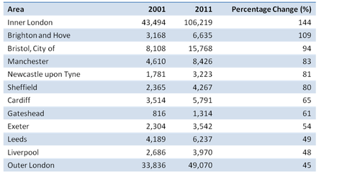](https://ielts-simon.com/.a/6a0120a5bb05d8970c01b8d05e4ed3970c-pi)

The table compares the numbers of people who cycled to work in twelve areas of the UK in the years 2001 and 2011.

Overall, the number of UK commuters who travelled to work by bicycle rose considerably over the 10-year period. Inner London had by far the highest number of cycling commuters in both years.

In 2001, well over 43 thousand residents of inner London commuted by bicycle, and this figure rose to more than 106 thousand in 2011, an increase of 144%. By contrast, although outer London had the second highest number of cycling commuters in each year, the percentage change, at only 45%, was the lowest of the twelve areas shown in the table.

Brighton and Hove saw the second biggest increase (109%) in the number of residents cycling to work, but Bristol was the UK’s second city in terms of total numbers of cycling commuters, with 8,108 in 2001 and 15,768 in 2011. Figures for the other eight areas were below the 10 thousand mark in both years.

(172 words)

***20 失业率失业率***

***The graph below shows changes in young adult unemployment rates in England between 1993 and 2012.***

[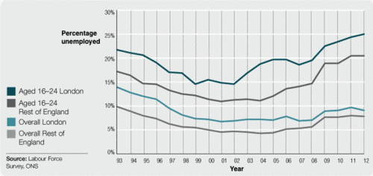](https://ielts-simon.com/.a/6a0120a5bb05d8970c01a511e37300970c-pi)

The line graph compares levels of unemployment among 16 to 24-year-olds with overall unemployment figures over a period of 20 years in England.

It is clear that the proportion of young adults who were unemployed at any time between 1993 and 2012 was significantly higher than the overall proportion of adults without work. Unemployment rates for both groups of adults were consistently higher in London than in the rest of England.

In 1993, around 18% of English 16 to 24-year-olds living outside London were unemployed, but the figure for those living in the capital was 5% higher, at 22%. Similarly, the overall adult unemployment rate in London, at 14%, was 4% higher than the rate in the rest of England. While levels of joblessness fell significantly over the following 10 years, the trend for higher levels in London and among young adults continued.

Young adult unemployment in England rose dramatically between 2002 and 2012, from 12% to 21% outside London, and from around 15% to a peak of 25% in the capital. By contrast, the proportions of all adults without work remained below 10%, both in London and in the rest of the country.

(194 words)

***21 电子游戏的全球销售额***

***The bar graph shows the global sales (in billions of dollars) of different types of digital games between 2000 and 2006.***

[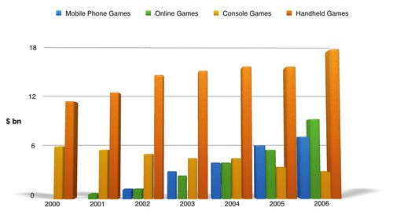](https://ielts-simon.com/.a/6a0120a5bb05d8970c01a511b3a611970c-pi)

The bar chart compares the turnover in dollars from sales of video games for four different platforms, namely mobile phones, online, consoles and handheld devices, from 2000 to 2006.

It is clear that sales of games for three out of the four platforms rose each year, leading to a significant rise in total global turnover over the 7-year period. Sales figures for handheld games were at least twice as high as those for any other platform in almost every year.

In 2000, worldwide sales of handheld games stood at around $11 billion, while console games earned just under $6 billion. No figures are given for mobile or online games in that year. Over the next 3 years, sales of handheld video games rose by about $4 billion, but the figure for consoles decreased by $2 billion. Mobile phone and online games started to become popular, with sales reaching around $3 billion in 2003.

In 2006, sales of handheld, online and mobile games reached peaks of 17, 9 and 7 billion dollars respectively. By contrast, turnover from console games dropped to its lowest point, at around $2.5 billion.

(187 words)

***22 热狗竞吃比赛***

[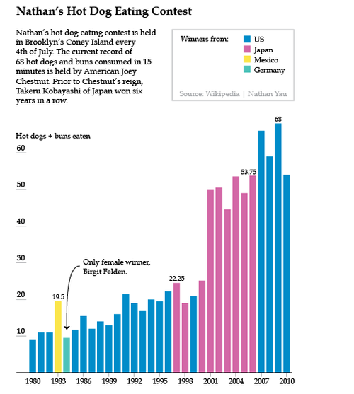](https://ielts-simon.com/.a/6a0120a5bb05d8970c01a5115f192e970c-pi)

The bar chart shows the number of hot dogs and buns eaten in 15 minutes by the winners of ‘Nathan’s Hot Dog Eating Contest’ in Brooklyn, USA between 1980 and 2010.

It is noticeable that the number of hot dogs and buns eaten by winners of the contest increased dramatically over the period shown. The majority of winners were American or Japanese, and only one woman had ever won the contest.

Americans dominated the contest from 1980 to 1996, and the winning number of hot dogs and buns consumed rose from only 8 to around 21 during that time. 1983 and 1984 were notable exceptions to the trend for American winners. In 1983 a Mexican won the contest after eating 19.5 hot dogs, almost double the amount that any previous winner had eaten, and 1984 saw the only female winner, Birgit Felden from Germany.

A Japanese contestant, Takeru Kobayashi, reigned as hot dog eating champion for six years from 2001 to 2006. Kobayashi’s winning totals of around 50 hot dogs were roughly double the amount that any previous winner had managed. However, the current champion, American Joey Chestnut, took hot dog eating to new heights in 2009 when he consumed an incredible 68 hot dogs and buns in the allotted 15 minutes.

(212 words)

***23 美国肉禽类消耗量***

***The graph below shows trends in US meat and poultry consumption.***

[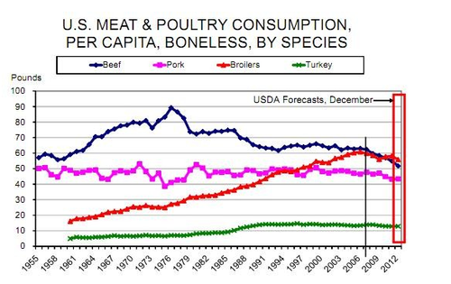](https://ielts-simon.com/.a/6a0120a5bb05d8970c019b0161cef5970d-pi)

The line graph shows changes in the per capita consumption of beef, pork, broilers and turkey in the United States between 1955 and 2012.

It is noticeable that beef was by far the most popular of the four types of meat for the majority of the 57-year period. However, a considerable rise can be seen in the consumption of broilers, with figures eventually surpassing those for beef.

Between 1955 and 1976, US beef consumption rose from around 60 to a peak of 90 pounds per person per year. During the same period, consumption of broilers also rose, to nearly 30 pounds per person, while the figures for pork fluctuated between 50 and 40 pounds per person. Turkey was by far the least popular meat, with figures below 10 pounds per capita each year.

By 2012, the amount of beef consumed by the average American had plummeted to around 50 pounds, but the consumption of broilers had doubled since the 1970s, to approximately 55 pounds per capita. By contrast, there were no significant changes in the trends for pork and turkey consumption over the period as a whole.

(187 words)

***24 十二国奥运会奖牌数对比***

***The chart below shows the total number of Olympic medals won by twelve different countries.***

[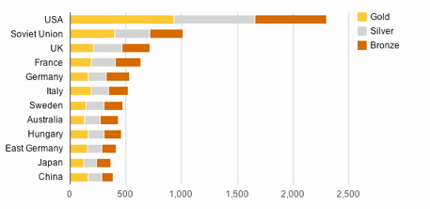](https://ielts-simon.com/.a/6a0120a5bb05d8970c0192ac6f6b4b970d-pi)

The bar chart compares twelve countries in terms of the overall number of medals that they have won at the Olympic Games.

It is clear that the USA is by far the most successful Olympic medal winning nation. It is also noticeable that the figures for gold, silver and bronze medals won by any particular country tend to be fairly similar.

The USA has won a total of around 2,300 Olympic medals, including approximately 900 gold medals, 750 silver and 650 bronze. In second place on the all-time medals chart is the Soviet Union, with just over 1,000 medals. Again, the number of gold medals won by this country is slightly higher than the number of silver or bronze medals.

Only four other countries - the UK, France, Germany and Italy - have won more than 500 Olympic medals, all with similar proportions of each medal colour. Apart from the USA and the Soviet Union, China is the only other country with a noticeably higher proportion of gold medals (about 200) compared to silver and bronze (about 100 each).

(178 words)

***25 手机不同功能使用情况***

[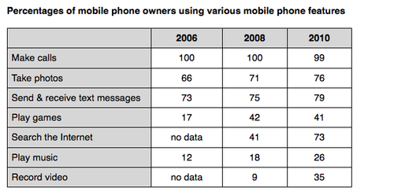](https://ielts-simon.com/.a/6a0120a5bb05d8970c01901e1a37a6970b-pi)

The table compares the percentages of people using different functions of their mobile phones between 2006 and 2010.

Throughout the period shown, the main reason why people used their mobile phones was to make calls. However, there was a marked increase in the popularity of other mobile phone features, particularly the Internet search feature.

In 2006, 100% of mobile phone owners used their phones to make calls, while the next most popular functions were text messaging (73%) and taking photos (66%). By contrast, less than 20% of owners played games or music on their phones, and there were no figures for users doing Internet searches or recording video.

Over the following 4 years, there was relatively little change in the figures for the top three mobile phone features. However, the percentage of people using their phones to access the Internet jumped to 41% in 2008 and then to 73% in 2010. There was also a significant rise in the use of mobiles to play games and to record video, with figures reaching 41% and 35% respectively in 2010.

(178 words)

***26 英国使用不同交通工具的通勤者数量***

***The graph below shows the average number of UK commuters travelling each day by car, bus or train between 1970 and 2030.***

[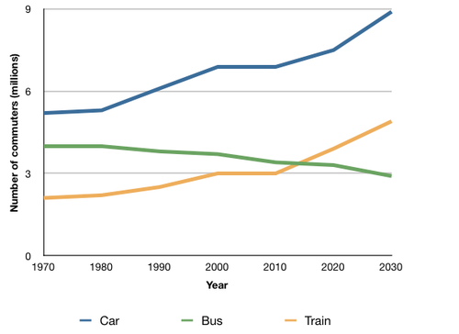](https://ielts-simon.com/.a/6a0120a5bb05d8970c019101f28f36970c-pi)

The line graph compares figures for daily travel by workers in the UK using three different forms of transport over a period of 60 years.

It is clear that the car is by far the most popular means of transport for UK commuters throughout the period shown. Also, while the numbers of people who use the car and train increase gradually, the number of bus users falls steadily.

In 1970, around 5 million UK commuters travelled by car on a daily basis, while the bus and train were used by about 4 million and 2 million people respectively. In the year 2000, the number of those driving to work rose to 7 million and the number of commuting rail passengers reached 3 million. However, there was a small drop of approximately 0.5 million in the number of bus users.

By 2030, the number of people who commute by car is expected to reach almost 9 million, and the number of train users is also predicted to rise, to nearly 5 million. By contrast, buses are predicted to become a less popular choice, with only 3 million daily users.

(188 words)

***27 美国人手机和座机的年消费额***

***The graph below shows US consumers' average annual expenditures on cell phone and residential phone services between 2001 and 2010.***

[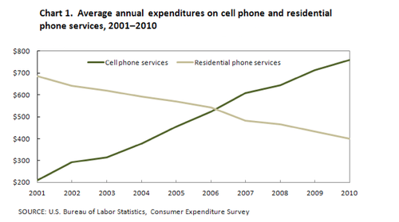](https://ielts-simon.com/.a/6a0120a5bb05d8970c017ee8c6278b970d-pi)

The line graph compares average yearly spending by Americans on mobile and landline phone services from 2001 to 2010.

It is clear that spending on landline phones fell steadily over the 10-year period, while mobile phone expenditure rose quickly. The year 2006 marks the point at which expenditure on mobile services overtook that for residential phone services.

In 2001, US consumers spent an average of nearly $700 on residential phone services, compared to only around $200 on cell phone services. Over the following five years, average yearly spending on landlines dropped by nearly $200. By contrast, expenditure on mobiles rose by approximately $300.

In the year 2006, the average American paid out the same amount of money on both types of phone service, spending just over $500 on each. By 2010, expenditure on mobile phones had reached around $750, while the figure for spending on residential services had fallen to just over half this amount.

(162 words)

***28 电子游戏的全球销售额***

***The climograph below shows average monthly temperatures and rainfall in the city of Kolkata.***

[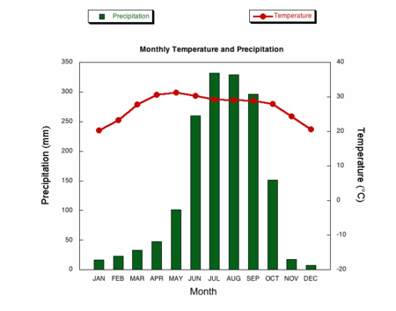](https://ielts-simon.com/.a/6a0120a5bb05d8970c017c33d5fcc0970b-pi)

The chart compares average figures for temperature and precipitation over the course of a calendar year in Kolkata.

It is noticeable that monthly figures for precipitation in Kolkata vary considerably, whereas monthly temperatures remain relatively stable. Rainfall is highest from July to August, while temperatures are highest in April and May.

Between the months of January and May, average temperatures in Kolkata rise from their lowest point at around 20°C to a peak of just over 30°C. Average rainfall in the city also rises over the same period, from approximately 20mm of rain in January to 100mm in May.

While temperatures stay roughly the same for the next four months, the amount of rainfall more than doubles between May and June. Figures for precipitation remain above 250mm from June to September, peaking at around 330mm in July. The final three months of the year see a dramatic fall in precipitation, to a low of about 10mm in December, and a steady drop in temperatures back to the January average.

(173 words)

***29 不同地区每周家庭开支对比***

***Average weekly household expenditure, by region, 2007-09***

[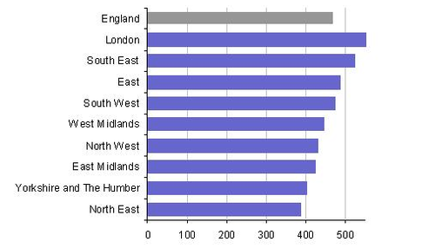](https://ielts-simon.com/.a/6a0120a5bb05d8970c017744ad09b1970d-pi)

Weekly expenditure (£)

The bar chart shows average weekly spending by households in different areas of England between 2007 and 2009.

Households in the south of the country spent more on average than those in the north. Average weekly spending by households was highest in London and lowest in the North East.

English households spent on average around £470 per week. The average expenditure for households in London was about £560 per week, almost £100 more than the overall figure for England. Households in the South East, East and South West also spent more than the national average. Weekly household spending figures for those three regions were approximately £520, £490 and £480 respectively.

Similar levels of household spending were seen in the West Midlands, the North West and the East Midlands, at about £430 to £450 per week. In the region of Yorkshire and the Humber, households spent approximately £400 per week, while expenditure in the North East was around £10 per week lower than this. It is noticeable that average weekly expenditure by households in the North East was around £80 less than the national average, and around £170 less than the London average.

(192 words)

***30 不同年龄群学生的学习原因及雇主支持度***

***The charts below show the main reasons for study among students of different age groups and the amount of support they received from employers.***

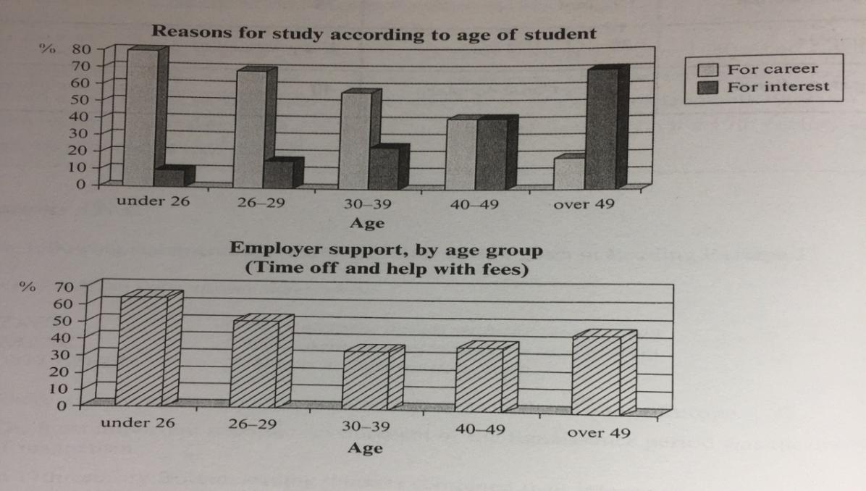

The bar charts compare students of different ages in terms of why they are studying and whether they are supported by an employer.

It is clear that the proportion of students who study for career purposes is far higher among the younger age groups, while the oldest students are more likely to study for interest. Employer support is more commonly given to younger students.

Around 80% of students aged under 26 study to further their careers, whereas only 10% study purely out of interest. The gap between these two proportions narrows as students get older, and the figures for those in their forties are the same, at about 40%. Students aged over 49 overwhelmingly study for interest (70%) rather than for professional reasons (less than 20%).

Just over 60% of students aged under 26 are supported by their employers. By contrast, the 30-39 age group is the most self-sufficient, with only 30% being given time off and help with fees. The figures rise slightly for students in their forties and for those aged 50 or more.

(178 words)

***31 不同交通工具产生的事故量对比***

***The chart below shows numbers of incidents and injuries per 100 million passenger miles travelled (PMT) by transportation type in 2002.***

[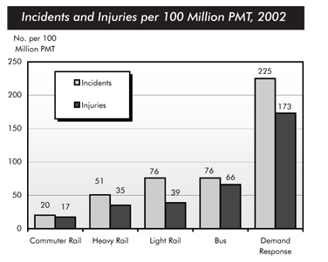](https://ielts-simon.com/.a/6a0120a5bb05d8970c0163062e1ad2970d-pi)

The bar chart compares the number of incidents and injuries for every 100 million passenger miles travelled on five different types of public transport in 2002.

It is clear that the most incidents and injuries took place on demand-response vehicles. By contrast, commuter rail services recorded by far the lowest figures.

A total of 225 incidents and 173 injuries, per 100 million passenger miles travelled, took place on demand-response transport services. These figures were nearly three times as high as those for the second highest category, bus services. There were 76 incidents and 66 people were injured on buses.

Rail services experienced fewer problems. The number of incidents on light rail trains equalled the figure recorded for buses, but there were significantly fewer injuries, at only 39. Heavy rail services saw lower numbers of such events than light rail services, but commuter rail passengers were even less likely to experience problems. In fact, only 20 incidents and 17 injuries occurred on commuter trains.

(165 words)

***32 三国老龄化人口比例变化***

***The graph below shows the proportion of the population aged 65 and over between 1940 and 2040 in three different countries.***

[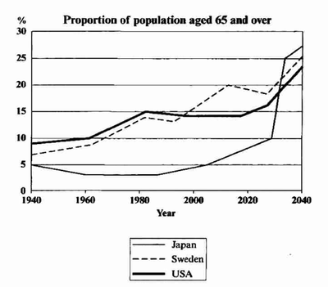](https://ielts-simon.com/.a/6a0120a5bb05d8970c016302d4a2b7970d-pi)

The line graph compares the percentage of people aged 65 or more in three countries over a period of 100 years.

It is clear that the proportion of elderly people increases in each country between 1940 and 2040. Japan is expected to see the most dramatic changes in its elderly population.

In 1940, around 9% of Americans were aged 65 or over, compared to about 7% of Swedish people and 5% of Japanese people. The proportions of elderly people in the USA and Sweden rose gradually over the next 50 years, reaching just under 15% in 1990. By contrast, the figures for Japan remained below 5% until the early 2000s.

Looking into the future, a sudden increase in the percentage of elderly people is predicted for Japan, with a jump of over 15% in just 10 years from 2030 to 2040. By 2040, it is thought that around 27% of the Japanese population will be 65 years old or more, while the figures for Sweden and the USA will be slightly lower, at about 25% and 23% respectively.

(178 words)

***33 家庭汽车拥有率变化***

***The graph below gives information about car ownership in Britain from 1971 to 2007.***

[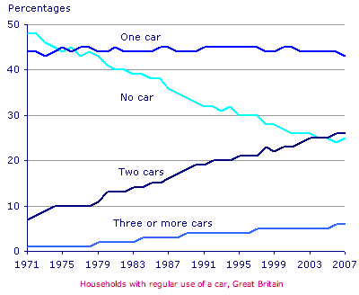](https://ielts-simon.com/.a/6a0120a5bb05d8970c0133f08ccc2a970b-pi)

The graph shows changes in the number of cars per household in Great Britain over a period of 36 years.

Overall, car ownership in Britain increased between 1971 and 2007. In particular, the percentage of households with two cars rose, while the figure for households without a car fell.

In 1971, almost half of all British households did not have regular use of a car. Around 44% of households had one car, but only about 7% had two cars. It was uncommon for families to own three or more cars, with around 2% of households falling into this category.

The one-car household was the most common type from the late 1970’s onwards, although there was little change in the figure for this category. The biggest change was seen in the proportion of households without a car, which fell steadily over the 36-year period to around 25% in 2007. In contrast, the proportion of two-car families rose steadily, reaching about 26% in 2007, and the proportion of households with more than two cars rose by around 5%.

(176 words)

***34 五国不同类别消费占比***

***The table below gives information on consumer spending on different items in five different countries in 2002.***

Percentage of national consumer expenditure by category - 2002

[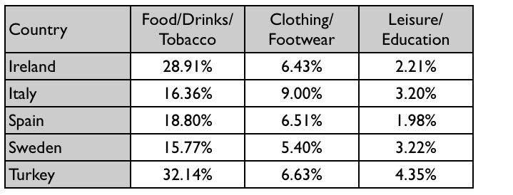](https://ielts-simon.com/.a/6a0120a5bb05d8970c0148c78b1eaf970c-pi)

The table shows percentages of consumer expenditure for three categories of products and services in five countries in 2002.

It is clear that the largest proportion of consumer spending in each country went on food, drinks and tobacco. On the other hand, the leisure/education category has the lowest percentages in the table.

Out of the five countries, consumer spending on food, drinks and tobacco was noticeably higher in Turkey, at 32.14%, and Ireland, at nearly 29%. The proportion of spending on leisure and education was also highest in Turkey, at 4.35%, while expenditure on clothing and footwear was significantly higher in Italy, at 9%, than in any of the other countries.

It can be seen that Sweden had the lowest percentages of national consumer expenditure for food/drinks/tobacco and for clothing/footwear, at nearly 16% and just over 5% respectively. Spain had slightly higher figures for these categories, but the lowest figure for leisure/education, at only 1.98%.

(155 words)

***35 全球和区域性用水量***

***The graph and table below give information about water use worldwide and water consumption in two different countries.***

[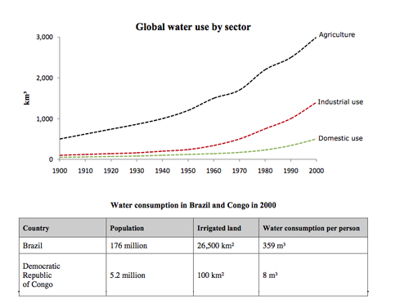](https://ielts-simon.com/.a/6a0120a5bb05d8970c0153940d0aee970b-pi)

The charts compare the amount of water used for agriculture, industry and homes around the world, and water use in Brazil and the Democratic Republic of Congo.

It is clear that global water needs rose significantly between 1900 and 2000, and that agriculture accounted for the largest proportion of water used. We can also see that water consumption was considerably higher in Brazil than in the Congo.

In 1900, around 500km³ of water was used by the agriculture sector worldwide. The figures for industrial and domestic water consumption stood at around one fifth of that amount. By 2000, global water use for agriculture had increased to around 3000km³, industrial water use had risen to just under half that amount, and domestic consumption had reached approximately 500km³.

In the year 2000, the populations of Brazil and the Congo were 176 million and 5.2 million respectively. Water consumption per person in Brazil, at 359m³, was much higher than that in the Congo, at only 8m³, and this could be explained by the fact that Brazil had 265 times more irrigated land.

(184 words)

***36 饮食结构成分占比***

[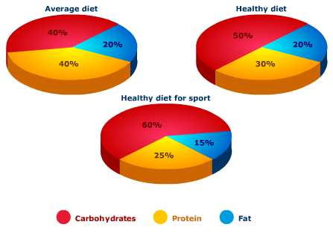](https://ielts-simon.com/.a/6a0120a5bb05d8970c015392ea56f7970b-pi)

The pie charts compare the proportion of carbohydrates, protein and fat in three different diets, namely an average diet, a healthy diet, and a healthy diet for sport.

It is noticeable that sportspeople require a diet comprising a significantly higher proportion of carbohydrates than an average diet or a healthy diet. The average diet contains the lowest percentage of carbohydrates but the highest proportion of protein.

Carbohydrates make up 60% of the healthy diet for sport. This is 10% higher than the proportion of carbohydrates in a normal healthy diet, and 20% more than the proportion in an average diet. On the other hand, people who eat an average diet consume a relative greater amount of protein (40%) than those who eat a healthy diet (30%) and sportspeople (25%).

The third compound shown in the charts is fat. Fat constitutes exactly one fifth of both the average diet and the healthy diet, but the figure drops to only 15% for the healthy sports diet.

(164 words)

***37 不同行业的酸雨产生量变化***

***The graph below shows UK acid rain emissions, measured in millions of tonnes, from four different sectors between 1990 and 2007.***

***[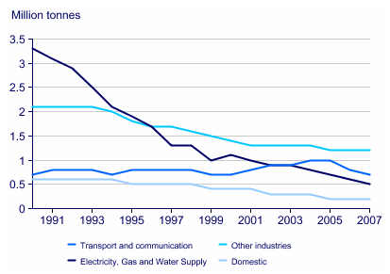](https://ielts-simon.com/.a/6a0120a5bb05d8970c0120a8cfa023970b-pi)***

The line graph compares four sectors in terms of the amount of acid rain emissions that they produced over a period of 17 years in the UK.

It is clear that the total amount of acid rain emissions in the UK fell considerably between 1990 and 2007. The most dramatic decrease was seen in the electricity, gas and water supply sector.

In 1990, around 3.3 million tonnes of acid rain emissions came from the electricity, gas and water sector. The transport and communication sector was responsible for about 0.7 million tonnes of emissions, while the domestic sector produced around 0.6 million tonnes. Just over 2 million tonnes of acid rain gases came from other industries.

Emissions from electricity, gas and water supply fell dramatically to only 0.5 million tonnes in 2007, a drop of almost 3 million tonnes. While acid rain gases from the domestic sector and other industries fell gradually, the transport sector saw a small increase in emissions, reaching a peak of 1 million tonnes in 2005.

(169 words)

***38 英国男女日常活动所耗时间***

***The chart below shows average hours and minutes spent by UK males and females on different daily activities.***

[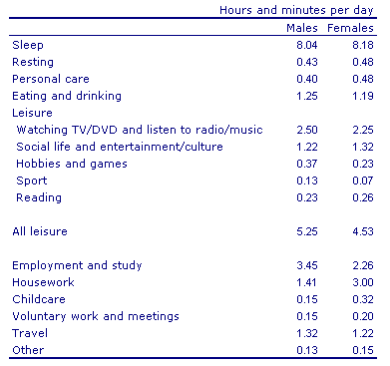](https://ielts-simon.com/.a/6a0120a5bb05d8970c0133ece0cc24970b-pi)

The table compares the average amount of time per day that men and women in the UK spend on different activities.

It is clear that people in the UK spend more time sleeping than doing any other daily activity. Also, there are significant differences between the time spent by men and women on employment/study and housework.

On average, men and women in the UK sleep for about 8 hours per day. Leisure takes up the second largest proportion of their time. Men spend 5 hours and 25 minutes doing various leisure activities, such as watching TV or doing sport, while women have 4 hours and 53 minutes of leisure time.

It is noticeable that men work or study for an average of 79 minutes more than women every day. By contrast, women spend 79 minutes more than men doing housework, and they spend over twice as much time looking after children.

(151 words)

***39 平均房价变化与对比***

***The chart below shows information about changes in average house prices in five different cities between 1990 and 2002 compared with the average house prices in 1989.***

[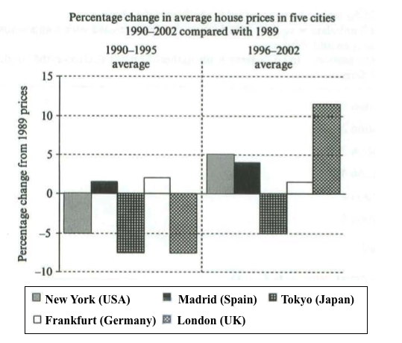](https://ielts-simon.com/.a/6a0120a5bb05d8970c0154359876fe970c-pi)

The bar chart compares the cost of an average house in five major cities over a period of 13 years from 1989.

We can see that house prices fell overall between 1990 and 1995, but most of the cities saw rising prices between 1996 and 2002. London experienced by far the greatest changes in house prices over the 13-year period.

Over the 5 years after 1989, the cost of average homes in Tokyo and London dropped by around 7%, while New York house prices went down by 5%. By contrast, prices rose by approximately 2% in both Madrid and Frankfurt.

Between 1996 and 2002, London house prices jumped to around 12% above the 1989 average. Homebuyers in New York also had to pay significantly more, with prices rising to 5% above the 1989 average, but homes in Tokyo remained cheaper than they were in 1989. The cost of an average home in Madrid rose by a further 2%, while prices in Frankfurt remained stable.

(165 words)

***40 澳洲贫困家庭比例对比***

***The table below shows the proportion of different categories of families living in poverty in Australia in 1999.***

[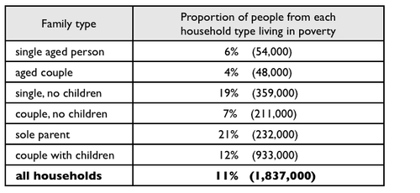](https://ielts-simon.com/.a/6a0120a5bb05d8970c015434c9f23f970c-pi)

The table gives information about poverty rates among six types of household in Australia in the year 1999.

It is noticeable that levels of poverty were higher for single people than for couples, and people with children were more likely to be poor than those without. Poverty rates were considerably lower among elderly people.

Overall, 11% of Australians, or 1,837,000 people, were living in poverty in 1999. Aged people were the least likely to be poor, with poverty levels of 6% and 4% for single aged people and aged couples respectively.

Just over one fifth of single parents were living in poverty, whereas only 12% of parents living with a partner were classed as poor. The same pattern can be seen for people with no children: while 19% of single people in this group were living below the poverty line, the figure for couples was much lower, at only 7%.

(150 words)

***41 四国不同产品的消费额对比***

[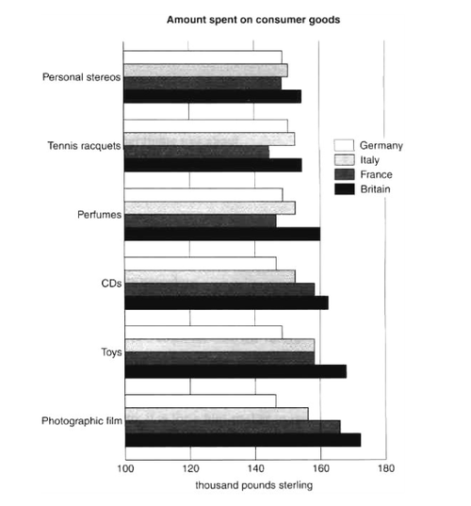](https://ielts-simon.com/.a/6a0120a5bb05d8970c015432debcdd970c-pi)

The bar chart compares consumer spending on six different items in Germany, Italy, France and Britain.

It is clear that British people spent significantly more money than people in the other three countries on all six goods. Of the six items, consumers spent the most money on photographic film.

People in Britain spent just over £170,000 on photographic film, which is the highest figure shown on the chart. By contrast, Germans were the lowest overall spenders, with roughly the same figures (just under £150,000) for each of the six products.

The figures for spending on toys were the same in both France and Italy, at nearly £160,000. However, while French people spent more than Italians on photographic film and CDs, Italians paid out more for personal stereos, tennis racquets and perfumes. The amount spent by French people on tennis racquets, around £145,000, is the lowest figure shown on the chart.

(150 words)

***42 食品和油价变化***

***The graph below shows changes in global food and oil prices between 2000 and 2011.***

[](https://ielts-simon.com/.a/6a0120a5bb05d8970c01bb099eef2a970d-pi)

The line graph compares the average price of a barrel of oil with the food price index over a period of 11 years.

It is clear that average global prices of both oil and food rose considerably between 2000 and 2011. Furthermore, the trends for both commodities were very similar, and so a strong correlation (93.6%) is suggested.

In the year 2000, the average global oil price was close to $25 per barrel, and the food price index stood at just under 90 points. Over the following four years both prices remained relatively stable, before rising steadily between 2004 and 2007. By 2007, the average oil price had more than doubled, to nearly $60 per barrel, and food prices had risen by around 50 points.

A dramatic increase in both commodity prices was seen from 2007 to 2008, with oil prices reaching a peak of approximately $130 per barrel and the food price index rising to 220 points. However, by the beginning of 2009 the price of oil had dropped by roughly $90, and the food price index was down by about 80 points. Finally, in 2011, the average oil price rose once again, to nearly $100 per barrel, while the food price index reached its peak, at almost 240 points.

(211 words)

***43 六城市地铁数据对比***

***The table below gives information about the underground railway systems in six cities.***

[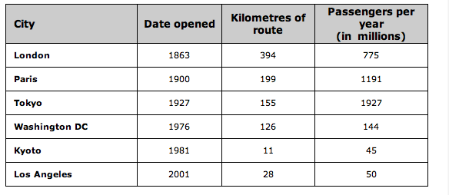](https://ielts-simon.com/.a/6a0120a5bb05d8970c0147e2f6c162970b-pi)

The table shows data about the underground rail networks in six major cities.

The table compares the six networks in terms of their age, size and the number of people who use them each year. It is clear that the three oldest underground systems are larger and serve significantly more passengers than the newer systems.

The London underground is the oldest system, having opened in 1863. It is also the largest system, with 394 kilometres of route. The second largest system, in Paris, is only about half the size of the London underground, with 199 kilometres of route. However, it serves more people per year. While only third in terms of size, the Tokyo system is easily the most used, with 1927 million passengers per year.

Of the three newer networks, the Washington DC underground is the most extensive, with 126 kilometres of route, compared to only 11 kilometres and 28 kilometres for the Kyoto and Los Angeles systems. The Los Angeles network is the newest, having opened in 2001, while the Kyoto network is the smallest and serves only 45 million passengers per year.

(185 words)

***44 澳洲与法国不同能源的电产量变化与对比***

***The pie charts below show units of electricity production by fuel source in Australia and France in 1980 and 2000.***

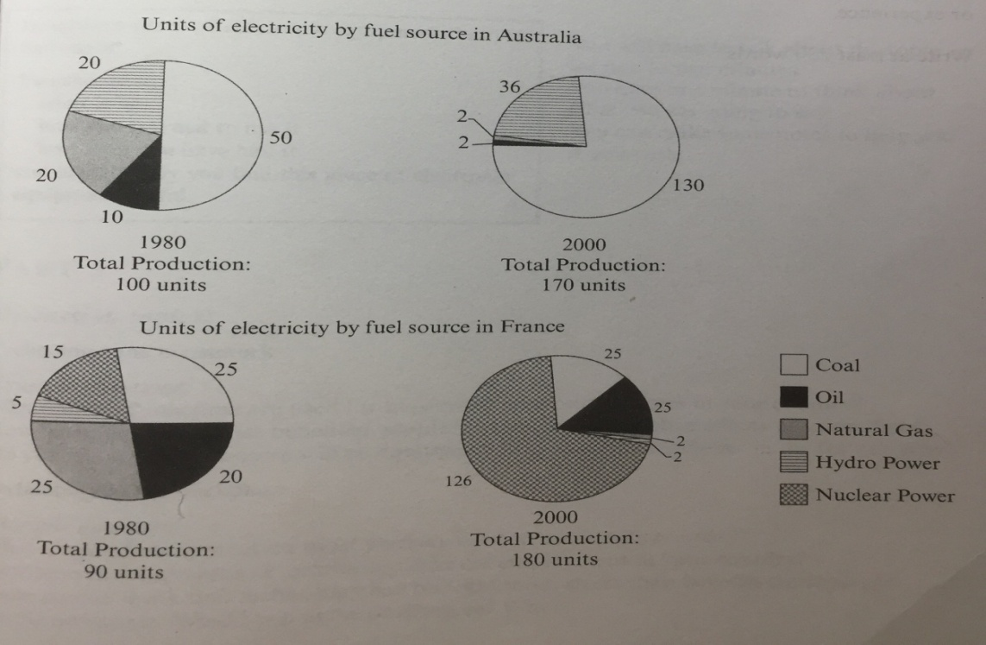

The pie charts compare the amount of electricity produced using five different sources of fuel in two countries over two separate years.

Total electricity production increased dramatically from 1980 to 2000 in both Australia and France. While the totals for both countries were similar, there were big differences in the fuel sources used.

Coal was used to produce 50 of the total 100 units of electricity in Australia in 1980, rising to 130 out of 170 units in 2000. By contrast, nuclear power became the most important fuel source in France in 2000, producing almost 75% of the country’s electricity.

Australia depended on hydro power for just under 25% of its electricity in both years, but the amount of electricity produced using this type of power fell from 5 to only 2 units in France. Oil, on the other hand, remained a relatively important fuel source in France, but its use declined in Australia. Both countries relied on natural gas for electricity production significantly more in 1980 than in 2000.

(170 words)

***45 发展中与工业化国家的科教水平对比***

***The charts below show the levels of participation in education and science in developing and industrialised countries in 1980 and 1990.***

[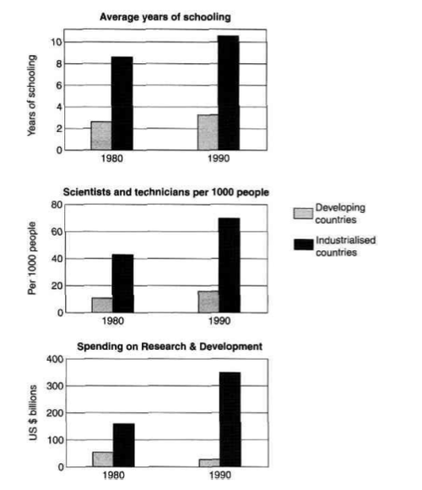](https://ielts-simon.com/.a/6a0120a5bb05d8970c0133f4d59ded970b-pi)

The three bar charts show average years of schooling, numbers of scientists and technicians, and research and development spending in developing and developed countries. Figures are given for 1980 and 1990.

It is clear from the charts that the figures for developed countries are much higher than those for developing nations. Also, the charts show an overall increase in participation in education and science from 1980 to 1990.

People in developing nations attended school for an average of around 3 years, with only a slight increase in years of schooling from 1980 to 1990. On the other hand, the figure for industrialised countries rose from nearly 9 years of schooling in 1980 to nearly 11 years in 1990.

From 1980 to 1990, the number of scientists and technicians in industrialised countries almost doubled to about 70 per 1000 people. Spending on research and development also saw rapid growth in these countries, reaching $350 billion in 1990. By contrast, the number of science workers in developing countries remained below 20 per 1000 people, and research spending fell from about $50 billion to only $25 billion.

(187 words)

***46 英国移民***

[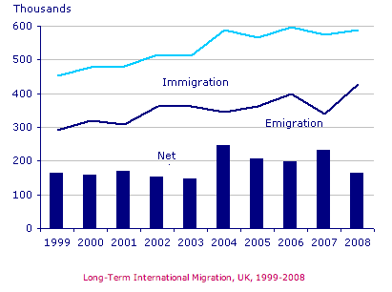](https://ielts-simon.com/.a/6a0120a5bb05d8970c0133f5936064970b-pi)

The chart gives information about UK immigration, emigration and net migration between 1999 and 2008.

Both immigration and emigration rates rose over the period shown, but the figures for immigration were significantly higher. Net migration peaked in 2004 and 2007.

In 1999, over 450,000 people came to live in the UK, while the number of people who emigrated stood at just under 300,000. The figure for net migration was around 160,000, and it remained at a similar level until 2003. From 1999 to 2004, the immigration rate rose by nearly 150,000 people, but there was a much smaller rise in emigration. Net migration peaked at almost 250,000 people in 2004.

After 2004, the rate of immigration remained high, but the number of people emigrating fluctuated. Emigration fell suddenly in 2007, before peaking at about 420,000 people in 2008. As a result, the net migration figure rose to around 240,000 in 2007, but fell back to around 160,000 in 2008.

(159 words)

***47 三国互联网用户比例变化***

[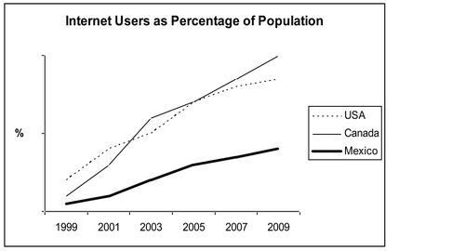](https://ielts-simon.com/.a/6a0120a5bb05d8970c0133f3433b15970b-pi)

The line graph compares the percentage of people in three countries who used the Internet between 1999 and 2009.

It is clear that the proportion of the population who used the Internet increased in each country over the period shown. Overall, a much larger percentage of Canadians and Americans had access to the Internet in comparison with Mexicans, and Canada experienced the fastest growth in Internet usage.

In 1999, the proportion of people using the Internet in the USA was about 20%. The figures for Canada and Mexico were lower, at about 10% and 5% respectively. In 2005, Internet usage in both the USA and Canada rose to around 70% of the population, while the figure for Mexico reached just over 25%.

By 2009, the percentage of Internet users was highest in Canada. Almost 100% of Canadians used the Internet, compared to about 80% of Americans and only 40% of Mexicans.

(151 words)

***48 英国人出行距离***

***The table below gives information about changes in modes of travel in England between 1985 and 2000.***

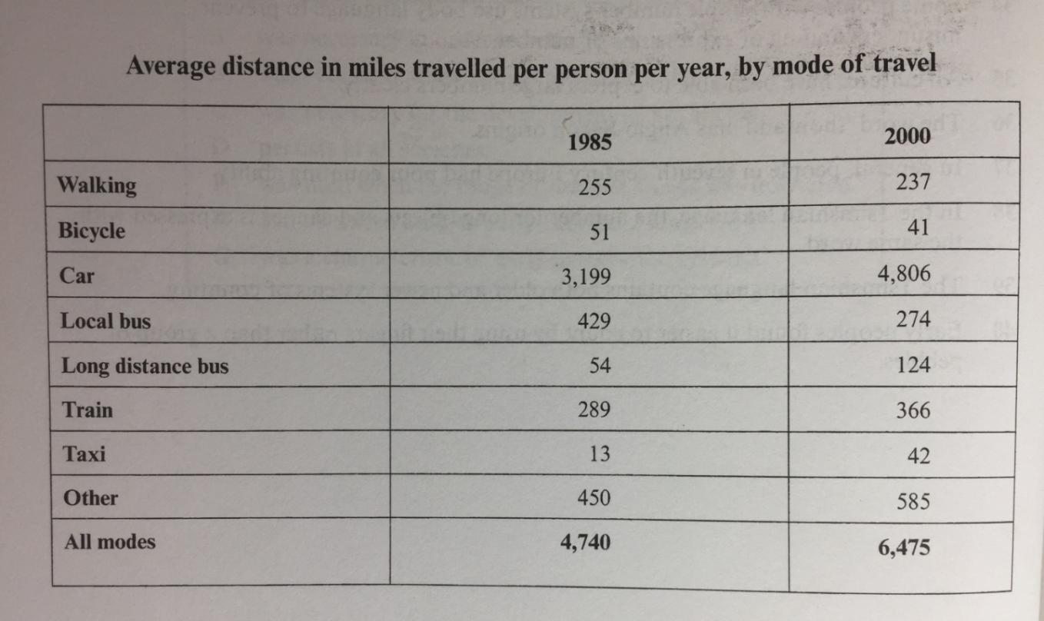

The chart shows average distances that people in England travelled using different forms of transport in the years 1985 and 2000.

It is clear that the total number of miles travelled by English people using all modes of transport increased significantly between 1985 and 2000. The car was by far the most used form of transport in both years.

In 1985, the average person travelled 3,199 miles by car, and this rose to 4,806 miles in the year 2000. The figures for miles travelled by train, long distance bus, taxi and other modes also increased from 1985 to 2000. Travel by taxi saw the most significant change, with more than a threefold increase from 13 miles per person per year in 1985 to 42 miles in 2000.

There was a fall in the average distances for three forms of transport, namely walking, bicycle and local bus. In 1985, English people walked an average of 255 miles, but this figure fell by 18 miles in 2000. Bicycle use fell from 51 to 41 miles over the period shown, while the biggest downward change was in the use of local buses, with average miles per person falling from 429 to 274 over the 15-year period.

(203 words)