**一、动态变化趋势**

**1. 基础词汇**

**动词、名词、形容词、副词**

|  |  |
| --- | --- |
| **Intransitive Verbs** | **Nouns** |
| (to) increase | (an) increase |
| (to) rise (rose, risen) | (a) raise (US), rise (UK) |
| (to) go/be up | (an) upswing |
| (to) grow(grew, grown) | (a) growth |
| (to) extend, (to) expand | (an) extension, expansion |
| (to) progress | (a) progression |
| (to) boom/soar/climb/surge | (a) boom/surge |
| (to) jump, (to) skyrocket | (a) jump |
| (to) reach a peak, (to) peak | (a) peak |
| (to) reach an all-time high |  |

|  |  |
| --- | --- |
| **Intransitive** | **Nouns** |
| (to) decrease | (a) decrease |
|  | (a) cut, (a) reduction |
| (to) fall (off) (fall, fell, fallen) | (a) fall |
| (to) plunge, to plummet | (a) plunge |
| (to) drop (off) | (a) drop |
| (to) go down | (a) downswing |
| (to) decline | (a) decline |
| (to) collapse | (a) collapse (dramatic fall) |
| (to) slump, (to) go bust | (a) slump |
| (to) bottom out |  |

|  |  |  |
| --- | --- | --- |
| **Verbs** | | **Nouns** |
| **Transitive** | **Intransitive** |  |
| (to) keep ... stable | (to) remain stable |  |
| (to) hold ... constant | (to) stay constant |  |
| (to) stabilize | (to) stabilize | stability |

|  |  |  |
| --- | --- | --- |
| **Verbs** | | **Nouns** |
| **Transitive** | **Intransitive** |  |
| (to) level off | (to) level off/out, to flatten out | (a) levelling-off |
|  | (to) stop falling/rising | (a) change |
| (to) stand at | (to) remain steady |  |
|  | (to) stop falling and start rising |  |

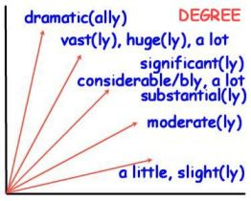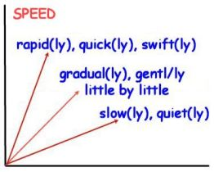

**补充：**

波动 fluctuate v. fluctuation n.

平稳地/持续地 steadily

**介词**

from 起点值

to 终点值

by 变化值（涨幅/降幅）

at 定点值（begin at；stand at；peak at；bottom out at；remain unchanged/stable at）

with 给具体数据

**量和值**

the number/amount/quantity of

the proportion/percentage/rate of

the figure for/of

the number of students 可数的“人”

the number/quantity of water bottles 可数的“物”

the amount/quantity of water 不可数的“物”

~~ratio~~

The proportion of fish imported from Canada decreased, while ~~the percentage of fish imported from~~ the figures for China and other countries increased.

**模糊量词**

around/roughly/about/approximately/almost/nearly

**注意拼写**

用48%；尽量不用48 percent

用325,000；不用325000

区分2022 vs 2,022

**2. 小作文：描述动态趋势的六种常用基础句式**

2000年到2010年间鸡肉的消耗量小幅增长。

1. The consumption of chicken slightly increased from 220 kgs in 2000 to 235 kgs in 2010.

b. There was a slight rise in the amount of chicken consumed from 220 kgs in 2000 to 235 kgs in 2010.

c. The ten years from 2000 to 2010 witnessed/saw a slight growth in the chicken consumption. 时间点/时间段/地点作主语

d. A slight growth was seen/could be seen in the consumption of chicken from 2000 to 2010.

e. The consumption of chicken showed an upward trend, slightly increasing/with a slight increase from 2000 to 2010.

f. The overall trend of the chicken consumption was upward, which slightly increased/with a slight increase from 2000 to 2010.

注意区分：动词/名词；副词/形容词

**3. 添加分词关联**

The number at 6am is 480, rising to 690 by 8am before falling again. There is then a peak of 700 at midday, followed by an afternoon decline to a low of 230 at 4pm. A third spike is at 6pm, reaching 670 before tailing off.

The number of tuna was 130,000 in 1982, rising significantly to 160,000 in 1992 before increasing again by 10,000 in the next ten years (1992-2002). After that, there was a slight decrease in its figure, ending at 150,000 in 2007.

“然后”

“在那之后”

The 8am passenger surge is matched by a high price of $29, followed by a peak of $31 at midday and a decrease to $17 by 4pm.

There was a 2-decade period of stability in the number of street robberies at around just 0.05 million, followed by a slight increase in the next 10 years to 0.2 million.

The number of street robberies stabilized at around just 0.05 million in the first two decades before increasing slightly to 0.2 million in 2000.

The percentage of households with washing machines increased moderately during the first four decades from 40% to 70% in 1960 before declining slightly by 5% in 1980. After that, this figure grew again, but less significantly, ending at approximately 72%.

Starting at 40%, the percentage of households with washing machines showed an upward trend in the following four decades, rising to 70% in 1960 before falling slightly by 8% in 1980 when it began to grow again, finally reaching a peak of 72%.

In Sweden, there was a significant rise in average CO2 emissions per person from around 9 metric tonnes to a peak of 10.5 metric tonnes, followed by a dramatic decline of 3.5 metric tonnes in 1987. After that, the figure continued to decrease at a much slower rate, ending at approximately 5.8 metric tonnes.

to a low/high of xx

four decades from 1980 to 2019

, followed by another period/span/duration of growth for the last four decade, ending at 72%. 或者, followed by another four-decade span of growth

during a 35-year period of stability 去替换 It became stable from 1965 to 2000.

, followed by another five-year duration of decline 去替换It declined again from 1965 to 2000.

**4. 句式表达提升**

*The chart below shows the total number of minutes (in billions) of telephone calls in the UK, divided into three categories, from 1995-2002.*

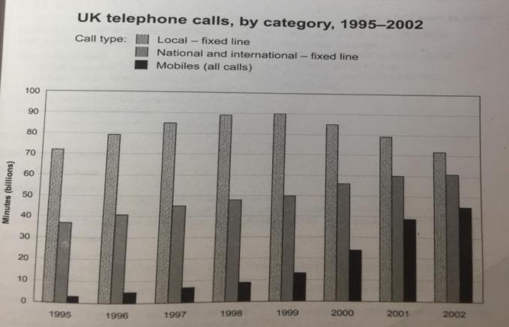

Local fixed line calls were the highest throughout the period, rising from 72 billion minutes in 1995 to just under 90 billion in 1998. After peaking at 90 billion the following year, these calls had fallen back to the 1995 figure by 2002.

National and international fixed line calls grew steadily from 38 billion to 61 billion at the end of the period in question, though the growth slowed over the last two years.

There was a dramatic increase in mobile calls from 2 billion to 46 billion minutes. This rise was particularly noticeable between 1999 and 2002, during which time the use of mobile phones tripled.

To sum up, although local fixed line calls were still the most popular in 2002, the gap between the three categories had narrowed considerably over the second half of the period in question.

**二、表达占比关系的句式**

第一组句式变换：

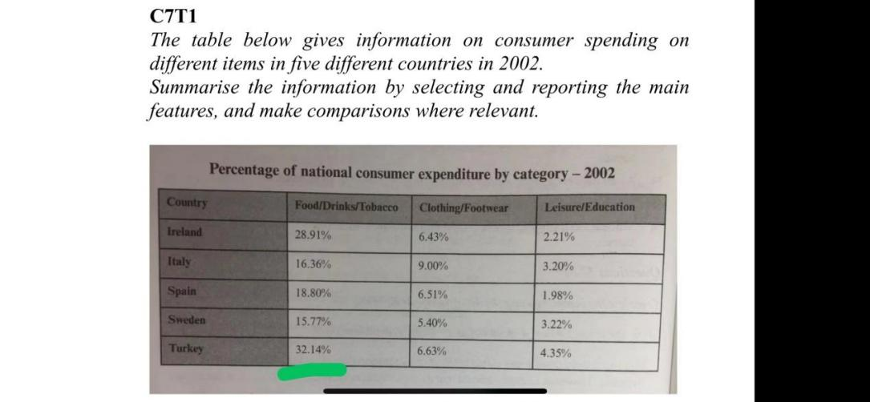

1. The percentage of Turkish consumer expenditure on food, drinks and tobacco was 32.14%.

2. 32.14% of Turkish consumer expenditure was spent on food, drinks and tobacco.

3. Turkish consumers spent 32.14% of their expenditure on food, drinks and tobacco.

4. Food, drinks and tobacco cost Turkish consumers 32.14% of their expenditure.

**account for/take up/make up/constitute “占”**

5. Turkish consumer spending on food, drinks and tobacco accounted for 32.14% of their total expenditure.

6. Turkey was the country where its consumers spent 32.14% of their expenditure on food, drinks and tobacco.

7. The consumers who spent 32.14% of their expenditure on food, drinks and tobacco were Turkish/Turks.

8. The category that Turkish consumers spent 32.14% of their expenditure on was food, drinks and tobacco.

第二组句式变换：

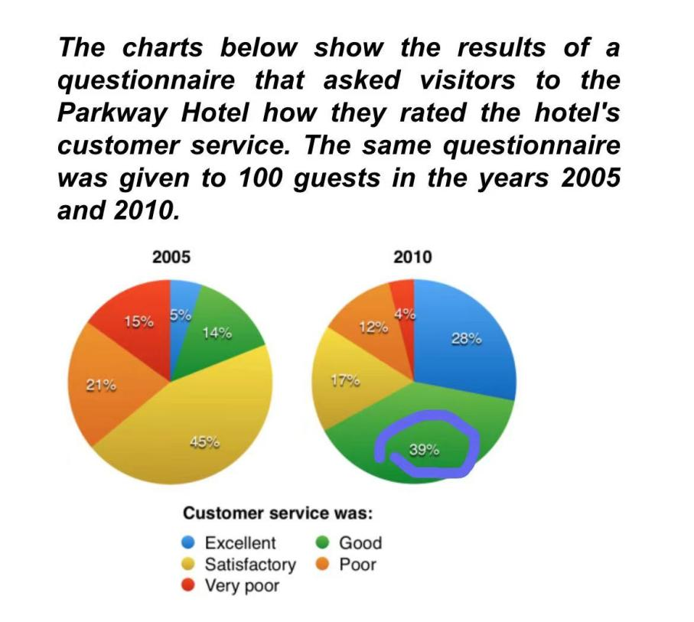

1. The percentage of guests who rated the hotel’s customer service as good was 39%.

2. 39% of guests rated the hotel’s customer service as good.

3. The hotel’s customer service was rated by 39% of guests as good.

4. The response given by 39% of guests about the hotel’s customer service was good.

5. Good was the response/feedback given by 39% of guests about the hotel’s customer service.

6. Guests who rated the hotel’ customer service as good accounted for 39%.

**三、描述差距的句式**

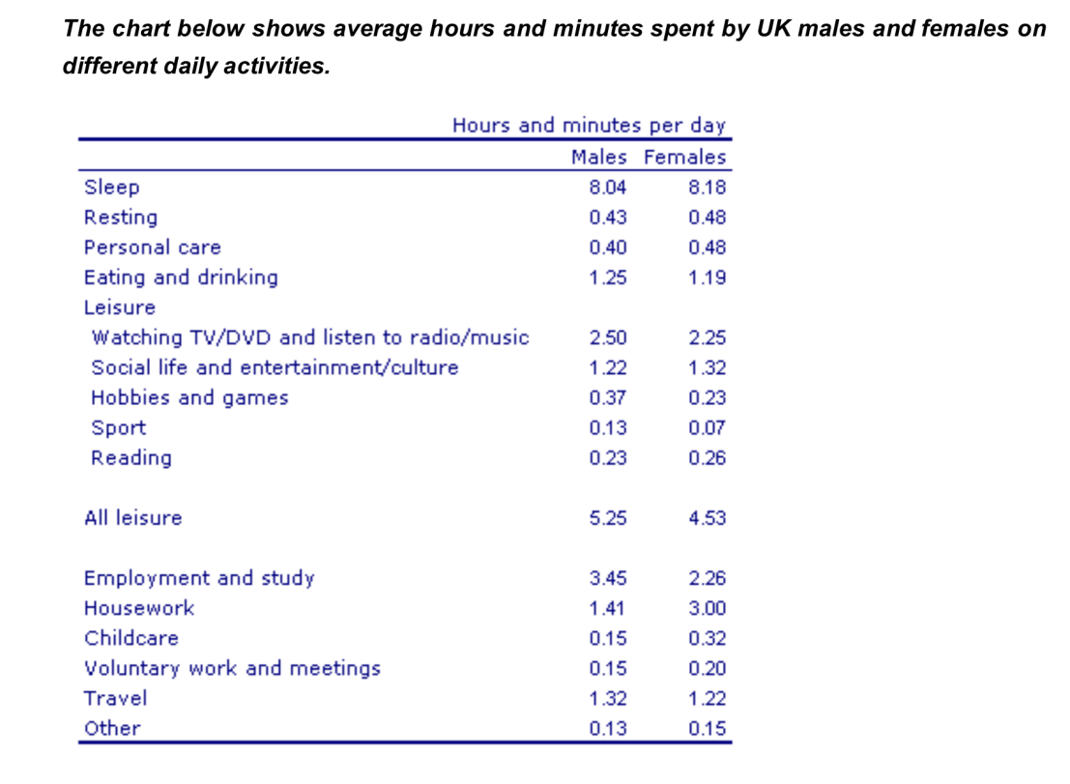

There are significant differences between the time spent by men and women on employment/study and housework.

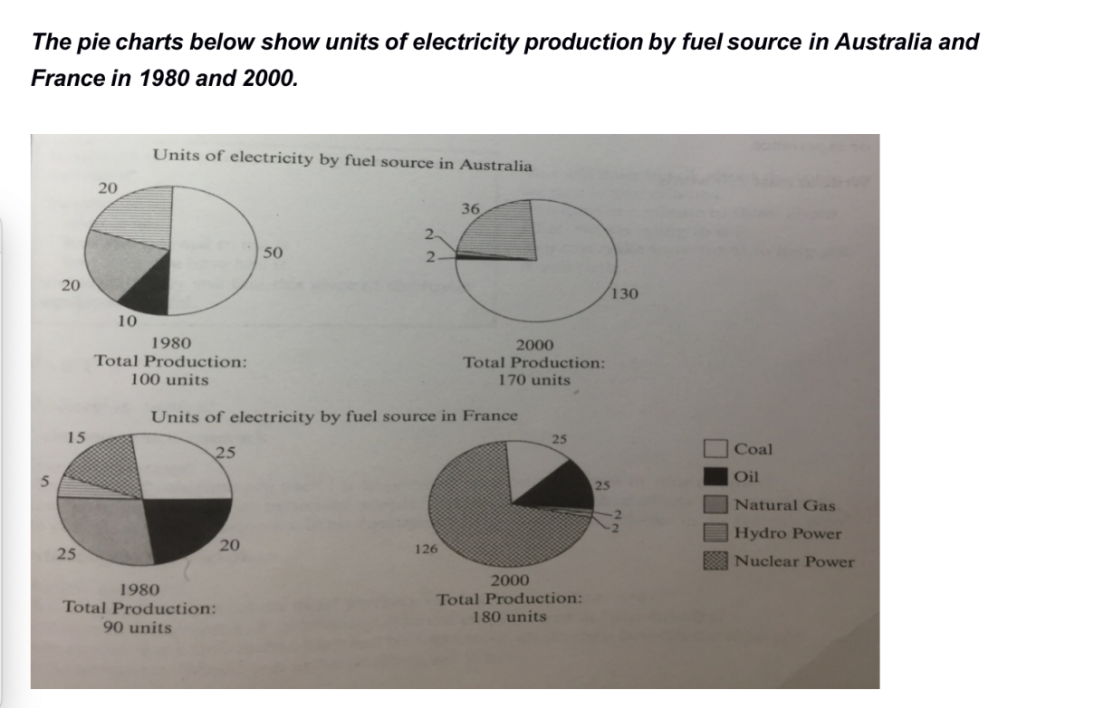

Total electricity production increased dramatically from 1980 to 2000 in both Australia and France. While the totals for both countries were similar, there were big differences in the fuel sources used.

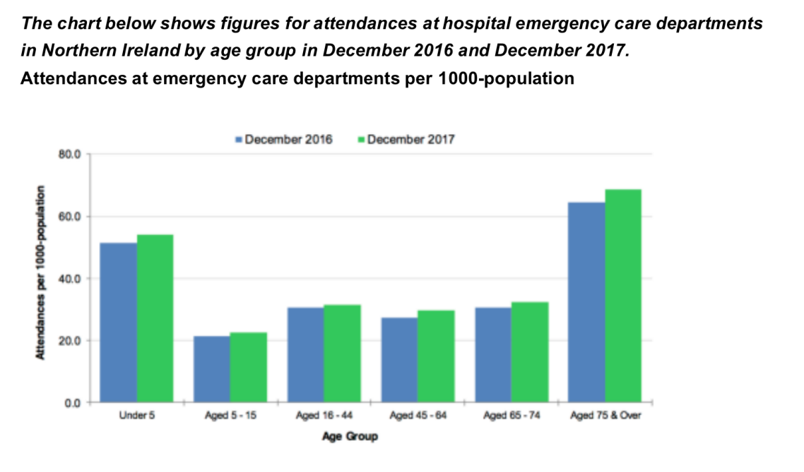

There was almost no difference in the figures for emergency care attendances among people aged 16 to 44, 45 to 64 and 65 to 74.

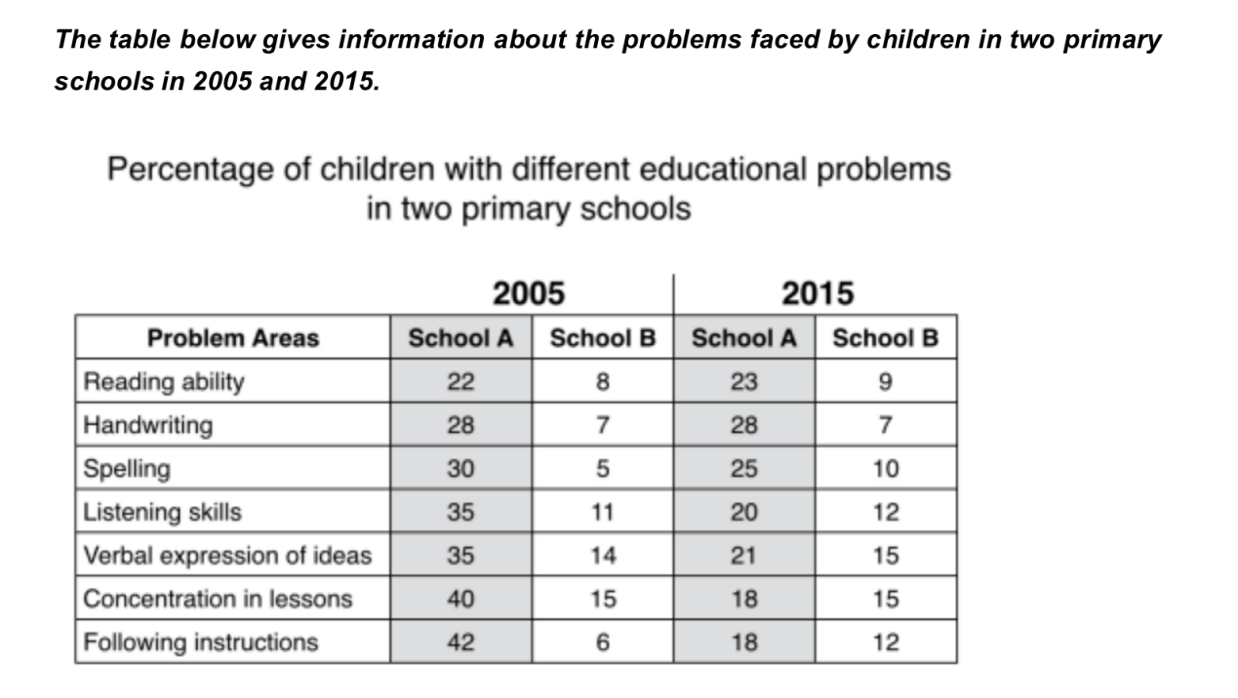

In 2015, the difference between the two schools was less pronounced.

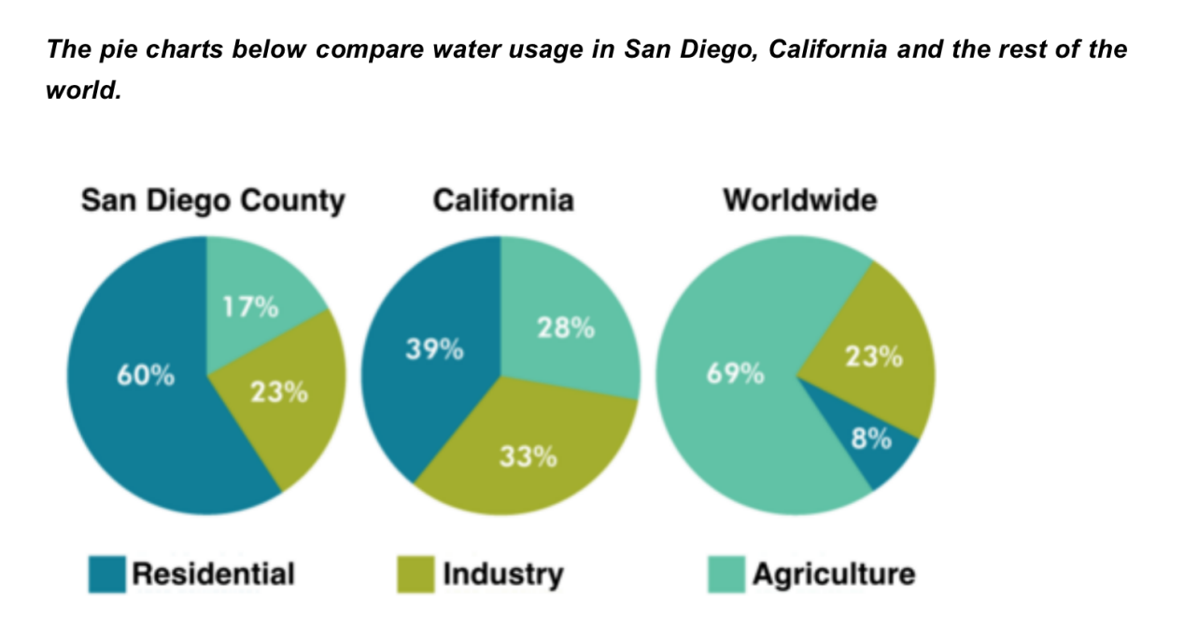

Such dramatic differences are not seen when we compare the figures for industrial water use. The same proportion of water (23%) is used by industry in San Diego and worldwide, while the figure for California is 10% higher, at 33%.

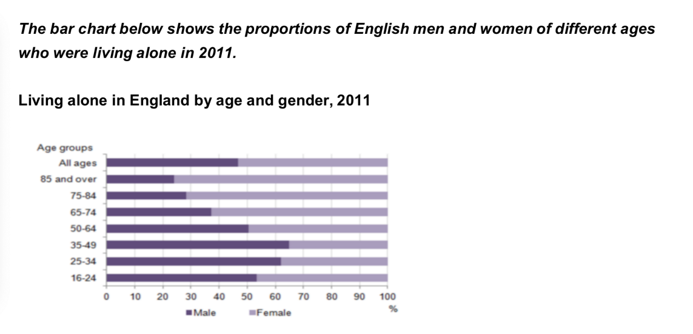

Overall, females made up a higher proportion of people living alone than males, and this difference is particularly noticeable in the older age categories.

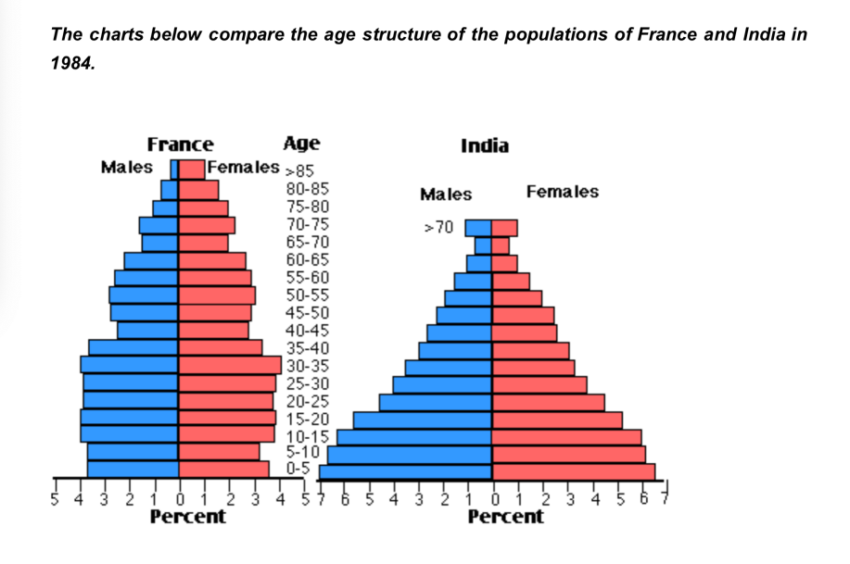

No significant gender differences can be seen on the Indian population chart.

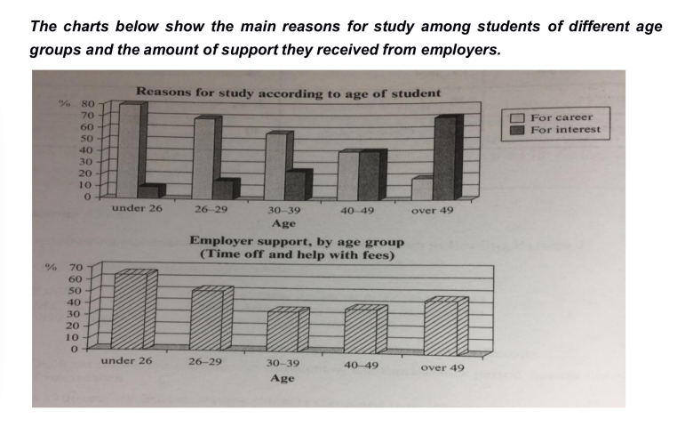

The gap between these two proportions narrows as students get older.

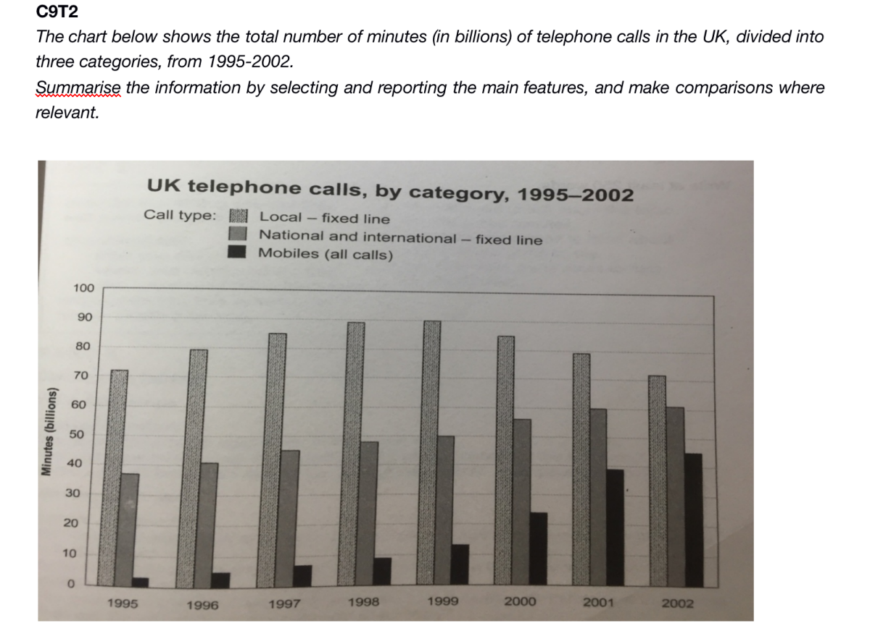

Although local fixed line calls were still the most popular in 2002, the gap between the three categories had narrowed considerably over the second half of the period in question.

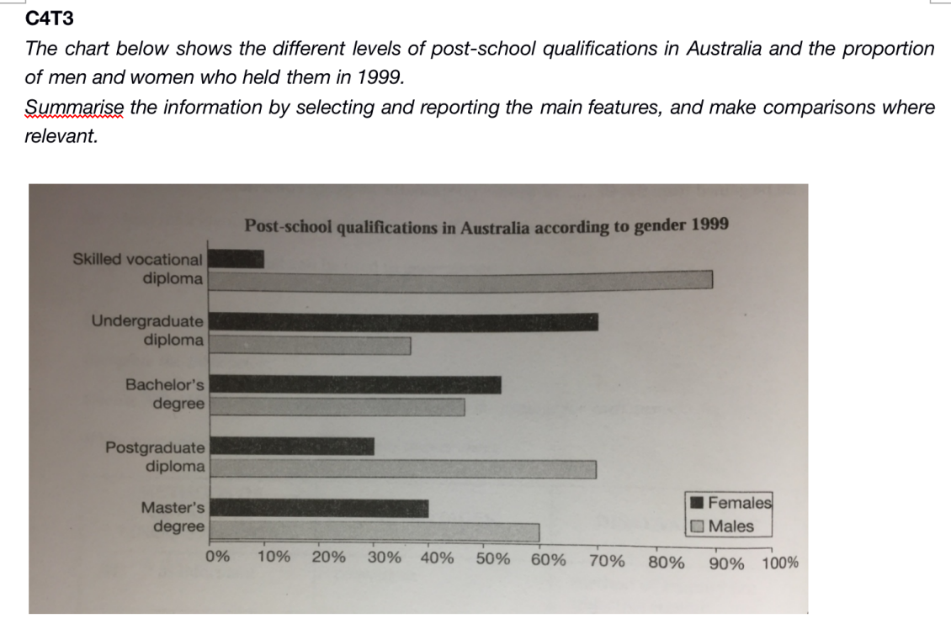

We can see immediately that there were substantial differences in the proportion of men and women at different levels. The biggest gender difference is at the lowest post-school level, where 90% of those who held a skilled vocational diploma were men, compared with only 10% of women. The gender difference is smallest at the level of Bachelor's degree, however.

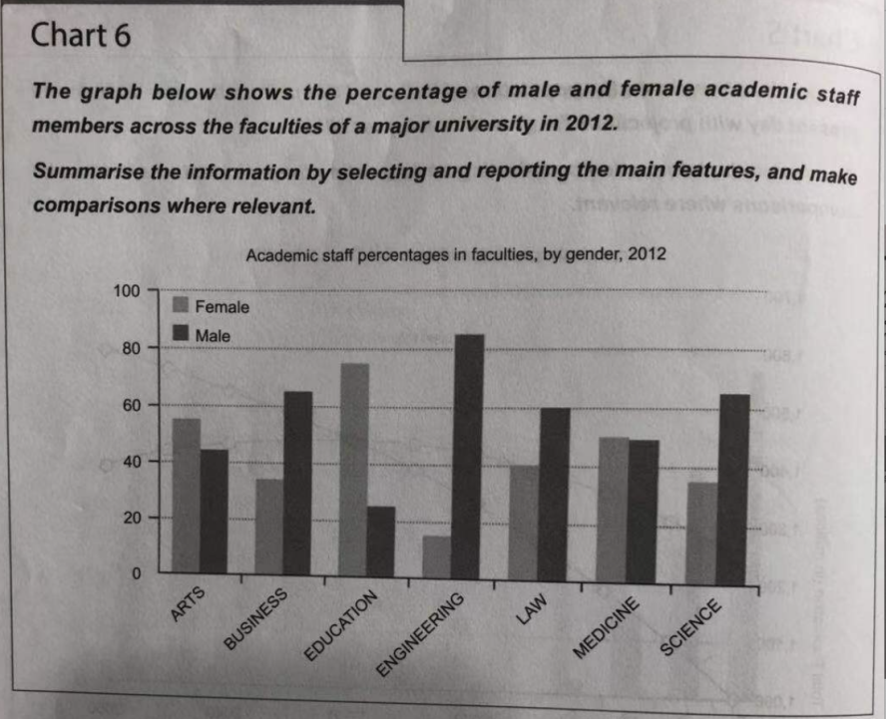

There are a large gender disparity in some faculties: engineering was dominated by male academics whereas education had the highest percentage of female academics. However, other faculties were more balanced in their composition.

**四、描述比较/倍数关系**

His income is double hers.

In 1983 a Mexican won the contest after eating 19.5 hot dogs, almost double the amount that any previous winner had eaten.

However, those consisting of only one parent or a single adult had almost double this proportion of poor people, with 21% and 19% respectively.

Sales figures for handheld games were at least twice as high as those for any other platform in almost every year.

By contrast, women spend 79 minutes more than men doing housework, and they spend over twice as much time looking after children.

In 1995, people in the UK used fixed lines for a total of just over 70 billion minutes for local calls, and about half of that amount of time for national or international calls.

By 2004, however, sales of Fairtrade coffee in the UK had risen to €20 million, and this was over three times higher than Switzerland’s sales figure for Fairtrade coffee in that year.

A total of 225 incidents and 173 injuries, per 100 million passenger miles travelled, took place on demand-response transport services. These figures were nearly three times as high as those for the second highest category, bus services. There were 76 incidents and 66 people were injured on buses.

Furthermore, while only 14% of guests described customer service in the hotel as good in 2005, almost three times as many people gave this rating five years later.

**五、给数据支持的方式**

介词

分词

从句

括号

, doing（分词）

Globally, 65% of degradation is caused by too much animal grazing and tree clearance, constituting 35% and 30% respectively.

The transport sector saw a small increase in emissions, reaching a peak of 1 million tonnes in 2005.

, which （非限定性定语从句）

The biggest change was seen in the proportion of households without a car, which fell=falling steadily over the 36-year period to around 25% in 2007.

, at/with/from/to/by... （介词）

Wildlife parks and zoos were the least popular of the four types of tourist attraction, with only 9% of visitors.

Similarly, the overall adult unemployment rate in London, (standing) at 14%, was 4% higher than the rate in the rest of England.

, with somebody doing/with something done （with的复合结构）

It was uncommon for families to own three or more cars, with only around 2% of households falling into this category.

对比：It was uncommon for families to own three or more cars, and only around 2% of households fell into this category.

There was also a significant rise in the use of mobiles to play games and to record video, with figures reaching 41% and 35% respectively in 2010.

In 1979 beef was by far the most popular of these foods, with about 225 grams consumed per person per week.

These causes affected different regions differently in the 1990s, with Europe having as much as 9.8% of degradation due to deforestation, while the impact of this on Oceania and North American was minimal, with only 1.7% and 0.2% of land affected respectively. Europe, with the highest overall percentage of land degraded (23%), also suffered from over-cultivation (7.7%) and over-grazing (5.5%). In contrast, Oceania had 13% of degraded farmland and this was mainly due to over-grazing (11.3%). North America had a lower proportion of degraded land at only 15%, and the main causes of this were over-cultivation (3.3%) and, to a lesser extent, over-grazing (1.5%).

括号（数据为次要/不重要信息点）

Lamb and chicken were eaten in similar quantities (around 150 grams), while much less fish was consumed (just over 50 grams).

**六、关联前后信息点的词**

while/whereas

Conversely/In contrast/By contrast/On the contrary/On the other hand

compared to/with

as opposed to

However

but

Similarly/Likewise

The same trend/pattern could be seen in …

In the meantime/Meanwhile/In the same year/period

also

and

respectively/separately （信息点整合后再拆分）

before/after（有方向性的变化）

despite/although （次重要信息点处理成让步）

as 表示同步发生 “随着”

with regard to/regarding 引出数据对象

in terms of

over the period given/shown

during the same period/over this span

This accounts for a massive 69% of global water use, but only 17% and 28% of water usage in San Diego and California respectively.

Looking at the positive responses first, in 2005 only 5% of the hotel’s visitors rated its customer service as excellent, but this figure rose to 28% in 2010.

Females made up a higher proportion of people living alone than males, and this difference is particularly noticeable in the older age categories.

Throughout the century, the largest quantity of water was used for agricultural purposes, and this increased dramatically from about 500 km3 to around 3,000 km3 in the year 2000.

Expenditure on resources such as books had increased to 20% by 1991 before decreasing to only 9% by the end of the period. In contrast, the cost of furniture and equipment saw an opposite trend.

While the figures for the Western countries grew to about 15% in around 1990, the figure for Japan dipped to only about 2.5% for much of this period, before rising to almost 5% again at the present time.

After peaking at 90 billion the following year, these calls had fallen back to the 1995 figure by 2002.

During this 25-year period the consumption of beef and lamb fell dramatically to approximately 100 grams and 55 grams respectively. The consumption of fish also declined, but much less significantly to just below 50 grams.

Usage of buses remained steady as trains grew in popularity, but in 2000, this also started to a high of just over 7 million trips in 2010.

Despite some initial fluctuation, from 1995 there was a steady increase.

Although local fixed line calls were still the most popular in 2002, the gap between the three categories had narrowed considerably over the second half of the period in question.

This cost decreased to only 5% of total expenditure in 1991 but rose dramatically in 2011 when it represented 23% of the school budget. Similarly, the cost of insurance saw a rising trend, growing from only 2% to 8% by 2001.

These causes affected different regions differently in the 1990s, with Europe having as much as 9.8% of degradation due to deforestation, while the impact of this on Oceania and North American was minimal, with only 1.7% and 0.2% of land affected respectively.

In 1970, around 5 million people travelled to work by car each day, compared to/with about 4 million who used the bus and only 2 million who commuted by train. Over the next 30 years there was a significant increase in the number of car users, to almost 7 million, and a steady rise in rail passengers, to 3 million. In contrast, the number of bus commuters decreased slightly.

Comparing the two charts, we can see that the percentage of people living alone was similar in both age groups. The biggest difference concerned people living with their partner/spouse, where the proportion was over two times larger in the older age group. On the other hand, among 25-34-year-olds, living with parents was more than twice as common as it was among 35-44-year-olds.

The first table shows low-level coffee sales increasing in all five countries, albeit to widely varying degrees. In two places sales increased by the same small amount: 1.8-2 million euros in Denmark, and 0.8-1 million in Sweden. The increment was slightly larger in Belgium, from 1-1.7 million euros. Meanwhile, in Switzerland sales doubled from 3-6 million euros. Finally, in the UK there was an enormous increase, from 1.5-20 million euros.

In 1999, Switzerland had the highest sales of Fairtrade coffee, at €3 million, while revenue from Fairtrade bananas was highest in the UK, at €15 million. By 2004, however, sales of Fairtrade coffee in the UK had risen to €20 million, and this was over three times higher than Switzerland’s sales figure for Fairtrade coffee in that year. The year 2004 also saw dramatic increases in the money spent on Fairtrade bananas in the UK and Switzerland, with revenues rising by €32 million and €4.5 million respectively.