**小作文**

The x presents a comparison of xx in terms of xxx in xxxx.

The x presents an illustration of how xx changed over a period of xxx (--).

石油产量--the number of/the amount of/the percentage

一个特定国家

25年--1980-2005

The pie charts present a comparison of eight areas in terms of the percentage of water consumed/used for three purposes in 2014.

第一种模式：

The table presents a comparison of five countries in terms of their oil production in two years 2010 and 2015.

xx=4 age groups/three cities/four areas/six countries/two schools/males and females

xxx=数据对象 the amount/number/percentage

名词+动词 five countries produced oil

The two pie charts present a comparison of males and females in terms of their participation rates in five sports in 2010.

rate=the percentage of

名词+动词 males and females participated in five sports

第二种模式：

The bar chart presents an illustration of how the oil production/the amount of oil produced in a particular country changed over a period of 15 years (2000-2015).

时间段

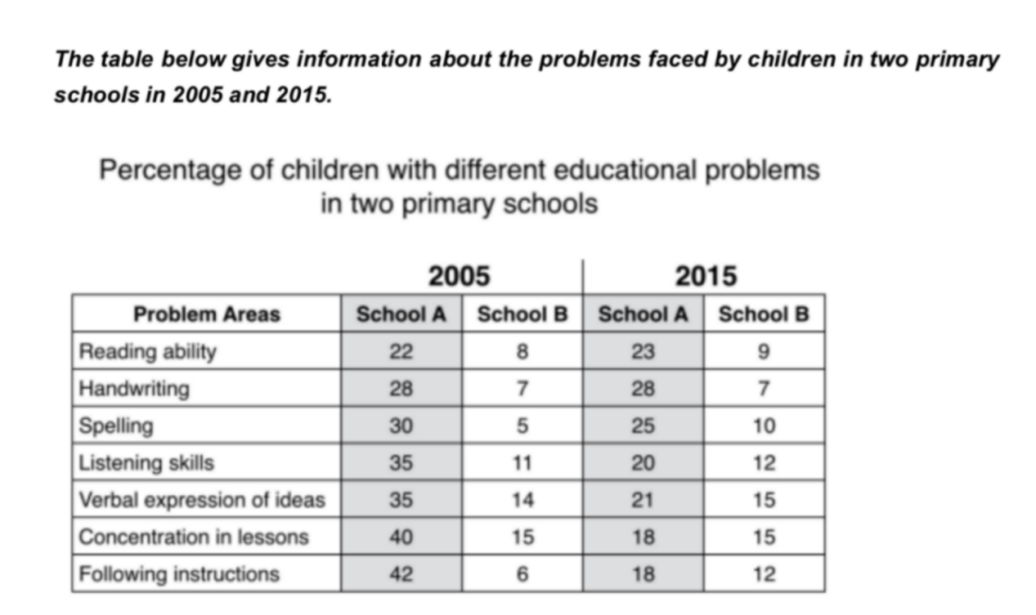

三个变量：

时间 2005 2015

学校 A and B

教育方面的问题 7

~~Number~~

~~Amount~~

The percentage of children who faced/had 7 educational problems

名词+动词 children faced/had 7 educational problems

The x presents a comparison of xx in terms of xxx in xxxx.

The table presents a comparison of two schools in terms of the percentage of their pupils who faced 7 educational problems in two years 2005 and 2015.

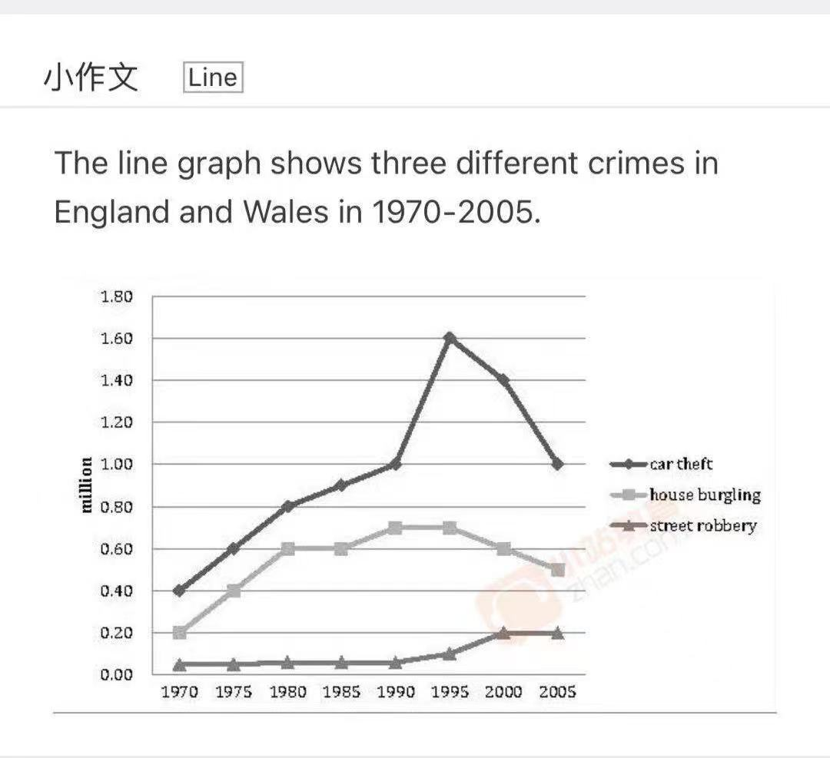

The x presents an illustration of how xx changed over a period of xxx (--).

The line chart presents an illustration of how the number of three different crimes committed in England and Wales changed over a period of 35years (1970-2005).

名词+动词

生产石油 produced oil

面临问题 faced problems

犯罪 committed crimes

The line chart presents an illustration of how the number of three different crimes committed in England and Wales changed over a period of 35 years (1970-2005).

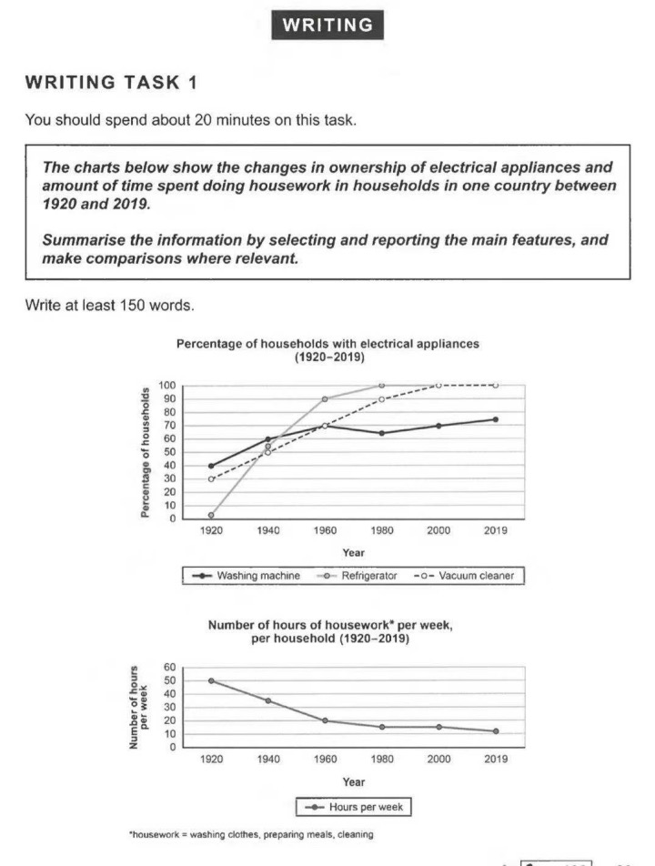

The percentage of households who had/owned electrical appliances

名词+动词 households had/owned electrical appliances

The first line chart presents an illustration of how the percentage of households who owned three types of electrical appliances changed over a period of ten decades (1920-2019).

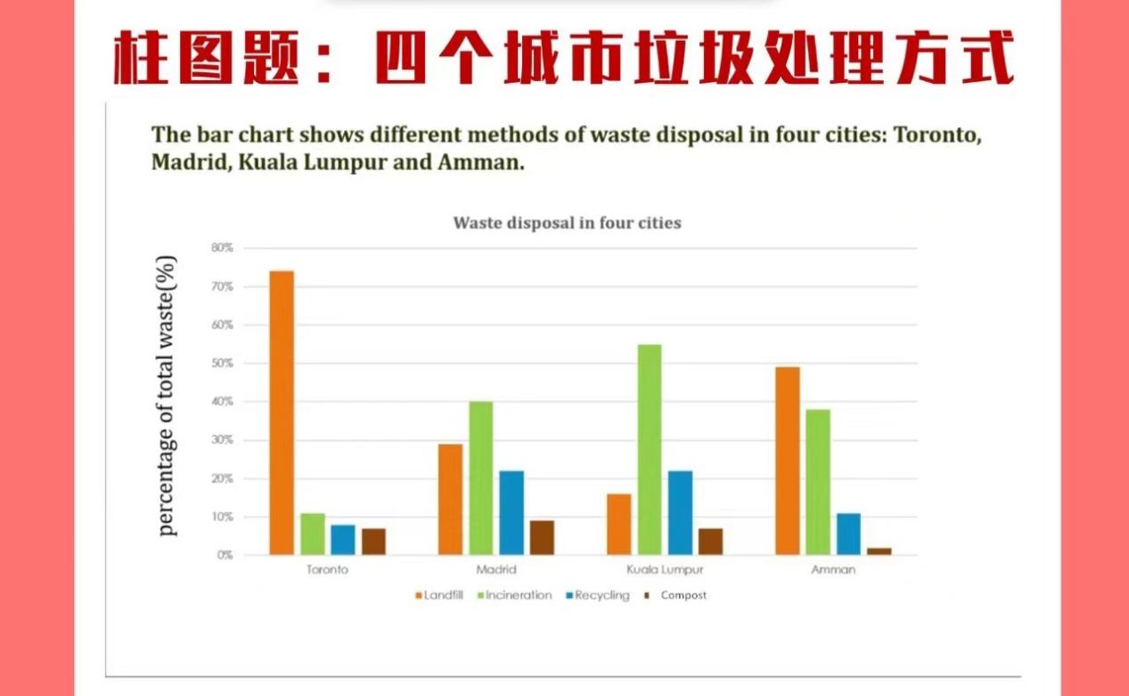

The bar charts presents a comparison of four cities in terms of the percentage of their total waste disposed/managed by different methods: landfill, incineration, recycling and compost.