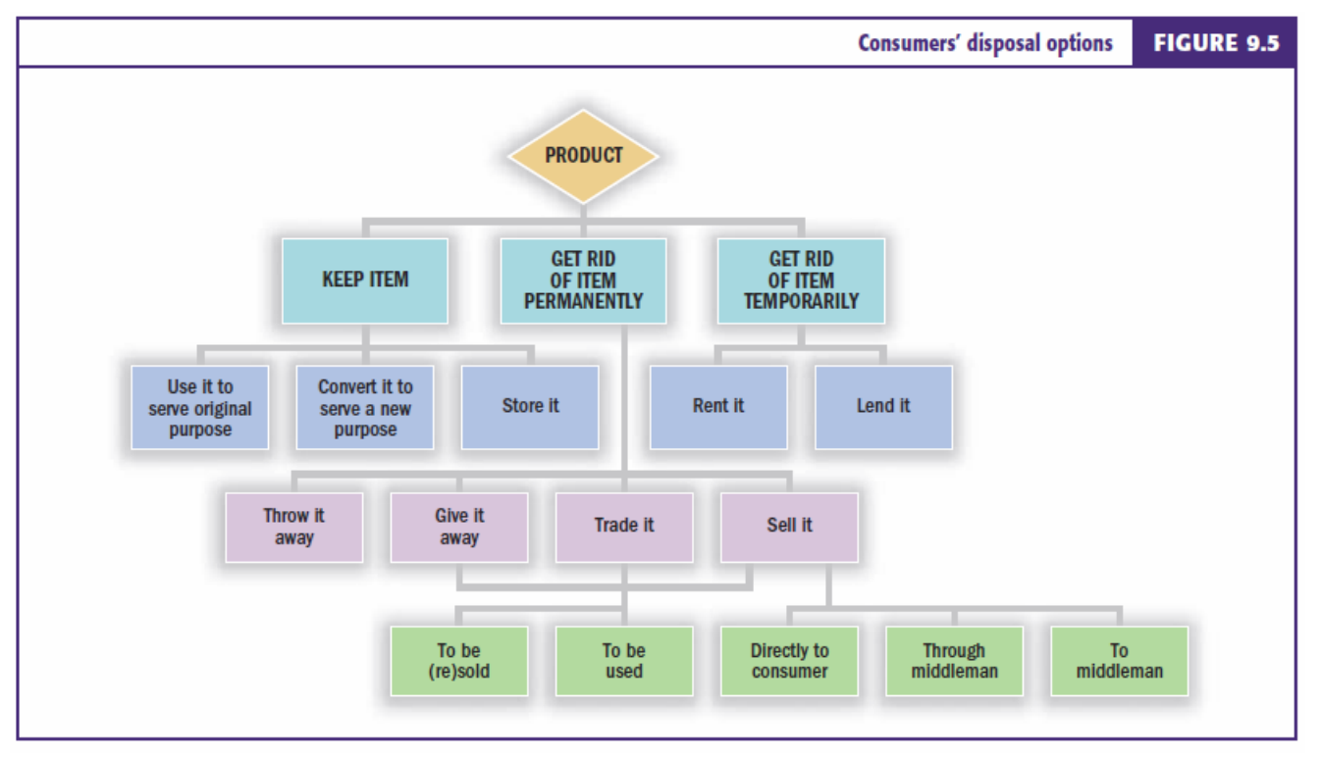**Consumer Behaviour:** The study of the processes involved when individuals or groups select, purchase, use or dispose of products, services, ideas or experiences to satisfy needs and desires, is an Economic process, is an ongoing process, not merely the exchange of goods or services. **Marketing Exchange**: A transaction in which two or more parties (B2C or B2B) give and receive something of value. **Consumption Phases**: 1. Pre-consumption; 2. Consumption; 3; post-consumption. **Interdisciplinary influences**: diversity in approach and background; micro-focus (individual behaviour); macro-focus (group behaviour). **Positivist**: nature of reality: Objective, goal: prediction, knowledge generated: time free + non-contextual, causality view: existence of real causes, research relationship: Separation between researcher and subject. **Interpretivist**: nature of reality: Socially constructed, goal: understanding, knowledge generated: time bound + contextual, causality view: multiple, research relationship: Interactive. **Choice**: does not necessarily mean identifying what brand of product to buy (is whether to buy at all). **Decision-making processes:** lead to consumer choice, frequently do not involve finding a tangible product. **Types of consumer decisions**: routine response behaviour -> limited problem solving -> extensive problem solving (less to more). **Steps in process**: 1. **Problem recognition:** Occurs when a consumer sees a difference between current state and ideal state, 2. **Information search**: The process by which we survey the environment for appropriate data to make a reasonable decision, 3. **Evaluation of alternatives**: Alternatives actively considered during decision making are call the evoked set Inept set are those we would never consider. 4. **Product choice**: Decision rules for product choice can be very simple or very complicated - Prior experience with (similar) product - Present information at time of purchase - Beliefs about brands (from advertising). **Information Processing Perspective**: carefully integrate information about a product, weigh up pros and cons of alternatives before to arrive at a satisfactory decision. **Irrational**: Overspending on credit cards. **Impulsive**: ‘spending spree’. **Emotional Experiencers**: choices based upon emotional responses **Habitual Actors**: Buying and consuming for routine, habitual reasons rather than on the basis of emotion. **Problem Solvers**: large amount of effort put into a purchase decision differs with each purchase. **Theory of Emotion**: Places emotions as the result of mental evaluations (Buy -> think -> feel (affect)). **Affective Events Theory**: experiencing an affective event can create an emotion which leads to an affect driven attitude and behaviour (Feel -> think -> do (buy)). **Behavioural influence perspective:** Concentration on these low involvement decisions**. Behavioural Economics perspective:** Focuses on context of decisions. **Mental Categories of Products**: Superordinate level: top level (dessert), Basic level: more abstract (fattening vs non-fattening), Subordinate level: individual brands or types of products we are choosing from. **Nudging**: recognises that out everyday decisions are often not conscious and rational (also has smack, shove and hug). **Heuristics**: Mental rules-of-thumb, aid speedy decisions, can be general or specific. **Hedonic Consumption**: The multi-sensory, fantasy, and emotional aspects of consumers’ interactions with products. **Mental Accounting**: process in which decisions are influenced by: the way the problem is posed (called framing), and whether it is put in the terms of gain or loss. **Prospect Theory**: utility is a function of gains and losses. **Loss Aversion**: people place more emphasis on the loss than any gains. **Sunk-cost fallacy**: where having paid for something makes a consumer reluctant to waste it. **Experiences**: are personal - existing in the mind of an individual engaging in an emotional, physical, or spiritual level with an event. **Four** **Realms of Experience**: Entertainment, Educational, Escapist, Aesthetic (difference is the required level of customer participation and absorption). **Temporal Factors**: **SERVCON:** classify convenience, five components: Decision-convenience, Access-convenience, Benefit-convenience, Transaction-convenience, Post-benefit-convenience. **Return-on-time**: used to refer to consumers seeking a return-on-investment relating to the time to get product vs what they receive. **Economic time**: Time is an economic variable, must be allocated. **Queuing Theory:** experience of waiting can radically influence their perception of service quality**. Antecedent State**: pleasure and arousal (2 dimensions to consumers reaction of environment). **Brand Loyalty**: Two components – Attitudinal (has a favourable attitude towards the brand), Behavioural (repeated purchases as a result of a strong internal disposition). **Sensation**: The immediate response of our sensory receptors to basic stimuli. **Perception:** The process by which sensations are selected, organised and interpreted, can permanently change the customer’s buying behaviour. **Sensory Marketing**: **Vision**: Rely heavily on visual elements in advertising, store design and packaging, **Touch**: little but observation tells us it's important, **Smell**: Odours can stir emotions or create a calming feeling, Likes and dislikes learned rather than innate, **Taste**: Cultural changes determine desirable tastes, **Sound**: Advertising jingles create brand awareness, Background music creates desired moods, Sound affects people's feelings and behaviour. **Stages of Perception**: **Exposure**: Occurs when a stimulus comes within range of someone's sensory receptor, **Attention**: The extent to which processing activity is devoted to a particular stimulus, **Interpretation**: The meaning we assign sensory stimuli. **Classical Conditioning**: Occurs when a stimulus that elicits a response is paired with another stimulus that initially does not elicit a response on its own (Pavlov’s dog). **Instrumental Conditioning:** Occurs as the individual learns to perform behaviours that produce positive outcomes and avoid behaviours that yield negative outcomes (positive and negative reinforcement, punishment). **Weber’s Law**: Amount of change needed is related to the intensity of original stimulus. **Sensory Threshold: Absolute**: The minimum amount of stimulation that can be detected on a given sensory channel, **Differential**: The ability of a sensory system to detect changes or differences between two stimuli. **Cognitive Learning Theory**: We watch others, we model behaviour, observational Learning. **Attitude:** Traditionally thought to be lasting, general evaluation of people, objects, advertisements or issues, created through beliefs (cognitive) and feelings (affective) towards an object. **Functional Theory of attitudes:** **Utilitarian**: Relates to rewards and punishments, **Value Expressive**: Expresses consumers values or self-concept, **Ego-defensive**: Protect ourselves from external threats of internal feelings, **Knowledge**: Need for order, structure or meaning. **Nature of Attitudes: Emotion**: the way a consumer feels about an attitude object, **Cognition**: the beliefs a consumer holds about an attitude object. **Three Hierarchies of Effects: Standard learning**: Cognition -> affect -> behaviour = attitudes based on cognitive information processing. **Low-Involvement**: Cognition -> Behaviour -> affect = attitudes based on behavioural learning processes. **Experiential**: affect -> behaviour -> Cognition = attitudes based on hedonic consumption. **Theory of Cognitive Dissonance**: a state of tension occurs when beliefs or behaviours conflict with one another. **Balance Theory:** relations among elements in a triad to be harmonious, Triad attitude structures consist of three elements: A person and his/her perceptions of an attitude object, and some other person or object. **The Extended Fishbein Model (The Theory of Reasoned Action):** **Intentions versus behaviour**: measure behavioural intentions, not just intentions, **Social pressure:** acknowledge the power of other people in purchasing decision, **Attitude toward buyin**g: measure attitude toward the act of buying, not just the product.

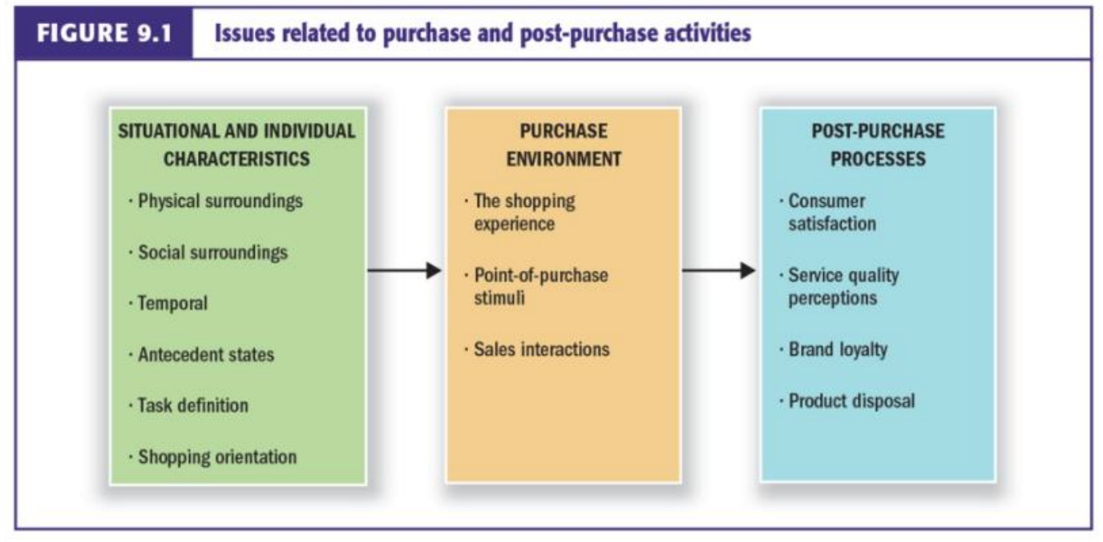**Consumer Disposal Options: Contextual Effects:**