**Internet Of Things**

**Contactless Thermometer**

**Group - 11**

|  |  |  |
| --- | --- | --- |
| **Sl no** | **Student ID** | **Student Name** |
| 1 | TEJAS BHATNAGAR | 20171CSE0721 |
| 2 | THAJUDHEEN TK | 20171CSE0724 |
| 3 | THANUJ KUMAR S | 20171CSE0726 |
| 4 | UTSAV DEEP | 20171CSE0734 |
| 5 | UDITH L | 20171CSE0732 |

**Aim: Demonstrating the working model of Contactless thermometer**

**Objective**: We can measure body temperature without contact with this device

**Abstract:** Continuous body temperature monitoring is the one of the ways to detect a corona patient. So many types of thermometers are available in market. The normal thermometer can measure the temperature of a COVID-19 patient and also may spread the virus. In this special situation we can use the Non-Contact Thermometer. And also known this device as temperature gun. The biggest manufacture of this Temperature Gun China. And this device is costly. But this lock down and Covid-19 threads make the production of this device is more difficult.

We can make a Contactless Thermometer with some commonly available components.

**The main components used in our project are: // For ex should be as shown below**

1. Non Contact Temperature Sensor
2. Arduino board
3. OTG Adapter

**Other components used are:**

1. Breadboard
2. Android phone
3. Jumper Cables
4. Serial Monitor Android App

**Pin-out diagram // For example it should be as shown below**

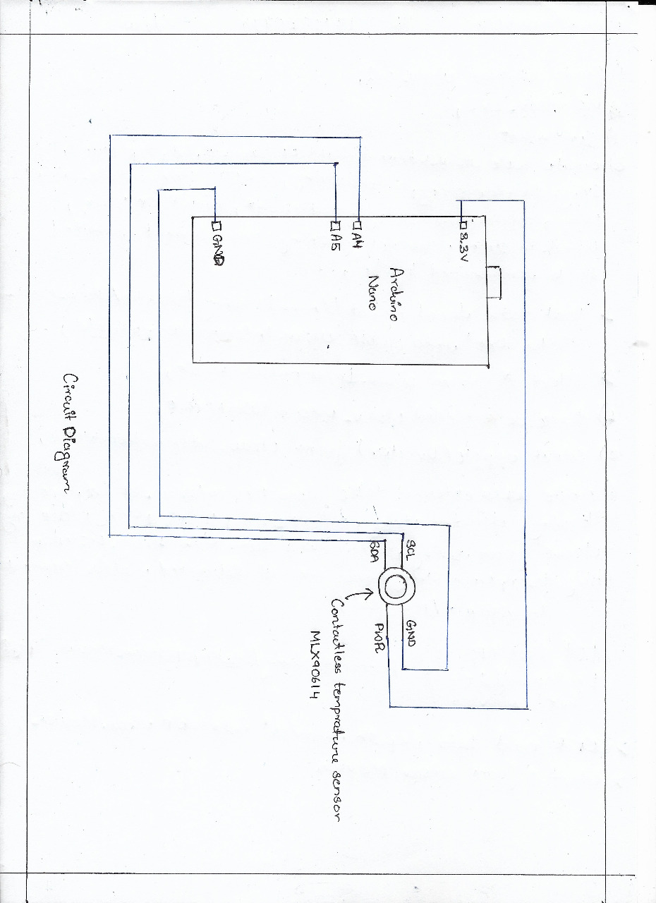

**Contactless temperature sensor**

* GND 🡪 ground pin
* PWR 🡪 3.3V pin
* SDA 🡪 A4 pin
* SCL 🡪 A5 pin

**Program for our project // Place your entire program code**

#include <Wire.h>

#include <Adafruit_MLX90614.h>

Adafruit_MLX90614 mlx = Adafruit_MLX90614();

void setup() {

Serial.begin(9600);

mlx.begin();

}

void loop() {

Serial.print("Temperature : ");

Serial.print(mlx.readObjectTempC());

Serial.println(" Celsius");

Serial.print("Temperature : ");

Serial.print(mlx.readObjectTempF());

Serial.println(" Fahrenheit");

Serial.println();

delay(500);

}

**Pictures of Components**

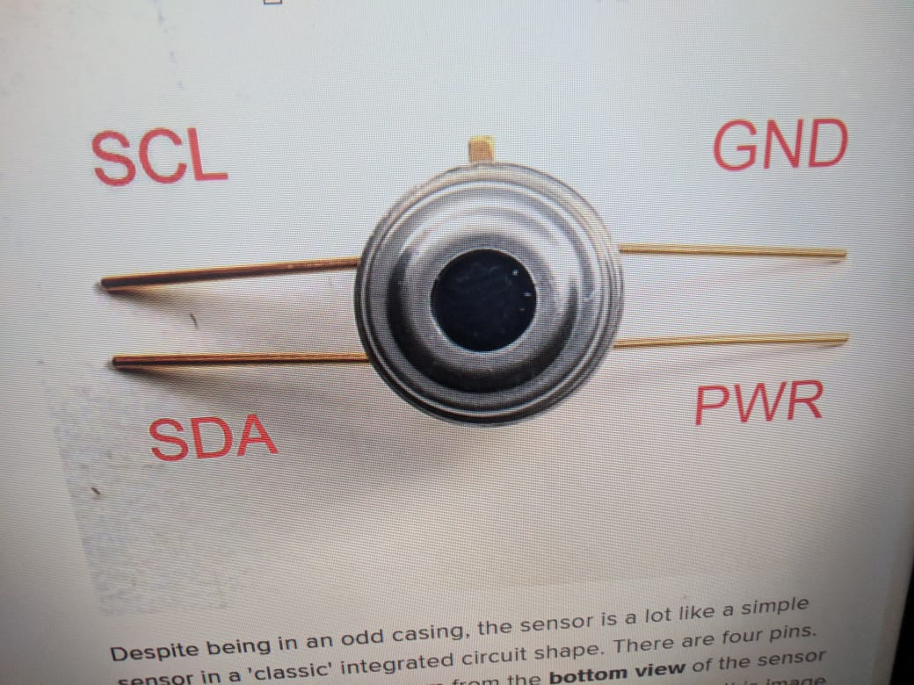

Contactless temperature sensor

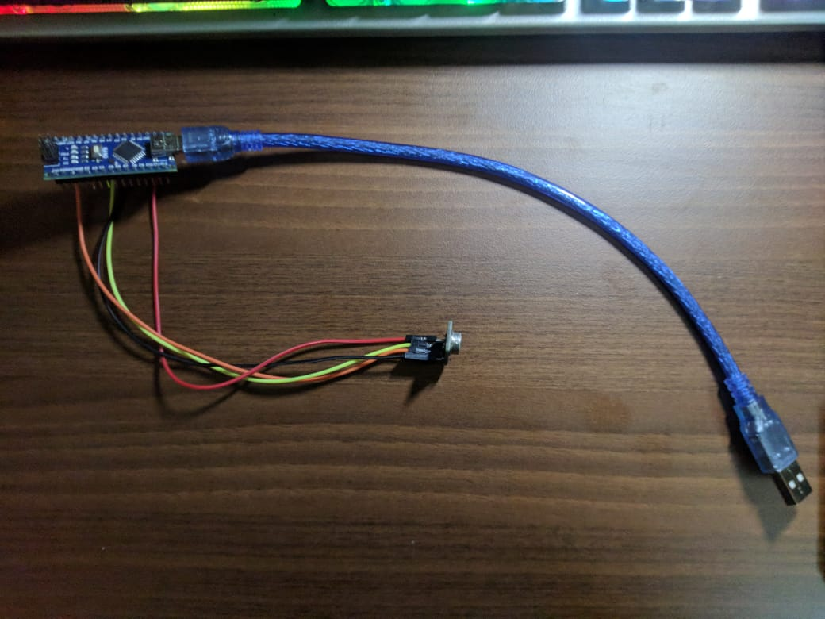

Arduino with OTG Adapter connected to sensor with jumper cables

**The Complete picture of our Project**

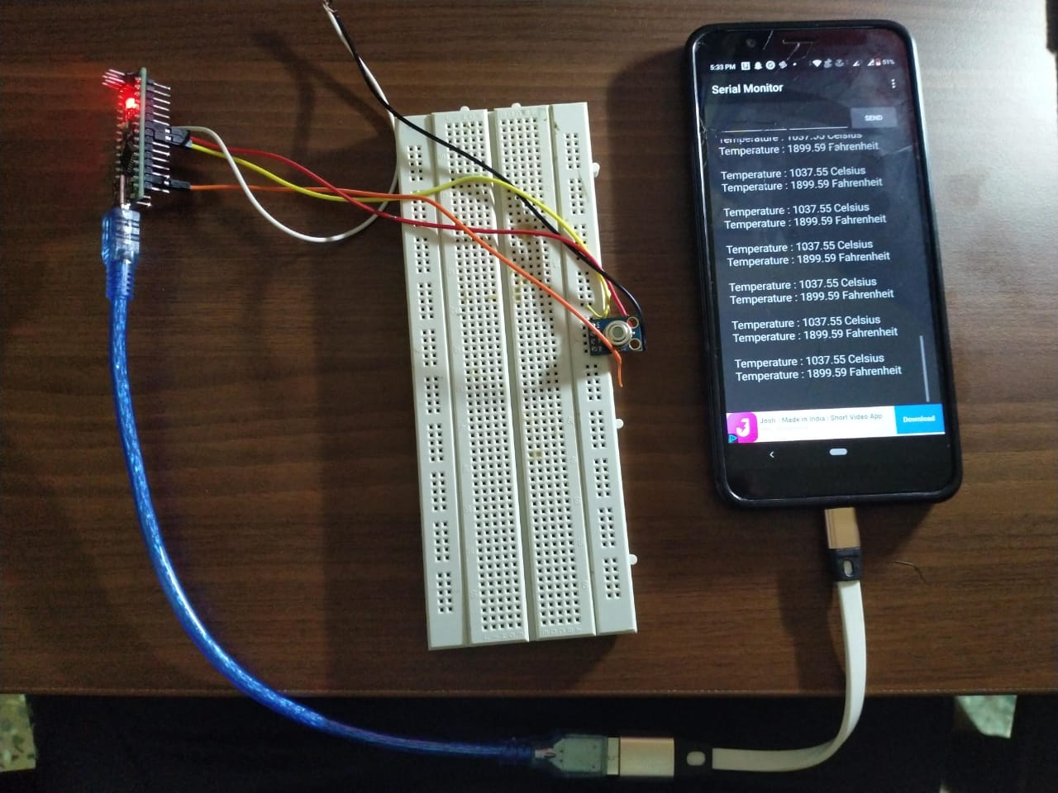

**Done by**

**Group - 11**

|  |  |  |
| --- | --- | --- |
| **Sl no** | **Student ID** | **Student Name** |
| 1 | TEJAS BHATNAGAR | 20171CSE0721 |
| 2 | THAJUDHEEN TK | 20171CSE0724 |
| 3 | THANUJ KUMAR S | 20171CSE0726 |
| 4 | UTSAV DEEP | 20171CSE0734 |
| 5 | UDITH L | 20171CSE0732 |

**THANK YOU**