practice: control operators

Submitted By

**Thanuj Kumar S**

1. Each question can be answered by one command line!
2. When you type **passwd**, which file is executed ?



1. What kind of file is that ?

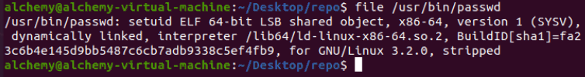

1. Execute the **pwd** command twice. (remember 0.)



1. Execute **ls** after **cd /etc**, but only if **cd /etc** did not error.



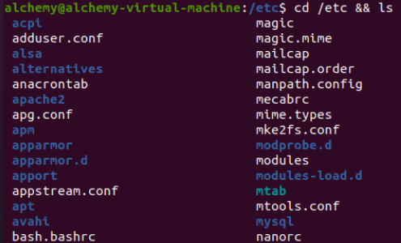

1. Execute **cd /etc** after **cd etc**, but only if **cd etc** fails.



1. Echo **it worked** when **touch test42** works, and echo **it failed** when the **touch** failed. All on one command line as a normal user (not root). Test this line in your home directory and in **/bin/** .

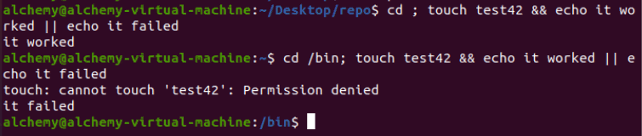

1. Execute **sleep 6**, what is this command doing ?

Answer:

Pausing for six seconds

1. Execute **sleep 200** in background (do not wait for it to finish).



1. Write a command line that executes **rm file55**. Your command line should print 'success' if file55 is removed, and print 'failed' if there was a problem.

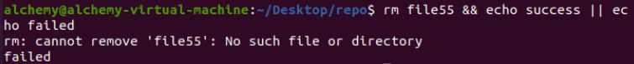

1. Use echo to display "Hello World with strange' characters \ * [ } ~

\\ ." (including all quotes)

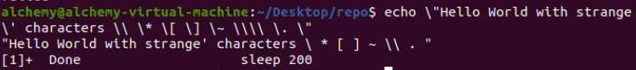

Submitted By

**Thanuj Kumar S**