practice: file contents

**Submitted By : Thanuj Kumar S**

1. Display the first 12 lines of /etc/services.

1. Display the last line of /etc/passwd.

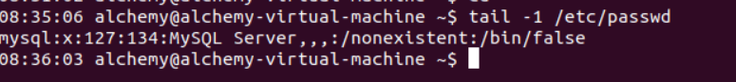

1. Use cat to create a file named count.txt that looks like this: One

Two Three Four Five

1. Use cp to make a backup of this file to cnt.txt.



1. Use cat to make a backup of this file to catcnt.txt.



1. Display catcnt.txt, but with all lines in reverse order (the last line first).

1. Use more to display /etc/services.



1. Display the readable character strings from the /usr/bin/passwd command.

1. Use ls to find the biggest file in /etc.

1. Open two terminal windows (or tabs) and make sure you are in the same directory in

both. Type echo this is the first line > tailing.txt in the first terminal, then issue tail -f

tailing.txt in the second terminal. Now go back to the first terminal and type echo This is

another line >> tailing.txt (note the double >>), verify that the tail -f in the second terminal

shows both lines. Stop the tail -f with Ctrl-C.

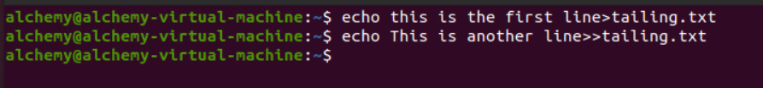



1. Use cat to create a file named tailing.txt that contains the contents of tailing.txt followed

by the contents of /etc/passwd

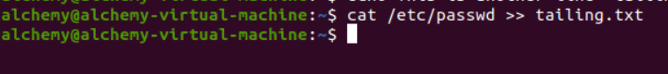

1. Use cat to create a file named tailing.txt that contains the contents of tailing.txt preceded

by the contents of /etc/passwd.

